5.3.19.2 Spring Hill

5.3.19.2.1 Location and extent

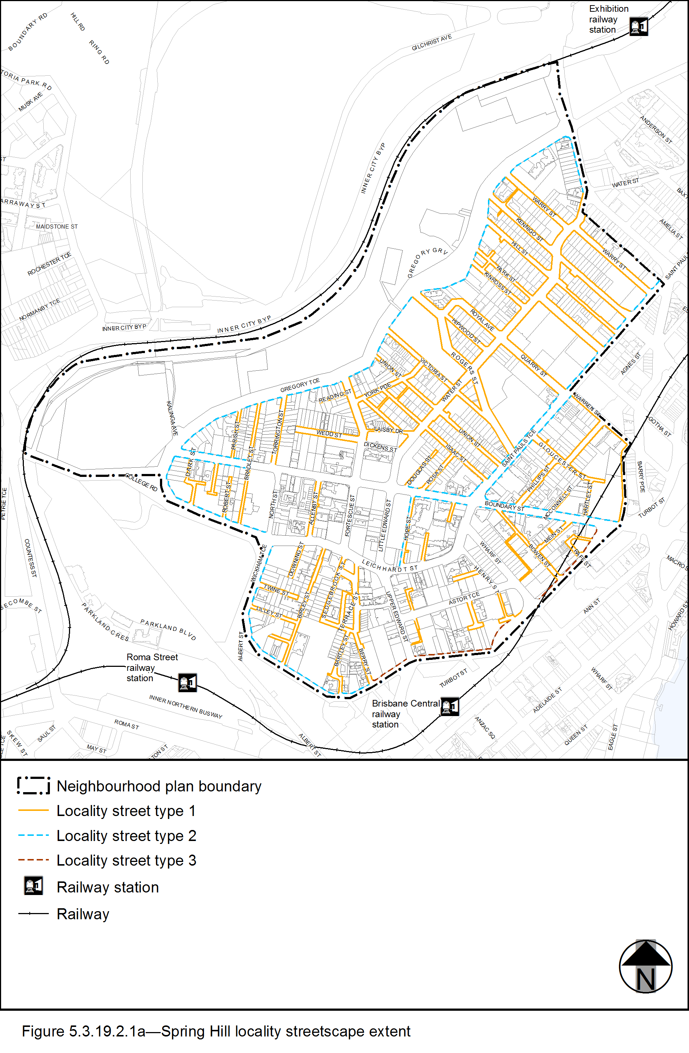
View the high resolution of Figure a–Spring Hill locality streetscape extent (PDF file size is 488Kb)
- The Locality Streets in the Spring Hill neighbourhood plan area are indicated on the Streetscape hierarchy overlay map and on Figure 5.3.19.2.1a.
- All streetscape works occurring within the Locality streets indicated in Figure 5.3.19.2.1a, must comply with the character specified in this document.
- Streetscapes outside these areas may be developed in keeping with this character, at the discretion of the developer and subject to Council approval.

5.3.19.2.2 Standard footway elements and materials
- These locality guidelines are to be read in conjunction with Chapter 3 – Road corridor design of the Infrastructure design planning scheme policy.
- Footway upgrades are to include new surfacing, new or reinstated kerb and channel, driveways, pedestrian kerb crossings, tactile markers, roof water drainage line connections, service pit lids, street trees, garden beds, furniture and pedestrian lighting applicable to the streetscape type.
- The scope, layout and detail of the footway upgrades are to be agreed on a site by site basis through the development assessment process.

5.3.19.2.3 Streetscape hierarchy

5.3.19.2.3.1 Streetscape types overview
- The locality streets within the Spring Hill neighbourhood plan area are exceptions to the standard streetscape hierarchy.
- The streetscape type and specifications for locality streets in this area are outlined in Table 5.3.19.2.3.1A and shown in Figure 5.3.19.2.1a.

Table 5.3.19.2.3.1A - Streetscape type and specifications
Component | Locality Streets Type 1 in the Spring Hill neighbourhood plan area
Verge width | Retain existing width.
Description | Full width pavement.
Unobstructed pavement | Refer to Table 5.3.19.2.3.1B.
Paving materials | Full width asphalt:  - Type: BCC Type 1 asphalt;  - Width: 25mm thick.
Tactile markers  (consistent with BSD-5218) | Type: Concrete tactile paver.  Supplier: Chelmstone, Urbanstone or approved equivalent.  Colour: CCS ‘Pewter’.
Driveways | Broom finished concrete.
Furniture | All furniture is to be located outside of the unobstructed pavement area.  Furniture elements and layout requirements are to be agreed on a site by site basis through the development assessment process.  Refer to 3.7.6 Design standards for street furniture for standard furniture elements and specifications.
Trees | Street trees planted in asphalt footpaths are to be planted in garden beds or tree grates and are permitted in accordance with the footway width requirements set out in Table 5.3.19.2.3.1B.  Streets trees include:  - a mix of tree species laid out in an informal manner with clusters of trees;  - medium and small crown trees to be planted at minimum 2m spacing, if within garden beds, or minimum 6m spacing outside of garden beds;  - large crown feature trees to be planted at minimum 10m centres.  Distance:  - all tree centrelines are 750mm from the nominal face of the kerb and a minimum of 600mm from the edges of the pavement.  Layout:  - a mix of species, in a single row at the rear of kerb;  - to be planted as singles and in pairs or clusters.
Garden beds | Garden beds are permitted subject to the footway width requirements set out in Table 5.3.19.2.3.1B.  A garden bed located adjacent to the kerb has a:  - 1.5m minimum spacing between garden beds;  - maximum length of 10m;  - layout and length to accommodate car parking and other kerbside allocation.
Component | Locality Streets Type 2 in the Spring Hill neighbourhood plan area
Verge width | 3.75m.
Description | Full width pavement.
Unobstructed pavement | 2.4m.
Paving materials | Full width asphalt:  - Type: BCC Type 1 asphalt;  - Width: 25mm thick.
Tactile markers (consistent with BSD-5218) | Type: Concrete tactile paver.  Supplier: Chelmstone, Urbanstone or approved equivalent.  Colour: CCS ‘Pewter’.
Driveways | Broom finished concrete.
Furniture | All furniture is to be located outside of the unobstructed pavement area.  Furniture elements and layout requirements are to be agreed on a site by site basis through the development assessment process.  Refer to 3.7.6 Design standards for street furniture for standard furniture elements and specifications.
Trees | Street trees planted in asphalt footpaths are to be planted in garden beds or tree grates and are permitted in accordance with the footway width requirements set out in Table 5.3.19.2.3.1B.  Streets trees include:  - a mix of tree species laid out in an informal manner with clusters of trees;  - medium and small crown trees to be planted at minimum 2m spacing, if within garden beds, or minimum 6m spacing outside of garden beds;  - large crown feature trees to be planted at minimum 10m centres.  Distance:  - all tree centrelines are 750mm from the nominal face of the kerb and a minimum of 600mm from the edges of the pavement.  Tree grates:  - 1.2m x 1.6m.  Layout:  - a mix of species, in a single row at the rear of kerb;  - to be planted as singles and in pairs or clusters.
Garden beds | Garden beds – minimum widths: 1.2m.  A garden bed located adjacent to the kerb has a:  - 1.5m minimum spacing between garden beds;  - maximum length of 10m;  - layout and length to accommodate car parking and other kerbside allocation.
Component | Locality Streets Type 3 in the Spring Hill neighbourhood plan area
Verge width | Retain existing width.
Description | Full width pavement.
Unobstructed pavement | 2.4m.
Paving materials | Type: Honed coloured concrete with sawcut pattern:  - Supplier: Hanson (code IP321BM24), Boral or approved equivalent;  - Colour: CCS ‘Liquorice’ 90% ‘Blue Heeler’ + 10% ‘Winter Brown’.
Tactile markers (consistent with BSD-5218) | Type: Concrete tactile paver 300 x 300mm.  Supplier: Chelmstone, Urbanstone or approved equivalent.  Colour: CCS ‘Voodoo’.
Driveways | Honed coloured concrete to match footway.
Furniture | All furniture is to be located outside of the unobstructed pavement area.  Furniture elements and layout requirements are to be agreed on a site by site basis through the development assessment process.  Refer to 3.7.6 Design standards for street furniture for standard furniture elements and specifications.
Trees | Street trees are to be planted in tree grates and are permitted in accordance with the footway width requirements set out in Table 5.3.19.2.3.1B.  Streets trees include:  - a mix of tree species laid out in an informal manner with clusters of trees;  - medium and small crown trees to be planted at minimum 2m spacing, if within garden beds, or minimum 6m spacing outside of garden beds;  - large crown feature trees to be planted at minimum 10m centres.  Distance:  - all tree centrelines are 750mm from the nominal face of the kerb and a minimum of 600mm from the edges of the pavement.  Tree grates:  - 1.6m x 1.6m where footway width permits;  - 1.2m x 1.6m elsewhere.  Layout:  - a mix of species, in a single row at the rear of kerb;  - to be planted as singles and in pairs or clusters.
Garden beds | No garden beds.

Table 5.3.19.2.3.1B—Footway width exceptions
Verge widths (from nominal face of kerb) | Garden bed width | Street trees | Unobstructed pavement width
Less than 2.1m | No garden beds | No | Full width
2.1m - 2.49m | 750mm - 1.15m | No | 1.2m
2.50m - 3.14m | 1.15m | Yes | 1.2m - 1.8m
3.15m - 3.74m | 1.2m | Yes | 1.8m - 2.4m
3.75m | 1.2m | Yes | 2.4m

5.3.19.2.4 Planting

5.3.19.2.4.1 Street trees
- Street trees are permitted as identified in Table 5.3.19.2.3.1A.
- Table 5.3.19.2.4A and Chapter 3 of this planning scheme sets out the approved street tree species for use on the various streets within the Spring Hill area.
- Each street has a minimum of 2 approved street tree species to encourage variety and diversity within the precinct.
- Where 2 or more street trees are required on the same development frontage, a mixture of the appropriate species as listed in Table 5.3.19.2.4A and Chapter 3 of this planning scheme policy is required.

5.3.19.2.4.2 Garden beds
- Garden beds are permitted as identified in Table 5.3.19.2.3.1A.
- Shrub and groundcover species are to be selected from Chapter 3 of this planning scheme policy.

Table 5.3.19.2.4A—Street trees
Street | Preferred species—trees
Gregory Terrace | Jacaranda mimosifolia  Handroanthus impetiginosus  Buckinghamia celsissima
Rogers Street | Flindersia australis  Ficus benjamina  Buckinghamia celsissima

