5.3.23.2 Wynnum—Manly

5.3.23.2.1 Location and extent
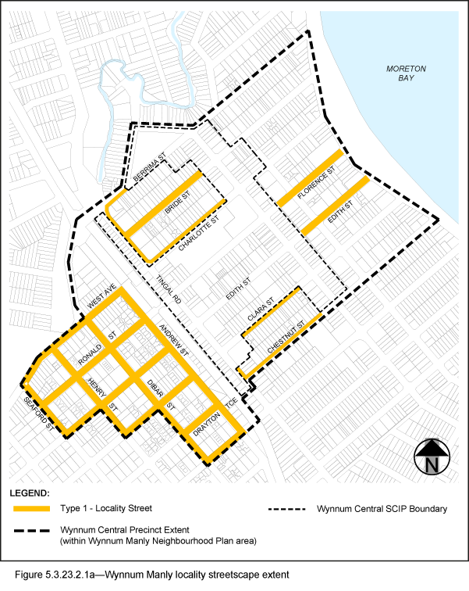
- The Locality Streets in the Wynnum Manly Neighbourhood Plan area are indicated on the Streetscape hierarchy overlay map and on Figure 5.3.23.2.1a.
- All streetscape works occurring within the Locality Streets indicated in Figure 5.3.23.2.1a, must comply with the character specified in this document.
- Streetscapes outside these areas may be developed in keeping with this character, at the discretion of the developer and subject to Council approval.

5.3.23.2.2 Standard footway elements and materials
- These locality guidelines are to be read in conjunction with Chapter 3 – Road corridor design of the Infrastructure design planning scheme policy.
- Footway upgrades are to include new surfacing, new or reinstated kerb and channel, driveways, pedestrian kerb crossings, tactile markers, roof water drainage line connections, service pit lids, street trees, garden beds, furniture and pedestrian lighting applicable to the streetscape type.
- The scope, layout and detail of the footway upgrades are to be agreed on a site by site basis through the development assessment process.

5.3.23.2.3 Streetscape hierarchy

5.3.23.2.3.1 Streetscape types overview
- The locality streets within the Wynnum Manly Neighbourhood Plan area are exceptions to the standard streetscape hierarchy.
- The streetscape type and specifications for locality streets in this area are outlined in Table 5.3.23.2.3.1A and shown in Figure 5.3.23.2.1a.
- If the total footway width is narrower than 3.75m, the turf strip with street trees and pedestrian paths shall comply with the dimensions outlined in Table 5.3.23.2.3.1B.

Table 5.3.23.2.3.1A—Streetscape type and specifications
Specifications | Locality Streets in Wynnum Manly Neighbourhood Plan area (excluding locality streets within Wynnum Central SCIP area)
Verge Width | Existing width (as per Table 5.3.23.2.3.1B)
Pavement width | As per Table 5.3.23.2.3.1B
Description | Concrete footpath in turf
Paving materials | Broom finished: Standard Portland Grey concrete
Tactile Paving  (consistent with BSD-5218) | Type: Concrete tactile paver  Supplier: Chelmstone, Urbanstone or approved equivalent  Colour: CCS ‘Voodoo’
Driveways | Broom finished: Standard Portland Grey concrete
Turf strip adjacent kerb – minimum width | As per Table 5.3.23.2.3.1B
Street Trees | Street trees:  - All trees minimum of 750mm from nominal face of kerb.  - Distance between trees and edges of pavement varies depending on turf width in accordance with Table 5.3.23.2.3.1B.  - Mix of tree species laid out in an informal manner with clusters of trees;  - Medium and small crown trees to be planted at minimum 2m spacing, if within garden beds, or minimum 6m spacing outside of garden beds;  - Large crown feature trees to be planted at minimum 10m centres.  Layout:  - Street trees are a mix of species, in a single row at the rear of kerb.  - Trees to be planted as singles and in pairs or clusters.  Trees planted in: Mulched tree planting area in turf.  Tree planting beds – minimum widths:  - 1.2m where turf width permits;  - Equal to turf width where less than 1.2m.
Furniture | None.

Table 5.3.23.2.3.1B—Streetscape width exceptions
Verge widths (from nominal face of kerb) | Pavement width | Turf strip adjacent kerb – minimum width | Turf strip at rear of verge | Street trees | Distance between tree and edge of pavement
Less than 2.1m | Full width | No turf | None | No | N/A
2.1m – 2.49m | 1.2m | 750mm – 1.14m | None | No | N/A
2.50m – 3.14m | 1.2m | 1.15m – 1.79m | None | Yes | 550mm – 1.19m
3.15m – 3.74m | 1.8m | 1.2m – 1.69m | None | Yes | 600mm – 1.09m
3.75m | 1.8m | 1.3m | 0.5m | Yes | 600mm
Note—Dimensions are indicative only. Footway layout will be assessed on a site by site basis at the discretion of Council’s Development Assessment Officer.

5.3.23.2.3.2 Wynnum Central Suburban Centre Improvement Project
Any works required to footways within the Wynnum Central Suburban Centre Improvement Project (SCIP) area, as shown on Figure 5.3.23.2.1a, is to be in accordance with section 5.3.23.3 Wynnum Central of the Infrastructure Design Planning Scheme Policy.

5.3.23.2.4 Planting

5.3.23.2.4.1 Street trees
- Street trees are permitted as identified in Table 5.3.23.2.3.1A.
- Table 5.3.23.2.4A sets out the approved street tree species for use on the various streets within the Wynnum Manly area.
- Each street has a minimum of two approved street tree species to encourage variety and diversity within the precinct.
- Where two or more street trees are required on the same development frontage, a mixture of the appropriate species as listed in Table 5.3.23.2.4A is required.

Table 5.3.23.2.4A—Street trees
Street | Tree species
Andrew Street | Peltophorum pterocarpum  Xanthostemon chrysanthus
Berrima Street | Callistemon viminalis  Xanthostemon chrysanthus
Besham Parade | Harpullia pendula  Xanthostemon chrysanthus
Bride Street | Melaleuca linariifolia  Peltophorum pterocarpum
Charlotte Street | Buckinghamia celsissima  Peltophorum pterocarpum
Chestnut Street | Cupaniopsis anacardiodes  Peltophorum pterocarpum
Clara Street | Harpullia pendula  Xanthostemon chrysanthus
Collina Street | Callistemon viminalis  Xanthostemon chrysanthus
Dibar Street | Peltophorum pterocarpum  Xanthostemon chrysanthus
Edith Street* | Cupaniopsis anacardiodes  Peltophorum pterocarpum
Emsworth Street | Cupaniopsis anacardiodes  Peltophorum pterocarpum
Florence Street* | Pongamia pinnata  Peltophorum pterocarpum
Henry Street | Peltophorum pterocarpum  Xanthostemon chrysanthus
Ronald Street | Pongamia pinnata  Peltophorum pterocarpum
*Except in Wynnum Central SCIP

