SC6.28 Storage and dispensing of petroleum products planning scheme policy

Contents
1 Introduction
1.1 Relationship to planning scheme
1.2 Purpose
1.3 Terminology

2 Standards
2.1 General
2.2 Surface water and groundwater protection standards
2.2.1 Underground tanks
2.2.2 Leak detection systems
2.2.2.1 Leak detection systems for underground tanks
2.2.2.2 Leak detection systems for pipework
2.2.3 Self-bunded above-ground tanks
2.2.4 Single-skin above-ground tanks
2.2.5 Pipework
2.2.6 Fuel dispensing area
2.2.7 Uncovered forecourt area
2.3 Air quality standards
2.3.1 Vapour recovery systems

1 Introduction

1.1 Relationship to planning scheme
This planning scheme policy:
- provides information the Council may request for a development application;
- provides guidance or advice about satisfying an assessment benchmark which identifies this planning scheme policy as providing that guidance or advice;
- states a standard for the following assessment benchmarks identified in the table.
Column 1 –  Section or table in the code | Column 2 –  Assessment benchmark reference | Column 3 –  Standard in the planning scheme policy
Industry code
Table 9.3.12.3.A | AO8.4 | Section 2.2
Table 9.3.12.3.A | AO9 | Section 2.2
Service station code
Table 9.3.21.3.A | AO6 | Section 2.2
Table 9.3.21.3.A | AO7.1 | Section 2.3.1
Table 9.3.21.3.A | AO7.2 | Section 2.3

1.2 Purpose
This planning scheme policy outlines standards to mitigate surface water, groundwater and air pollution risks from the storage and dispensing of petroleum products.

1.3 Terminology
In this planning scheme policy, unless the context or subject matter otherwise indicates or requires, a term has the following meaning:

fuel dispensing area (FDA): the immediate area surrounding the fuel dispensing unit/s where vehicles or other equipment are routinely refuelled and at which there is a higher risk of contamination. This area is generally delineated by the canopy line.

petroleum products: any fuel that consists predominantly of a mixture of hydrocarbons derived from crude oil whether or not the fuel includes additives (such as ethanol) and includes oil and used oil

product piping: piping that routinely contains petroleum product. For the purposes of this document, vent piping and vapour recovery piping are not classified as product piping.

road tanker delivery stand : the area where the bulk fuel delivery vehicle stands to deliver its load of fuel by hose to the underground/above-ground tank fill point/s

significantly modified: any modification to an underground petroleum storage system that involves the replacement of half or more of the tanks in a system

uncovered forecourt area (UFA): uncovered forecourt areas can include vehicular access ways, parking bays and related areas such as remote air/water supply areas. It generally includes all outside areas apart from the FDA.

underground petroleum storage system (UPSS): one or more completely or partially buried tanks that contain, or are intended to contain, petroleum products and includes leak monitoring systems and all associated piping to, from or associated with the tanks.

Stage 1 vapour recovery: a system of pipes and valves designed to capture fuel vapour emissions as fuel delivery tankers unload petroleum to refill the underground tanks. The system captures the vapours that are displaced from the underground tank and diverts them back to the tanker compartment instead of releasing them to the atmosphere through the tank’s vent pipe. This vapour is then returned to the fuel terminal where it can be recondensed back to motor spirit.
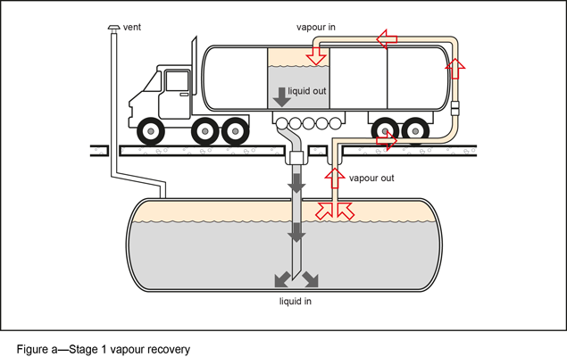
Stage 2 vapour recovery: a system designed to reduce the emission of vapour to atmosphere by capturing fuel vapour as a vehicle’s fuel tank is being refilled. The fuel entering a vehicle’s fuel tank displaces vapour which is captured at the fill point through the nozzle with the aid of an added vacuum system and is returned to the underground storage tank.
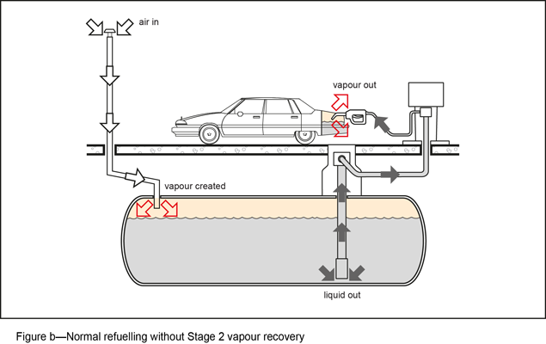
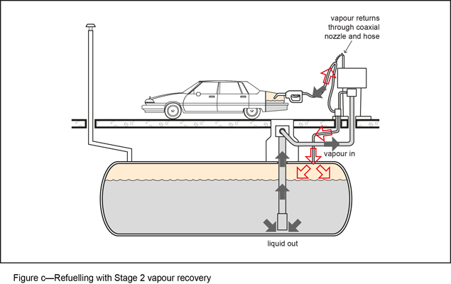

2 Standards
- This section outlines the standards that can be used to satisfy assessment benchmarks to mitigate pollution risks from facilities undertaking storage and dispensing of petroleum products.
- Alternative measures that achieve the same or better performance than the stated standards may be used where justification is made to and accepted by Council.

2.1 General
- The site is to be designed to avoid or minimise the risk of pollutants, including but not limited to dust, fumes, odour, liquid wastes, contaminated stormwater, sediments, diesel or petroleum products, and contaminated firewater from leaving the site by means of wind carriage, vehicle movements, stormwater run-off, wastewater discharge, or seepage into or onto land.
- The requirements of AS1940-2004 The storage of flammable and combustible liquids are to be considered when designing, constructing or modifying facilities for the storage and dispensing of petroleum products.

2.2 Surface water and groundwater protection standards

2.2.1 Underground tanks
- All tanks are to be non-corrodible and be constructed of either:
- fibre-reinforced thermosetting resin (fibreglass) that is compatible with the product; or
- a steel inner wall and a fibre-reinforced thermosetting resin composite (fibreglass) outer wall with an interstitial space between the 2 walls.
- All tanks are to be double walled and have an interstitial space between the 2 walls of the tanks that is capable of being monitored for any breach of either the inner or outer wall of the tank.
- All tanks are to meet the requirements of AS1692-2006 Steel tanks for flammable and combustible liquids, UL 1316 Glass fibre reinforced underground storage tanks for petroleum products, alcohols and alcohol gasoline mixtures or the equivalent.
- An overfill protection valve is to be installed in the drop tube of the tank and calibrated to prevent the tank from being filled in excess of 90% of its capacity. An overfill alarm is to be installed to visually and audibly alert persons in the vicinity of the tank.

2.2.2 Leak detection
All underground petroleum storage systems are to include an approved leak detection system that:
- can detect a leak from any portion of the underground storage system;
- uses equipment that has been installed, calibrated and commissioned in accordance with the manufacturer's instructions;
- is capable of detecting a leak at a rate of 0.76L per hour or more with at least 95% accuracy and a probability of false detection of 0.05 or less (United States Environmental Protection Agency (USEPA));
- has been certified by an independent third party, consistent with the current USEPA protocols and system of verification (USEPA 1990, 40 CFR Part 280, Subpart D).

2.2.2.1 Leak detection systems for tanks
The following leak detection systems are to be used:
- statistical inventory reconciliation (SIR) that includes a software-based system where daily tank dip readings, delivery records and sales records are entered onto a proprietary software package; or
- automatic tank gauging (ATG) that includes an automatic system using an arrangement of sensor probes and other devices that monitor the underground petroleum storage system and provide inventory information and leak testing;
- a tank pit observation well at the lowest point of each tank excavation pit.

2.2.2.2 Leak detection systems for pipework
Leak detection systems for underground pipework are to include:
- electronic line leak detection (ELLD) for pressure piping; or
- safe suction for suction piping.
Note—Sites with remote fill lines shall also operate a statistical inventory reconciliation system to monitor leaks in fill lines.

2.2.3 Self-bunded above-ground tanks
- The capacity of any self-bunded tank is not to exceed the following:
- 55,000L for PGII liquids;
- 110,000L for PGIII liquids;
- 110,000L for combustible (C1, C2) liquids.
- Signage indicating the capacity and type of product is to be prominently displayed on the tank/s.
- Tanks are to be located to meet all relevant separation distances of AS1940-2004 The storage of flammable and combustible liquids. Where a tank having multiple compartments is installed, the separation to boundaries and protected places is to be based on the volume of the compartments and the lowest flashpoint of the liquid in any tank compartment.
- Spacing between adjacent tanks is to be at least 600mm.
- The tank, including the inner and outer walls, is to comply with AS1692-2006 Tanks for flammable and combustible liquids or equivalent standard.
- The tank is to be fitted with a means of determining the level of the contents. Such means are to be available to the delivery operator.
- Provision is to be made for the relief of any pressure in the interstitial space during fire engulfment conditions.
- All piping connections to the tank are to be above the normal maximum fill level.
- The tank is to be fitted with anti-siphon protection.
- An overfill protection valve is to be installed in the drop tube of the tank and calibrated to prevent the tank from being filled in excess of 90% of its capacity. An overfill alarm is to be installed to visually and audibly alert persons in the vicinity of the tank.
- A means shall be provided to empty the fill hose after filling the tank, such that the risk of spillage is minimised and any spillage which does occur is contained.
- A system is to be installed to monitor the interstitial space between the inner and outer walls for leakage from the inner tank.
- Where the tank is located in a position where it could be struck by vehicles, it is to be protected from such impact by barriers strategically placed and firmly anchored to the ground or surrounding structure/s.

2.2.4 Single-skin above-ground tanks
Single-skin above-ground tanks are to be installed within a bunded compound to contain any leaks or spillages and are to comply with the following:
- Signage indicating the capacity and type of product is to be prominently displayed on the tank/s.
- Tanks are to be located to meet all relevant separation distances of Clause 5.7, AS1940-2004 The storage of flammable and combustible liquids. Where a tank having multiple compartments is installed, the separation to boundaries and protected places is to be based on the volume of the compartments and the lowest flashpoint of the liquid in any tank compartment.
- The tank is to be fitted with a means of determining the level of the contents. Such means are to be made available to any delivery operator.
- The tank fill point is to be fitted with a camlock type or other liquid-tight connection and provided with spill containment of at least 15L capacity per spill point.
- The bunded compound is to be sufficiently impervious to retain spillage and to enable recovery of any such spillage. The compound is to be:
- chemically resistant and fire resistant as far as is necessary to fulfil its functions. Suitable materials may include waterproofed, reinforced concrete or an equivalent (permeability should be <10–9 m/s);
- constructed so that in a fire situation, the bund will retain its structural integrity;
- designed to withstand the hydrostatic head when full.
- The net capacity of a bunded compound is to be at least 100% of the capacity of the largest tank. The capacity of on-site containment is to be increased to include the calculated output of any fire water over a 20-minute period. If 2 or more tanks are operated as a single unit, then the capacity of all such tanks is to be used when calculating the capacity of the compound.
- The bund is to have no direct openings, outlets or valves connecting the bund to any drain, sewer or watercourse or that allows discharge onto unmade ground.
- The bunded compound is to have a drainage provision installed that slopes away from any tank to a catchment sump which is to be constructed at the lowest point of the bunded area.
- Any pipework is to be directed over the bund wall and not through it, unless seals/pipework are specifically designed to retain liquid tightness in a fire situation.
- Any valve controlling the drainage from a compound is to be:
- located outside the bund (except for any valves for intermediate sub-compounds);
- of a type in which the distinction between the open and shut positions is obvious, and is to incorporate a provision to be locked shut when not actually draining;
- kept closed and locked except during supervised drainage. A notice with the words 'BUND DRAIN VALVE - TO BE KEPT CLOSED AND LOCKED' is to be prominently displayed in the vicinity of the bund drain valve.
- The location of a bund relative to the closest tank is to be such that the top inside perimeter of the bund is not inside the crest locus limit as specified in Figure 5.2 AS1940-2004 The storage and handling of flammable and combustible liquids, except where it can be demonstrated that a reduced distance would be appropriate due to viscosity or other considerations.
- Where flammable liquids are stored, the distance from the top inside perimeter of the bund to protected places or on-site protected places is to be at least one-half of the specified separation distance given in Table 5.4 AS1940-2004 The storage and handling of flammable and combustible liquids or 15 m, whichever is less.
Note—The design of bunded compounds for above-ground tanks is also to comply with Clause 5.8, AS1940-2004 The storage and handling of flammable and combustible liquids, or the equivalent, in regard to fire safety related matters.
- Where the tank bund is located in a position where it could be struck by vehicles, it is to be protected from such impact by barriers strategically placed and firmly anchored to the ground or surrounding structure/s.

2.2.5 Pipework
- All underground pipework is to be made of approved, non-corrodible materials. Approved materials include either:
- fibre-reinforced thermosetting resin composite (fibreglass) compatible with the product to be transferred; or
- flexible plastic meeting the requirements of UL971 Standard for non-metallic underground piping for flammable liquids.
- All product piping is to have secondary containment consisting of double-walled piping with an interstitial space.
- Each tank fill point is to be:
- clearly labelled and identified in compliance with AS 4977-2008 Petroleum products - Pipeline, road tanker compartment and underground tank identification;
- fitted with a camlock type or other liquid-tight connection;
- provided with spill containment of at least 15L capacity per spill point.
- All fill and vapour recovery points are to be earthed in compliance with AS/NZS 1020- The control of undesirable static electricity and AS/NZS 3000- Electrical installations.

2.2.6 Fuel dispensing area
- All ground surfaces within the FDA are to be constructed of impermeable materials free of gaps and/or cracks. Suitable materials include waterproofed, reinforced concrete or an approved equivalent.
- The FDA is to be clearly demarcated from the outer forecourt area, access roads, general parking bays and all other areas to clearly delineate the higher contamination risk area from lower risk areas. Acceptable demarcation methods include a painted line on the ground, roll-over bunds, drainage lines or different coloured impermeable material.
- A canopy is to be installed over all FDAs. The canopy is to be designed to minimise the amount of rain entering the dispensing area and shall overhang by a horizontal distance of at least one-quarter of the roof height out from the vertical above the boundary of the demarcated fuel dispensing area.
- The area within the FDA is to be graded and drained to a containment vessel having no connections to stormwater or sewer (also referred to as a ‘blind sump’) and is to be compatible with petroleum products. Acceptable materials of construction include precast concrete with a minimum certified design life of 50 years, designed in accordance with AS 3600-2009 Concrete structures. Other materials of construction may be used where approved by Council.
- The containment vessel is to have a capacity to hold a volume equivalent to at least that of the largest tanker compartment likely to be delivering fuel to the site plus an allowance for windblown rain. Windblown rain allowance in m3 (Vr) can be calculated using the following equation: Vr = 0.005 x 3 x Po where Po is the total length of the open perimeter of the canopy in metres.
- Signage indicating the rate of flow is to be provided for drainage inlets in the FDA. Examples include 'Flows to blind sump', or 'Flows to containment facility'. Signage is to be painted or otherwise indicated around the drain inlets.
- Where fuel deliveries are intended within the FDA, the standing area is to be clearly demarcated and graded to the FDA containment vessel.
- A liquid-tight dispenser sump is to be installed under each dispensing unit. It is to be designed to house all pipework joins and fittings and to collect and contain any leak from contaminating the surrounding soil/groundwater.

2.2.7 Uncovered forecourt area
- All ground surfaces of UFAs liable to contamination from vehicular activities are to be constructed of impermeable materials, free of gaps or cracks. Suitable materials include asphalt, waterproofed, reinforced concrete or an approved equivalent.
- All stormwater from UFAs is to be captured and drained to an approved stormwater treatment system. Treatment systems for stormwater from areas other than FDAs are to be designed to comply with the Urban Stormwater Quality Planning Guidelines 2010.
- Stormwater quality improvement devices (SQIDs) are to be installed as part of the stormwater drainage system for the UFA, and are to incorporate the following design measures:
- steel bars or trash gates with at least 20mm spacing;
- filtration devices such as sand filters or gross pollutant traps capable of removing litter (diameter greater than 5mm) and at least 70% of fine sediments (>125µm);
- a wastewater treatment device, such as an oil and hydrocarbon separator, triple interceptor or equivalent, capable of removing droplets larger than 60µm (i.e. corresponding to outlet discharge of approximately 15mg/L) and to a point where there is no visible sheen or odour on stormwater. This device is to be able to meet these requirements during a storm up to the 2 year ARI-6 minute design rainfall event without surcharging or backing up the drainage system;
- flow cut-off valves are to be installed at the outlet from the separator to use in case of an emergency or cleaning operations.
- Signage indicating the rate of flow is to be provided for drainage inlets in the UFA. Examples may include 'flows to stormwater treatment system' or 'flows to creek'. Signage is to be painted or otherwise indicated around the drain inlets.
- Road tanker delivery stands located within the UFA are to be clearly demarcated and sited away from buildings, traffic areas, dispensing areas and emergency escape routes. The road tanker delivery stand is to be normally drained to the UFA stormwater treatment system, however, diversion valves are to be engaged during fuel delivery operations to divert drainage to the FDA containment system (blind sump).

2.3 Air quality standards

2.3.1 Stage 1 vapour recovery systems
Stage 1 vapour recovery systems are to return displaced vapour to the delivery tanker via a vapour return line. Each underground storage tank is to have:
- vapour return lines that return all vapour displaced from the storage tank to the delivery tanker;
- vapour-tight couplings on the vapour line that close automatically when disconnected;
- liquid-tight couplings on the liquid transfer hoses;
- incompatible liquid and vapour couplings;
- spill containment enclosures for the storage tank fill connection point;
- secure seals on tank filling pipes and vapour return pipes that minimise vapour leaks when the pipes are not in use;
- submerged fill pipes, so they terminate below the suction inlet used for pumping petrol out of the storage tank;
- overfill protection devices (float vent valves) fitted to shut off the petrol flow at the level advised by the tank manufacturer;
- for new petrol service stations, overfill prevention devices (mechanical or electronic) that slow delivery of petrol into the storage tank as the level in the storage tank approaches the design fill level – the devices should be positioned to stop the petrol flow before the float vent valve operates;
- secure seals on any dip hatch openings;
- a pressure vacuum valve and a 10-millimetre orifice in parallel fitted to the storage tank vent pipe. Similar devices are permitted, but will only be accepted by Council where they are shown by an independent certifier to perform the same duty.

2.3.2 Stage 2 vapour recovery systems
- All dispensers for motor spirit/petrol shall be fitted with stage 2 vapour recovery equipment (VR2) in compliance with NSW DECC Standards and Best Practice Guidelines for Vapour Recovery at Petrol Service Stations.
- Before commissioning, the stage 2 vapour recovery system must be certified by the manufacturer or the supplier as being of the following type and hydrocarbon capture efficiency:
- Type: a stage 2 vapour recovery system approved by the German TÜV with a visual indicator that the vacuum operates when fuel is dispensed. The approval must be in accordance with the provisions of Ordinance on the Limitation of Hydrocarbon Emission Resulting from the Fuelling of Motor Vehicles – 21, BImSchV (section 3, paragraph 6) [2002], and
- Hydrocarbon capture efficiency: a hydrocarbon capture efficiency of not less than 85% vapour recovery to liquid dispensed by volume as measured using a test for active vapour recovery systems in Verein Deutscher Ingenieure (VDI) specification 4205.
- The certification obtained must certify that the VR2 system achieves at least 85% vapour recovery and must specify the test used. A copy of this certification shall be provided to Council before commissioning of the system.
- The stage 2 vapour recovery equipment shall be installed in accordance with the manufacturer’s specifications by a duly qualified person. A copy of this certification shall be provided to Council before commissioning of the system.
- Before commissioning, the stage 2 vapour recovery equipment shall be tested by a duly qualified person in the manner specified in the NSW DECC Standards and Best Practice Guidelines for Vapour Recovery at Petrol Service Stations. A copy of this certification shall be provided to Council before commissioning of the system.
- Each petrol dispenser that is fitted with VR2 control equipment must display a sign stating VR2 equipment is present. If every petrol dispenser is fitted, a sign indicating that vapour recovery equipment is in use must also be attached to the petrol service station premises.

