SC6.32 Transport air quality corridor planning scheme policy

Contents
1. Introduction
1.1 Relationship to planning scheme
1.2 Purpose

2 Transport air quality corridor report

3. Built form and landscape design elements to facilitate pollutant dispersal
3.1 Element 1 – avoiding the ‘street canyon’ effect
3.1.1. Street canyon dimensions
3.1.2 Gaps for airflow
3.2 Element 2 – encouraging turbulence
3.2.1 Building ‘roughness’
3.2.2 Variation in streetscape
3.2.3 Significant vegetation

1 Introduction

1.1 Relationship to planning scheme
This planning scheme policy provides:
- information the Council may request for a development application;
- guidance or advice about satisfying an assessment benchmark which identifies this planning scheme policy as providing that guidance or advice.

1.2 Purpose
This planning scheme policy provides guidance and information required for preparing a transport air quality corridor report to demonstrate how a development for a multiple dwelling, residential care facility or retirement facility incorporates best-practice built form and landscape design elements to maximise wind movement around buildings and the dispersion of road-traffic air pollutants.

2 Transport air quality corridor report
- The transport air quality corridor report is to contain a description of the proposed development including drawings and illustrations to show the dimensions and form of the development on the site, including balconies and other facade features, podia and above-podium towers and setbacks, roof shapes, location of significant trees and position of outside air intakes for any mechanical ventilation.
- The transport air quality corridor report is to include a description of the best-practice design features to be included in the development that address the built form and landscape design elements in section 3 of this planning scheme policy. Justification of all departures from the design guidelines in section 3 of this planning scheme policy is to be provided, including examples of how the proposed design elements have been applied in other existing developments to maximise dispersion of road-traffic pollutants.

3 Built form and landscape design elements to facilitate pollutant dispersal

3.1 Element 1 – avoiding the ‘street canyon’ effect

3.1.1 General
A street canyon is the deep, narrow, valley-like space above a street in a city which is created by tall buildings on both sides that do not have gaps for airflow, thereby trapping and preventing the dispersion of traffic air pollutants.

3.1.2 Street canyon dimensions
- Certain street canyon dimensions produce poor flushing of the air at street level and thereby, a build-up of pollutant levels. Figure a shows how to calculate street canyon dimensions.
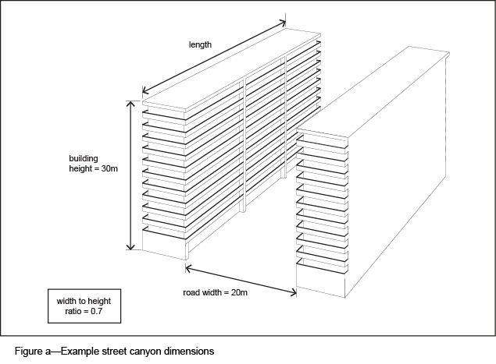
- Modelling of air movement within different canyon geometries has found that the width-to-height and length-to-height ratios and roof shapes have a significant effect on pollutant concentrations within the canyon. Pollutant concentrations can be reduced by the following:
- maintaining a canyon width-to-height ratio greater than 0.7;
- constructing buildings asymmetrically, so that those on one side of the road are preferably 1.5 times taller (preferably the upwind side) than those on the other side;
- placing slanting roofs on buildings, ensuring that the slope and height of the roof is not identical to roof slope and height of buildings neighbouring the development or on the opposite side of the road.
- The transport air quality corridor report is to include illustrations with the following information to demonstrate that the development addresses the street canyon effect:
- height and width of the proposed building;
- distance from the building to the kerb of the road;
- distance from the building to the side boundaries of the site;
- width of the road from kerb to kerb;
- the average height of existing buildings along the road, for a distance of 5 times the height of the proposed development, in both directions from the development.

3.1.3 Gaps for airflow
- Significant gaps in the streetscape through which air can flow and pollutants can disperse, are an important design element. This includes gaps between buildings and between towers above a podium (refer to Figure c). Variation in building height and form also assists in achieving airflow.
- Figure b illustrates poor dispersal whilst Figure c illustrates good dispersal.
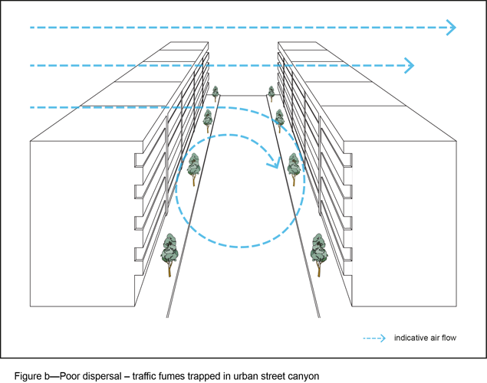
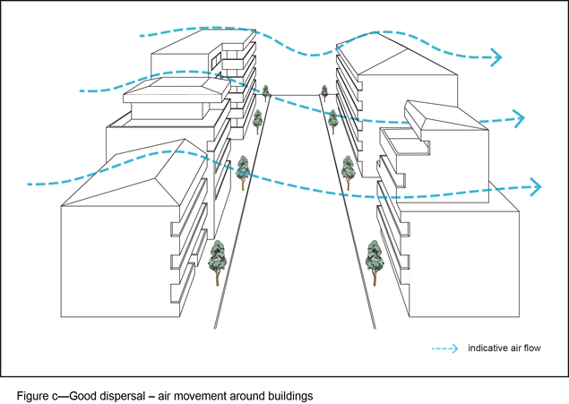
- The following design elements can increase the dispersion of traffic air pollutants:
- above podium height, the width of the building extends for no more than 75% of the width of the property, and is a maximum of 30m in any direction;
- where there is more than 1 tower above the podium, the towers are separated by a distance of at least 10m;
- a gap is maintained between buildings at the 3rd storey and above of at least 3m;
- a setback is maintained from the side boundary;
- upper storeys of multi-level buildings are set back.
- The transport air quality corridor report is to include illustrations containing the following information to demonstrate that the development includes gaps for:
- distance between development and existing neighbouring buildings at the 3rd storey and above, on both sides of the development (refer to Figure d);
- dimensions of above podium towers and where more than 1 tower forms part of the development, the distance between towers;
- a photograph or short description of the roof shape of existing buildings neighbouring and opposite the development (refer to Figure e).
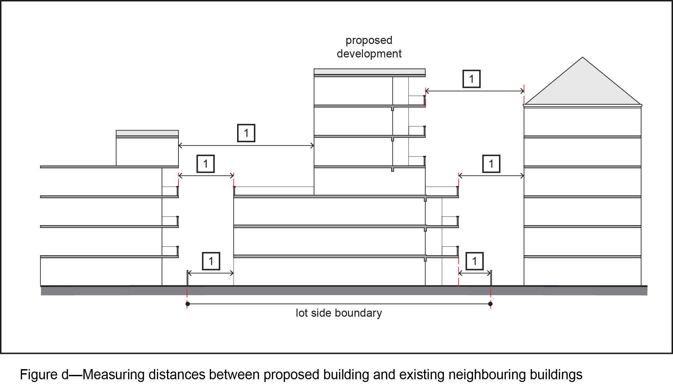
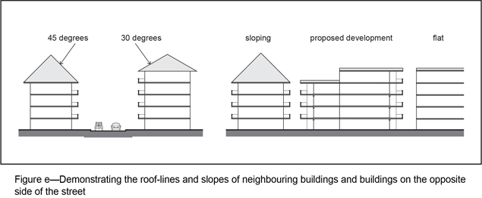

3.2 Element 2 – encouraging turbulence
- Dispersion of traffic air pollutants is improved where building design, streetscape and urban form increases wind turbulence in the road corridor. This can be achieved by incorporating a high degree of building 'roughness', which includes varying building heights, widths, tiers and shapes, providing air gaps between buildings to avoid continuous built form and varying roof shapes. Using significant vegetation along the roadside also encourages turbulence.
- Figure f and Figure g illustrate the design elements that contribute to building roughness and wind turbulence.
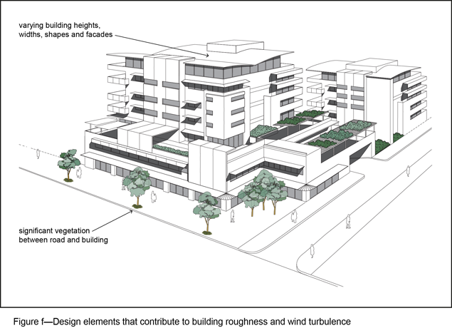
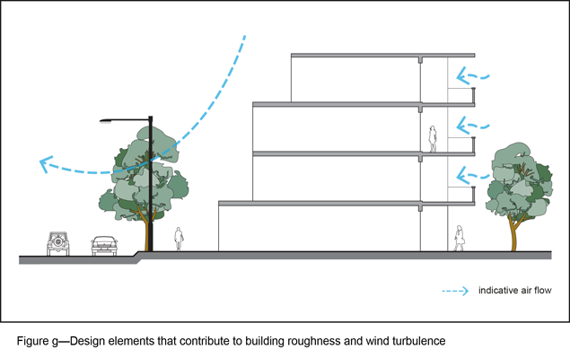

3.2.1 Building ‘roughness’
- Each building is to have a degree of 'roughness’ to its form and not be a sheer-walled box built to each boundary.
- The transport air quality corridor report is to include illustrations to demonstrate the following:
- the building incorporates variation into the facade, so as to avoid a flat, uniform surface. This is additional to external balconies;
- the building achieves a minimum variation in sectional elevation of 3 storeys.

3.2.2 Variation in streetscape
- Variation in built form along the road corridor to create a variation in streetscape is to maximise wind turbulence and the dispersal of traffic air pollutants.
- The transport air quality corridor report is to include illustrations of the development and photographs of the site showing neighbouring buildings and buildings on the opposite side of the road to demonstrate that the building will not be identical in height and form to neighbouring buildings or buildings on the opposite side of the road.

3.2.3 Significant vegetation
- Significant vegetation situated between the road and the building can increase wind turbulence and assist dispersion of road-traffic air pollutants. Development design is to allow for deep plantings to facilitate larger trees along the road frontage.
- The transport air quality corridor report is to include the location of trees that are to be retained or planted between the road and the development, including the species names and expected height and width at maturity.

