7.2.3.5 Centenary suburbs neighbourhood plan code

7.2.3.5.1 Application
- This code applies to assessing a material change of use, reconfiguring a lot, operational work or building work in the Centenary suburbs neighbourhood plan area if:
- assessable development where this code is an applicable code identified in the assessment benchmarks column of a table of assessment for a neighbourhood plan (section 5.9); or
- impact assessable development.
- Land in the Centenary suburbs neighbourhood plan area is identified on the NPM-003.5 Centenary suburbs neighbourhood plan map and includes the following precincts:
- Mount Ommaney mixed use centre precinct (Centenary suburbs neighbourhood plan/NPP-001);
- Mount Ommaney Hotel site precinct (Centenary suburbs neighbourhood plan/NPP-002);
- Housing diversity precinct (Centenary suburbs neighbourhood plan/NPP-003)
- Centenary sport and recreation precinct (Centenary suburbs neighbourhood plan/NPP-004):
- Centenary sport and recreation (private) sub-precinct (Centenary suburbs neighbourhood plan/NPP-004a);
- Centenary sport and recreation (public) sub-precinct (Centenary suburbs neighbourhood plan/NPP-004b);
- Centenary sport and recreation (private) sub-precinct (Centenary suburbs neighbourhood plan/NPP-004c).
- Monier Road precinct (Centenary suburbs neighbourhood plan/NPP-005);
- Seventeen Mile Rocks industrial precinct (Centenary suburbs neighbourhood plan/NPP-006);
- Jennifer Street precinct (Centenary suburbs neighbourhood plan/NPP-007);
- Horizon Drive bushland precinct (Centenary suburbs neighbourhood plan/NPP-008);
- Old turf farm precinct (Centenary suburbs neighbourhood plan/NPP-009);
- Sinnamon Farm heritage precinct (Centenary suburbs neighbourhood plan/NPP-010).
- When using this code, reference should be made to section 1.5, section 5.3.2 and section 5.3.3.
Note—The following purpose, overall outcomes, performance outcomes and acceptable outcomes comprise the assessment benchmarks of this code.
Note—This neighbourhood plan includes a table of assessment with variations to categories of development and assessment. Refer to Table 5.9.15.A, Table 5.9.15.B, Table 5.9.15.C and Table 5.9.15.D.

7.2.3.5.2 Purpose
- The purpose of the Centenary suburbs neighbourhood plan code is to provide finer grained planning at a local level for the Centenary suburbs neighbourhood plan area.
- The purpose of the Centenary suburbs neighbourhood plan code will be achieved through overall outcomes including overall outcomes for each precinct of the neighbourhood plan area.
- The overall outcomes for the neighbourhood plan area are:
- Development reflects the area's strong sense of place, which includes its relationship to the Brisbane River, predominantly low-density housing supported by a variety of different housing types and sizes in specific areas accommodating the community’s housing needs at various stages of life, environmental values and a sense of community identity.
- Development maintains the different functions of retail centres across the neighbourhood plan area.
- The natural assets of the area, particularly the Brisbane riverfront parklands, Wolston Creek, Mount Ommaney Creek, Jindalee Creek and the Horizon Drive bushland precinct, are protected and rehabilitated enhancing their ecological, hydrological and recreational functions and their contribution to the biodiversity of the city.
- Development within parts of Wolston Creek that reduces koala habitat provides supplementary habitat planting within the site to maintain habitat connectivity.
- An accessible network of green space focused on the Brisbane River, environment and waterway corridors, natural area corridors and desirable parkland is retained and enhanced throughout the area. These green spaces contain valuable bushland areas and public parks and offer a wide range of recreational opportunities. Privately owned sport and recreation land is protected from intrusion from other land uses to ensure the ongoing provision of a range of sport and recreation venues and community activities. Walking and cycling opportunities are enhanced throughout the green-space network.
- Development provides for public transport usage, cycling and walking and incorporates easy and convenient access to these modes, avoiding safety hazards in accordance with Figure a.
- Development is of a height, scale and form which is consistent with the amenity and character, community expectations and infrastructure assumptions intended for the relevant precinct, sub-precinct or site and is only developed at a greater heights, scale and form where there is both a community need and an economic need for the development.
- Mount Ommaney mixed use centre precinct (Centenary suburbs neighbourhood plan/NPP-001) overall outcomes are:
- This precinct becomes a mixed use centre accommodating a range of centre activities including multiple dwellings, commercial/office, retail, entertainment and community uses.
- Development is in accordance with a structure plan, which meets the requirements of the Centenary suburbs neighbourhood plan code.
- The existing Mount Ommaney centre is predominantly for retail uses and to meet the needs of the community in terms of retail services, housing choice, local entertainment choices, and the ability to work in the local area. This precinct incorporates a community hub, Council library, bus interchange, cycle facilities and excellent pedestrian and cyclist links.
- A town square is the focus for community and after-hours activity. The square is surrounded by uses with active building frontages, particularly at ground level. Food and drink outlets with provision for outdoor dining and community uses are particularly encouraged outside of the main centre building, to achieve a more active hub outside of retail trading hours. Uses fronting the town square are capable of operating independently of the main shopping complex.
- Development provides a high level of pedestrian permeability, connectivity and comfort to encourage walking and cycling within and to the precinct and to provide better links to surrounding residential, employment, parkland and educational facilities.
- Convenient and secure bike locking facilities are provided at all access points to the centre, including the bus interchange. Conflict between pedestrians and vehicles is minimised.
- Parking is concealed from view and located in basements or multistorey car parking areas to allow for more efficient use of this site.
- Residential living within the centre has residential amenity preserved, commensurate with levels achievable and expected in a vibrant, mixed use centre.
- Mount Ommaney Hotel site precinct (Centenary suburbs neighbourhood plan/NPP-002) overall outcomes are:
- Medium density residential development, hotel and short-term accommodation uses are appropriate in this precinct.
- Access to the site is achieved via Dandenong Road.
- Safe and direct pedestrian access to Mount Ommaney mixed use centre is provided generally in accordance with Figure a.
- Housing diversity precinct (Centenary suburbs neighbourhood plan/NPP-003) overall outcomes are:
- The precinct contains a mix of houses and multiple dwellings.
- Opportunities for some multiple dwellings are intended to facilitate housing choice for residents.
- Bulk and scale of buildings is consistent with surrounding housing.
- Centenary sport and recreation precinct (Centenary suburbs neighbourhood plan/NPP-004) overall outcomes are:
- The precinct includes McLeod Country Golf Club, Peter Lightfoot Oval, Jindalee Golf Club, Jindalee Bowls Club, Jindalee Pool, a private sport club/facility and a number of Council-owned allotments which are to be used for sport and recreation purposes or community facilities. Should these uses discontinue or the sites be sold, any other form of development is not supported due to the high need for additional publicly accessible sport and recreation classified land in the Centenary suburbs neighbourhood plan area.
- Development other than for sport and recreational purposes, community facilities or reconfiguring a lot other than volumetric subdivision associated with an existing or approved building is inconsistent with the outcomes sought for this precinct.
- The Centenary sport and recreation (private) sub-precinct (Centenary suburbs neighbourhood plan/NPP-004a) forms part of an important link for wildlife, including koalas, between the Brisbane River and the Horizon Drive bushland precinct. Development in this sub-precinct:
- for any material change of use or reconfiguration of a lot ensures that this link is protected and enhanced with additional native vegetation.
- Development in Centenary sport and recreation (public) sub-precinct (Centenary suburbs neighbourhood plan/NPP-004b):
- addresses potential flooding constraints.
- The Centenary sport and recreation (private) sub-precinct (Centenary suburbs neighbourhood plan/NPP-004c) consists of privately owned sport and recreation land. Development in this sub-precinct:
- addresses potential flooding constraints and considers sites to the north of Sinnamon Road that are constrained by vehicular access issues.
- Monier Road precinct (Centenary suburbs neighbourhood plan/NPP-005) overall outcomes are:
- This precinct remains an industrial area as it provides a local industry and employment node within the Centenary suburbs and Western gateway area.
- Uses that compromise this industrial focus such as showroom and shop, do not locate in this precinct.
- Low impact industry in this precinct provides a buffer to the existing medium and high impact industrial land uses.
- Further expansion of residential uses into the precinct is not supported, as the precinct forms a transition between existing residential uses in Sinnamon Park and established industrial areas to the south and south-west across Monier Road.
- Vehicular access to this precinct is achieved via at least 2 access points.
- Bellwood Street remains closed to through traffic to ensure protection of residential areas from impacts associated with industrial traffic.
- Seventeen Mile Rocks industrial precinct (Centenary suburbs neighbourhood plan/NPP-006) overall outcomes is:
- This precinct provides a local industry and employment node within the Centenary suburbs.
- Industrial uses are protected from further intrusion by residential uses and further reconfiguring of a lot is discouraged.
- Development for residential uses is not to occur within the precinct.
- Commercial uses are supported only where they provide commercial support to and have a direct nexus with surrounding industrial uses.
- Jennifer Street precinct (Centenary suburbs neighbourhood plan/NPP-007) overall outcomes are:
- This precinct is a low impact industrial node and acts as a buffer between the existing industrial area in Counihan Road and nearby sensitive land uses to the south.
- Low impact industry uses are consistent with the outcomes sought in this precinct. Other industrial uses, showrooms and any type of retailing are not consistent with the outcomes sought, due to the proximity of the site to sensitive land uses.
- The site bounded by Jennifer Street, Seventeen Mile Rocks Road and the unformed Yalford Street contains significant landscape trees. This area is retained and rehabilitated. Development with an interface to this corridor is sensitive to the corridor’s environmental values and protects and enhances the vegetation and habitat values.
- Buildings do not exceed 9m above ground level due to the visual prominence of the area affected by its topography.
- In the long term, the industrial activity in the Seventeen Mile Rocks Road industrial precinct is consolidated in an employment centre. Within Jennifer Street only those interim uses which do not compromise existing industrial uses and the long-term industrial intent are consistent with the outcomes sought.
- An office, where directly connected with industrial uses in this precinct, is consistent with the outcomes sought for the precinct.
- Horizon Drive bushland precinct (Centenary suburbs neighbourhood plan/NPP-008) overall outcomes are:
- This precinct supports significant areas of remnant native vegetation that form part of an ecological corridor that links the Brisbane River to this precinct via the McLeod Country Golf Course and Peter Lightfoot Oval. The precinct contains an important habitat and movement corridor for local wildlife.
- Council-owned land within this precinct is used as a park for nature conservation purposes and may accommodate nature-based recreation.
- Remnant native vegetation on privately owned land in this precinct is protected.
- Further development is not consistent with the outcomes sought.
- Old turf farm precinct (Centenary suburbs neighbourhood plan/NPP-009) overall outcome is:
- This precinct is intended for residential uses and includes land that is required for park and waterway purposes that must be enhanced and protected as part of any redevelopment of the site in accordance with Figure b.
- Sinnamon Farm heritage precinct (Centenary suburbs neighbourhood plan/NPP-010) overall outcomes are:
- Development conserves the heritage values and protects the amenity of nearby residential areas, including respecting existing residential building scale.
- Non-residential uses such as community use, function facility, food and drink outlet, office or short-term accommodation may be supported where development:
- preserves the character and fabric of rural structures within their original farm setting;
- maintains the existing level of separation between Seventeen Mile Rocks Road and the established residential area to the north of the precinct in its traffic layout design.

7.2.3.5.3 Performance outcomes and acceptable outcomes

Table 7.2.3.5.3.A—Performance outcomes and acceptable outcomes
Performance outcomes | Acceptable outcomes
General
PO1  Development is of a height, scale and form that achieves the intended outcome for the precinct, improves the amenity of the neighbourhood plan area, contributes to a cohesive streetscape and built form character and is:  - consistent with the anticipated density and assumed infrastructure demand;  - aligned with community expectations about the number of storeys to be built;  - proportionate to and commensurate with the utility of the site area and frontage width;  - designed to avoid a significant and undue adverse amenity impact to adjoining development;  - sited to enable existing and future buildings to be well separated from each other and to avoid affecting the potential development of an adjoining site.  Note—Development that exceeds the intended number of storeys or building height can place disproportionate pressure on the transport network, public space or community facilities in particular.  Note—Development that is over-scaled for its site can result in an undesirable dominance of vehicle access, parking and manoeuvring areas that significantly reduce streetscape character and amenity. | AO1  Development complies with the number of storeys and building height in Table 7.2.3.5.3.B.  Note—Neighbourhood plans will mostly specify a maximum number of storeys where zone outcomes have been varied in relation to building height. Some neighbourhood plans may also specify height in metres. Development must comply with both parameters where maximum number of storeys and height in metres are specified.
If in the Mt Ommaney mixed use centre precinct (Centenary suburbs neighbourhood plan/NPP-001)
PO2  Development provides high-quality design outcomes which includes the following features:  - an expanded and upgraded bus interchange that accommodates the provision of park-and-ride facilities;  - key transport spines in accordance with Figure a;  - a high level of accessibility by all modes of transport including pedestrians, cyclists, public transport and private vehicle access that is appropriate for the proposed land uses;  - efficient use of the site to allow for a wider variety of land uses including residential, office, entertainment and community uses;  - strategic placement of buildings to maintain key transport spines and allow for future multistorey development;  - efficient site use for car parking, for example via a multistorey parking station;  - multistorey low-rise buildings designed to allow for future development above them;  - provision of a community hub which centres around a town square and encourages night-time use of the site and includes provision for a community meeting place, library, food and drink outlet and entertainment uses;  - provision for deep planting of large trees;  - design of buildings that are externalised such that views to the outside are available;  - rehabilitation of open sections of waterway.  Note—A structure plan prepared in accordance with the Structure planning planning scheme policy can assist in demonstrating achievement of this outcome and is a useful tool to integrate subdivision layout with the relevant spatial attributes in overlays and neighbourhood plans. | AO2  No acceptable outcome is prescribed.
PO3  Development size, bulk and height maintains a human scale especially in relation to heights at street level. | AO3  Development has a maximum plot ratio as specified in Table 7.2.3.5.3.C.
PO4  Development avoids design of parking areas which undermine the visual attraction of the centre, dominate the centre, or diminish the quality of spaces between buildings. | AO4  Development conceals parking within basements or the building structure or within separate building structures.
If in the Mount Ommaney Hotel site precinct (Centenary suburbs neighbourhood plan/NPP-002) or Housing diversity precinct (Centenary suburbs neighbourhood plan/NPP-003)
PO5  Development supports the intent of the area and is compatible with the medium density character of the precinct. | AO5  Development has a maximum plot ratio as specified in Table 7.2.3.5.3.C.
If in the Seventeen Mile Rocks industrial precinct (Centenary suburbs neighbourhood plan/NPP-006) or Jennifer Street precinct (Centenary suburbs neighbourhood plan/NPP-007)
PO6  Development for a commercial or office use has a direct connection to and association with the surrounding industrial uses. | AO6  Development for an office use provides administrative, clerical or other office services directly associated with or supporting the surrounding industrial uses. The majority of the business client base is drawn from the existing industrial uses in the Jennifer Street or Seventeen Mile Rocks industrial precincts.
PO7  Development supports the intent of the area and maintains the prominence of the topography. | AO7  Development has a maximum plot ratio as specified in Table 7.2.3.5.3.C.
If in the Sinnamon Farm heritage precinct (Centenary Suburbs neighbourhood plan/NPP-010)
PO8  Development does not compromise the function of the local road hierarchy and does not introduce non-residential traffic to residential roads. | AO8  Development provides vehicle access only from Seventeen Mile Rocks Road.
PO9  Development minimises light nuisance, particularly to any adjoining residential uses. | AO9  Development complies with the requirements of AS 4282-1997 Control of the obtrusive effects of outdoor lighting.
PO10  Development enhances the amenity, character and identity of the precinct. | AO10  Development is designed to:  - locate air-conditioning units and refrigeration units so they are not visually obtrusive and do not cause adverse visual or noise impacts on adjoining premises;  - make the location and appearance of rubbish bin storage areas unobtrusive.
PO11  Development ensures that the amenity of adjoining uses is maintained, with impacts eliminated or sufficiently mitigated. | AO11  Development for potentially noisy activities such as intensive activity spaces such as function rooms and outdoor entertainment areas adjacent to a residential use provide a 1.8m-high acoustic fence and landscaping.

Table 7.2.3.5.3.B—Maximum building height
Location of development | Building height  (number of storeys) | Building height (m)
If in the Mount Ommaney mixed use centre precinct (Centenary suburbs neighbourhood plan/NPP-001)
Development of a shop or shopping centre use | 3 | 10.5
Development of an office use only | 5 | Not specified
Development of a mixed office/residential use | 5 | Not specified
Development of a mixed office/shop or shopping centre use | 5 | Not specified
Development of a residential use only | 5 | Not specified
If in the Mount Ommaney Hotel site precinct (Centenary suburbs neighbourhood plan/NPP-002)
Any development in this precinct | 2 above ground level at Endeavour Street and when viewed from Dandenong Street | 9.5m above ground level at Endeavour Street and when viewed from Dandenong Street
If in the Housing diversity precinct (Centenary suburbs neighbourhood plan/NPP-003)
Any development in this precinct | 2 | 9.5
If in the Jennifer Street precinct (Centenary suburbs neighbourhood plan/NPP-007)
Any development in this precinct | Not specified | 9

Table 7.2.3.5.3.C—Maximum plot ratio
Precinct | Maximum plot ratio
If in the Mount Ommaney mixed use centre precinct (Centenary suburbs neighbourhood plan/NPP-001)
Development of a shop or shopping centre use only | 75% of the precinct area
Development of an office use only | 125% of the precinct area
Development of a mixed office/shop or shopping centre use | 125% of the precinct area
Development of a mixed office/residential use | 175% of the precinct area
Development of a residential use only | 175% of the precinct area
If in the Mount Ommaney Hotel site precinct (Centenary suburbs neighbourhood plan/NPP-002)
Any development in this precinct | 100%
If in the Housing diversity precinct (Centenary suburbs neighbourhood plan/NPP-003)
Any development in this precinct | 50%
If in the Jennifer Street precinct (Centenary suburbs neighbourhood plan/NPP-007)
Any development in this precinct | Not specified
Note— ‘Precinct areas’ within the Mount Ommaney mixed use centre precinct are to be identified in a structure plan prepared in accordance with the Structure planning planning scheme policy.
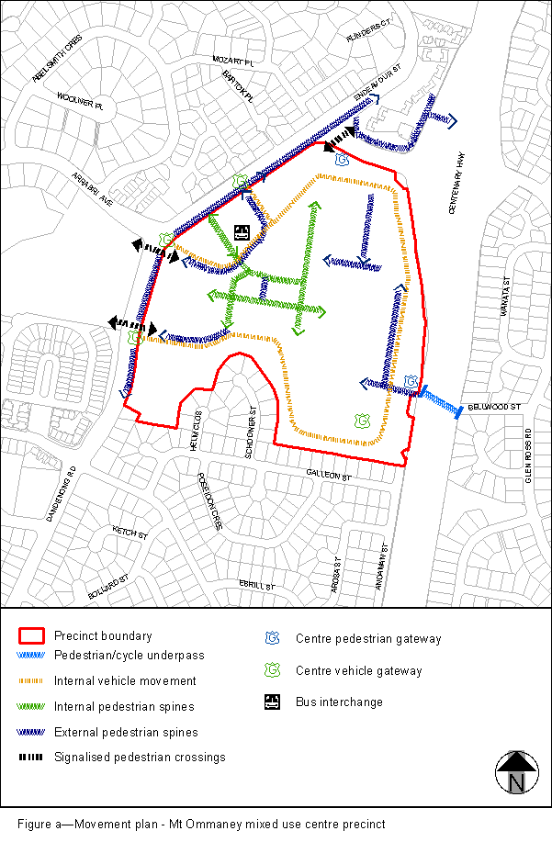
View the high resolution of Figure a–Movement plan – Mt Ommaney mixed use centre precinct (PDF file size is 117Kb)
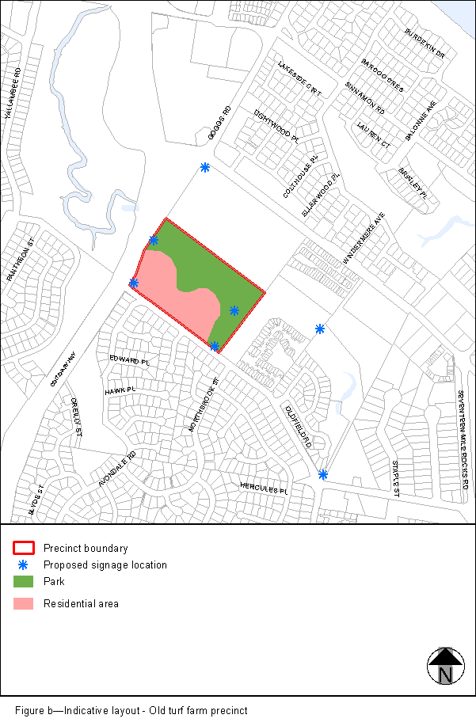
View the high resolution of Figure b–Indicative layout – Old turf farm precinct (PDF file size is 172Kb)

