7.2.13.10 Mt Gravatt corridor neighbourhood plan code

7.2.13.10.1 Application
- This code applies to assessing a material change of use, reconfiguring a lot, operational work or building work in the Mt Gravatt corridor neighbourhood plan area if:
- assessable development where this code is an applicable code identified in the assessment benchmarks column of a table of assessment for a neighbourhood plan (section 5.9); or
- impact assessable development.
- Land in the Mt Gravatt corridor neighbourhood plan area is identified on the NPM-013.10 Mt Gravatt corridor neighbourhood plan map and includes the following precincts:
- Upper Mt Gravatt precinct (Mt Gravatt corridor neighbourhood plan/NPP-001):
- Upper Mt Gravatt core sub-precinct (Mt Gravatt corridor neighbourhood plan/NPP-001a);
- Upper Mt Gravatt mixed use frame sub-precinct (Mt Gravatt corridor neighbourhood plan/NPP-001b);
- Upper Mt Gravatt high density residential sub-precinct (Mt Gravatt corridor neighbourhood plan/NPP-001c);
- Upper Mt Gravatt medium density residential sub-precinct (Mt Gravatt corridor neighbourhood plan/NPP-001d);
- Upper Mt Gravatt aged care sub-precinct (Mt Gravatt corridor neighbourhood plan/NPP-001e);
- Everett Street north medium density residential sub-precinct (Mt Gravatt corridor neighbourhood plan/NPP-001f).
- Mt Gravatt central precinct (Mt Gravatt corridor neighbourhood plan/NPP-002):
- Mt Gravatt central core sub-precinct (Mt Gravatt corridor neighbourhood plan/NPP-002a);
- Mt Gravatt central mixed use frame sub-precinct (Mt Gravatt corridor neighbourhood plan/NPP-002b);
- Mt Gravatt central medium density residential sub-precinct (Mt Gravatt corridor neighbourhood plan/NPP-002c).
- Logan Road precinct (Mt Gravatt corridor neighbourhood plan/NPP-003):
- Logan Road mixed use frame sub-precinct (Mt Gravatt corridor neighbourhood plan/NPP-003a);
- Logan Road medium to high density residential sub-precinct (Mt Gravatt corridor neighbourhood plan/NPP-003b);
- Logan Road low to medium density residential sub-precinct (Mt Gravatt corridor neighbourhood plan/NPP-003c).
- Kessels Road precinct (Mt Gravatt corridor neighbourhood plan/NPP-004):
- Kessels Road corridor sub-precinct (Mt Gravatt corridor neighbourhood plan/NPP-004a);
- Kessels Road medium density residential sub-precinct (Mt Gravatt corridor neighbourhood plan/NPP-004b).
- When using this code, reference should be made to section 1.5, section 5.3.2 and section 5.3.3.
Note—The following purpose, overall outcomes, performance outcomes and acceptable outcomes comprise the assessment benchmarks of this code.
Note—This neighbourhood plan includes a table of assessment with variations to categories of development and assessment. Refer to Table 5.9.49.A, Table 5.9.49.B, Table 5.9.49.C and Table 5.9.49.D.

7.2.13.10.2 Purpose
- The purpose of the Mt Gravatt corridor neighbourhood plan code is to provide finer grained planning at a local level for the Mt Gravatt corridor neighbourhood plan area.
- The purpose of the Mt Gravatt corridor neighbourhood plan code will be achieved through overall outcomes including overall outcomes for each precinct of the neighbourhood plan area.
- The overall outcomes for the neighbourhood plan area are:
- The Upper Mt Gravatt precinct (Mt Gravatt corridor neighbourhood plan/NPP-001) is the main focus of the plan given its function as a Major Centre. The Major Centre is highly accessible by most modes of transport and serves as a focal point for employment, administration, cultural, entertainment, retail and service activities on the south side of Brisbane.
- The Mt Gravatt central precinct (Mt Gravatt corridor neighbourhood plan/NPP-002) and Logan Road precinct (Mt Gravatt corridor neighbourhood plan/NPP-003) are more local service and retail focused, while the Kessels Road precinct (Mt Gravatt corridor neighbourhood plan/NPP-004) serves both local and city-wide retail catchments.
- The Upper Mt Gravatt precinct (Mt Gravatt corridor neighbourhood plan/NPP-001) and Mt Gravatt central precinct (Mt Gravatt corridor neighbourhood plan/NPP-002) concentrate higher density mixed use development within core sub-precincts, which create the heart of each activity centre. Each is supported by a mixed use frame sub-precinct with a lesser intensity of development. Adjacent residential sub-precincts support the development of transit oriented communities, while scaling down to the surrounding lower density urban areas.
- Development exhibits high-quality built form and landscaping, including unique landmark sites at major intersections and deep-planted subtropical shade tree species, which enhance the image of the Mt Gravatt corridor, achieving a strong subtropical character.
- Streets are designed as pedestrian places with development maintaining a human scale to the street. Development contributes to the creation of wider footways in locations of high pedestrian traffic. Activation of the street is ensured through building design and a mix of uses at ground level. Vehicle entrances, servicing and parking are designed and located to facilitate an enjoyable, safe pedestrian environment.
- Development is co-located with transit to encourage public transport use, walking and cycling to reach employment, retail, community, entertainment, recreation and education facilities.
- A safe and efficient road network, including motorways, inter-regional freight corridors, arterial, and suburban and local roads, is preserved and enhanced to support increased business and residential vehicular trips.
- An integrated network of high-quality accessible open space is protected, including the Mt Gravatt Outlook Reserve and Mt Gravatt Showgrounds, which are major recreational assets locally and city-wide. A system of green space areas, plazas, community facilities and boulevard streets support the needs of existing and future residents.
- Maintaining existing community facilities, improvements to existing parks and new public domains through the area supports the intensification of urban nodes and meets the needs of existing and future residents.
- Development does not compromise the provision, function and operation of the Queensland Government’s existing road and future transport upgrades.
- Development is of a height, scale and form which is consistent with the amenity and character, community expectations and infrastructure assumptions intended for the relevant precinct, sub-precinct or site and is only developed at a greater height, scale and form where there is both a community need and an economic need for the development.
- Upper Mt Gravatt precinct (Mt Gravatt corridor neighbourhood plan NP/NPP-001) overall outcomes are:
- This precinct is characterised by the highest development intensity in the neighbourhood plan area, containing a mix of uses in keeping with its role as a Major Centre and the southern anchor to the ‘Brisbane CBD to Upper Mt Gravatt Growth Corridor’. It serves a catchment of regional significance and provides a focal point for regional employment and retail including the Garden City Shopping Centre.
- The precinct capitalises on the accessibility provided by major arterial roads, the South East Busway and active transport routes.
- This precinct provides opportunities for employment, shopping and businesses, high density residential, community facilities, entertainment, leisure and supporting services. The mix of uses provides the level of activity needed to support a Major Centre and attract businesses and residents.
- To facilitate increased densities and heights, amalgamation of sites is encouraged.
- A range of high-quality public spaces are established as an integral part of the centre's growth, providing a high level of urban amenity for residents, workers and visitors.
- Uses considered consistent with the outcomes sought include centre activities where in the core and mixed use frame sub-precincts and medium- to high-density residential uses where in the residential sub-precincts.
- Uses considered inconsistent with the outcomes sought include multiple dwellings not associated with a retirement facility or residential care facility in the Upper Mt Gravatt aged care sub-precinct (Mt Gravatt corridor neighbourhood plan/NPP-001e);
- Development in the Upper Mt Gravatt core sub-precinct (Mt Gravatt corridor neighbourhood plan/NPP-001a):
- has a strong focus on the provision of high density commercial and retail uses in keeping with the goal of establishing a Major Centre and supporting high-quality public transport;
- extends the Regional centre zone precinct boundary of the Principal centre zone south-east along Logan Road and north along Kessels Road and Mt Gravatt-Capalaba Road, to allow additional office/commercial activity, shops, food and drink outlets and multiple dwellings. Higher intensity development provides opportunities for landmark sites at the intersection of Logan Road and Mt Gravatt-Capalaba Road to define the core;
- supports and complements the existing and future Queensland Government road upgrades for major transport corridors and does not conflict with or hinder the establishment of centre activities consistent with a Major Centre;
- ensures that ground storey tenancies provide vibrant uses with active frontages, such as shops, cafes, food and drink outlets, offices and extended-hour services, including health care service and indoor sport and recreation (gymnasium), to encourage pedestrian activity and vitality. Above-ground, commercial activities and residential units are preferred. Building design presents a human scale to the street with a seamless transition between indoor and outdoor spaces;
- provides new road, pedestrian and cycle linkages. Legible public access between Logan Road, Mt Gravatt-Capalaba Road and the South East Busway station is established through the Garden City Shopping Centre site.
- Development in the Upper Mt Gravatt mixed use frame sub-precinct (Mt Gravatt corridor neighbourhood plan/NPP-001b):
- provides a transition to the surrounding residential areas;
- comprising a mix of business/commercial uses is located on the podium and lower tower levels with residential uses on higher levels to create a vibrant and activated space through most hours of the day.
- Development in the Upper Mt Gravatt high density residential sub-precinct (Mt Gravatt corridor neighbourhood plan/NPP-001c):
- for high density residential development takes advantage of its close proximity to centre activities;
- complements the function of major transport corridors and does not conflict with or hinder the establishment of high density residential development.
- Development in the Upper Mt Gravatt medium density residential sub-precinct (Mt Gravatt corridor neighbourhood plan/NPP-001d):
- locates medium density residential development at the periphery of the centre to provide a transition to surrounding low density residential areas;
- complements the function of major transport corridors and does not conflict with or hinder the establishment of medium density residential development.
- Development in the Upper Mt Gravatt aged care residential sub-precinct (Mt Gravatt corridor neighbourhood plan/NPP-001e):
- provides opportunities for residents to age in place by constructing high density residential units for aged care, people with special needs and/or retirement purposes;
- for multiple dwellings is not consistent with the outcomes sought.
- Development in the Everett Street north medium density residential sub-precinct (Mt Gravatt corridor neighbourhood plan/NPP-001f):
- ensures that medium density residential uses provide a transition from high density residential development to surrounding low density residential areas north of Mount Gravatt-Capalaba Road and east of Newnham Road;
- ensures that building bulk and design complements the natural topography of the land and does not require significant filling or excavation. Development on steeply sloping land occurs on large sites created through lot amalgamation;
- complements the function of major transport corridors and does not conflict with or hinder the establishment of medium density residential development;
- ensures that there is no vehicular access to Mount Gravatt-Capalaba Road and no net increase in driveway crossovers onto Newnham Road.
- Mt Gravatt central precinct (Mt Gravatt corridor neighbourhood plan/NPP-002) overall outcomes are:
- This precinct is revitalised as a traditional high street to create a distinctive urban village, with an emphasis on services and facilities for local residents.
- The precinct achieves a mix of uses and provides activity and opportunities for local shopping, commercial activity, urban living, community facilities, food and drink outlets and supporting services. Mt Gravatt Outlook Reserve provides green space to the precinct.
- Arcades improve pedestrian permeability and improve east–west movements.
- Landmark sites create a legible and vibrant public realm.
- To facilitate a mix of uses in individual developments and provide sufficient frontage to separate commercial and residential vehicular access, amalgamation of sites is encouraged.
- Residential development in close proximity to the Mt Gravatt Showgrounds is adequately buffered from noise and lighting impacts to ensure the ongoing provision of social and community services.
- Uses considered consistent with the outcomes sought include centre activities in core and mixed use frame sub-precincts and medium density residential uses in the medium density residential sub-precinct.
- Development in the Mt Gravatt central core sub-precinct (Mt Gravatt corridor neighbourhood plan/NPP-002a):
- creates a mixed use centre to service the local area. This includes the development of a landmark site at the intersection of Logan Road and Creek Road to help inform way-finding and define the core;
- ensures that active frontages enhance the high street experience of this sub-precinct and encourage pedestrian activity. Located at ground storey, active frontages include a mix of shops, food and drink outlets, offices and extended-hour services, including health care service and indoor sport and recreation (gymnasium);
- provides a mix of office and residential uses above podium level.
- Development in the Mt Gravatt central mixed use frame sub-precinct (Mt Gravatt corridor neighbourhood plan/NPP-002b):
- helps to further define the centre;
- for mixed use development, including shops, food and drink outlets and offices on podium and lower tower levels front Logan Road and Creek Road;
- provides active and continuous street frontages that further support the Mt Gravatt central core sub-precinct (Mt Gravatt corridor neighbourhood plan/NPP-002a) and provides an attractive, activated public realm;
- provides arcades to improve permeability, particularly to Logan Road from shared car parking areas at the rear of sites.
- Development in the Mt Gravatt central medium density residential sub-precinct (Mt Gravatt corridor neighbourhood plan/NPP-002c):
- takes advantage of its accessibility to high-frequency public transport and centre activities and has a high level of urban amenity;
- for medium density residential purposes is consistent with the outcomes sought;
- ensures that buildings address the street and provide a distinct urban village character;
- provides an appropriate transition to existing detached housing areas outside the sub-precinct through the provision of reduced building heights.
- Logan Road precinct (Mt Gravatt corridor neighbourhood plan NPP-003) overall outcomes are:
- This precinct provides an active corridor by concentrating development at the intersection of Logan Road and Dawson Road framed by high density and medium density residential development to the east.
- This precinct capitalises upon its accessibility to 2 high-frequency public transportation routes to create a highly accessible neighbourhood.
- The precinct's proximity to Griffith University also presents opportunities for well-located, affordable student accommodation.
- Uses considered consistent with the outcomes sought include centre activities where in the mixed use frame sub-precinct and low density residential and medium density to high density residential where in the residential sub-precincts.
- Development in the Logan Road mixed use frame sub-precinct (Mt Gravatt corridor neighbourhood plan/NPP-003a):
- ensures that mixed use development extends north from the Upper Mt Gravatt precinct (Mt Gravatt corridor neighbourhood plan/NPP-001) on the eastern side of Logan Road, to promote a mixed use centre to service local residents, including the existing schools on the opposite side of Logan Road;
- provides a range of residential accommodation options above ground storey and commercial and retail activities create a vibrant and activated space through most hours of the day;
- locates higher density mixed use development east of the intersection of Logan Road and Dawson Road, creating a highly accessible and walkable hub at the junction of 2 high-frequency public transport routes. Active frontages are encouraged at ground level throughout this sub-precinct.
- Development in the Logan Road medium to high density residential sub-precinct (Mt Gravatt Corridor neighbourhood plan/NPP-003b):
- locates medium density residential development on the eastern side of Logan Road, within walking distance of public transport, and supports the creation of a strong and active corridor. Restricting medium density residential development to the eastern side of Logan Road safeguards existing amenity and views to the west and green space;
- locates high density residential development east of the Logan Road and Dawson Road intersection, creating a highly accessible and walkable residential precinct at the junction of 2 high-frequency public transport routes.
- Development in the Logan Road low to medium density residential sub-precinct (Mt Gravatt corridor neighbourhood plan/NPP-003c):
- provides a transition between the mixed use development to the south and low density residential areas to the north and east;
- ensures that multiple dwellings are consistent with the outcomes sought.
- Kessels Road precinct (Mt Gravatt corridor neighbourhood plan/NPP-004) overall outcomes are:
- This precinct reinforces its existing role as a showroom. The surrounding medium density residential areas support the Upper Mt Gravatt precinct and capitalise on high-frequency public transport.
- Uses considered consistent with the outcomes sought include showrooms where in the District centre zone precinct of the District centre zone, and medium density residential where in the Kessels Road medium density residential sub-precinct (Mt Gravatt corridor neighbourhood plan/NPP-004b).
- Development in the Kessels Road corridor sub-precinct (Mt Gravatt corridor neighbourhood plan NPP-004a):
- reinforces and protects the showroom uses along Kessels Road, which require large floor plates not suitable within the Upper Mt Gravatt precinct (Mt Gravatt corridor neighbourhood plan/NPP-001);
- maintains allotments greater than 2,500m2 unless facilitating the primary use/purpose of the sub-precinct;
- creates a network of shared driveways, access ways and service roads between sites to minimise access to Kessels Road;
- ensures that landscaped buffers to adjoining residential development minimise visual and amenity impacts.
- Development in the Kessels Road medium density residential sub-precinct (Mt Gravatt corridor neighbourhood plan NPP-004b):
- provides medium density residential development to the east of the showroom area along Kessels Road, supporting the adjacent Upper Mt Gravatt precinct (Mt Gravatt corridor neighbourhood plan NPP-001);
- responds to the flood hazard and waterway corridor along Mimosa Creek;
- provides a new park to meet the needs of residents;
- to the north along the eastern side of Mains Road, additional medium density residential development takes advantage of its close proximity to Griffith University and direct access to high-frequency public transport accessing the South East Busway. Pedestrian connectivity across Mains Road is improved.

7.2.13.10.3 Performance outcomes and acceptable outcomes

Table 7.2.13.10.3.A—Performance outcomes and acceptable outcomes
Performance outcomes | Acceptable outcomes
PO1  Development is of a height, scale and form that achieves the intended outcome for the precinct, improves the amenity of the neighbourhood plan area, contributes to a cohesive streetscape and built form character and is:  - consistent with the anticipated density and assumed infrastructure demand;  - aligned to community expectations about the number of storeys to be built;  - proportionate to and commensurate with the utility of the site area and frontage width;  - designed to avoid a significant and undue adverse amenity impact to adjoining development;  - sited to enable existing and future buildings to be well separated from each other and to avoid affecting the potential development of adjoining sites.  Note—Development that exceeds the intended number of storeys or building height can place disproportionate pressure on the transport network, public space or community facilities in particular.  Note—Development that is over-scaled for its site can result in an undesirable dominance of vehicle access, parking and manoeuvring areas that significantly reduce streetscape character and amenity. | AO1  Development complies with the number of storeys, building height and plot ratio in Table 7.2.13.10.3.B.  Note—Neighbourhood plans will mostly specify a maximum number of storeys where zone outcomes have been varied in relation to building height. Some neighbourhood plans may also specify height in metres. Development must comply with both parameters where maximum number of storeys and height in metres are specified.
PO2  Development ensures building setbacks and design:  - create a uniform building line consistent with the intended character of the streetscape;  - ensure existing and future buildings are well separated from each other;  - allow reasonable access to sunlight for neighbouring dwellings and their open spaces;  - allow air circulation and access to breezes for neighbouring dwellings;  - maintain the privacy of adjoining residents. | AO2  Development has minimum front, side and rear boundary setbacks in accordance with Table 7.2.13.10.3.C.
PO3  Development includes a mix of non-residential and residential land uses that provide the level of activity needed to support the role and function of each sub-precinct. | AO3  Development provides a land use mix that complies with Table 7.2.13.10.3.D.
PO4  Development ensures building heights and setbacks protect the character, privacy and amenity of adjoining residential areas through:  - transitions between higher and lower rise residential areas by stepping down in height and scale at site boundaries;  - sympathetic built form along the interface that does not create an overbearing appearance or significantly impact on the privacy and amenity of adjoining residences;  - landscaped buffers and screens. | AO4.1  For development with a side boundary to a residential area not within the Upper Mt Gravatt, Mt Gravatt central, Logan Road or Kessels Road precincts:  - building height is no more than 2 storeys within 10m of the common property boundary;  - building height is no more than 4 storeys within 10m to 20m of the common property boundary;  - development is set back a minimum of 4m from the common property boundary;  - the total straight length of any wall does not exceed 25m.
AO4.2
Development with a rear boundary to land in a zone in the residential zones category, not within the Upper Mt Gravatt precinct (Mt Gravatt corridor neighbourhood plan/NPP-001), Mt Gravatt central precinct (Mt Gravatt corridor neighbourhood plan/NPP-002), Logan Road precinct (Mt Gravatt corridor neighbourhood plan/NPP-003) or Kessels Road precinct (Mt Gravatt corridor neighbourhood plan/NPP-004), ensures:
- any building is set back a minimum of 10m from the rear boundary;
- deep planting is incorporated along the rear boundary and includes mature trees of a type consistent with the locality, planted at intervals that will ensure a significant level of screening between the development and the adjoining land where in a zone in the residential zones category.
PO5  Development:  - creates an integrated pedestrian and cyclist network that provides direct access to public transport routes, activity centres and public open space;  - provides arcades of a scale, width, design and tenure that reflect their function and location. | AO5  Development ensures bin collection, car parking and service driveways are not located within, or adjacent to arcades.
PO6  Development provides for the widening of streets to enable safe and efficient regional, city and local transport networks. | AO6  Development:  - provides land for new Council roads, cycleways, road widening and upgrades;  - is sited and designed so as to not prejudice the ultimate road corridor upgrade indicated in Figure g.  Note—The ultimate width of roads is determined by the Infrastructure design planning scheme policy.
PO7  Development provides a range of open space and recreational opportunities to meet the needs of the community. | AO7  Development incorporates future parks in accordance with Figure a and Figure d and which are designed in accordance with the Infrastructure design planning scheme policy.
PO8  Development ensures access and servicing does not compromise the function of arterial roads and future Queensland government road upgrades. | AO8.1  Development does not provide additional vehicular access and servicing from Kessels Road, Mt Gravatt-Capalaba Road or Logan Road where alternative access is available.
AO8.2
Development which adjoins a site with a frontage to Kessels Road, Mt Gravatt-Capalaba Road or Logan Road that has no alternative access other than to these roads, provides access (including manoeuvring space) for the future development of that adjoining site via the development site’s main access point.
Note—Easements are created over shared vehicular access ways to all adjoining owners and where Council determines these are to serve more than an individual development and property.
If in a core sub-precinct or mixed use frame sub-precinct
PO9  Development involving non-residential and mixed use development:  - includes a podium design that:  - avoids the creation of a canyon of buildings along streets;  - obscures views of tall buildings, promoting a fine-grain, human-scaled development at street level;  - sensitively responds to changes in topography and gradients;  - adds variety and interest to the streetscape;  - provides variation in building form, height and materials, articulation of facades and space to allow for deep planting within the front setback;  - ensures design and siting of buildings above podium allows sufficient space between buildings to allow for breezes and views through the site. | AO9.1  Development ensures buildings incorporate a podium and tower form as specified in Figure e.
AO9.2
Development ensures podium heights are a minimum of 2 storeys.
AO9.3
Development involving a commercial podium adjoining a site where residential uses exist at ground or first storey levels ensures that the maximum height of the podium is 2 storeys at that side boundary.
AO9.4
Development ensures that podiums are built to the side boundary with a minimum setback distance of 10m from the front property boundary, except where:
- there is a requirement for the provision of an overland flow path;
- the development adjoins a property not included within a centre, in which case all parts of the development are set back a minimum of 2m from the boundary with the adjoining land.
AO9.5
Development ensures the podium is occupied by commercial uses.
AO9.6
Development ensures the tower is no more than 75% of the width of the site or a maximum of 30m in any direction, whichever is less, as shown in Figure e.
Note—On large sites more than 1 tower will be required to achieve the acceptable outcome.
AO9.7
Development involving more than 1 tower within a site ensures towers are separated by a distance of at least 12m.
PO10  Development provides landmark sites:  - at key intersections that act as gateways to the Mt Gravatt Central and Upper Mt Gravatt centres;  - that mark the prominence of specific corner sites through their height, siting towards the corner, high-quality design and materials, integrated public space and public artwork. | AO10  Development at key intersections, as shown in Figure a and Figure b, include landmark sites where:  - building height and plot ratio comply with provisions for landmark sites in Table 7.2.13.10.3.B;  - overall height is varied by stepping with heights increasing towards the corner;  - buildings include unique roof forms;  - landmark towers are located on the corner within 30m of the corner frontage;  - podium street level incorporates a continuous active frontage with integrated building entries and public spaces at the corner and public artwork;  - podium and tower elements are located towards the corner;  - building materials are varied, high quality and durable, and positively contribute to the design quality of the centre.
PO11  Development contributes to the role of the street as the focus for commercial and community life, and promotes activation and casual surveillance of streets, laneways, arcades, plazas, busway stations and pedestrian/cycle ways, through active uses, building design and site layout. | AO11  Development provides active frontage streets specified in Figure a, Figure b and Figure c or adjoining publicly accessible spaces, such as parks, arcades, laneways, town centres, busway stations and pedestrian/cycleways.
If in the Upper Mt Gravatt core sub-precinct (Mt Gravatt corridor neighbourhood plan/NPP-001a), where in the Garden City Shopping Centre
PO12  Development involving any redevelopment or expansion of Garden City Shopping Centre where involving more than 6,000m2 of additional gross floor area achieves the following:  - expands the mix of land uses beyond retail to include office and residential;  - includes a site layout and built form that visually and physically integrates the site into the area, and improves legibility through the siting of entries/exits, arcades and landmark sites;  - includes highly articulated buildings with significant recesses and projections and a range of building materials (including glass), to visually reduce their bulk and scale and enhance the appearance of the area;  - breaks down the edges of the existing ‘big box’ and creates active frontages with multiple building breaks for building articulation and separation, pedestrian and vehicular access along Logan Road, Kessels Road, Macgregor Street, Link Road, and provides arcades to add to the vibrancy of the area;  - maximises pedestrian accessibility to and from the site and pedestrian safety through the site, particularly to the busway stations and future bus interchanges, via the introduction of legible arcades with 24-hour access where supported by active frontages as shown in Figure a;  - provides vibrant and safe publicly accessible open spaces in the form of plazas and meeting places integrated with the development;  - site layout and design is in accordance with crime prevention through environmental design principles to achieve public safety;  - includes significant landscaped areas incorporating deep planting;  - screens car parking areas from adjoining streets;  - provides safe and efficient accesses for vehicles (including service vehicles) and internal circulation networks that do not detrimentally impact on the surrounding road network;  - provides sufficient car parking, servicing and loading/unloading areas;  - facilitates the permeability and connectivity for vehicles and pedestrians to the surrounding road network.  Note—A structure plan prepared in accordance with the Structure planning planning scheme policy can assist in demonstrating the achievement of this outcome. | AO12  No acceptable outcome is prescribed.
If in the Mt Gravatt central mixed use frame sub-precinct (Mt Gravatt corridor neighbourhood plan NPP-002b)
PO13  Development:  - protects and complements the character of the existing retail/commercial centre along Logan Road, between Mountain/Springwood Streets and Virgil Street.  - provides buildings that:  - contribute to a fine-grain urban form and maintain low-scale awnings with parapet facades to the street, similar to traditional buildings in the street;  - create a strong visual interest, and are complementary to the level of detail and articulation of the existing streetscape. | AO13  Development ensures buildings fronting Logan Road between Mountain/Springwood Streets and Virgil Street:  - are clearly expressed as individual shop fronts of 10m–15m in width, and of a grain consistent with traditional widths in the street;  - incorporate a continuous awning and parapet;  - have building facades that are articulated through frequent recesses and projections and elements of a finer scale than the main structural framing of the building.
If in the Neighbourhood centre zone on the southern corner of Logan and Kempsie Roads
PO14  Development:  - provides for a mix of uses incorporating small-scale retail and residential activities;  - contributes to the activation and casual surveillance of the street. | AO14.1  Development ensures the retail gross floor area does not exceed 750m2.
AO14.2
Development ensures retail activities are at street level and provide an active frontage along Logan Road and Kempsie Road.
AO14.3
Development ensures car parking is at the rear or in a basement.
If in the Kessels Road corridor sub-precinct (Mt Gravatt corridor neighbourhood plan/NPP-004a)
PO15  Development ensures that large-format buildings accommodating showroom centres (bulky goods/retail warehouse uses) continue to be located in this sub-precinct. | AO15  Reconfiguring a lot does not realign or create additional smaller lots unless there is a structure plan prepared in accordance with the Structure planning planning scheme policy.
PO16  Development includes large floor plates and lot sizes consistent with the role and function of this sub-precinct. | AO16  Development has a minimum lot size of 2,500m2.
PO17  Development provides a landscaped buffer along the common boundary of all adjoining residential uses. | AO17  Development provides a minimum 10m wide landscape buffer.  Refer to Figure f.  Note—The building footprint and basement footprint do not intrude into the landscape buffer.
PO18  Development provides an integrated network of access ways and car parking areas that have limited access to arterial roads and which benefit all sites within the sub-precinct. | AO18.1  Development does not provide additional vehicular access and servicing is not provided from Mains Road or Kessels Road where alternative access is available.
AO18.2
Development which adjoins a site with a frontage to Mains Road or Kessels Road that has no alternative access other than to these roads provides for access (including manoeuvring space) to the future development of that adjoining site via the development site’s main access point.
Note—Easements are created over shared vehicular access ways to benefit all adjoining owners and Council where Council determines these are to serve more than an individual development and property.
Refer to Figure f.
If in the Kessels Road corridor sub-precinct (Mt Gravatt corridor neighbourhood plan/NPP-004a) or if in the Kessels Road corridor sub-precinct (Mt Gravatt corridor neighbourhood plan/NPP-004b)
PO19  Development manages the flood risk and environmental values associated with Mimosa Creek and ensures that structures and people are safe with respect to the flood hazard by:  - maintaining the natural drainage system;  - ensuring no loss in the flood conveyance capacity of the Mimosa Creek for all storms;  - ensuring the building location and design is safe by mitigating the flood hazard;  - providing safe egress and emergency access to the site. | AO19.1  Development is not subject to high hazard flood conditions.  Note—Compliance with this acceptable outcome can be demonstrated by submitting a hydraulic and hydrology report identifying the site area with a level of risk and flood immunity suitable for development in accordance with the Infrastructure design planning scheme policy and acceptable flood impacts. In some cases, sites will need to be amalgamated to achieve a suitably sized area for development.
AO19.2
Development fronting Bedser Street and Benaud Street provide emergency access in accordance with the flood immunity levels identified in the Infrastructure design planning scheme policy.
AO19.3
Structural elements are outside the waterway corridor and set back a minimum of 5m from the top of the waterway embankment.
Note—Structural elements include walls, piers and columns that may interfere with the free flow of water and be susceptible to damage from creek scour.
AO19.4
Cantilevered elements over high-hazard floodway areas must have a minimum clearance of 2m from ground level to the underside of the floor or the relevant flood immunity requirement (whichever is greater).
If in the Everett Street north medium density residential sub-precinct (Mt Gravatt corridor neighbourhood plan/NPP-001f)
PO20  Development ensures building bulk and size are consistent with the intent of the area and design complements the natural topography of the area. | AO20.1  Development has a minimum site area of 800m2 and has a minimum frontage of 20m.
AO20.2
Development has a minimum site area of 1,200m2 where the site has a slope equal to or greater than 1 in 4.
PO21  Development must not occur on a site subject to potential landslide. | AO21  Development does not occur on land with a slope greater than 1 in 3.  Note—A geotechnical report will be required for any development occurring on site with a gradient in excess of 1 in 4.
PO22  Development provides vehicle access, servicing and car parking structures which are designed and located to:  - protect the functioning of arterial roads with minimal disruption;  - not visually dominate the site and streetscape;  - protect the safety of pedestrians. | AO22.1  Development does not provide vehicular access from Mount Gravatt-Capalaba Road.
AO22.2
Development does not provide vehicular access from Newnham Road where alternative access is available.
AO22.3
Development does not provide a net increase in driveway crossovers on Newnham Road.
AO22.4
Development provides car parking and servicing areas at the rear or underneath buildings.
AO22.5
Development ensures driveway crossovers maintain the integrity, quality and primacy of footpaths.
If in the Logan Road low to medium density residential sub-precinct (Mt Gravatt corridor neighbourhood plan/NPP-003c)
PO23  Vehicular access is provided from side streets to protect the arterial road function of Logan Road and to improve the safety of pedestrians. | AO23  Vehicular access is provided from Wanda Road.

Table 7.2.13.10.3.B—Maximum building height and plot ratios
Development | Site area 800m2 or greater but less than 1,200m2 where minimum site frontage is 20m | Site area 1,200m2 or greater but less than 2,500m2 where minimum site frontage is 30m | Site area 2,500m2 or greater where minimum site frontage is 30m | Any other case
If in the Upper Mt Gravatt Precinct (Mt Gravatt corridor neighbourhood plan/NPP-001)
Development of a landmark building site (refer to Figure a) | 15 storeys  350% plot ratio |  |  | Not specified
Development of a site in the Upper Mt Gravatt Core sub-precinct (Mt Gravatt corridor neighbourhood plan/NPP-001a) | 6 storeys  150% plot ratio | 10 storeys  250% plot ratio | 15 storeys  350% plot ratio | Where in the Principal centre zone:  6 storeys  150% plot ratio  Where in any other zone:  not specified
Development of a site in the Upper Mt Gravatt mixed use frame sub-precinct (Mt Gravatt corridor neighbourhood plan/NPP-001b) | 6 storeys  150% plot ratio | 8 storeys  200% plot ratio | 10 storeys  250% plot ratio | Where in the Principal centre zone:  6 storeys  150% plot ratio  Where in any other zone:  not specified
Development of a site in the Upper Mt Gravatt high density residential sub-precinct (Mt Gravatt corridor neighbourhood plan/NPP-001c) | 6 storeys  150% plot ratio | 8 storeys  200% plot ratio | 8 storeys  200% plot ratio | 6 storeys  150% plot ratio
Development of a site in the Upper Mt Gravatt medium density residential sub-precinct (Mt Gravatt corridor neighbourhood plan/NPP-001d) | 5 storeys  125% plot ratio | 5 storeys  125% plot ratio | 5 storeys  125% plot ratio | Not specified
Development of a site in the Upper Mt Gravatt aged care sub-precinct (Mt Gravatt corridor neighbourhood plan/NPP-001e) | 6 storeys  150% plot ratio | 8 storeys  200% plot ratio | 8 storeys  200% plot ratio | 6 storeys  150% plot ratio
Development of a site in the Everett Street north medium density residential sub-precinct (Mt Gravatt corridor neighbourhood plan/NPP-001f) | 5 storeys  125% plot ratio | 5 storeys  125% plot ratio | 5 storeys  125% plot ratio | Not specified
If in the Mt Gravatt central precinct (Mt Gravatt corridor neighbourhood plan/NPP-002)
Development of a site in the landmark building site (refer to Figure b) | 8 storeys  200% plot ratio |  |  | Not specified
Development of a site in the Mt Gravatt central core sub-precinct (Mt Gravatt corridor neighbourhood plan/NPP-002a) | 5 storeys  125% plot ratio | 6 storeys  150% plot ratio | 8 storeys  200% plot ratio | Not specified
Development of a site in the Mt Gravatt central mixed use frame sub-precinct (Mt Gravatt corridor neighbourhood plan/NPP-002b) | 5 storeys  125% plot ratio | 6 storeys  150% plot ratio | 6 storeys  150% plot ratio | Not specified
Development of a site in the Mt Gravatt central medium density residential sub-precinct (Mt Gravatt corridor neighbourhood plan/NPP-002c) | 5 storeys  125% plot ratio | 5 storeys  125% plot ratio | 5 storeys  125% plot ratio | Not specified
If in the Logan Road precinct (Mt Gravatt corridor neighbourhood plan/NPP-003)
Development of a site in the Logan Road mixed use frame sub-precinct (Mt Gravatt corridor neighbourhood plan/NPP-003a) | 5 storeys  125% plot ratio | 6 storeys  150% plot ratio | 6 storeys  150% plot ratio | Not specified
Development of a site in the Logan Road medium to high density residential sub-precinct (Mt Gravatt corridor neighbourhood plan/NPP-003b) | 3 storeys  90% plot ratio | 5 storeys  125% plot ratio | 5 storeys  125% plot ratio | 3 storeys  90% plot ratio
Development of a site in the Logan Road precinct (Mt Gravatt corridor neighbourhood plan/NPP-003) where identified with a maximum building height of 6 to 8 storeys in Figure c | 6 storeys  150% plot ratio | 8 storeys  200% plot ratio | 8 storeys  200% plot ratio | Where in the High density residential zone:  6 storeys  150% plot ratio  Where in any other zone:  not specified
If in the Kessels Road precinct (Mt Gravatt corridor neighbourhood plan/NPP-004)
Development of a site in the Kessels Road corridor sub-precinct (Mt Gravatt corridor neighbourhood plan/NPP-004a) | Not specified
Development of a site in the Kessels Road medium density residential sub-precinct (Mt Gravatt corridor neighbourhood plan/NPP-004b) | 5 storeys  125% plot ratio | 5 storeys  125% plot ratio | 5 storeys  125% plot ratio | Not specified

Table 7.2.13.10.3.C—Minimum building setbacks
Development | Minimum setback
 | Ground storey | Levels 2-4 | Level 5 and above
If in the Upper Mt Gravatt precinct (Mt Gravatt corridor neighbourhood plan NPP-001)
Development of a site in the Upper Mt Gravatt core sub-precinct (Mt Gravatt corridor neighbourhood plan/NPP-001a) | Front – 3m  Side – 0m  Rear – 6m | Front – 0m  Side – 0m  Rear – 6m | Front – 3m  Side – 5m  Rear – 10m  12m separation between towers where multiple towers exist on a site
Development of a site in the Upper Mt Gravatt mixed use frame sub-precinct (Mt Gravatt corridor neighbourhood plan/NPP-001b)
Development of a site in the Upper Mt Gravatt high density residential sub-precinct (Mt Gravatt corridor neighbourhood plan/NPP-001c) | Side – 4m  Rear – 10m  All other setbacks as per the Multiple dwelling code |  | Not specified
Development of a site in the Upper Mt Gravatt medium density residential sub-precinct (Mt Gravatt corridor neighbourhood plan/NPP-001d) | Side – 4m  Rear – 10m  All other setbacks as per the Multiple dwelling code |  | Not specified
Development of a site in the Upper Mt Gravatt aged care sub-precinct (Mt Gravatt corridor neighbourhood plan/NPP-001e) | As per the Multiple dwelling code |  | Not specified
Development of a site in the Everett Street north medium density residential sub-precinct (Mt Gravatt corridor neighbourhood plan/NPP-001f) | Side – 4m  Rear – 15m (for lots adjoining Mt Gravatt-Capalaba Road)  Rear – 10m (for all other lots)  All other setbacks are as per the Multiple dwelling code |  | Not specified
If in the Mt Gravatt central precinct (Mt Gravatt corridor neighbourhood plan/NPP-002)
Development of a site in the Mt Gravatt central core sub-precinct (Mt Gravatt corridor neighbourhood plan/NPP-002a) | Front – 0m  Side – 0m  Rear – 6m |  | Front – 3m  Side – 4m  Rear – 6m  12m separation between towers where multiple towers exist on a site
Development of a site in the Mt Gravatt central mixed use frame sub-precinct (Mt Gravatt corridor neighbourhood plan/NPP-002b) | Front – 0m  Front – 3m where fronting Tenby Street and Lauder Street  Side – 0m  Rear – 6m |  | Front – 3m  Front – 6m where fronting Tenby Street and Lauder Street  Side – 3m  Rear – 6m  12m separation between towers where multiple towers exist on a site
Development of a site in the Mt Gravatt central medium density residential sub-precinct (Mt Gravatt corridor neighbourhood plan/NPP-002c) | Side – 4m  Rear – 10m  All other setbacks as per the Multiple dwelling code
If in the Logan Road precinct (Mt Gravatt corridor neighbourhood plan NPP-003)
Development of a site in the Logan Road mixed use frame sub-precinct (Mt Gravatt corridor neighbourhood plan/NPP-003a) | Front – 3m  Side – 0m  Rear – 6m | Front – 0m  Side – 0m  Rear – 6m | Front – 4m  Side – 4m  Rear – 10m  12m separation between towers where multiple towers exist on a site
Development of a site in the Logan Road medium to high density residential sub-precinct (Mt Gravatt corridor neighbourhood plan/NPP-003b) | Side – 4m  Rear – 10m  All other setbacks as per the Multiple dwelling code
If in the Kessels Road Precinct (Mt Gravatt corridor neighbourhood plan/NPP-004)
Development of a site in the Kessels Road corridor sub-precinct (Mt Gravatt corridor neighbourhood plan/NPP-004a) | As per Centre or mixed use code
Development of a site in the Kessels Road medium density residential sub-precinct (Mt Gravatt corridor neighbourhood plan/NPP-004b) | Side – 4m  Rear – 10m  All other setbacks as per the Multiple dwelling code
Note—Setbacks will be derived from the results of the corridor investigations illustrated in.

Table 7.2.13.10.3.D—Land use mix
Development | Maximum land use mix on individual sites(1)
If in the Upper Mt Gravatt core sub-precinct (Mt Gravatt corridor neighbourhood plan/NPP-001a)
Any development in this precinct | Up to 30% residential  Up to 100% non-residential
If in the Upper Mt Gravatt mixed use frame sub-precinct (Mt Gravatt corridor neighbourhood plan/NPP-001b)
Any development in this precinct | Up to 80% residential  Up to 50% non-residential
If in the Mt Gravatt central core sub-precinct (Mt Gravatt corridor neighbourhood plan/NPP-002a)
Any development in this precinct | Up to 30% residential  Up to 100% non-residential
If in the Mt Gravatt central mixed use frame sub-precinct (Mt Gravatt corridor neighbourhood plan/NPP-002b)
Any development in this precinct | Up to 80% residential  Up to 50% non-residential
If in the Logan Road mixed use frame sub-precinct (Mt Gravatt corridor neighbourhood plan/NPP-003a)
Any development in this precinct | Up to 80% residential  Up to 50% non-residential
If in the Kessels Road corridor sub-precinct (Mt Gravatt corridor neighbourhood plan/NPP-004a)
Any development in this precinct | 100% non-residential  0% residential uses (residential uses are not supported in this sub-precinct)
If in the Aged care sub-precincts ((Mt Gravatt corridor neighbourhood plan/NPP-001e) and (Mt Gravatt corridor neighbourhood plan/NPP-003c))
Any development in this precinct | Minimum of 75% of residential care facility or retirement facility
Note—
(1) Development that achieves a similar mix for the overall sub-precinct will be considered as a performance outcome.
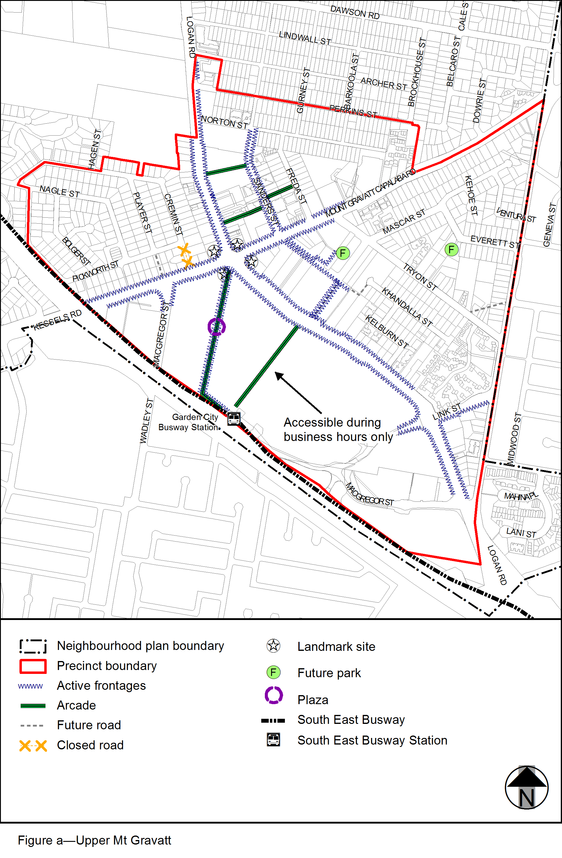
View the high resolution of Figure a–Upper Mt Gravatt (PDF file size is 219Kb)
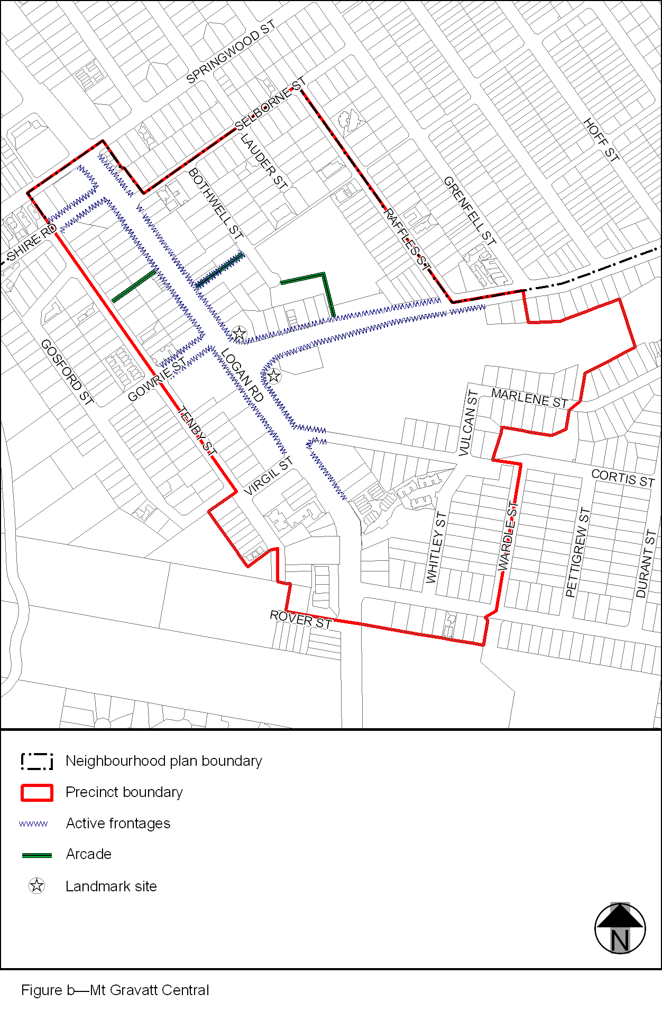
View the high resolution of Figure b–Mt Gravatt Central (PDF file size is 120Kb)
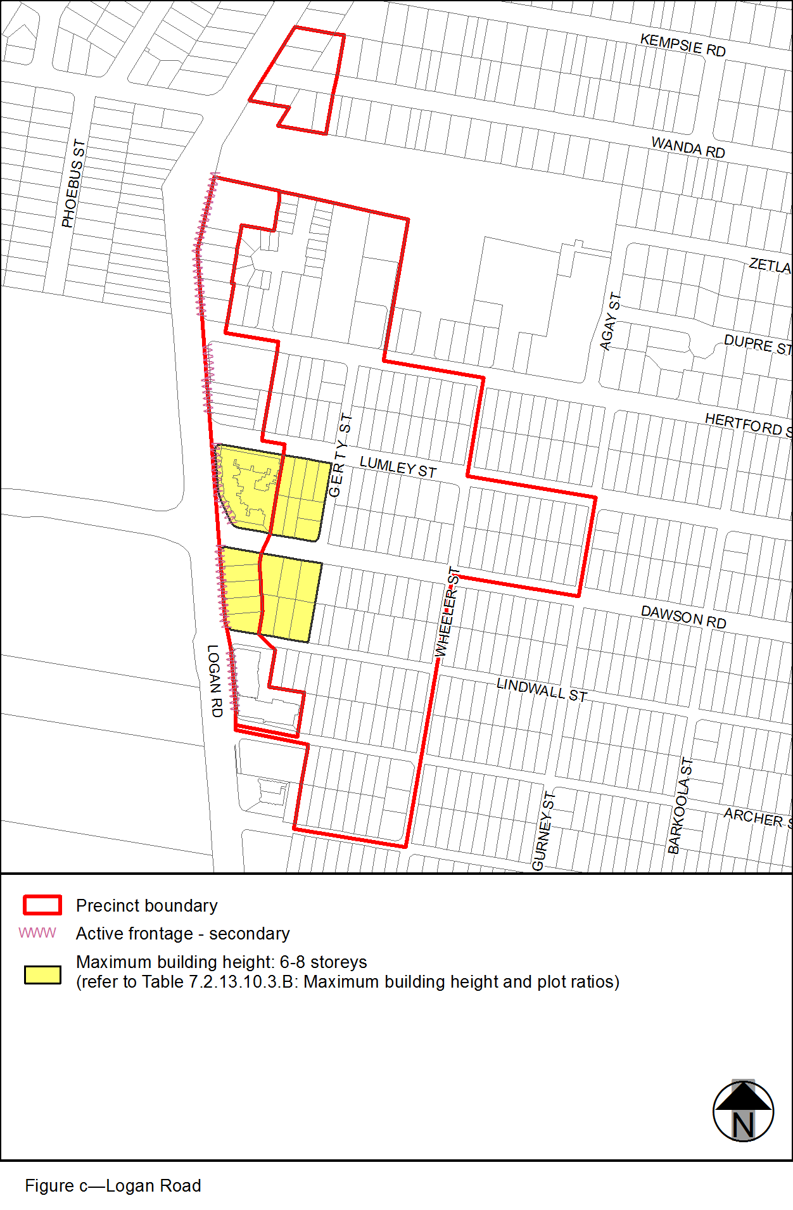
View the high resolution of Figure c–Logan Road (PDF file size is 107Kb)
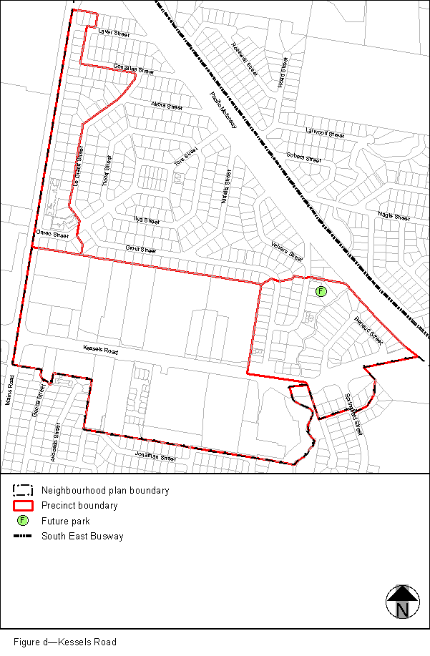
View the high resolution of Figure d–Kessels Road (PDF file size is 122Kb)
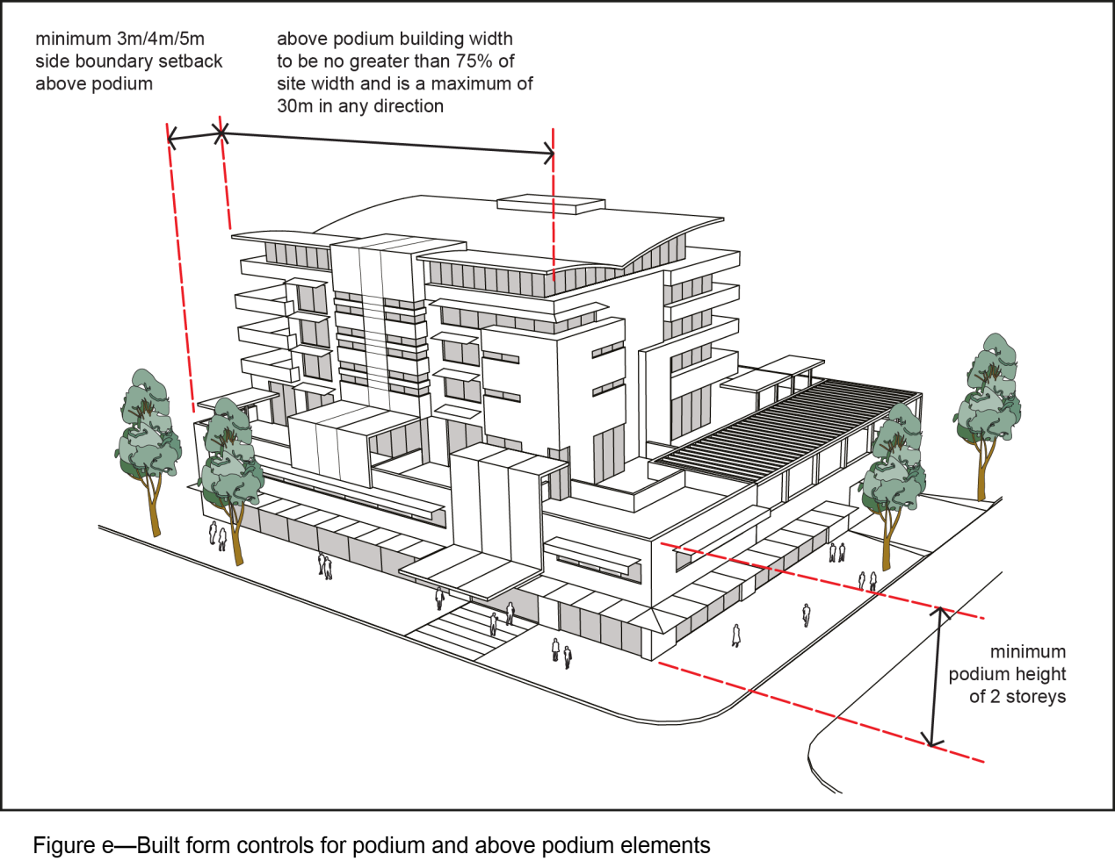
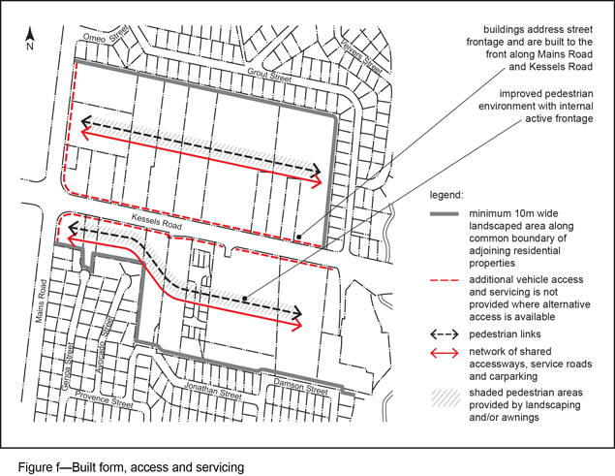
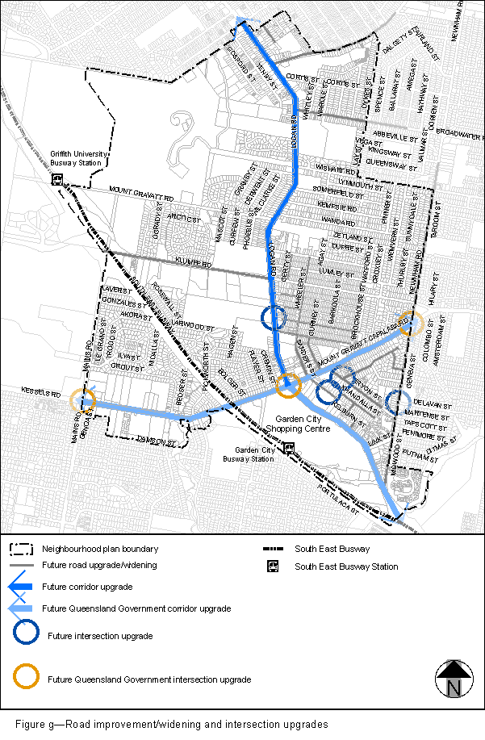
View the high resolution of Figure g–Road improvement/widening and intersection upgrades (PDF file size is 359Kb)

