7.2.18.1 Racecourse precinct neighbourhood plan code

7.2.18.1.1 Application
- This code applies to assessing a material change of use, reconfiguring a lot, operational work or building work in the Racecourse precinct neighbourhood plan area if:
- assessable development where this code is an applicable code identified in the assessment benchmarks column of a table of assessment for a neighbourhood plan (section 5.9); or
- impact assessable development.
- Land in the Racecourse precinct neighbourhood plan area is identified on the NPM-018.1 Racecourse precinct neighbourhood plan map and includes the following precincts:
- Racecourse Road precinct (Racecourse precinct neighbourhood plan/NPP-001);
- Racecourses precinct (Racecourse precinct neighbourhood plan/NPP-002);
- Eagle Farm racing sub-precinct (Racecourse precinct neighbourhood plan/NPP-002a);
- Eagle Farm mixed use sub-precinct (Racecourse precinct neighbourhood plan/NPP-002b);
- Eagle Farm community use sub-precinct (Racecourse precinct neighbourhood plan/NPP-002c);
- Doomben racing and community use sub-precinct (Racecourse precinct neighbourhood plan/NPP-002d);
- Doomben south sub-precinct (Racecourse precinct neighbourhood plan/NPP-002e).
- Kingsford Smith Drive precinct (Racecourse precinct neighbourhood plan NP/NPP-003);
- Kingsford Smith Drive west sub-precinct (Racecourse precinct neighbourhood plan/NPP-003a);
- Kingsford Smith Drive east sub-precinct (Racecourse precinct neighbourhood plan/NPP-003b).
- Hendra stables precinct (Racecourse precinct neighbourhood plan/NPP-004).
- When using this code, reference should be made to section 1.5, section 5.3.2 and section 5.3.3.
Note—The following purpose, overall outcomes, performance outcomes and acceptable outcomes comprise the assessment benchmarks of this code.
Note—This neighbourhood plan includes a table of assessment with variations to categories of development and assessment. Refer to Table 5.9.56.A, Table 5.9.56.B, Table 5.9.56.C and Table 5.9.56.D.

7.2.18.1.2 Purpose
- The purpose of the Racecourse precinct neighbourhood plan code is to provide finer grained planning at a local level for the Racecourse precinct neighbourhood plan area.
- The purpose of the Racecourse precinct neighbourhood plan code will be achieved through overall outcomes including overall outcomes for each precinct of the neighbourhood plan area.
- The overall outcomes for the neighbourhood plan area are:
- The Eagle Farm and Doomben racecourses remain as racecourses and racing facilities and are upgraded to world-class standards by incorporating a mix of residential and retail uses on select areas surplus to horse racing needs. This reinforces their role as significant horse-racing venues through the progressive redevelopment of racing and spectator facilities to international standards and development of new higher density mixed use development community facilities. This redevelopment is consistent with the outcomes sought as it ensures the financial viability of both racecourses.
- The Eagle Farm and Doomben racecourses remain the principal foci for metropolitan horse racing in South East Queensland and elements of historical and cultural heritage significance are protected.
- The Hendra area continues to support the racing industry by providing equine-related services, residential accommodation and stables. Over time, the area's importance for stables will diminish as new stables are established within the grounds of the racecourses.
- The predominant low and low–medium density residential area is retained, with select locations for higher density mixed use development along arterial roads and within select areas of the Eagle Farm and Doomben racecourses, where impacts can be best managed and access to public transport is available.
- Racecourse Road continues to be the focal point for the area’s retail, small business and cafe/dining activities. The proximity of the neighbourhood plan area to the Brisbane Airport also supports complementary uses such as short-term accommodation.
- The proximity of the neighbourhood plan area to the airport means that aircraft noise will be greater than other areas of the city.
- New development incorporates a built form that addresses the street, respects the established character and provides noise mitigation, including for aircraft, rail and road traffic noise.
- Access onto arterial roads is rationalised to improve traffic movements servicing key economic infrastructure, such as the Brisbane Airport and Australia Trade Coast.
- Landscaping and water features are designed to manage potential wildlife hazards for aircraft.
- Development is contained within the precincts as described in Table 7.2.18.1.3.B.
- Development is of a height, scale and form which is consistent with the amenity and character, community expectations and infrastructure assumptions intended for the relevant precinct, sub-precinct or site and is only developed at a greater height, scale and form where there is both a community need and an economic need for the development.
- Racecourse Road precinct (Racecourse precinct neighbourhood plan/NPP-001) overall outcomes are:
- The Racecourse Road centre remains the focus of business activity and community life in the Racecourse Precinct. Racecourse Road consolidates its role as the primary commercial/retail, entertainment and leisure centre in the neighbourhood.
- Uses consistent with the outcomes sought in the precinct include centre activities (a mix of active uses at ground level such as shops, offices, cafes and services), childcare centre, community care centre, indoor sport and recreation (gymnasium), multiple dwellings (located above ground), office (small-scale commercial offices located above ground) and short-term accommodation.
- Development in the precinct provides a human scale to the street while also managing impacts on the adjoining Low density residential zone and the Low–medium density residential zone. The maximum building height on sites containing buildings built in 1946 or before contributes to the traditional building character of the precinct.
- Increased gross floor area is appropriate on consolidated development sites in the precinct and development rationalises vehicle access to Racecourse Road and improves the pedestrian environment and safety.
- Driveway crossovers to Racecourse Road and Kingsford Smith Drive are limited to achieve a safe and continuous pedestrian spine. Additional access to Racecourse Road or Kingsford Smith Drive is not consistent with the outcomes sought. Access for car parking and servicing is via side streets and shared where possible. Car parking and servicing areas are located behind or under buildings to ensure a continuous active frontage is provided to the street.
- Artwork and entrance features reinforce the precinct’s identity and sense of place.
- Racecourses precinct (Racecourse precinct neighbourhood plan/NPP-002) overall outcomes are:
- Integrated planning outlining the long-term vision for the racecourses, including the racing land uses and ancillary uses and buildings; mixed use development; built form and heights; publicly accessible open space and community facilities; vehicular (including servicing) and pedestrian/cycle access and connectivity; heritage; and view corridors is demonstrated through a structure plan.
- The cultural heritage significance of Eagle Farm contributes to the development of the racing industry in Queensland. The heritage-listed buildings, structures, gardens and significant trees continue to be protected and buildings are adaptively re-used for non-residential purposes.
- New horse training facilities, day stables, restored and realigned track surfaces, new grandstands and off-street parking areas, located infield of each track, attract and accommodate event visitors and minimise impacts on the surrounding neighbourhood. These facilities and amenities provide multipurpose uses with a broader range of activities including markets, concerts and festivals, occurring on both courses outside of race days.
- A range of land uses occur over 19ha of land across both Eagle Farm and Doomben racecourses. New development embodies a high standard of architectural design and sensitively integrates with the heritage features of the racecourses, while establishing a cohesive built form identity for the precinct. Development density, height and land use capitalises on the proximity to transit and does not prejudice the current or future operations of Brisbane Airport.
- This precinct also retains significant active and passive recreation open spaces. The privately owned component of the existing park at the intersection of McGill Avenue, Lancaster Road and Kitchener Road, is to be remediated and transferred to public ownership. A second park, situated in the south-eastern corner of the Eagle Farm Racecourse site fronting Nudgee Road, is obtained through development infrastructure contributions. Community facilities including the bowls club and scout hall are retained for community use. Additional community recreation facilities are consistent with the outcomes sought in this precinct.
- Development in the Eagle Farm racing sub-precinct (Racecourse precinct neighbourhood plan/NPP-002a):
- provides a horse-racing venue and associated facilities of international standards as well as public parkland;
- involves uses that are consistent with the outcomes sought in the sub-precinct including animal keeping (stable), outdoor sport and recreation, park and veterinary service.
- Development in the Eagle Farm mixed use sub-precinct (Racecourse precinct neighbourhood plan/NPP-002b):
- caters for mixed use residential, retail, commercial uses and parkland with the dominant land use being residential;
- also provides an internal network for pedestrian, cycle and vehicle access that gives convenient and safe linkages to Racecourse Road, Nudgee Road, local communities and development north of Hampden Street;
- involves uses that are consistent with the outcomes sought in the sub-precinct including centre activities (where childcare centre, community use, community care centre, educational establishment, food and drink outlet, health care service, indoor sport and recreation, multiple dwelling, office, shop (supermarket) and short-term accommodation;
Note—Development of a shop (supermarket) occurs after the completion of residential development in the sub-precinct. The supermarket forms part of a single building located at a podium level, so that it integrates with other uses into the development design.
- provides vehicular access via a new road that connects to Nudgee Road with an upgraded intersection at Hampden Street. Other vehicular access directly to Nudgee Road is not consistent with the outcomes sought. In addition, the sub-precinct provides an internal network for pedestrian, cycle and vehicle access that gives convenient and safe linkages to Racecourse Road, Nudgee Road and local community facilities.
- Development in the Eagle Farm community use sub-precinct (Racecourse precinct neighbourhood plan/NPP-002c):
- retains the historic scout hall for meeting purposes or similar community functions;
- ensures that community uses including the bowls club and State Emergency Service facility are also retained and improved. Additional community recreation facilities are consistent with the outcomes sought;
- provides for some residential purposes, including short-term accommodation, subject to integration with the above community uses;
- does not support direct vehicle access onto Nudgee Road from this sub-precinct;
- has uses consistent with the outcomes sought in the sub-precinct including club, community use, indoor sport and recreation, multiple dwelling, park and short-term accommodation.
- Development in the Doomben racing and community use sub-precinct (Racecourse precinct neighbourhood plan/NPP-002d):
- retains a horse-racing venue and ancillary racing facilities as well as providing community facilities and publicly accessible open space;
- has uses consistent with the outcomes sought in the sub-precinct including animal keeping (stable), outdoor sport and recreation, park and veterinary service.
- Development in the Doomben south sub-precinct (Racecourse precinct neighbourhood plan/NPP-002e):
- contains uses that minimise residential exposure to aircraft noise, are low traffic generators, complement the scale of surrounding residential development and support the horse-racing industry, as well as stables for community-based equestrian activities, subject to adequate landscape screening and setbacks to residential development;
- incorporates retention of racecourse facilities, including racing-day stalls and a grandstand;
- has uses consistent with the outcomes sought in the sub-precinct including club, community use, community care centre, indoor sport and recreation, outdoor sport and recreation, multiple dwelling (where located outside of the 20 ANEF contour), park, short-term accommodation, veterinary service, utility installation, warehouse (self storage facility) and utility installation;
- does not support uses inconsistent with the outcomes sought in the sub-precinct including childcare centre, dwelling house, food and drink outlet, multiple dwelling (where located inside the 20 ANEF contour), office and shop;
- provides vehicular access from Hampden Street. Direct vehicular access to Nudgee Road is not consistent with the outcomes sought. Development ensures safe and convenient public access is provided to public recreation areas, including horse-riding spaces, within the grounds of Doomben Racecourse.
- Kingsford Smith Drive precinct (Racecourse precinct neighbourhood plan/NPP-003) overall outcomes are:
- This precinct predominantly contains residential and commercial (office) uses.
- Residential development along Kingsford Smith Drive provides a transition between the high-rise development of Northshore Hamilton and, the low- and low-to-medium-scale residential development north of Allen Street. The interface with existing low to medium density residential uses outside of the precinct along the north and south of Allen Street is managed with transitions in height and scale, to protect the amenity of adjoining low to medium density development.
- Development for short-term accommodation caters for travellers, given the location’s proximity to the city, Brisbane Airport, and convenient access to other destinations via the arterial road network.
- New development respects the established surrounding character of the precinct by providing significant rear building setbacks and vegetated screening to lots fronting Allen Street and incorporating traditional character elements in building design where within the Allen Street streetscape.
- Development in the Kingsford Smith Drive west sub-precinct (Racecourse precinct neighbourhood plan/NPP-003a):
- involves uses that are consistent with the outcomes sought in the area including office, multiple dwelling and short-term accommodation;
- does not support uses inconsistent with the outcomes sought in the sub-precinct including food and drink outlet and shop;
- does not support retail activities given the difficulties of providing access onto Kingsford Smith Drive;
- does not provide direct access onto arterial roads, including Kingsford Smith Drive and Nudgee Road. Alternative access is obtained from Allen Street or Seymour Road via a single crossover and is shared where possible;
- must not compromise future upgrades of Kingsford Smith Drive and Nudgee Road. Any buildings, structures, fixtures and landscaping associated with development are located outside the area required for the upgrading of Nudgee Road and Kingsford Smith Drive.
- Development in the Kingsford Smith Drive east sub-precinct (Racecourse precinct neighbourhood plan/NPP-003b):
- has uses consistent with the outcomes sought in the sub-precinct including multiple dwellings and short-term accommodation;
- provides alternative access to Kingsford Smith Drive for new development. Development site access for car parking from Allen Street, Oxford Street or College Street is via a single crossover and is shared where possible. Additional access to Kingsford Smith Drive is not consistent with the outcomes sought.
- Hendra stables precinct (Racecourse precinct neighbourhood plan/NPP-004) overall outcomes are:
- The Hendra Stables precinct is an area where stables are likely to be sited. New stables in this area maintain an appropriate level of amenity for the land uses on and near the site of the stables development.
Note—A stable is an example of animal keeping as defined in Table SC1.1.1.B.

7.2.18.1.3 Performance outcomes and acceptable outcomes

Table 7.2.18.1.3.A—Performance outcomes and acceptable outcomes
Performance outcomes | Acceptable outcomes
General
PO1  Development is of a height, scale and form that achieves the intended outcome for the precinct, improves the amenity of the neighbourhood plan area, contributes to a cohesive streetscape and built form character and is:  - consistent with the anticipated density and assumed infrastructure demand;  - aligned to community expectations about the number of storeys to be built;  - proportionate to and commensurate with the utility of the site area and frontage width;  - designed to avoid a significant and undue adverse amenity impact to adjoining development;  - sited to enable existing and future buildings to be well separated from each other and to avoid affecting the potential development of adjoining sites.  Note—Development that exceeds the intended number of storeys or building height can place disproportionate pressure on the transport network, public space or community facilities in particular.  Note—Development that is over-scaled for its site can result in an undesirable dominance of vehicle access, parking and manoeuvring areas that significantly reduce streetscape character and amenity. | AO1  Development complies with the number of storeys and building height in Table 7.2.18.1.3.C and is in accordance with Figure a, Figure b and Figure c.  Note—Neighbourhood plans will mostly specify maximum number of storeys where zone outcomes have been varied in relation to building height. Some neighbourhood plans may also specify height in metres. Development must comply with both parameters where maximum number of storeys and height in metres are specified.
PO2  Development of a building incorporates a design, bulk and setbacks which:  - enable existing and future buildings to be well separated from each other to allow light penetration, air circulation, privacy and ensure windows are not built out by adjoining buildings;  - do not prejudice the development of adjoining sites;  - do not dominate the street or other pedestrian spaces;  - result in sensitive massing and articulation that ensures the building does not dominate the street or other pedestrian spaces. | AO2.1  Development has a maximum gross floor area in accordance with Table 7.2.18.1.3.D.
AO.2.2
Development has building setbacks in accordance with Table 7.2.18.1.3.E.
PO3  Development ensures vehicle access, servicing and car parking structures are designed and located to:  - minimise disruption to the established building line;  - ensure they do not visually dominant the site and streetscape;  - protect the safety of pedestrians;  - ensure vehicle access is not provided from an arterial road where an alternative access is available. | AO3.1  Development does not provide vehicular access from Racecourse Road or Kingsford Smith Drive.
AO3.2
Development ensures there is no net increase in driveway crossovers on Racecourse Road and Kingsford Smith Drive.
AO3.3
Development ensures common accessdriveways, car parking and servicing areas are created where possible and secured in perpetuity through the granting of reciprocal access easements.
AO3.4
Development ensures car parking and servicing areas are located at the rear or underneath buildings.
AO3.5
Development provides driveway crossovers that maintain the integrity, quality and primacy of footpaths.
If adjoining an operational rail corridor
PO4  Development involving a sensitive use affected by environmental emissions generated by an operational rail corridor, mitigates noise impacts on the development generated by the rail corridor.  Note—Sensitive use includes childcare centre, community uses, educational establishment, health care service, and short-term accommodation. | AO4  No acceptable outcome is prescribed.
If in the Racecourse Road precinct (Racecourse precinct neighbourhood plan/NPP-001)
PO5  Development ensures that the siting and design of a building:  - respect the layout, scale (including height and setback) and character of existing buildings in Racecourse Road;  - incorporate elements of traditional shopping street design;  - provide a continuous active street frontage;  - provide opportunities for natural surveillance of the street to improve safety;  - provide continuous pedestrian shelter to maximise pedestrian comfort and accessibility and maintains the tree-lined streetscape;  - maintain privacy for adjoining residential properties including by vegetated buffers. | AO5.1  Development incorporates elements of traditional shopping street design including exposed gables, timber joinery and well-defined shopfronts and entry doors.
AO5.2
Development ensures the ground storey of buildings is built to the street frontage.
AO5.3
Development incorporates balconies and openings that overlook the street.
AO5.4
Development provides awnings to the Racecourse Road and Kingsford Smith Drive street frontages that are located to avoid interference with street trees.
PO6  Development provides a mix of active uses at ground level that contribute to a vibrant pedestrian realm. | AO6.1  Development includes active uses such as shops, offices and food and drink outlets located at ground level.
AO6.2
Development containing a residential component locates that component above ground level.
If in the Racecourses precinct (Racecourse precinct neighbourhood plan/NPP-002)
PO7  Development demonstrates an integrated long-term vision for the Eagle Farm and Doomben racecourses and ensures the following:  - Eagle Farm and Doomben racecourses remain the principal foci for metropolitan horse racing in South East Queensland through the upgrade of on- and off-track facilities and amenities including new horse-training facilities, day stables, restored and realigned track surfaces, new grandstands and off-street parking areas;  - high-quality urban design creates a world-class urban racing precinct that is sympathetic to the local character and environment;  - land uses comply with the intent for the sub-precincts and do not prejudice the use of the racecourses as a horse-racing venue;  - maximum building heights comply with Table 7.2.18.1.3.C and Figure b and exhibit a range of building heights across the sub-precincts to create an interesting townscape and preserve the amenity, privacy, outlook and levels of sunlight enjoyed by neighbouring residential properties and character of the precinct;  - compliance with the maximum gross floor area in Table 7.2.18.1.3.D and must not materially impact on the function of nearby suburban centres;  - the cultural heritage significance of the racecourses area, buildings (including heritage grandstands, federation-style ticket office, heritage entrance gates), significant vegetation and gardens are retained and heritage aspects celebrated through high-quality design and appropriate adaptive re-use of heritage structures;  - new buildings and grandstands respect and reinforce the heritage character of the site and complement adjacent heritage buildings;  - any enclosure of the grandstands is constructed with transparent materials for weather protection;  - building layout, heights and form protect the important views and vistas within and to/from the precinct;  - publicly accessible open space (including active and passive areas) and community facilities are provided to meet the needs of the precinct and surrounding area, including 11,122 m2 (L1 RP 44233 and L2 SL 2082) between Kitchener Road, McGill Avenue and Lancaster Road and a minimum 5,000m2 public park in the south-eastern corner of the Eagle Farm Racecourse and fronting Nudgee Road. This park configuration contains a square measuring 35m x 35m (minimum) and between 25% and 30% of the park’s perimeter fronts a public road.  Note—This can be demonstrated through a structure plan.  Note—Guidance for the preparing of a structure plan is provided in the Structure planning planning scheme policy. | AO7  No acceptable outcome is prescribed.
PO8  Development provides landscaping, including water features that minimise wildlife hazards for aircraft, through the following:  - designing and constructing water features to minimise areas of open water or refuge islands for waterbirds;  - providing water bodies with edges and substrates that inhabit access by waterbirds;  - by planting vegetation is planted throughout water bodies. | AO8  Development includes landscaped open spaces and water features and addresses the following:  - grassed areas are designed and constructed to be free draining;  - the design and construction of water bodies limits the surface area of open water bodies and does not involve the construction of islands within water bodies;  - open water bodies are densely planted with tall rushes (e.g. Schoenoplectus validis) to achieve an overall macrophyte vegetation cover over water of at least 90%;  - open water bodies are designed and constructed with steep sides of at least 70º;  - placement of emergent pipes, logs or rocks adjacent to or within water bodies is minimised;  - dry margins of water bodies are planted with dense low-growing vegetation that does not support roosting perches (e.g. Lomandra hystrix, Gahnia sieberiana) or nesting/breeding habitat for birds and flying foxes.
If in the Kingsford Smith Drive precinct (Racecourse precinct neighbourhood plan/NPP-003)
PO9  Development for the purpose of a stable avoids or minimises adverse impacts on the amenity of land uses of the subject site or adjoining sites, particularly in terms of noise and odour. | AO9  No acceptable outcome is prescribed.
PO10  Development setbacks protect the character, privacy and amenity of adjoining residential areas through:  - transitions between higher and lower rise residential areas by stepping down in height and scale at site boundaries;  - sympathetic built form along the interface that does not create an overbearing appearance or significantly impact on the privacy and amenity of adjoining residences. | AO10.1  Development with a side or rear boundary to land in a zone in the Residential zones category not within the sub-precinct has a maximum building height of 3 storeys within 10m of the common property boundary.
AO10.2
Development located across a street from land in a zone in the Residential zones category not within the sub-precinct has a maximum building height of 3 storeys within 10m of the boundary with a frontage to that street.
PO11  Development design and layout must not compromise future road upgrades. | AO11  Development, including buildings, structures, fixtures and landscaping are located outside any future road dedication area required for the upgrading of the Kingsford Smith Drive and Nudgee Road intersection.
If in the Kingsford Smith Drive west sub-precinct (Racecourse precinct neighbourhood Plan/NPP-003a)
PO12  Development ensures building siting and design:  - respects the layout, scale (including height and setback) and character of existing buildings;  - provides a continuous active street frontage;  - provides opportunities for natural surveillance of the street to improve safety;  - provides continuous pedestrian shelter to maximise pedestrian comfort and accessibility and maintains the tree-lined streetscape;  - maintains privacy for adjoining residential properties including by vegetated buffers. | AO12.1  Development ensures the ground storey of buildings is built to the street frontage.
AO12.2
Development incorporates balconies and openings that overlook the street.
AO12.3
Development provides awnings to the Kingsford Smith Drive street frontage that are located to avoid interference with street trees.
AO12.4
Development with a frontage to Allen Street is a maximum of 3 storeys.
If in the Hendra stables sub-precinct (Racecourse precinct neighbourhood plan/NPP-004)
PO13  Development for the purposes of a stable avoids or minimises adverse impacts on the amenity of land uses of the subject site or adjoining sites, particularly in terms of noise and odour. | AO13.1  Development for a stable locates:  - stable buildings, waste storage bin areas and vehicle loading areas for horse transport, a minimum of 10m from any residential building on an adjoining site without a stable;  - horse-training facilities, a minimum of 5m from any residential buildings on an adjoining site without a stable;  - stable buildings and horse-training facilities, a minimum of 1.5m from any residential building on an adjoining site that also includes a stable.
AO13.2
Development for a stable includes:
- rubber mats (or the like) on concrete floors, pavements, loading ramps, transport vehicles and trailers, where horses are walked and loaded into vehicles;
- stable doors and gates (including their component parts) that are made of non-metal materials, or prevents metal-on-metal contact;
- stable feed or waste storage containers that are made of non-metal materials, or prevents metal-on-metal contact;
- a 2m high acoustic fence along the boundary with a residential premises adjoining the site.

Table 7.2.18.1.3.B—Precinct and sub-precinct boundary descriptions
Precinct/sub-precinct number | Precinct/sub-precinct name | Precinct boundary description
NPP-001 | Racecourse Road | Precinct NPP-001 is defined by lot boundaries shown in NPM-018.1 Racecourse precinct neighbourhood plan map
NPP-002 | Racecourses | The Racecourses precinct, as shown in NPM-018.1 Racecourse precinct neighbourhood plan map, is divided into 7 sub-precincts as described below.
NPP-002a | Eagle Farm racing | Sub-precinct NPP-002a, as shown in NPM-018.1 Racecourse precinct neighbourhood plan map, encompasses the Eagle Farm racecourse and is bounded by the Doomben line railway corridor on the southern and western sides. The sub-precinct’s northern boundary is in common with the northern boundary of Lot 6 on RP866929 and the sub-precinct is bounded on the eastern side by sub-precinct NPP-002b. The sub-precinct includes land between McGill Avenue, Kitchener Road and Lancaster Road. The total land area in sub-precinct NPP-002a is 45.4ha.
NPP-002b | Eagle Farm mixed use | Sub-precinct NPP-002b, as shown in NPM-018.1 Racecourse precinct neighbourhood plan map, is bounded by Nudgee Road on the east and the Doomben line railway corridor to the south; its western boundary aligns with the eastern boundary of Lot 69 on RP33643, the northern boundary follows the circumference of the racecourse proper eastwards and shares the northern boundary of Lot 6 on RP866929 for 70m from Nudgee Road. The total land area in sub-precinct NPP-002b is 8ha.
NPP-002c | Eagle Farm community use | Sub-precinct NPP-002c, as shown in NPM-018.1 Racecourse precinct neighbourhood plan map, is bounded by Lancaster Road to the south, the Doomben line railway corridor to the north and Nudgee Road to the east. The total area contained in sub-precinct NPP-002c is 2.0ha.
NPP-002d | Doomben racing and community use | Sub-precinct NPP-002d, as shown in NPM-018.1 Racecourse precinct neighbourhood plan map, encompasses the Doomben Racecourse and is bounded on the western side by Nudgee Road and by sub-precinct NPP-002e on the southern side. Its northern and eastern boundaries are in common with Lot 2 on SP211404. The total area contained in sub-precinct NPP-002d is 29ha.
NPP-002e | Doomben south | Sub-precinct NPP-002e, as shown in NPM-018.1 Racecourse precinct neighbourhood plan map, fronts Hampden Street and the sub-precinct’s depth is measured 90m north from Hampden Street. The sub-precinct is bounded on the western side by Nudgee Road and its eastern boundary is shared with the eastern boundary of Lot 2 on SP211404. The total land area in sub-precinct NPP-002e is 6ha.
NPP-003 | Kingsford Smith Drive | The Kingsford Smith Drive precinct, as shown in NPM-018.1 Racecourse precinct neighbourhood plan map, is divided into 2 sub-precincts as described below.
NPP-003a | Kingsford Smith Drive west | Sub-precinct NPP-003a, as shown in NPM-018.1 Racecourse precinct neighbourhood plan map, is defined by lot boundaries between Racecourse Road and Nudgee Road.
NPP-003b | Kingsford Smith Drive east | Sub-precinct NPP-003b, as shown in NPM-018.1 Racecourse precinct neighbourhood plan map, is defined by lot boundaries between Nudgee Road and College Street.
NPP-004 | Hendra stables | Precinct NPP-004 is defined by lot boundaries shown in NPM018.1 Racecourse precinct neighbourhood plan map.

Table 7.2.18.1.3.C—Maximum building height
Development | Maximum building height (storeys (m))
If in the Racecourse Road precinct (Racecourse precinct neighbourhood plan/NPP-001)
Any development in this precinct | 3 to 5
If in the Racecourses precinct (Racecourse precinct neighbourhood plan/NPP-002)
Development of a site in the Eagle Farm racing sub-precinct (Racecourse precinct neighbourhood plan/NPP-002a) except for grandstands | 5 (20m)
Development of a site in the Eagle Farm racing sub-precinct (Racecourse precinct neighbourhood plan/NPP-002a) for grandstands | 7 (25m)
Development of a site in the Eagle Farm mixed use sub-precinct (Racecourse precinct neighbourhood plan/NPP-002b), where north of Hampden Street and located more than 20m from any property boundary adjoining the building height transition area | 7 (25m)
Development of a site in the Eagle Farm mixed use sub-precinct (Racecourse precinct neighbourhood plan/NPP-002b), where south of Hampden Street and located more than 20m from any property boundary adjoining the building height transition area | 15 (45m)
Development of a site in the Eagle Farm mixed use sub-precinct (Racecourse precinct neighbourhood plan/NPP-002b), where in all other areas and less than 10m from any property boundary that adjoins the building height transition area | 2
Development of a site in the Eagle Farm mixed use sub-precinct (Racecourse precinct neighbourhood plan/NPP-002b), where in all other areas and between 10m and 20m from any property boundary that adjoins the building height transition area | 5
Development of a site in the Eagle Farm community use sub-precinct (Racecourse precinct neighbourhood plan/NPP-002c), where less than 10m from any property boundary that adjoins the building height transition area | 2 (9.5m)
Development of a site in the Eagle Farm community use sub-precinct (Racecourse precinct neighbourhood plan/NPP-002c), where 10m or more from any property boundary that adjoins the building height transition area | 5 (20m)
If in the Kingsford Smith Drive precinct (Racecourse precinct neighbourhood plan/NPP-003)
Development of a site in the Kingsford Smith Drive west sub-precinct (Racecourse precinct neighbourhood plan/NPP-003a), where west of Seymour Road | 4 (14m)
Development of a site in the Kingsford Smith Drive west sub-precinct (Racecourse precinct neighbourhood plan/NPP-003a), where east of Seymour Road. | 5 (15m)
Development of a site in the Kingsford Smith Drive east sub-precinct (Racecourse precinct neighbourhood plan/NPP-003b) | 5 (17.5m)
Note—Building height transition area is shown in Figure b.

Table 7.2.18.1.3.D—Maximum plot ratio/gross floor area
Development | Site area | Maximum plot ratio/gross floor area
If in the Racecourse Road precinct (Racecourse precinct neighbourhood plan/NPP-001)
Development of a site in the Racecourse Road precinct (Racecourse precinct neighbourhood plan/NPP-001) | <800m2 | 125%
 | 800m2 or greater | 150%
If in the Racecourses precinct (Racecourse precinct neighbourhood plan/NPP-002)
Development of a site in the Eagle Farm racing sub-precinct (Racecourse precinct neighbourhood plan/NPP-002a) except for grandstands | Not specified | 9,000m2
Development of a site in the Eagle Farm mixed use sub-precinct (Racecourse precinct neighbourhood plan/NPP-002a) except for grandstands | Not specified | 131,000m2
Development of a site in the Eagle Farm community use sub-precinct (Racecourse precinct neighbourhood plan/NPP-002c) | Not specified | 15,000m2
Development of a site in the Doomben racing and community use sub-precinct (Racecourse precinct neighbourhood plan/NPP-002d) | Not specified | 3,000m2
Development of a site in the Doomben south sub-precinct (Racecourse precinct neighbourhood plan/NPP-002e) | Not specified | 31,500m2
If in the Kingsford Smith Drive precinct (Racecourse precinct neighbourhood plan/NPP-003)
Development of a site in the Kingsford Smith Drive west sub-precinct (Racecourse precinct neighbourhood plan/NPP-003a) | <1,200m2 | 125%
 | 1,200m2 or greater | 150%
Development of a site in the Kingsford Smith Drive east sub-precinct (Racecourse precinct neighbourhood plan/NPP-003b) | <1,200m2 | 80%
 | 1,200m2 or greater | 100%

Table 7.2.18.1.3.E—Minimum building setbacks
Development | Minimum setbacks
If in the Racecourse Road precinct (Racecourse precinct neighbourhood plan/NPP-001)
Development at ground level | Rear – 6m
Development above ground and fronting Kingsford Smith Drive | Front – 6m  Rear – 7m
Development above ground and fronting Racecourse Road | Front – 3m  Rear – 7m
If in the Kingsford Smith Drive precinct (Racecourse precinct neighbourhood plan/NPP-003)
Development at ground level | Rear – 6m
Development of a site in the Kingsford Smith Drive west sub-precinct (Racecourse precinct neighbourhood plan/NPP-003a) and where above ground | Front – 6m  Rear – 10m
Development of a site in the Kingsford Smith Drive east sub-precinct (Racecourse precinct neighbourhood plan/NPP-003b) and where above ground | Front – 6m  Rear – 10m

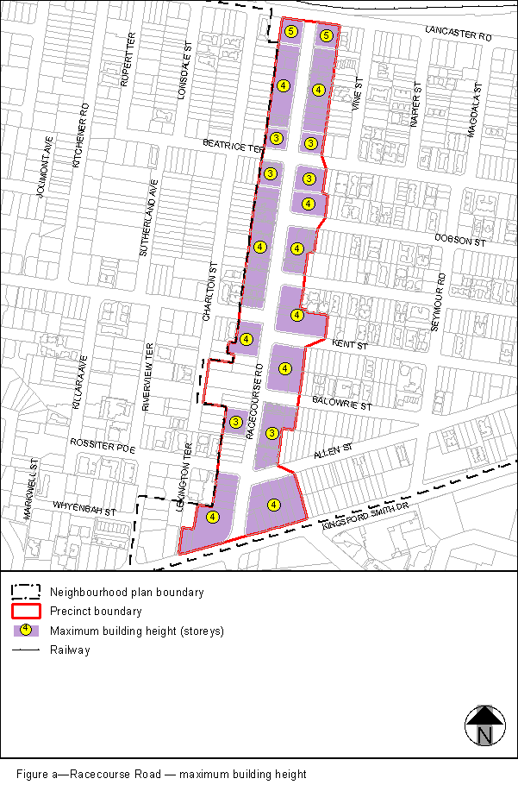
View the high resolution of Figure a–Racecourse Road – maximum building height (PDF file size is 135Kb)
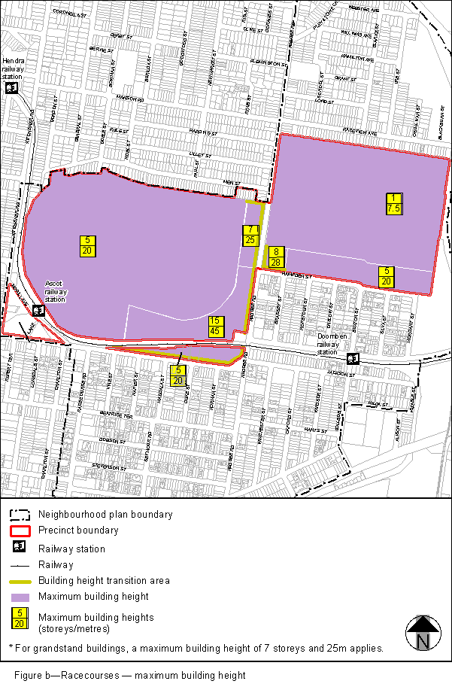
View the high resolution of Figure b–Racecourses – maximum building height (PDF file size is 248Kb)
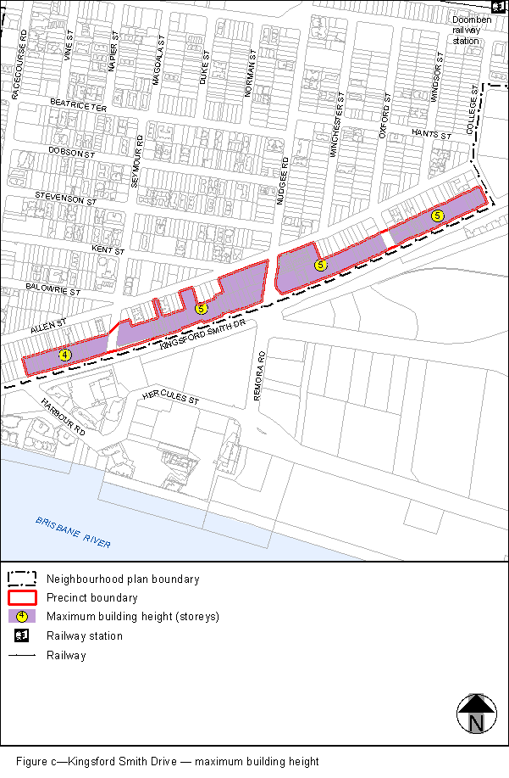
View the high resolution of Figure c–Kingsford Smith Drive – maximum building height (PDF file size is 217Kb)

