7.2.20.5 The Gap neighbourhood plan code

7.2.20.5.1 Application
- This code applies to assessing a material change of use, reconfiguring a lot, operational work or building work in The Gap neighbourhood plan area if:
- assessable development where this code is an applicable code identified in the assessment benchmarks column of a table of assessment for a neighbourhood plan (section 5.9); or
- impact assessable development.
- Land in The Gap neighbourhood plan area is identified on NPM-020.5 The Gap neighbourhood plan map and includes the following precincts:
- The Village precinct (The Gap neighbourhood plan/NPP-001):
- The Village centre sub-precinct (The Gap neighbourhood plan/NPP-001a);
- Potential development areas precinct (The Gap neighbourhood plan/NPP-002).
- When using this code, reference should be made to section 1.5, section 5.3.2 and section 5.3.3.
Note—The following purpose, overall outcomes, performance outcomes and acceptable outcomes comprise the assessment benchmarks of this code.
Note—This neighbourhood plan includes a table of assessment with variations to categories of development and assessment. Refer to Table 5.9.81.A, Table 5.9.81.B, Table 5.9.81.C and Table 5.9.81.D.

7.2.20.5.2 Purpose
- The purpose of The Gap neighbourhood plan code is to provide finer-grained planning at a local level for The Gap neighbourhood plan area.
- The purpose of The Gap neighbourhood plan code will be achieved through overall outcomes including overall outcomes for each precinct of the neighbourhood plan area.
- The overall outcomes for the neighbourhood plan area are:
- Development in The Gap is characterised by low density housing on suburban lots, complemented by established vegetation.
- Development of centre activities meets the retail, commercial, community and service needs of the local community, and are located in the existing centre zone category.
- Development responds to existing vegetation and land with ecological features.
- Development is of a high quality design incorporating subtropical design principles.
- Development adjacent to public open space increases casual surveillance and activation of the public open space.
- Development is of a height, scale and form which is consistent with the amenity, character, community expectations and infrastructure assumptions intended for the relevant precinct, sub-precinct or site.
- The Village precinct (The Gap neighbourhood plan/NPP-001) overall outcomes are:
- The precinct provides for the commercial, retail and entertainment needs of residents and visitors.
- Development for residential uses includes adaptable housing to meet the needs of the existing and future residents, support ageing in place and provide housing suited to elderly, single and young adult occupants.
- Development in The Village centre sub-precinct (The Gap neighbourhood plan/NPP-001a):
- supports a high level of accessibility within the sub-precinct and facilitates connections between Walton Bridge Reserve, surrounding residential uses, public transport and The Gap Village shopping centre, as identified in Figure a;
- is of high quality urban design catering to residents’ needs.
- The Potential development areas precinct (The Gap neighbourhood plan/NPP-002) overall outcomes are:
- Building envelope plans or development footprint plans are located wholly outside the areas of ecological features identified in Figure b.
- Development must be in accordance with an approved structure plan which considers how the proposed development will integrate with the surrounding uses and infrastructure, and protect ecological features identified in Figure b.
- Development does not exceed a maximum of 18 dwellings per hectare sited on a range of lot sizes consistent with the existing pattern of development.
Note—Densities are to be calculated excluding parts of the site that are identified in Figure b as having ecological features. Areas identified as having ecological features in Figure b may still form part of the development provided they do not contribute to the calculation of residential yield, and any building envelope plans or development footprint plans are wholly excluded from all areas identified as having ecological features.

7.2.20.5.3 Performance outcomes and acceptable outcomes

Table 7.2.20.5.3.A—Performance outcomes and acceptable outcomes
Performance outcomes | Acceptable outcomes
General
PO1  Development retains significant vegetation and provides substantial areas for landscaping and shade tree planting consistent with the character of the neighbourhood plan area and subtropical climate of the area. | AO1.1  Development retains significant vegetation within the property boundaries.  Note—Significant vegetation is defined in the Vegetation planning scheme policy.
AO1.2
Development is designed and located so that a new building, car parking, driveway or a crossover will not adversely impact the long-term viability of existing significant vegetation.
Note—Significant vegetation is defined in the Vegetation planning scheme policy.
AO1.3
Development provides deep-planting areas that:
- are a minimum of 15% of the site area;
- are exclusively for landscaping;
- are able to accommodate trees planted in natural ground;
- are 100% open to the sky;
- can be accessed for maintenance purposes.
Note—Landscape design incorporates planting in accordance with the Planting species planning scheme policy.
PO2  Development incorporates subtropical design principles to support healthy, energy efficient living in a local subtropical climate and reflects the suburban character of the area. | AO2  Development incorporates the following subtropical design principles:  - cross-ventilation in and around buildings by use of building forms, openings and windows, breezeways, open courtyards and landscaped areas;  - sun shading of openings;  - suitable building orientation;  - limited building depth to allow sunlight to penetrate into open space and living areas during winter;  - private open space of a suitable size and proportion, landscaped to provide shade from the summer sun and promote Brisbane’s climate and atmosphere;  - building form that maximises amenity, street activity and pedestrian connectivity;  - deep planting within setbacks along common boundaries and frontages.
PO3  Development mitigates adverse impacts to ecological features and visual amenity through:  - site design that is responsive to topography and land constraints;  - retention of existing vegetation;  - siting larger lots on steeper land;  - minimising impacts from site earthworks including cutting, filling and retaining walls. | AO3  No acceptable outcome is proposed.
If in The Village precinct (The Gap neighbourhood plan/NPP-001)
PO4  Development for dual occupancy or multiple dwelling meets a diverse range of community needs by providing adaptable housing that is responsive to changing lifecycles. | AO4  Development for dual occupancy or multiple dwelling provides housing and associated outdoor living areas, which are:  - adaptable to different persons and households with differing mobility needs;  - constructed in accordance with Table 9.3.14.3.D of the Multiple dwelling code.
If in The Village centre sub-precinct (The Gap neighbourhood plan/NPP-001a)
PO5  Development facilitates the integrated development of the centre which includes:  - publicly accessible shaded plazas and active frontages;  - hardstand space to locate a mobile library vehicle;  - an internal road layout that provides minimal impact to connecting roads, links with the surrounding parkland and ensures natural shade and safe pedestrian movements, vehicular and service vehicle access;  - improved pedestrian connections to Walton Bridge Reserve, specifically the amphitheatre, skate bowl and playing fields on the eastern side and public transport;  - improved pedestrian connections and active frontages to Enoggera Creek bikeway through a lookout gateway for improved casual surveillance;  - improved signage for key entry points;  - an arcade with a design, width, layout and ground-storey treatment that promotes activation and surveillance. | AO5  Development is in accordance with Figure a.
If in the Potential development areas precinct (The Gap neighbourhood plan/NPP-002)
PO6  Development is designed to retain and enhance ecological features, including existing vegetation, wildlife habitat and movement functions, and landscape character. | AO6.1  Development does not locate building envelope plans or development footprint plans in areas of ecological features identified in Figure b.
AO6.2
Development has a development footprint of a size and location that:
- retains the majority of existing vegetation;
- minimises loss or fragmentation of existing vegetation;
- is close to the lot boundary that has street access;
- protects the existing ecological features;
- minimises edge effects.
Note—Any bushfire management zone, asset protection zone or similarly defined area approved as part of a bushfire management plan used for bushfire management purposes is considered to be a bushfire management footprint plan. A building protection zone can comprise both the development footprint plan and the bushfire management footprint plan.
PO7  Development is designed to accommodate dwelling houses on a range of lot sizes consistent with existing development pattern and size. | AO7  Development achieves a maximum of 18 dwellings per hectare.
PO8  Development is undertaken in accordance with a structure plan that is prepared for the precinct and in accordance with the Structure planning planning scheme policy and which addresses site context and setting by responding to:  - transport infrastructure;  - stormwater infrastructure;  - density and scale of adjoining development;  - ecological features.  Note—A structure plan prepared in accordance with the Structure planning planning scheme policy can assist in demonstrating achievement of this outcome and is a useful tool to integrate development layout with all relevant spatial attributes as addressed in overlays and neighbourhood plans. | AO8  Development is consistent with an approved structure plan prepared in accordance with the Structure planning planning scheme policy.

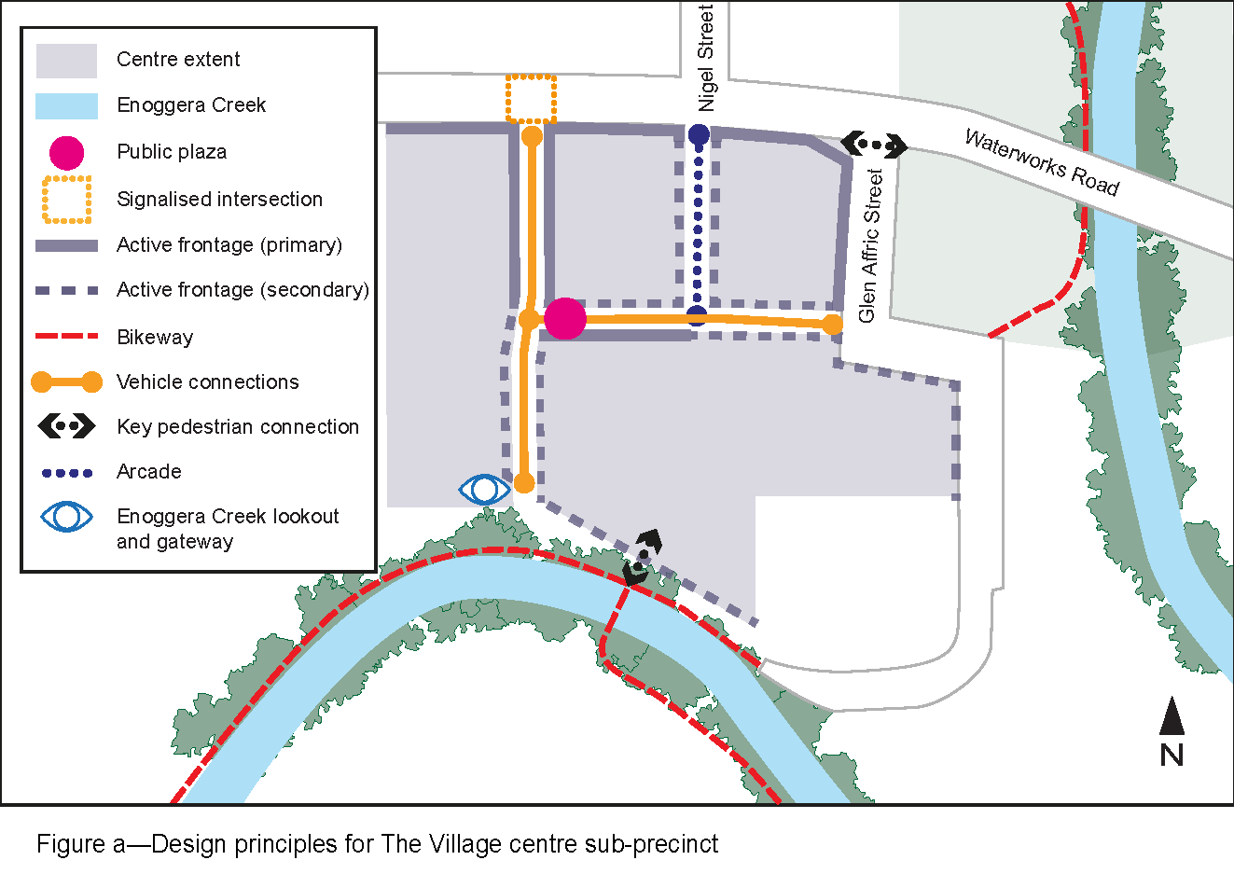

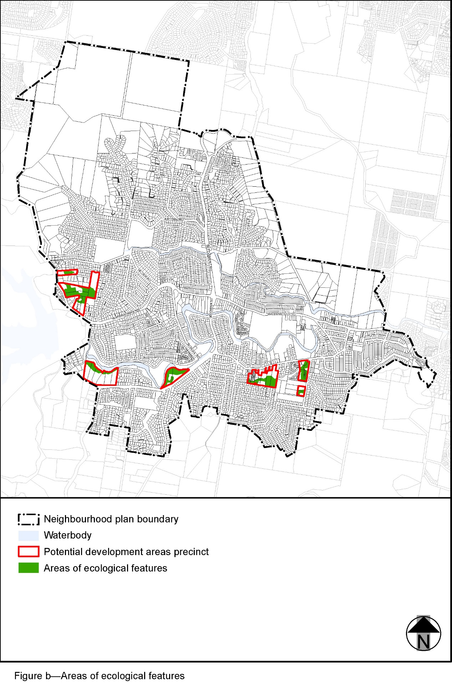
View the high resolution of Figure b–Areas of ecological features (PDF file size is 651Kb)

