7.2.23.6 Wynnum—Manly neighbourhood plan code

7.2.23.6.1 Application
- This code applies to assessing a material change of use, reconfiguring a lot, operational work or building work in the Wynnum—Manly neighbourhood plan area if:
- assessable development where this code is an applicable code identified in the assessment benchmarks column of a table of assessment for a neighbourhood plan (section 5.9); or
- impact assessable development.
- Land within the Wynnum—Manly neighbourhood plan area is identified on the NPM-023.6 Wynnum—Manly neighbourhood plan map and includes the following precincts:
- Wynnum north precinct (Wynnum—Manly neighbourhood plan/NPP-001):
- Wynnum north sub-precinct (Wynnum—Manly neighbourhood plan/NPP-001a);
- Light and service industry precinct (Wynnum—Manly neighbourhood plan/NPP-002);
- Wynnum central precinct (Wynnum—Manly neighbourhood plan/NPP-003):
- Wynnum CBD northern frame sub-precinct (Wynnum—Manly neighbourhood plan/NPP-003a);
- Parkside residential sub-precinct (Wynnum—Manly neighbourhood plan/NPP-003b);
- Western residential sub-precinct (Wynnum—Manly neighbourhood plan/NPP-003c);
- Wynnum central business district sub-precinct (Wynnum—Manly neighbourhood plan/NPP-003d);
- Bay Terrace sub-precinct (Wynnum—Manly neighbourhood plan/NPP-003e);
- Wynnum CBD southern frame sub-precinct (Wynnum—Manly neighbourhood plan/NPP-003f);
- Waterloo Bay Hotel sub-precinct (Wynnum—Manly neighbourhood plan/NPP-003g);
- Esplanade sub-precinct (Wynnum—Manly neighbourhood plan/NPP-003h).
- Manly harbour village precinct (Wynnum—Manly neighbourhood plan/NPP-004);
- Wynnum Hospital precinct (Wynnum—Manly neighbourhood plan/NPP-005);
- Wynnum Road precinct (Wynnum—Manly neighbourhood plan/NPP-006);
- Lota wetlands (Wynnum—Manly neighbourhood plan/NPP-007).
- When using this code, reference should be made to section 1.5, section 5.3.2 and section 5.3.3.
Note—The following purpose, overall outcomes, performance outcomes and acceptable outcomes comprise the assessment benchmarks of this code.
Note—This neighbourhood plan includes a table of assessment with variations to categories of development and assessment. Refer to Table 5.9.72.A, Table 5.9.72.B, Table 5.9.72.C and Table 5.9.72.D.

7.2.23.6.2 Purpose
- The purpose of the Wynnum—Manly neighbourhood plan code is to provide finer grained planning at a local level for the Wynnum—Manly neighbourhood plan area.
- The purpose of the Wynnum—Manly neighbourhood plan code will be achieved through overall outcomes including overall outcomes for each precinct of the neighbourhood plan area.
- The overall outcomes for the neighbourhood plan area are:
- Wynnum—Manly is a thriving, inclusive and accessible bayside community that retains and enhances its unique bayside character.
- Development in Wynnum—Manly retains its strong sense of place including the area’s relationship to Moreton Bay, its buildings, seaside landscapes, sense of community identity, and Aboriginal and Torres Strait Islander values.
- Development maintains the different functions of retail centres across the neighbourhood plan area, which includes the primacy of Wynnum Central, Manly Harbour Village and Wynnum Plaza shopping centres.
- Natural assets of the area including the Foreshore Parklands, wetlands, Wynnum and Lota creeks and Moreton Bay, are protected, rehabilitated and enhanced to contribute towards their ecological, hydrological and recreational functions and their contribution to the biodiversity of the region.
- The Foreshore Parklands serve local residents and visitors with a high-quality recreational experience for all ages.
- The area’s economic and employment growth is promoted through revitalising its centres, development of strategic relationships with the Brisbane Ports region (such as providing business accommodation), and capitalising on tourism opportunities in Wynnum, Manly and Moreton Bay. Development is of a height, scale and form which is consistent with the amenity and character, community expectations and infrastructure assumptions intended for the relevant precinct, sub-precinct or site and is only developed at a greater height, scale and form where there is both a community need and an economic need for the development.
- While making efficient use of land, development is consistent with community expectations and infrastructure assumptions.
- Wynnum north precinct (Wynnum—Manly neighbourhood plan/NPP-001) overall outcomes are:
- The precinct is a low density residential area with local parks and conservation areas. This precinct is located in close proximity to the Australia TradeCoast industrial area.
- All traffic enters and exits Wynnum north sub-precinct (Wynnum—Manly neighbourhood plan/NPP-001a) via Pritchard Street to minimise impacts on nearby residents.
- Light and service industry precinct (Wynnum—Manly neighbourhood plan/NPP-002) overall outcomes are:
- This precinct is retained for low impact industrial and service industry purposes, to provide local services and an employment node within the Wynnum—Manly area. Residential or commercial uses are not consistent with the outcomes sought.
- Wynnum Central precinct (Wynnum—Manly neighbourhood plan/NPP-003) overall outcomes are:
- Wynnum Central achieves its role as a Major Centre with enhanced economic viability and visual amenity.
- The precinct is an attractive and compact centre which serves a catchment of regional significance, provides business and service functions and accommodates district or branch offices of government. The South East Queensland Regional Plan envisages that such centres accommodate key concentrations of employment and provide a focus for residential intensification.
- Development is focused around the Wynnum Central railway station and the centre area. High density development around the Wynnum Central railway station takes advantage of its strategic location in close proximity to public transport. Medium density residential development frames the Wynnum CBD and forms a transition between the higher residential densities and the existing surrounding low–medium residential density uses.
- Residential amenity in the centre is commensurate to the levels achievable and expected in a vibrant, mixed use centre. Residential accommodation in centres will experience higher levels of noise and less amenity than that expected in suburban or semi-rural living.
- To maintain a compact and active centre, non-residential activities outside of the existing centre area and mixed use centre frame are not consistent with the outcomes sought for the precinct.
- Development in this precinct provides a high level of pedestrian permeability, connectivity and comfort to encourage walking and cycling in the area and creates strong links with the Wynnum Central railway station, Wynnum CBD, and surrounding residential and employment areas.
- Wynnum CBD northern frame sub-precinct (Wynnum—Manly neighbourhood plan NPP-003a) provides high density residential development, in close proximity to the Wynnum Central railway station and Wynnum CBD. This sub-precinct comprises solely of residential uses.
- Parkside residential sub-precinct (Wynnum—Manly neighbourhood plan/NPP-003b) accommodates high density residential development, based on its amenity achieved by overlooking Kitchener Park and through its proximity to the Wynnum Central railway station and Wynnum CBD. This sub-precinct is comprised solely of residential uses. Residential uses will not experience the same level of peace and quiet or privacy expected in suburban or semi-rural living due to the adjacent sporting uses undertaken in Kitchener Park during the day and night.
- Western residential sub-precinct (Wynnum—Manly neighbourhood plan/NPP-003c) contains residential development at medium density, based on its proximity to the Wynnum Central railway station and Wynnum CBD. This precinct provides a transition between high density developments of NPP-003b to the low–medium density developed located to the south-west of the precinct. This sub-precinct comprises solely residential uses.
- Wynnum central business district sub-precinct (Wynnum—Manly neighbourhood plan/NPP-003d) is the major focus of the Wynnum Central precinct (Wynnum—Manly neighbourhood plan/NPP-003) and contains a mix of retail, office and high density residential development. Active uses at the street (including ground level) are a feature of this sub-precinct. Amalgamation of sites is consistent with the outcomes sought to achieve higher density residential development with a mix of commercial, retail and residential uses. Renewal of the Wynnum CBD builds on the current mix of land uses, character values and transit opportunities to provide a greater and more diverse range of employment, residential, entertainment, recreation and service uses. The site is to be developed for uses such as park, community uses, short-term accommodation and multiple dwellings.
- Bay Terrace sub-precinct (Wynnum—Manly neighbourhood plan/NPP-003e) has high levels of amenity due to its views of the bay and streetscape appeal. The sub-precinct contains residential development at a medium density, to form a transition between the high density nature of Wynnum central business district sub-precinct (Wynnum—Manly neighbourhood plan/NPP-003d) and the low–medium density residential area to the north-east. Development includes commercial and retail uses at street level to provide active frontages to Bay Terrace.
- Wynnum CBD southern frame sub-precinct (Wynnum—Manly neighbourhood plan/NPP-003f) provides a residential transition between the mixed use higher density nature of Wynnum central business district sub-precinct (Wynnum—Manly neighbourhood plan/NPP-003d) and the surrounding low–medium density and community use areas. This sub-precinct contains medium density residential development. Non-residential centre activities in this sub-precinct are not consistent with the outcomes sought outside the existing centre area classification.
- Waterloo Bay Hotel sub-precinct (Wynnum—Manly neighbourhood plan/NPP-003g) accommodates medium density development. A mix of uses is consistent with the outcomes sought. Development is limited in proximity to the heritage building and surrounding low–medium density residential uses. The heritage-listed hotel and landscape character trees are protected and respected in any development of the site. Active uses along Berrima Street are features of this sub-precinct. Refer to Figure a. Residential accommodation will not experience the same level of peace and quiet or privacy expected in suburban or semi-rural living due to the nature of activities associated with the Waterloo Bay Hotel.
- Esplanade sub-precinct (Wynnum—Manly neighbourhood plan/NPP-003h) remains a residential area at low–medium density. Non-residential uses in this sub-precinct are not supported. Short-term accommodation supports the tourism in the area and is appropriate in this sub-precinct where it is consistent in bulk and scale with surrounding buildings.
- Manly harbour village precinct (Wynnum—Manly neighbourhood plan/NPP-004) overall outcomes are:
- The precinct functions as a centre, providing a range of retail, business and entertainment facilities for the local community and visitors to the Wynnum—Manly area. The precinct contains centre activities within the centre area to ensure a compact and pedestrian-friendly precinct.
- New development has a bulk and scale and building and landscape design that reflects the subtropical nature of the locality, and enhances Manly harbour village’s unique character and the existing distinctive traditional streetscape character.
- With significant views to Moreton Bay and a strong relationship with the Manly Boat Harbour, short-term accommodation supports the tourism associated with the Manly harbour village, Manly boat harbour and Moreton Bay.
- New development in the precinct maximises views but also protects vistas of Moreton Bay from areas adjoining the centre.
- Wynnum Hospital precinct (Wynnum—Manly neighbourhood plan/NPP-005) overall outcomes are:
- The precinct is an important habitat corridor containing one of the largest remnants of eucalypt open forest within and around the hospital grounds. It is a movement corridor for wildlife and also provides a partially fragmented corridor to Lota Creek.
- The site remains as a hospital and medical centre serving the bayside and eastern suburbs. Should the hospital change ownership or undergo redevelopment, aged-care facilities are preferred if they retain and enhance the site’s ecological values.
- Wynnum Road precinct (Wynnum—Manly neighbourhood plan/NPP-006) overall outcomes are:
- The precinct, located north of Wynnum Plaza, is for residential and park uses. The precinct contains multiple dwellings with a mix of medium and low–medium residential densities. Medium density residential abuts the Wynnum Plaza shopping centre. Low–medium density residential forms a transition between medium density residential and existing residential developments.
- A district park is provided in the precinct to form a safe and convenient pedestrian and cycle connection from the Sorrento Street Park through to Wynnum Plaza. The design of new developments in this precinct facilitates casual surveillance of the new district park. A road is provided connecting Sorrento Street to Alter Street in accordance with Figure b.
- Expansion of the Wynnum Plaza into this precinct is not consistent with the outcomes sought.
- Lota wetlands precinct (Wynnum—Manly neighbourhood plan/NPP-007) overall outcomes are:
- The precinct supports significant areas of melaleuca-dominated wetlands that form part of a larger ecological corridor along Lota Creek. The precinct is also an important habitat and movement corridor for local wildlife.
- Development is environmentally sensitive to the areas of conservation along Lota Creek and protects and enhances the vegetation and habitat value of the precinct.
- Should the driving range site (Lot 2 on SP11180) be redeveloped, environmental values are reinstated, including through revegetation on the rear portion of the site to strengthen the fauna movement corridor and provide vegetated buffers to the Lota wetlands.

7.2.23.6.3 Performance outcomes and acceptable outcomes

Table 7.2.23.6.3.A—Performance outcomes and acceptable outcomes
Performance outcomes | Acceptable outcomes
If in the Wynnum north precinct (Wynnum—Manly neighbourhood plan/NPP-001), where in the Wynnum north sub-precinct (Wynnum—Manly neighbourhood plan/NPP-001a)
PO1  Development which has industrial traffic and other non-residential movements does not adversely impact the residential amenity of nearby residents. | AO1  Development ensures all traffic enters and exits via Pritchard Street.  Note—This must be demonstrated on a structure plan in accordance with the Structure planning planning scheme policy.
If in the Wynnum central precinct (Wynnum—Manly neighbourhood plan/NPP-003)
PO2  Development for the siting and design of buildings and open spaces:  - responds to the local subtropical climate;  - reflects its bay setting and seaside character. | AO2  Development facilitates cross ventilation by locating and designing windows and other openings to respond to the dominant pattern of cooling coastal breezes and the local micro-climate.
If in the Wynnum central precinct (Wynnum—Manly neighbourhood plan/NPP-003), where in the Wynnum CBD northern frame sub-precinct (Wynnum—Manly neighbourhood plan/NPP-003a)
PO3  Development for high density residential achieves the intent of the area and supports its strategic location next to the Wynnum Central railway station and Wynnum CBD. | AO3.1  Development is in accordance with the maximum building height in Table 7.2.23.6.3.B.
AO3.2
Development comprises residential uses only.
If in the Wynnum central precinct (Wynnum—Manly neighbourhood plan/NPP-003), where in the Parkside residential sub-precinct (Wynnum—Manly neighbourhood plan/NPP-003b)
PO4  Development for high density residential achieves the intent for the area and supports its strategic location in close proximity to Kitchener Park, the Wynnum Central railway station and Wynnum centre. | AO4.1  Development is in accordance with the maximum building height in Table 7.2.23.6.3.B.
AO4.2
Development comprises residential uses only.
If in the Wynnum central precinct (Wynnum—Manly neighbourhood plan/NPP-003), where in the Western residential sub-precinct (Wynnum—Manly neighbourhood plan/NPP-003c)
PO5  Development:  - for medium density residential development supports the intent of the area and its strategic location in proximity to the Wynnum Central railway station;  - provides a transition between the Parkside residential sub-precinct and the adjoining low–medium density residential area to the south-west of the precinct. | AO5.1  Development has a maximum building height in accordance with Table 7.2.23.6.3.B.
AO5.2
Development comprises residential uses only.
If in the Wynnum central precinct (Wynnum—Manly neighbourhood plan/NPP-003), where in the Wynnum central business district sub-precinct (Wynnum—Manly neighbourhood plan/NPP-003d)
PO6  Development for high density mixed uses supports the intent for the area and its strategic location next to the Wynnum Central railway station. | AO6  Development is in accordance with the maximum building height in Table 7.2.23.6.3.B.  Note—No acceptable outcome for gross floor area applies within the sub-precinct. Building scale is managed through maximum height and the design requirements in the applicable codes that reduce bulk.
PO7  Development of the Wynnum Central School provides:  - open space with adequate space for recreation for residents, visitors and workers in the centre;  - retention of the grandeur of the building for parkland next to the building. | AO7  No acceptable outcome is prescribed.
If in the Wynnum central precinct (Wynnum—Manly neighbourhood plan/NPP-003), where in the Bay Terrace sub-precinct (Wynnum—Manly neighbourhood plan/NPP-003e)
PO8  Development for medium density mixed use development supports the intent for the area and its strategic location in proximity to the Wynnum Central railway station. | AO8  Development is in accordance with the maximum building height in Table 7.2.23.6.3.B.  Note—No acceptable outcome for gross floor area applies within the sub-precinct. Building scale is managed through maximum height and the design requirements in the applicable codes that reduce bulk.
If in the Wynnum central precinct (NPP-003), where in the Wynnum central business district sub-precinct (Wynnum—Manly neighbourhood plan/NPP-003d) or the Bay Terrace sub-precinct (Wynnum—Manly neighbourhood plan/NPP-003e)
PO9  Development provides a range of centre activities to support the revitalisation of the centre to provide a mix of employment, residential accommodation, entertainment, recreation and service uses. | AO9  Development has a:  - maximum of 80% of the gross floor area for residential uses;  - maximum of 40% of the gross floor area of the development used for non-residential centre activities.
PO10  Development has a building design which:  - provides active uses at ground level to public streets to improve surveillance and safety for pedestrians, and provides spaces for the community to meet and interact;  - provides a built form containing a podium, and for heights above 2 storeys a tower form, set back from the street frontages and side boundaries to allow for spaces between buildings or breaks in longer buildings to allow sunlight, breezes and permit views;  - provides pedestrian shelter at ground level;  - provides a podium that presents a continuous pedestrian friendly facade at a human scale to retain the village character of the centre. | AO10.1  Development in the centre area, the ground storey level facing the street is entirely occupied by commercial or retail uses.
AO10.2
Development has a minimum height of ground storey levels of 4.3m, floor to floor in accordance with Table 7.2.23.6.3.B.
Note—No acceptable outcome for gross floor area applies within the sub-precinct. Building scale is managed through maximum building height and the design requirements in the applicable codes that reduce bulk.
AO10.3
Development has the building set back a minimum of 3m at ground level from the front boundary.
AO10.4
Development has a maximum building length above podium of 30m in any direction.
AO10.5
Development contains a podium that is a maximum of 8m in height and 2 storeys.
AO10.6
Development higher than 2 storeys contains a tower form, set back from the podium. The tower complies with the following minimum setbacks from the property boundary:
- rear setback of 6m;
- side setbacks of 3m;
- front setbacks of 8m to the building line and 4m to the balcony.
AO10.7
Development has a maximum site cover for above podium or tower of 40%.
PO11  Development sites are of a suitable size to ensure coordinated and efficient development of the centre and provide a safe and comfortable pedestrian environment and an active, attractive streetscape. | AO11.1  Development has a minimum site area of 1,200m2.
AO11.2
Development has a minimum frontage width of 30m.
If in the Wynnum central precinct (Wynnum—Manly neighbourhood plan/NPP-003), where in the Wynnum CBD southern frame sub-precinct (Wynnum—Manly neighbourhood plan/NPP-003f)
PO12  Development provides a residential transition between the mixed use Wynnum central business district sub-precinct (Wynnum—Manly neighbourhood plan/NPP-003d) and the adjoining low–medium density residential areas and community uses. | AO12.1  Development has a maximum building height in accordance with Table 7.2.23.6.3.B.
AO12.2
Development comprises residential uses only.
If in the Wynnum central precinct (Wynnum—Manly neighbourhood plan/NPP-003), where in the Waterloo Bay Hotel sub-precinct (Wynnum—Manly neighbourhood plan/NPP-003g)
PO13  Development is set back from the heritage building to ensure that the heritage values are not compromised and that the heritage-listed building remains a key visual feature of the site. | AO13.1  Development up to 3 storeys is set back a minimum of 5m from the heritage building.
AO13.2
Development greater than 3 storeys is set back 10m from the heritage building.
Refer to Figure a.
PO14  Development provides a transition in built form to complement the scale of nearby residential areas. | AO14  Development has a maximum building height of 3 storeys and 12m where located within 10m of the boundary of the site to Byrneside Terrace and Bay Terrace in accordance with Figure a.
PO15  Development provides active uses at ground level to Berrima Street to provide:  - high levels of visual amenity and streetscape appeal;  - improved surveillance and safety for pedestrians;  - spaces for the community to meet and interact. | AO15  Development provides an active frontage to Berrima Street.
PO16  Development that is impacted by noise from the Waterloo Bay Hotel has these impacts minimised. | AO16  Development fronting Byrneside Terrace and Bay Terrace consists of short-term accommodation or residential uses.
If in the Manly harbour village precinct (Wynnum—Manly neighbourhood plan/NPP-004)
PO17  Development maximises views and protects vistas of Moreton Bay from areas adjoining the centre.  Note—A visual impact analysis is required for any application for development on a site that is greater than 10.5m from ground level in the existing centre. The view analysis should show how all views from existing and prospective developments further from Moreton Bay would be affected by the proposed development, including desirable views that are not necessarily directed towards Moreton Bay. | AO17  Development has a maximum building height in accordance with Table 7.2.23.6.3.B.
If in the Wynnum Road precinct (Wynnum—Manly neighbourhood plan/NPP-006)
PO18  Development for medium density residential development supports the intent for the area and steps down to a low density scale to provide a transition to existing adjoining residential development. | AO18  Development is in accordance with the maximum building height in Table 7.2.23.6.3.B.
PO19  Development provides a new district park to facilitate:  - pedestrian and bicycle connectivity and permeability from the existing park on Sorrento Street to Wynnum Plaza;  - recreational space in close proximity to the Wynnum Plaza. | AO19  Development provides a district level park along the Wynnum Road frontage in accordance with Figure b.
PO20  Development of the site provides a low-speed environment for vehicular permeability linking Sorrento Street to Alter Street. | AO20  Development for the local road connection is provided from Sorrento Street through to Alter Street in accordance with Figure b.
If in the Lota wetlands precinct (Wynnum—Manly neighbourhood plan/NPP-007)
PO21  Development on the driving range site (Lot 2 on SP 111080) is to ensure revegetation of the rear portion of the site adjacent to the Lota wetlands, in order to protect and enhance environmental values, strengthen fauna movement corridors and to provide appropriate buffering to the wetlands | AO21  No acceptable outcome is prescribed
Public domain
PO22  Development provides long term infrastructure for the parks network to meet the recreational needs of residents and workers. | AO22  Development protects land for the provision of a park in the general location specified in Figure c and in accordance with the Long term infrastructure plans.

Table 7.2.23.6.3.B—Maximum building height
Development | Maximum building height (number of storeys) | Maximum building height (m) | Minimum floor to floor heights | Maximum podium height
If in the Wynnum central precinct (Wynnum—Manly neighbourhood plan/NPP-003)
Development of a site in the Wynnum CBD northern frame sub-precinct (Wynnum—Manly neighbourhood plan/NPP-003a) | 8 | 25 | Residential – 2.9m | Not specified
Development of a site in the Parkside residential sub-precinct (Wynnum—Manly neighbourhood plan/NPP-003b) | 8 | 25 | Residential – 2.9m | Not specified
Development of a site in the Western residential sub-precinct (Wynnum—Manly neighbourhood plan/NPP-003c) | 5 | 16 | Residential – 2.9m  Ground storey – 4.3m  2nd storey of podium – 3.5m | Not specified
Development of a site in the Wynnum central business district sub-precinct (Wynnum—Manly neighbourhood plan/NPP-003d) | 8 | 28 | Residential – 2.9m  Ground storey – 4.3m  2nd storey of podium – 3.5m | 2 storeys
Development of a site in the Bay Terrace sub-precinct (Wynnum—Manly neighbourhood plan/NPP-003e) | 5 | 18 | Residential – 2.9m  Ground storey – 4.3m  2nd storey of podium – 3.5m | 2 storeys
Development of a site in the Wynnum central business district southern frame (Wynnum—Manly neighbourhood plan/NPP-003f) | 5 | 16 | Residential – 2.9m | Not specified
Development of a site in the Waterloo Bay Hotel sub-precinct (Wynnum—Manly neighbourhood plan/NPP-003g) within 10m of the boundary of the site to Byrneside Terrace and Bay Terrace | 3 | 12 | Residential – 2.9m  Ground storey – 4.3m  2nd storey of podium – 3.5m | 3 storeys to Berrima Street
Development of a site in the Waterloo Bay Hotel sub-precinct (Wynnum—Manly neighbourhood plan/NPP-003g), where adjacent to the heritage place | 3 | 12
Development of a site in the Waterloo Bay Hotel sub-precinct (Wynnum—Manly neighbourhood plan/NPP-003g) in all other areas | 6 | 21
If in the Manly harbour village precinct (Wynnum—Manly neighbourhood plan/NPP-004)
Any development in this precinct | Not specified | 10.5 | Not specified | Not specified
If in the Wynnum Road precinct (Wynnum—Manly neighbourhood plan/NP-006)
Development of a site within 25m of the northern and eastern boundaries of the precinct | 2 | Not specified | Not specified | Not specified
Development of a site in all other areas of this precinct | 5 | Not specified | Not specified | Not specified
Note—Maximum number of storeys is from ground level.
Note—Development within the Waterloo Bay Hotel sub-precinct (Wynnum—Manly neighbourhood plan/NPP-003g) is in accordance with Figure a.
Note—Development within the Wynnum Road precinct (Wynnum—Manly neighbourhood plan/NPP-006) has a maximum of 2 storeys in accordance with Figure b.
Note—Development within the Waterloo Bay Hotel sub-precinct (Wynnum—Manly neighbourhood plan/NPP-003g), located adjacent to the heritage place requires a minimum 5m setback to the heritage place.

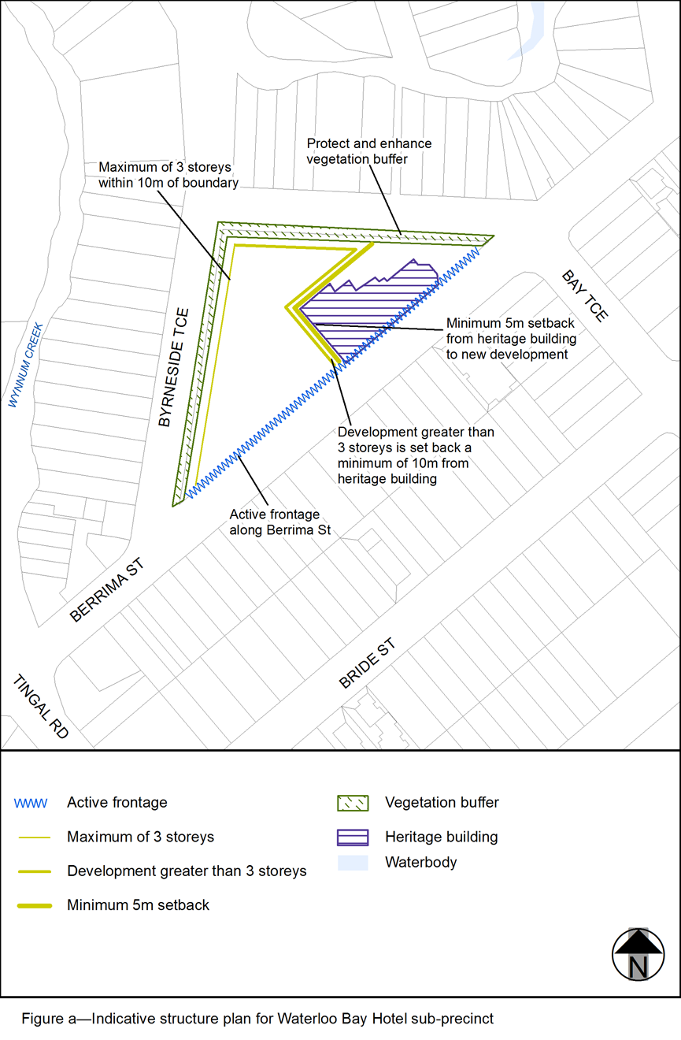View the high resolution of Figure a–Indicative structure plan for Waterloo Bay Hotel sub-precinct (PDF file size is 175Kb)

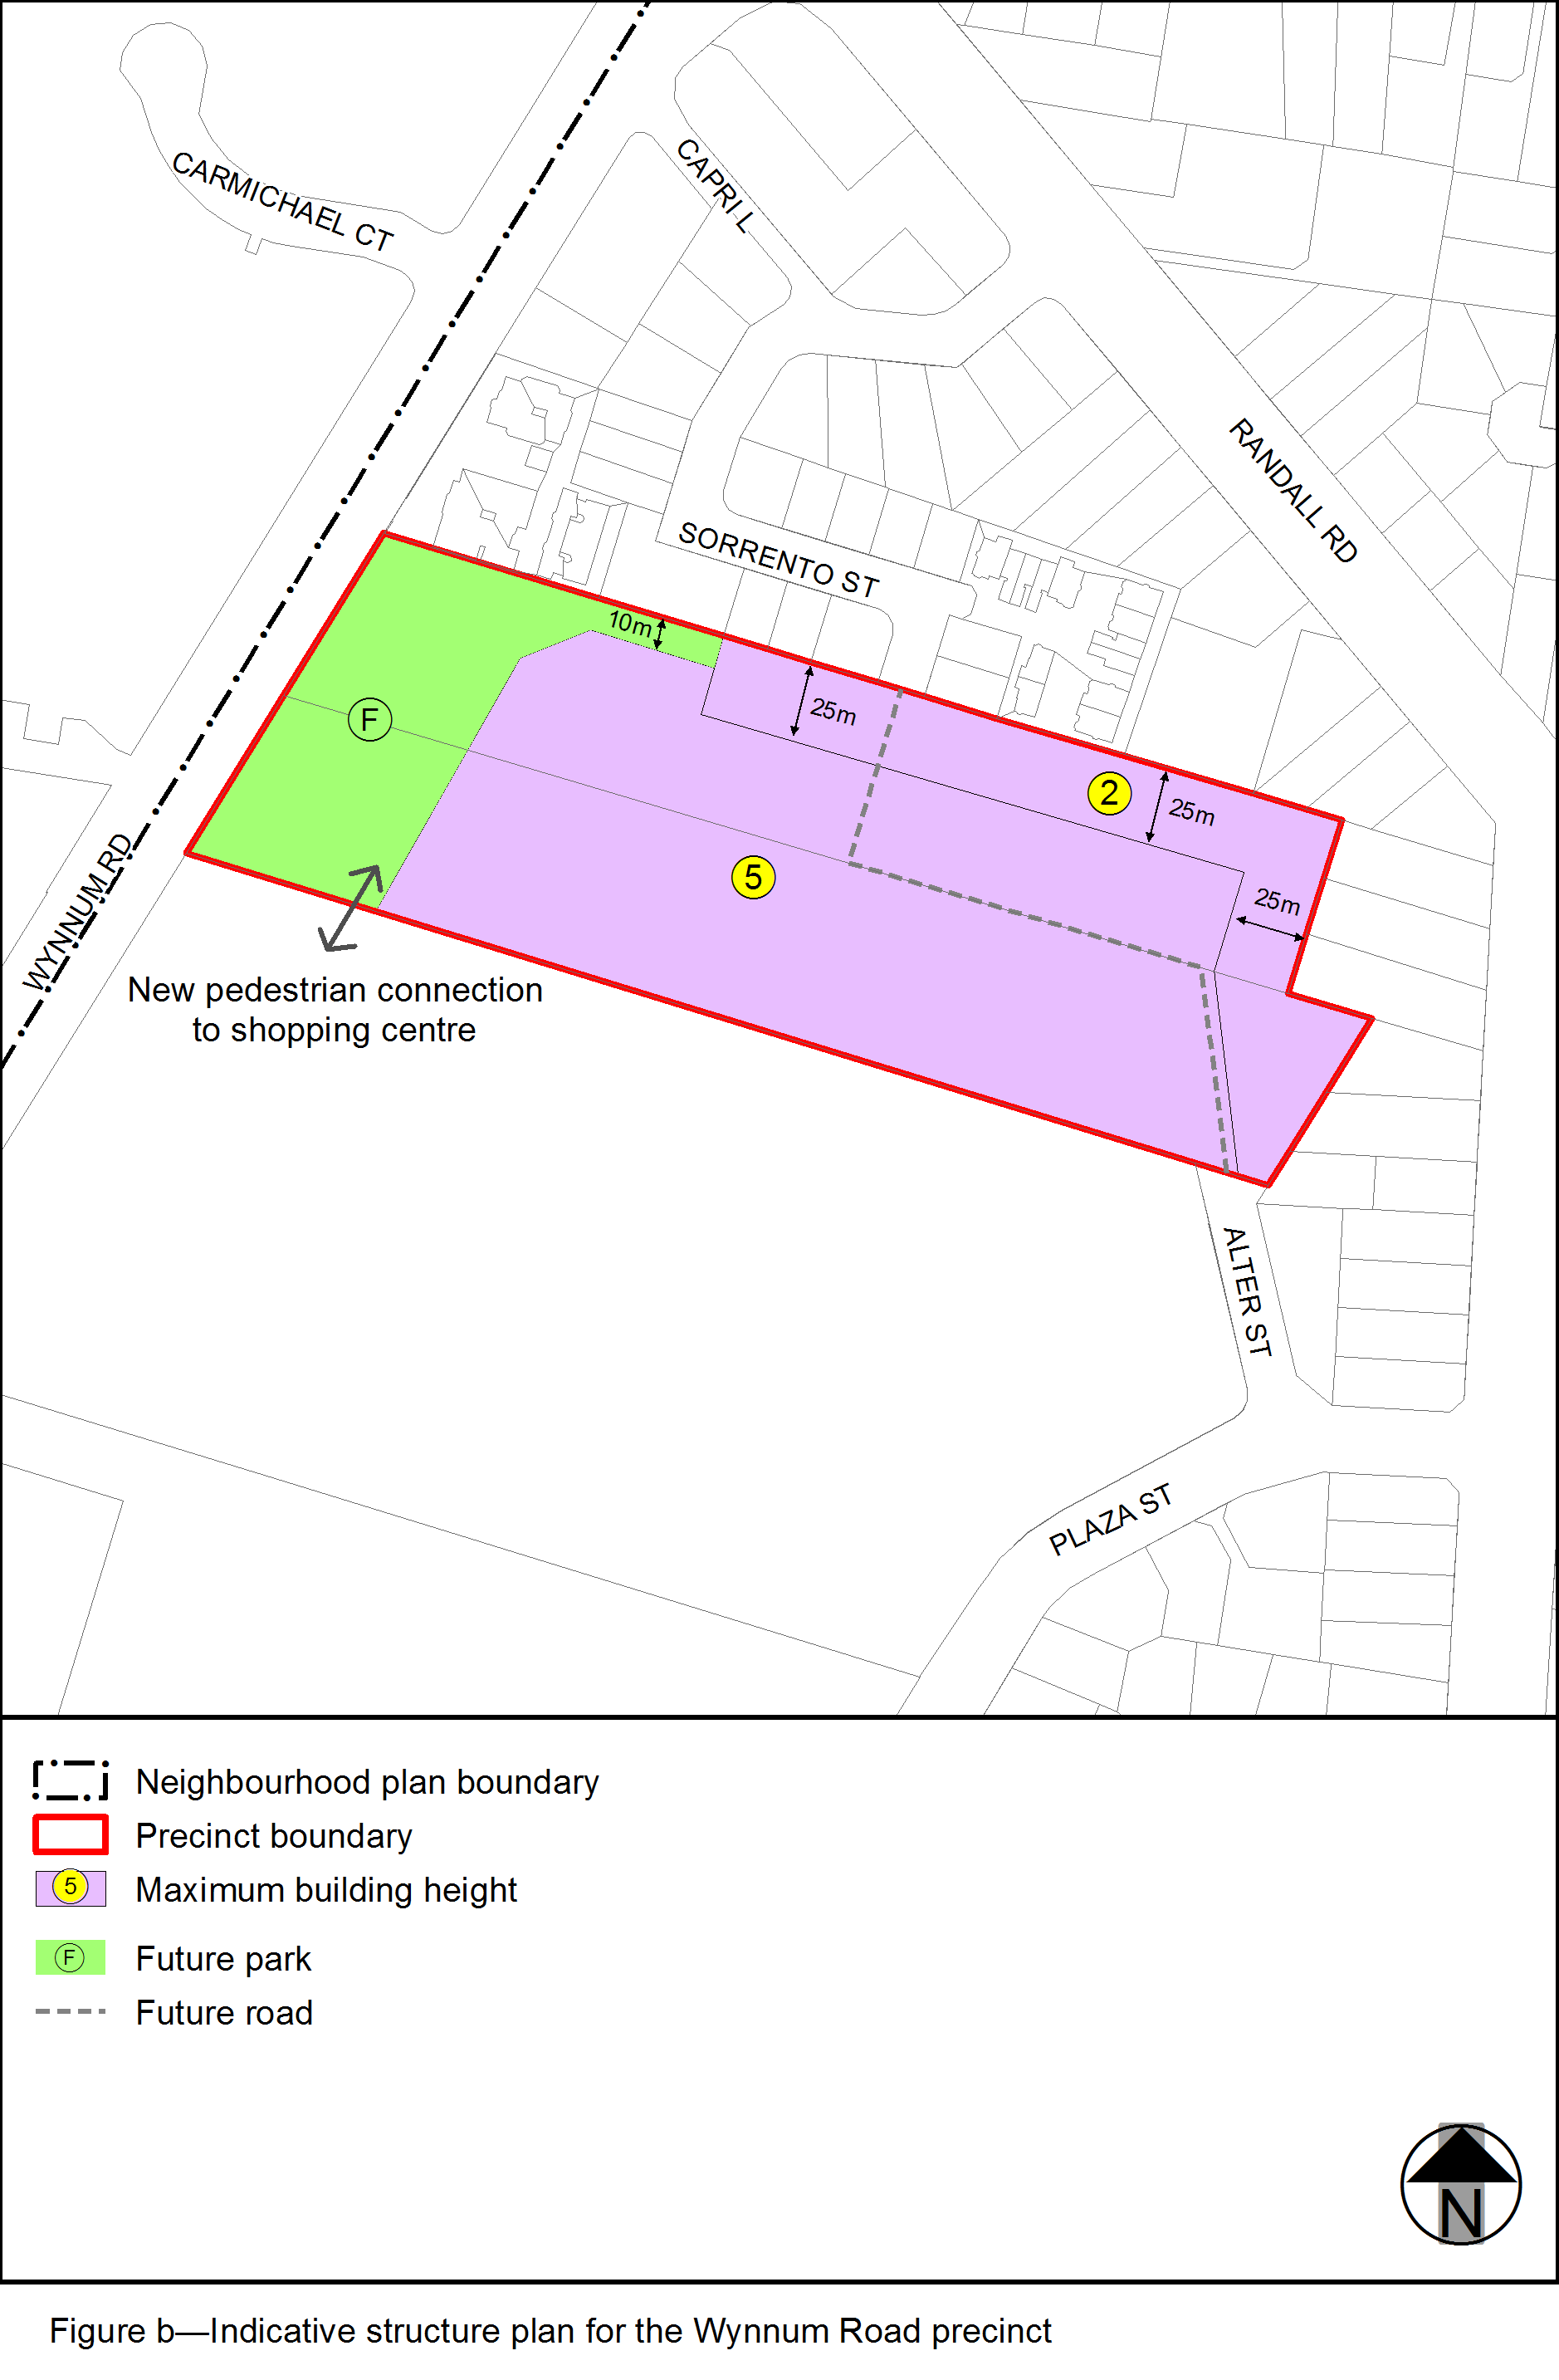View the high resolution of Figure b– Indicative structure plan for the Wynnum Road precinct (PDF file size is 87Kb)
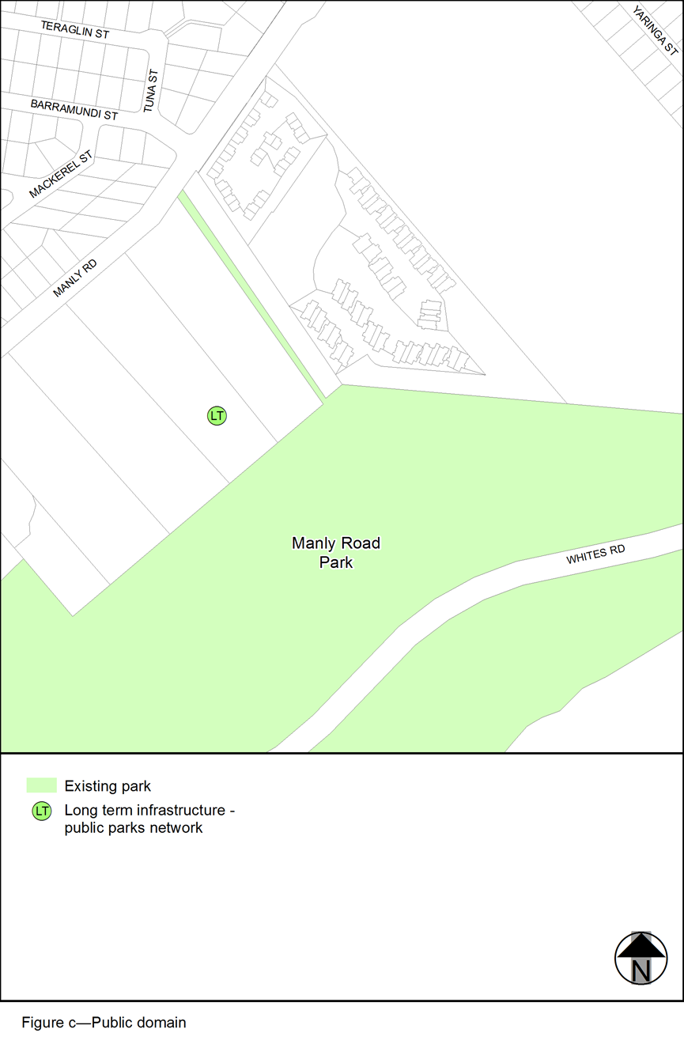View the high resolution of Figure c– Public domain (PDF file size is 90Kb)

