SC6.6 Commercial character building planning scheme policy

Contents
1 Introduction
1.1 Relationship to planning scheme
1.2 Purpose

2 Commercial character building form and character

3 Guidelines for desired built form and architectural design outcomes involving the extension, alteration, renovation or refurbishment of a commercial character building
3.1 Site layout
3.2 Design of extensions and alterations
3.3 External materials
3.4 Roof form
3.5 Detailing and articulation

1 Introduction

1.1 Relationship to planning scheme
This planning scheme policy provides guidance or advice about satisfying an assessment benchmark which identifies this planning scheme policy as providing that guidance or advice.

1.2 Purpose
This planning scheme policy provides:
- guidance on the identification of a commercial character building;
- advice on the desired built form and architectural design outcomes if a commercial character building is extended, altered, renovated or refurbished.

2 Commercial character building form and character
Commercial character buildings are buildings constructed in 1946 or earlier and usually have some or all of the following attributes and characteristics:
- designed for small scale commercial activities, for use as a local corner store or forms part of a group of shops;
- generally built to the front boundary alignment;
- often incorporates an awning over the footpath, often supported by timber or cast iron posts;
- originally designed for residential uses with traditional residential setbacks and materials and may be adapted and utilised for other uses.
Editor’s note—While the majority of these types of commercial character buildings are located in residential areas there are also examples in commercial, community and industrial areas.
Typical built form styles of commercial character buildings in Brisbane are illustrated in Figure a.

3 Guidelines for desired built form and architectural design outcomes involving the extension, alteration, renovation or refurbishment of a commercial character building

3.1 Site layout
- Any extension or alteration of the commercial character building is to continue the setback pattern of the commercial character building.
- Secondary buildings such as garages, carports or outbuildings are set back behind the alignment of the original commercial character building.
- On-site car parking is not to dominate the street frontage or detract from the traditional streetscape character and where possible, is located at the rear of the site.

3.2 Design of extensions and alterations
- An extension of the original commercial character building is to maintain the original commercial character building’s appearance and proportions and is not to visually dominate or overhang the existing building.
- An extension is to complement the scale and form of other character buildings in the neighbourhood. The height and bulk of the extended building is not markedly different from the original building and other character buildings, including dwelling houses constructed in 1946 or earlier in the area, and the roof line has a compatible pitch.
- An addition is built at the side or rear, to maintain the original character and streetscape presence of the commercial character building.
- The original street-front entrance of the commercial character building is retained or reinstated.
- The existing building is distinguished from new minor extensions by:
- setting back the new wall line from the existing wall; or
- creating a clear visual break, such as a recess, change in wall cladding or a full height opening such as a breezeway.
- The extension is at the rear of the existing commercial building (refer to Figure b) and:
- is of the same or lesser height;
- respects and maintains the extent of the original building form;
- maintains the relationship of the building to the ground level and streetscape character;
- clearly distinguishes old from new;
- is of a complementary size and form;
- enables modern facilities to be incorporated into the new extension;
- creates a connecting link that provides a distinct transition between the old and new parts of the building.
- Where in a zone in the residential zones category, in addition to (6) the extension will also;
- be a single storey pavilion style;
- allow for cross ventilation.
Note—The extension shown in Figure c constitutes an inappropriate alteration to a commercial character building as:
- the height and length of the structure is bulky, overbearing and inconsistent with the scale and architectural style of the existing commercial character building;
- the character and streetscape presence of the original commercial character building is significantly impacted by the proposed extension that sits above the rear of the building, behind the parapet.

3.3 External materials
- The same, like for like, or complementary elements, materials or detailing are used in the alteration, extension, renovation or refurbishment of the commercial character building as are commonly used in the original commercial character building or in other older buildings in the neighbourhood — generally this will be timber and tin.
- Timber external walls are used to maintain the typically lightweight appearance of traditional commercial character buildings. Masonry is only used for new components of the building when the original commercial character building comprises such materials.

3.4 Roof form
- Additions do not significantly alter the shape and character of the existing roof line of the original commercial character building, such as extending the height, direction or length of the original roof in a manner that results in a bulky, extruded roof line.
- The roof form of new structures complements the form of the original main roof in form and pitch, but remains visually distinct to the existing commercial character building.
- Dormer windows or other atypical roof elements are not added to the original building.
- Eaves and awnings are incorporated to make the facade of new extensions more consistent with the typical style of commercial character buildings, or to create areas of shade on the periphery of the building.

3.5 Detailing and articulation
Articulation of size, space and location of building openings, such as doors and windows, is sympathetic with the fabric of the existing commercial character building.
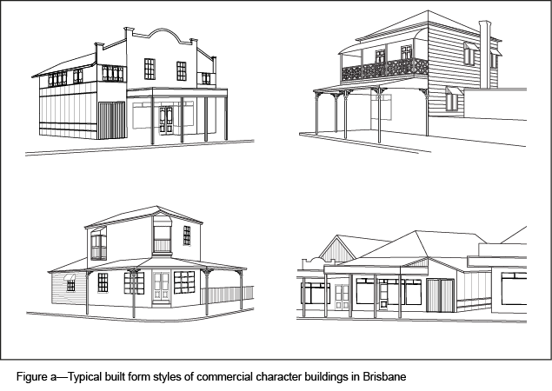
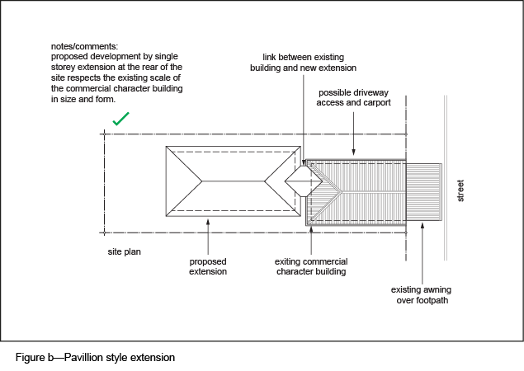
Editor's note—Figures are examples only and display one way the built form outcomes sought by the Commercial character building (activities) overlay code might be realised, in order to provide assistance to applicants in determining whether the building style of their proposed development achieves the desired outcomes.
