SC6.7 Compensatory earthworks planning scheme policy

Contents
1 Introduction
1.1 Relationship to planning scheme
1.2 Purpose

2 Balanced vs compensatory earthworks

3 Prelodgement guidance

4 Development application requirements
4.1 Detailed survey
4.2 Compensatory earthworks volumes
4.3 Hydraulic modelling

1 Introduction

1.1 Relationship to planning scheme
This planning scheme policy:
- provides information the Council may request for a development application;
- provides guidance or advice about satisfying an assessment benchmark which identifies this planning scheme as providing that guidance or advice;
- states a standard for the assessment benchmarks identified in the following table.
Column 1 –  Section or table in the code | Column 2 –  Assessment benchmark reference | Column 3 –  Planning scheme policy provisions
Flood overlay code
Table 8.2.11.3.A | PO8 | All
Waterway corridors overlay code
Table 8.2.26.3.A | AO8 | All
Operational works code
Table 9.4.6.3 | PO1 | All

1.2 Purpose
This planning scheme policy provides guidance and advice and standards for the reshaping of land within a waterway corridor or in the creek/waterway Flood planning area 1, 2 or 3 sub-categories within the Flood overlay, if contained within the 5% AEP flood extent of any creek, waterway for which no waterway corridor has been mapped. This is to ensure that earthworks do not reduce the flood-storage capacity or flood-carrying capacity of the area within a waterway corridor or the relevant part of a creek/waterway.

2 Balanced vs compensatory earthworks
- Where compensatory earthworks are required, for earthworks to be acceptable they must not adversely impact the hydraulic characteristics of the watercourse. Adverse impacts may be direct, indirect or cumulative and include:
- reducing the flood-carrying capacity of a watercourse;
- reducing flood storage;
- altering the hydraulic control of the stream (flow velocity and direction) and causing scour and sedimentation.
- Balanced earthworks occur when the total volume of ‘fill’ (material added) equals or is less than the total volume of ‘cut’ (material excavated). The balanced earthwork ‘total fill ≤ total cut’ equation will not guarantee that the flood-storage capacity and flood-carrying capacity of the area where compensatory earthworks are required.
- To preserve the hydraulic characteristics of areas where compensatory earthworks are required, the volume of ‘cut’ and ‘fill’ must be compensatory between incremental flood levels. In example 2, the volume of ‘fill’ is equal to or less than the volume of ‘cut’ between each incremental level. If more ‘fill’ than ‘cut’ were added between levels (see Example 1, 5.2–5.4m AHD) then the flood-storage capacity and flood-carrying capacity within the area where compensatory earthworks are required would be reduced for certain flood events with adverse consequences to flooding.

Example 1: Balanced earthworks
Level (m AHD) | Cut (m3) | Fill (m3)
5–5.2 | 600 | 200
5.2–5.4 | 300 | 500
5.4–5.6 | 300 | 500
Total | 1,300 | 1,300

Example 2: Compensatory earthworks
Level (m AHD) | Cut (m3) | Fill (m3)
5–5.2 | 600 | ≤ 600
5.2–5.4 | 300 | ≤ 300
5.4–5.6 | 400 | ≤ 400
Total | 1,300 | 1,300

- Balanced earthworks can reduce the hydraulic capacity of a watercourse for large floods. The reduction in hydraulic capacity arising from a single development may be small. However, the cumulative effect of this leads to unacceptable rises in flood levels. For this reason applications to develop within a floodplain are to be based on compensatory earthworks rather than balanced earthworks.

3 Prelodgement guidance
- Compensatory earthworks are not to be carried out below the 5% AEP flood inundation level based upon ultimate catchment development. Excavation below this limit is known to lead to erosion problems on the floodplain and watercourse banks that can be difficult to repair or stabilise.
- Compensatory earthworks will not be approved in areas close to the watercourse within the area where compensatory earthworks are required that is subject to high velocity water currents (such as areas affected by high hazard flood conditions). This is because altering the geometry of the watercourse in these areas is likely to raise upstream flood levels. Scour problems can also occur to the newly exposed surfaces whether or not they are cut or fill surfaces. Scour problems can also occur to undisturbed areas nearby caused by swirling eddies as a result of changes to the ground surface.
- Areas subject to backwater flooding or low flood hazard conditions are more suitable for compensatory earthworks as there is less impact on storage and conveyance. Earthworks are not to significantly worsen the flood hazard across a site.
Note—The 5% AEP flood event is equivalent to a 20 year ARI flood event.

4 Development application requirements

4.1 Detailed survey
A detailed survey of the area to be affected by the earthwork operations is required to be submitted with the development application. The survey enables earthwork volumes to be calculated with confidence.

4.2 Compensatory earthwork volumes
- A table of earthwork volumes is to be provided with the development application which demonstrates that the hydraulic characteristics within the area where compensatory earthworks are required are not adversely affected by the proposed development.
- The method to determine whether ‘cut and fill’ volumes are compensatory between specific flood levels is illustrated in Table 1 and Figure a and described below:
- Determine the lowest limit of the proposed earthworks (either ‘cut’ or ‘fill’ level).
- Acquire from Council the pre-development flood levels for the 1% AEP design event based upon ultimate catchment development. If unavailable, the applicant will need to determine this.
- Determine the increment y, where y is either 200mm or approximately one-quarter of the difference between the anticipated 100 year ARI flood level and the low earthwork limit, whichever is smaller.
- Determine the first increment between which to calculate cut and fill volumes is the low earthwork limit plus y (refer to Table 1).
- Determine 'cut and fill' volumes for each increment up to a level equal to the anticipated 1% AEP flood level, based on ultimate catchment development.
- In order for earthworks to be compensatory, the fill volumes must be equal to or less than the cut volumes at the corresponding increments.
Note—The 1% AEP flood event is equivalent to the 100 year ARI flood event.

Table 1—Calculating compensatory cut and fill volumes
Incremental level  (m AHD) | Proposed
 | Cut (m3) | Fill (m3)
Start at low earthwork limit – always > the 5% AEP flood level
Lowest earthworks to EL 1  (EL 1 = lowest earthwork limit + y) | a | A (≤ a)
EL 1 to EL 2  (EL 2 = EL 1 + y) | b | B (≤ b)
EL 2 to EL 3  (EL 3 = EL 2 + y) | c | C (≤ c)
Continue with increments as appropriate up to the 1% AEP flood level
EL… to 1% AEP flood level | z | Z (≤ z)
Note—
- A 5% AEP flood event is equivalent to a 20 year ARI flood event.
- A 1% AEP flood event is equivalent to a 100 year ARI flood event.
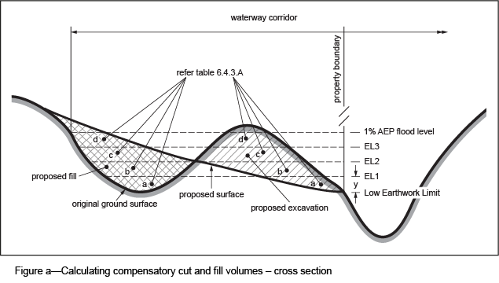

4.2.1 Typical compensatory earthworks
- Typical layouts for compensatory earthworks are shown in Figure b and Figure c.
- Figure b shows excavation of a ‘high area’ within a waterway corridor. Figure a shows the cross-section of a ‘high area’.
- Figure c shows where excavation outside the existing waterway corridor is required to meet the compensatory earthworks standard. In this example, the excavated area would need to be protected to prevent it being refilled at a later date. Where the adjoining waterway is to be in public ownership, this protection may be achieved through the dedication of the excavated area to Council. Where the adjoining waterway is intended to remain in private ownership, this may be addressed through means such as an easement for the purposes of protecting the excavated area.
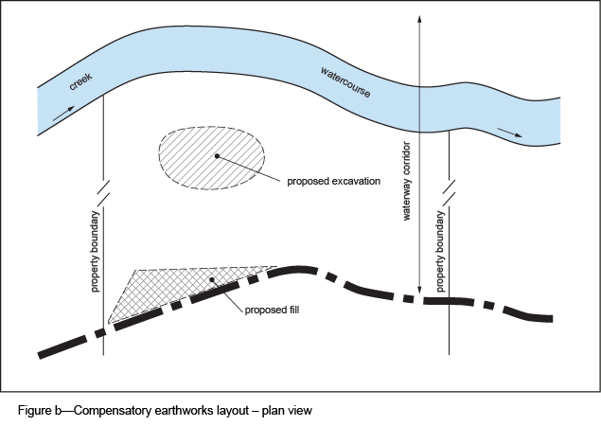
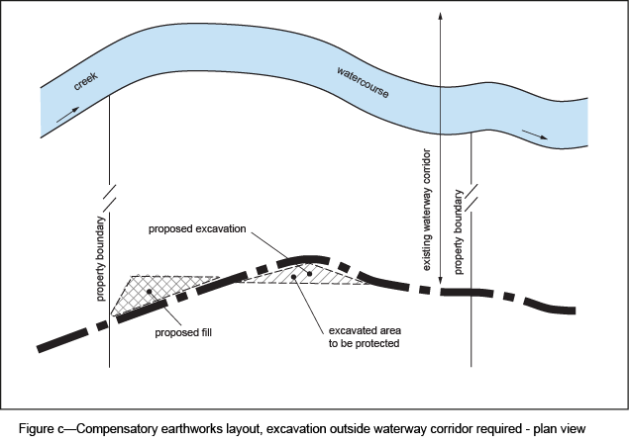

4.2.2 Typical example of balanced earthworks that is unacceptable
Figure d shows a ‘cut and fill’ operation within a waterway corridor that would be unacceptable. Even though the total volume of ‘cut’ equals the total volume of ‘fill’, these earthworks are unacceptable because at some incremental levels the volume of ‘fill’ exceeds the volume of ‘cut’. The earthworks therefore will change the storage characteristics of the watercourse, increasing flood levels downstream for some flood events. The resulting increase in flooding arising from a single development may be small; however, the cumulative effect of such developments leads to unacceptable rises in flood levels elsewhere in the floodplain.
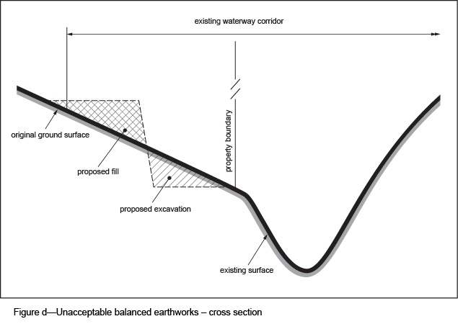

4.3 Hydraulic modelling
- Calculating compensatory ‘cut and fill’ volumes at incremental levels helps to identify the impact of earthworks on the storage capacity of a watercourse. The method does not, however, clearly show the likely impacts of the earthworks on a watercourse’s conveyance capacity.
- Hydraulic modelling is to be submitted with the development application to demonstrate pre-development and post-development flood levels for a range of flood events up to and including the defined flood event to test that the development causes no increase or decrease in flood level immediately upstream of the compensatory earthworks. The hydraulic modelling technique is to be suitable to estimate impacts on flood storage, requiring the use of an unsteady state model that uses flow hydrographs rather than peak flow values. If significant earthworks are proposed, a two-dimensional hydraulic modelling technique is to be used.
- Earthworks that increase or decrease the conveyance capacity of a watercourse are likely to be unacceptable. Increasing the conveyance capacity of the watercourse at the site of the earthworks reduces the effectiveness of flood storage and is likely to increase flooding downstream. Conversely, reducing the conveyance capacity of the watercourse at the site of the earthworks is likely to increase flooding upstream. Significant changes to flow velocity that would cause scour or excessive sedimentation are also unacceptable.

