SC6.11 Flood planning scheme policy

Contents
1 Introduction
1.1 Relationship to planning scheme
1.2 Purpose
1.3 Terminology

2 Floodplain risk management
2.1 Sources of flooding in Brisbane

3 Flood hazard
3.1 Flood hazard components
3.2 Flood velocity
3.3 Flood depth
3.4 Classification of hydraulic hazard
3.5 Flood warning time
3.6 Upper Brisbane River sections

4 Flood overlay code flood planning areas
4.1 Flood planning areas
4.2 Overland flow

5 Reconfiguring a lot
5.1 Flood planning levels
5.2 Flood hazard management
5.3 Reconfiguring the boundaries of an existing lot
5.4 Egress and evacuation

6 Road trafficability
6.1 New roads
6.2 Serviceability of existing road network external to the development during floods
6.3 Calculation of time of road closure

7 Building design
7.1 Building undercrofts
7.2 Undercroft minimum clearances
7.3 Building undercroft design and ground treatment
7.4 Examples of suitable building undercroft designs
7.5 Examples of unacceptable building undercroft design

8 Built form for flood resilience

9 Flood risk management
9.1 Flood risk assessment
9.2 Scope of application
9.3 Risk assessment process
9.4 Issues requiring consideration
9.5 Flood emergency management plans
9.6 Scope of application
9.7 Issues requiring consideration and information requirements

10 Requirements for a flood study
10.1 General
10.2 Preparation of a flood study
10.3 Choice of hydraulic model
10.4 Hydrological model assumptions
10.5 Adverse flood impacts
10.6 Assessment for creek/waterway flooding
10.7 Estimating flood planning levels for creeks/waterways
10.8 Assessment for overland flow flooding
10.9 Estimating flood planning levels for overland flow flooding
10.10 Vehicle parking

11 Earthworks in a floodplain
11.1 Filling
11.2 Interface of development to creek/waterways
11.3 Levees

1 Introduction

1.1 Relationship to planning scheme
This planning scheme policy:
- provides information the Council may request for a development application;
- provides guidance or advice about satisfying an assessment benchmark which identifies this planning scheme as providing that guidance or advice;
- states a standard for the following assessment benchmarks identified in the following table:
Column 1 –  Section or table in the code | Column 2 –  Assessment benchmark reference | Column 3 –  Planning scheme policy provisions
Flood overlay code
Table 8.2.11.3.A | AO1.3 | Section 7
Table 8.2.11.3.A | AO2 | Section 7
Table 8.2.11.3.A | AO2 note | All
Table 8.2.11.3.A | PO3 note | Section 9
Table 8.2.11.3.A | AO5.1 note | All
Table 8.2.11.3.A | AO7.1 note | All
Table 8.2.11.3.A | AO7.3 | All
Table 8.2.11.3.A | AO7.3 note | All
Table 8.2.11.3.A | PO7.1 | All
Table 8.2.11.3.A | PO9 | Section 7
Table 8.2.11.3.A | PO10 | Section 9
Table 8.2.11.3.A | AO11.2 | Section 10
Table 8.2.11.3.A | AO17.2 | Section 5 and 6
Table 8.2.11.3.A | AO17.3 | Section 10
Table 8.2.11.3.A | AO18.2 | Section 6
Table 8.2.11.3.C | Table note | All
Table 8.2.11.3.F | Table note | All
Table 8.2.11.3.I | Table note | All
Table 8.2.11.3.K | Table note | All
Table 8.2.11.3.L | Table note | All

1.2 Purpose
- Development on land affected by flooding is to be assessed against the risk, hazard and adverse consequences caused by flooding.
- This planning scheme policy provides information, processes, advice and specific design criteria which support the outcomes required by the Flood overlay code, the Coastal hazard overlay code and the Critical infrastructure and movement network overlay code.
- Management of flooding for flood events larger than the flood hazard overlay is undertaken through the Council and Queensland Government's emergency management framework.

1.3 Terminology
In this planning scheme policy, unless the context or subject matter otherwise indicates or requires, a term has the following meaning:

annual exceedence probability (AEP): the likelihood of a flood of a given discharge being exceeded within a period of 1 year, generally expressed as a percentage

flood hazard: a measure of safety which is applied to people, vehicles and structures during a flood. It represents the potential risk to life, risk of serious injury and potential damage to property resulting from flooding and may be directly caused by floodwaters (e.g. flood loads on structures) or an indirect action (e.g. a higher risk of electrocution due to major electrical services being inundated). Flood hazard is influenced by factors such as evacuation and warning time.

hydraulic hazard: the engineering classification of flood hazard with respect to the velocity depth product and maximum flood depth to define safe and unsafe conditions with respect to people, vehicles and property. Engineering hazard is related to the direct action of floodwaters during the flood event. Hydraulic hazard is not influenced by situations such as warning time or evacuation. Refer to section 3.4.

infill reconfiguring a lot: refers to a residential reconfiguring a lot where there is no dedication and opening of a road and the reconfiguring a lot creates 6 lots or fewer. Infill reconfiguring a lot typically occurs in a site with existing road frontage and either is fully or partly surrounded by developed sites

0.05% AEP flood event: equivalent to a 2000 year average recurrence interval (ARI) flood

0.2% AEP flood event: equivalent to a 500 year ARI flood. In the Brisbane River it is approximated by a discharge of 13,500m3/s flow at the Brisbane City Gauge.

1% AEP flood event: equivalent to a 100 year ARI flood

2% AEP flood event: equivalent to a 50 year ARI flood

5% AEP flood event: equivalent to a 20 year ARI flood

10% AEP flood event: equivalent to a 10 year ARI flood

2 Floodplain risk management
- The flood management strategy used by the Council is based on the principles of floodplain risk management to ensure that development on a floodplain occurs having regard to:
- the compatibility of the development type with the flood hazard to minimise the risk to people’s safety or structural damage to buildings;
- the social, economic and environmental costs and benefits of developing within a floodplain when balanced against the flood risks.
- While development controls may apply to land affected by the defined flood events which is typically, but not always a 1% AEP flood event, significantly larger floods can occur up to a probable maximum flood. Some types of development that are more susceptible to flooding will need to consider, mitigate for or design to floods larger than the 1% AEP.
- When considering the safety of people, a full range of flood probabilities up to the probable maximum flood need to be considered. Development should not wholly rely on Council's disaster management response for managing the risk with such rare floods, although it is a consideration in managing the risk.

2.1 Sources of flooding in Brisbane
The 5 types of flooding that may affect premises in Brisbane are:
- river flooding – This occurs when there is widespread prolonged rain over significant parts of the catchment of the Brisbane River. The extent of flooding may be significantly influenced from Somerset and Wivenhoe dams depending on where the rain is being generated. However, it is possible for flooding from the Bremer River to also cause significant flooding in the Brisbane River as its confluence with the Brisbane River is downstream of those dams.
- creek/waterway flooding (including those indicated on the planning scheme maps) – This is defined as any element of a river, creek, stream, gully or drainage channel, including the bed and banks. Waterway flooding occurs when the bank-full capacity of the channel is exceeded. On average Brisbane’s natural creeks may exceed their bank-full capacities once or twice in any 1 year.
- overland flow flooding – These are shallow gullies or drainage depressions that receive sheet flow run-off during storm events. However, in urban areas this may also occur when components of the stormwater drainage system such as pipes and gully inlets are blocked or design capacity is exceeded.
- storm-tide flooding – This is the effect on coastal water levels of a storm surge combining with the normally occurring astronomical tide. Storm surge is a rise above normal water level due to the combined effects of surface wind stress and atmospheric pressure fluctuations caused by severe weather conditions such as tropical cyclones.
- tidal inundation – This is the regular and periodic inundation of estuarine areas typically characterised by land located below the highest astronomical tide level.

3 Flood hazard

3.1 Flood hazard components
- Flood hazard is a measure of safety which is applied to people, vehicles and structures during a flood. It represents the potential risk to life, risk of serious injury and potential damage to property resulting from flooding and may be directly caused by floodwaters (e.g. flood loads on structures) or an indirect action (e.g. a higher risk of electrocution due to major electrical services being inundated).
- The derivation of flood hazard is based on the determination of hydraulic hazard with the main determinant being related to the velocity of the floodwater and flood depth.
- The degree of flood hazard is related to the severity of the hydraulic hazard (depth and velocity) but may be influenced by warning time, emergency management and population density.
- Hazard characteristics of floodwaters vary within the Brisbane River, waterways/creeks and overland flow paths. As a result, descriptions of flood hazard and hazard management solutions are also varied.

3.2 Flood velocity
- The velocity of floodwater greatly influences the ability of people to safely wade or evacuate an area, on foot or by vehicle. It may also limit the ability for emergency services to respond to people at risk. Velocity also has significant impact on the structural integrity of buildings and the resulting damage that may occur, both from the forces of the floodwater itself and from debris impacts on such structures.
- During the January 2011 flood, within the lower to mid parts of the Brisbane River, flood depth was a greater consideration than flood velocity within many existing developed areas. With the exception of within the river banks, many existing developed areas are subject to very low velocity backwaters. In addition, warning time means that people are less likely to be within higher velocity areas as they flood, or can easily move from those areas before velocity becomes a significant factor. However, velocity will vary with the severity of a flood event and even backwater areas may experience significant velocity during an extreme flood such as the probable maximum flood.
- Creeks/waterways and overland flow paths are areas where higher flow velocity is expected in frequent and rare flood events. Lowest parts of the creek areas that would typically flood more frequently, such as areas within the 10% AEP flood extent, are generally at the highest risk of exhibiting unsafe velocity because they represent the floodway of creeks conveying a large proportion of total flood flows. Shallower areas that are not regularly flooded are identified as flood fringe areas that would typically exhibit lower velocities in creeks. However in overland flow paths, unsafe velocity may occur throughout the full extent of flooded area depending on the underlying terrain.

3.3 Flood depth
The depth of floodwater has a direct relationship with peoples' safety, accessibility by vehicles and resulting flood damage to building contents. As evident in the January 2011 floods within Brisbane, most areas with the greatest flood damage were affected by the greatest flood depths even though the water was slow moving.

3.4 Classification of hydraulic hazard
- Hydraulic hazard is defined as the engineering classification of flood hazard with respect to the velocity depth product and maximum flood depth to define safe and unsafe conditions with respect to people, vehicles and structures.
- The engineering classification for unsafe hydraulic hazard during a defined flood event is defined as:
- >0.4m2/s depth X velocity product for publicly accessible areas, pathways, driveways, parking or private open space, or where the risk to life is reasonably foreseeable;
- >0.6m2/s velocity depth product for public roads, drains and flow paths through private property or communal open space areas;
- >600mm flood depth at any velocity.
- For safe depths and velocity depth products in road reserves and vehicle parking areas refer to QUDM section 7.4.1.
- If any use predominantly involves vulnerable uses such as elderly and/or disabled persons requiring assistance or small children, a childcare centre or educational establishment and those areas are readily accessible to children, implications of velocity depth products would need to be considered for each development as there is no safe velocity depth product applicable (refer to QUDM 7.4.2). However as a guide, a velocity depth product greater than 0.2m2/s would be considered highly unsafe for those uses.
- The interpretation of hydraulic hazard severity for overland flow flooding is to have consideration of national and Queensland Government standards such as Australian Rainfall and Runoff and the Queensland Urban Drainage Manual.

3.5 Flood warning time
- While the flood risk posed by floodwaters can be reduced by evacuation if adequate warning time is available, the hydraulic hazard remains unaffected. Available warning time is determined largely by catchment characteristics with larger and flatter catchments typically exhibiting a slower rate of rise of floodwaters, and therefore a longer available flood warning time. By comparison, in small or steep catchments there is often no available warning time as the rate of rise of floodwaters can be rapid.
- The key factors in evaluating safe evacuation time include:
- the time required to mobilise State Emergency Service resources and communicate flood and evacuation warnings to affected areas;
- the preparation time prior to self-evacuation;
- the time available until evacuation routes are cut off (for example development and evacuation routes located within low parts of the floodplain (Flood Planning Area 1 and 2A) will be cut-off by floodwater much sooner than higher parts of the floodplain, possibly before flood warnings are issued);
- the travel time which depends on the distance to be travelled to a safe area above the defined flood event flood level and the characteristics of the evacuation route.
- When considering these factors, in most instances a minimum of 10 hours or more warning would be required to effectively implement an evacuation. However, for creek/waterway or overland flow flooding there may be at most 2 hours warning time from the issue of a Bureau of Meteorology extreme weather warning, and possibly only minutes available for evacuation from when a major flood event occurs. Therefore, the only flooding sources that are considered to have suitable flood warning time include:
- Brisbane River flooding excluding the Upper Brisbane River sections and Flood Planning Area 1 and 2A within any part of the floodplain. The assumed times in these sections are based on approximate flood peak travel times. It is noted that the time for floodwaters to rise is variable within the Brisbane River, with flood peaks at Moggill, for instance, occurring approximately 10 hours before the city centre. Council has a flood forecasting model that uses Council’s network of real-time rainfall and flood-level monitoring systems and a flood modelling program, together with the Council’s geographical information system to provide a flood warning and information service to the community;
- Storm-tide flooding from tropical cyclones and severe low pressure systems are able to be predicted or tracked and advanced warnings provided by the Bureau of Meteorology.
- All other flooding sources are not suitable for applying warning time as a consideration to mitigating flood hazard. This is because the time of concentration, critical storm duration and rise of floodwaters, often from minutes to less than a few hours, is too short to allow for adequate warning time. In addition, there is no ability to predict with any certainty how severe a flood would be in small catchments. Therefore, these creeks may already be significantly flooded before an evacuation is clearly required.

3.6 Upper Brisbane River sections
- The upper sections of the Brisbane River within Brisbane’s local government area, where the residential flood level is greater than 12.8m AHD, have been identified as having unique flooding characteristics when compared to the lower sections of the Brisbane River floodplain due primarily to its proximity closer to Wivenhoe Dam and the narrower topography of the floodplain within this area. This results in the following:
- reduced warning time, which is insufficient for adequate flood evacuation planning;
- significant increases in flood level with only minor exceedance of the flow rate used to set the flood planning levels;
- higher in-river flow velocity;
- isolation of some areas during a flood.
- The Flood overlay code requires consideration of the 0.2% AEP flood event, for estimating safety, which can be approximated by a peak flow of 13,500m3/s at the Brisbane City gauge.
- The 0.2% AEP flood has been chosen because it represents the following:
- an extreme flood event above the defined flood event that aids in identifying whether rapid changes to the flood risk occur from moderate increases in flows, but less onerous than the 0.05% AEP flood or probable maximum flood;
- a current standard used for regulating some essential community infrastructure such as hospital flood immunity;
- approximately a 20% chance of being exceeded in a 100 year period or design life.
- Therefore, the 0.2% AEP represents a flood event which has a significant probability of occurrence over the lifetime of a land use, particularly for reconfiguring a lot.

4 Flood overlay code flood planning areas

4.1 Flood planning areas
- Land identified in the Flood overlay map is included in flood planning area sub-categories as shown in Table 1.

Table 1—Flood planning area sub-categories
Sub-Category | Brisbane River flooding |  | Creek/waterway flooding | Overland flow flooding
Flood planning area 1 sub-category | Within the 10% AEP Brisbane River flood extent; and DV>1.2m2/s in RFL |  | Within the 10% AEP flood extent; and  DV>1.2m2/s in 1% AEP flood | Not applicable
Flood planning area 2 sub-category | >1.2m deep; or  DV>1.2m2/s in RFL | FPA2A sub-category >2m deep in RFL | Deeper than 1.2m in 1% AEP flood; or  DV>1.2 m2/s in 1% AEP flood | Not applicable
 |  | FPA2B sub-category 1.2m to 2m deep in RFL
Flood planning area 3 sub-category | 0.6–1.2m deep in RFL; or  0.6 m2/s<DV <1.2 m2/s in RFL |  | 0.6–1.2m deep in 1% AEP flood; or  0.6m2/s<DV<1.2m2/s in 1% AEP flood | Not applicable
Flood planning area 4 sub-category | 0–0.6m deep in RFL; or  DV of <0.6 m2/s in RFL |  | 0–0.6m deep in 1% AEP flood; or  DV<0.6 m2/s in 1% AEP flood | Not applicable
Flood planning area 5 sub-category | From the RFL extent to the 0.2% AEP flood extent |  | 1% AEP flood extent to the 0.2% AEP flood extent | Not applicable
Overland flow flood planning area sub-category | Not applicable |  | Not applicable | Indicative 2% AEP overland flow for local catchments
- The flood planning area that makes up each category is based on Figure a.
- Flood overlay mapping will be amended periodically if required as new flood studies become available.
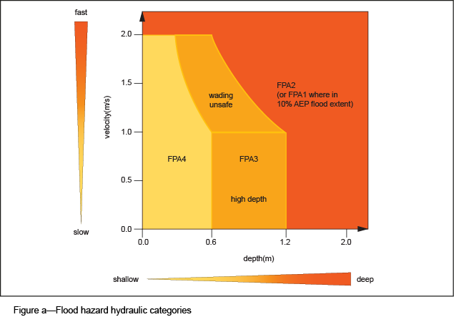

4.2 Overland flow
Flooding from overland flow sources is substantially different from other flooding types in that it is often associated with flash flooding and has a very high degree of uncertainty with respect to the terrain. Such flow paths may contain obstructions, many of which can be modified over time with no planning approvals such as fences, paving or landscaping. Therefore, determining flood risk often requires a detailed hydraulic assessment of the hydraulic controls and roughness parameters through the study area. In all cases, the determination of hydraulic hazard should use actual design Manning’s roughness values, not those used to set flood immunity which often assume rougher conditions.

5 Reconfiguring a lot

5.1 Flood planning levels
The flood planning levels are intended to create an appropriate level of safety and minimise the risk to people and property, eliminate the creation of new lots below the desired flood immunity level and provide unburdened building areas for new buildings, whilst ensuring the risk to people by rarer flood events is acceptable.

5.2 Flood hazard management
- Flood hazard management seeks to:
- ensure that new lots have an appropriate level of flood hazard, including freedom from existing overland flow paths or unsafe hydraulic hazard flooding for a useable portion of the lot;
- ensure that areas of unsafe hydraulic hazard are not intensified for residential development;
- minimise filling associated with reconfiguring a lot in an area that would be likely to create a flood impact;
- reduce the aesthetic issues associated with level changes for infill reconfiguration of a lot, particularly in land affected by Brisbane River flooding.
- Where filling is undertaken to enable reconfiguring a lot in areas affected by flood hazard, it should be recognised that filling mitigates the hydraulic hazard for the particular design flood event, but does not remove the flood risk in larger floods. Therefore, regard must be given to the impacts of flood events greater than the defined flood event on the development, with specific care to:
- reduce the potential for filling to create islands surrounded by unsafe hydraulic hazard conditions that could be cut off early in a flood;
- ensure that new residential subdivisions are not created in an area which would increase hazard to people and property in larger events, such as by enabling filling in an area which would become a floodway in a larger event or isolated by unsafe hydraulic hazard flood conditions as an island.
- Figure b and Figure c depict desired reconfiguring of a lot outcomes.
- In Figure b, filling is located on the fringe of the floodplain. As a result, during a defined flood event:
- development is located clear of unsafe hydraulic hazard flooding;
- lots have good proximity to higher ground;
- development is not isolated.
- Figure c depicts the same development in a flood event larger than the defined flood event, such as the 0.2% AEP flood. In this event:
- some flood damages are likely as the flood is greater than the defined flood event;
- development is not affected by unsafe flood hydraulic hazard conditions;
- unsafe hydraulic hazard areas are restricted to within the waterway;
- flood risk must be appropriately managed.
- Figure d depicts an unacceptable hazardous reconfiguring a lot outcome. It shows the impacts of larger flood, such as the 0.2% AEP flood. In this event:
- development located in the floodway at the defined flood event subjects residents to unsafe hydraulic hazard conditions in larger floods;
- development is isolated and potentially cut off early in a flood event, hindering evacuation;
- development has poor proximity to higher ground for evacuation.
Note—A flood event with an AEP of 0.2% is the equivalent of a 500 year ARI flood event.
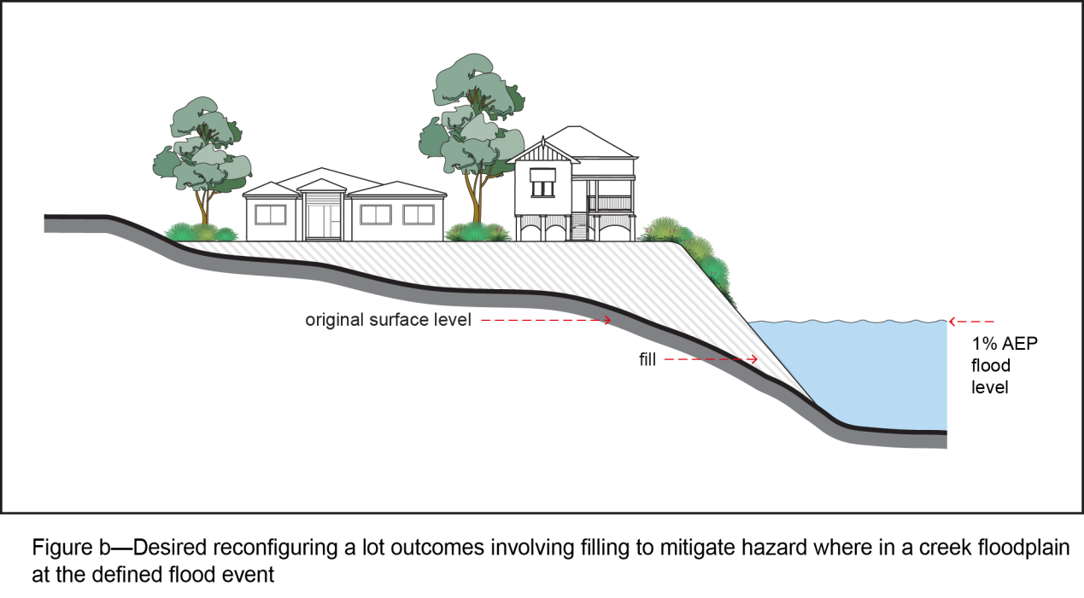
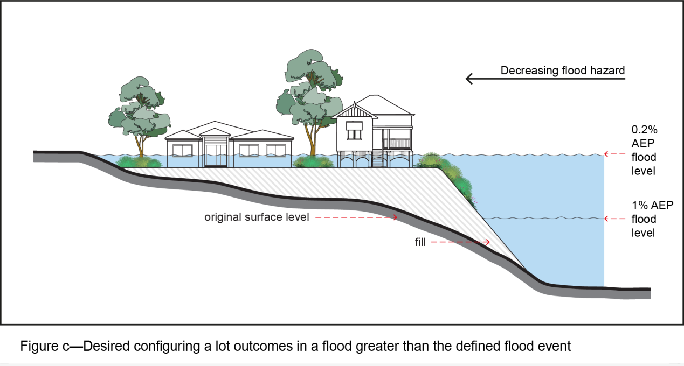
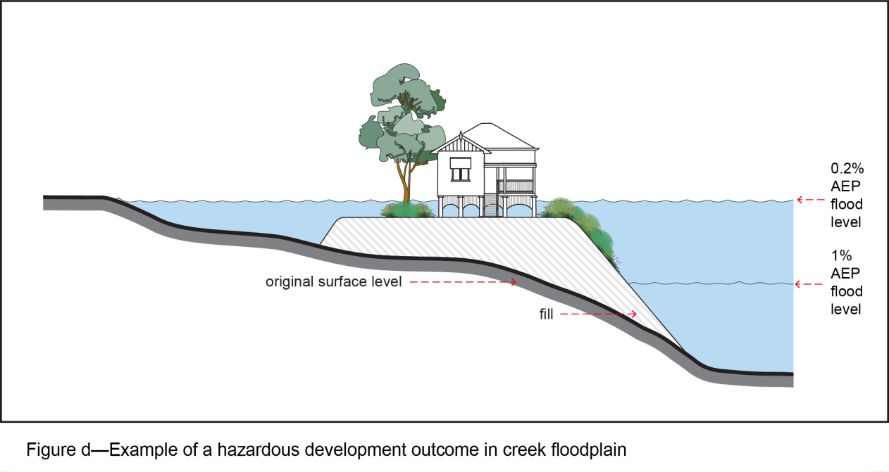

5.3 Reconfiguring the boundaries of an existing lot
- Where infill configuration occurs that reconfigures the boundaries of a lot without creating additional lots, such as 2 into 2 lots, care is to be taken to manage the flood hazard. An example of a poor reconfiguring a lot would be where the flood-free access to the existing lots was reduced, or where the proportion of the lot affected by unsafe hydraulic hazard area was being increased through the development proposal.
- Figure e depicts an acceptable outcome for an existing area with 2 narrow lots on land sloping away from the road towards the rear of the lot. In this instance:
- unsafe flood hydraulic hazard areas which become worse are generally restricted towards the rear of the site and can be avoided by buildings, providing opportunity to locate buildings in a flood-free or low hazard area;
- both lots have flood-free access to the road in a defined flood event;
- there is opportunity to locate buildings in an area above the defined flood event or safe hydraulic area, with possible suspended structure into the unsafe hazard areas.
- Figure f shows an unacceptable design for reconfiguration of boundaries for the same lots. In this instance:
- the new boundaries significantly increase flood hazard on the lower lot to the rear, providing no opportunity to locate buildings in a flood-free or safe hydraulic area;
- loss of flood-free access to the road for 1 lot;
- driveway subject to unsafe hydraulic hazard flooding;
- significant development constraint to locate buildings in flood-free and safe hydraulic hazard areas;
- any building works or filling are much more likely to result in flood impacts.
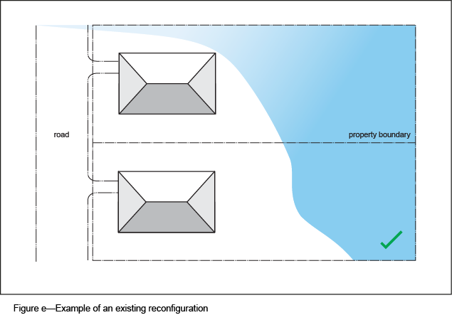
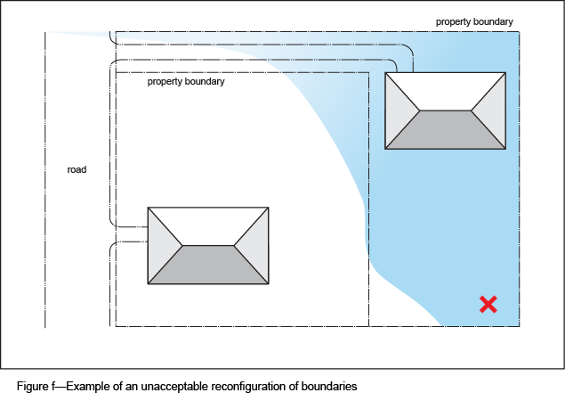

5.4 Egress and evacuation

5.4.1 Retaining walls and batters
- If an overland flow path or area affected by creek/waterway flooding is modified through earthworks, those works are to ensure that the modifications do not impact on flood behaviour and still allow for people to move safely from the area affected by the flooding.
- Issues requiring consideration include the following:
- if batters are proposed, typical maximum grades that will facilitate safe egress for people (including children) are 1V:6H;
- breaks are provided in retaining walls along the length of the flood hazard area to provide safe egress points between the development and flood hazard areas;
- retaining walls are constructed to provide ledges and/or steps that would aid children to escape from floodwaters and/or aid emergency services in the recovery of people.

5.4.2 Road design considerations for evacuation
If a road is required to act as an evacuation route from a flood hazard area, the road is designed to:
- provide a rising escape route from the development that will not be cut off by a smaller AEP flood event other than the defined flood event;
- have a minimum road level higher than the surrounding lot levels to ensure that it is the last part of the development flooded; which in most cases will require a road at the 1% AEP flood + 500mm where required to be used as a flood evacuation route;
- have consideration of flood risk under more severe flood events.

6 Road trafficability

6.1 New roads
The pavement level of a new dedicated or internal road resulting from reconfiguration of a lot (freehold lots or community title scheme) is to be sufficient to ensure the safety of people and vehicles during a flood by complying with the minimum flood immunity levels specified in the Flood overlay code and ensuring the flood risk under more severe flood events is managed.

6.2 Serviceability of existing road network external to the development during floods
If reconfiguring a lot (excluding infill reconfiguring a lot):
- The level of serviceability to be provided to traffic at a creek/waterway crossing depends on the AEP of the flood for which the creek crossing is to be passable to traffic and the duration of the road closure during times of flooding. Trafficability will need to consider the flow depths and velocity limitations as in Queensland Urban Drainage Manual sections 7.3 and 7.4.
- Trafficable access to the site from at least 1 suburban road (or higher category road network) is required to maintain emergency services having regard to the number of affected properties and the proposed use of the development with the following trafficability criteria for the road network between the site and the closest district or neighbourhood centre:
- The time of closure for the 2% AEP flood event from all the nominated flooding sources with the exception of Brisbane River, is not to exceed 6 hours.
- The average annual time of closure from all the nominated flooding sources, with the exception of Brisbane River, is not to exceed 2 hours.

6.3 Calculation of time of road closure
- Road closure is assumed when the total head (static plus velocity) on a carriageway with a two-way crossfall or across the highest edge of a carriageway with a one-way crossfall exceeds 300mm. For detailed procedures or explanations of terminologies, refer to the publication Waterway Design—A Guideline to the Hydraulic Design of Bridges, Culverts and Floodways (Austroads, 1994).
- The time of closure is calculated by drawing a horizontal line on a stage hydrograph or flow hydrograph at the trafficable level (flow or stage) and measuring the time for which the flooding is above this trafficable level. Refer to Figure g.
- The time of closure for each AEP event is not necessarily the design hydrograph which produces the highest peak flood level, but rather the critical duration envelope is usually derived from a series of flood hydrographs of different durations. For example, for a given trafficable capacity, the 24-hour storm may generate a longer period of closure at the crossing than the 6-hour critical duration storm that produces the highest peak flood level at the crossing.
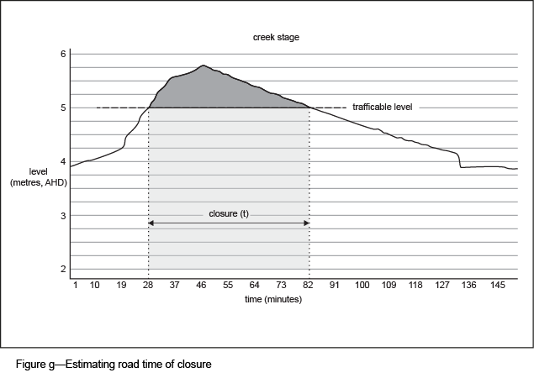

7 Building design
- Development is not to create a substantial blockage (such as by filling, erection of a building, retaining walls or acoustic fences across an overland flow path) that is to be offset by the provision of an underground drainage system, such as pipes, to convey major overland flows for the following reasons:
- 'open' overland flow paths provide significant conveyance for floods larger than the design storm (up to probable maximum flood) which a piped system cannot replicate;
- additional maintenance costs are incurred by the Council, such as whole-of-life costs;
- the loss of flood storage and potential cumulative impacts;
- the potential adverse flooding impacts in extreme storms;
- safety hazards at inlets and outlets;
- debris blockage (full or partial blockage).
- Development is to provide an easement for an overland flow path or creek/waterway within private premises. This is to ensure the conveyance capacity is protected from further filling or development.

7.1 Building undercrofts
- A building suspended to allow floodwaters to pass underneath can be subject to a higher flood risk than that of development adjacent to a floodway. Unlike open flow paths (overland flow paths and creek/waterways) that may have the ability to convey a significant proportion of floodwaters up to the probable maximum flood, building over a floodway can significantly constrict the ability of that area to convey floodwaters in any design flood event and for extreme floods.
- If a building or structure is located within a creek/waterway or overland flow path, debris carried by the floodwaters could cause an obstruction or blockage to flood flow when impacting on building components. These blockages can significantly increase flood levels, cause significant damage to structures due to flood loads or impact flood levels on other premises.
- Buildings or structures suspended partially over an overland flow path (or other flood-affected area) are to have sufficient clearance between the building structure and ground to convey floodwaters, minimise debris blockages and reduce the risk of structural failure. Sufficient clearance is also required for appropriate and safe maintenance of the undercroft area.
- Complete covering of a flow path is not permitted as this is essentially piping the overland flow and does not facilitate the management of blockages and extreme storms (refer Queensland Urban Drainage Manual).
- Where unsafe hydraulic hazard conditions exist at the defined flood event under the structure or building, the adequacy of the undercroft clearance is to be checked using a severe storm impact assessment as detailed in Queensland Urban Drainage Manual sections 7.2.4 and 7.2.5. This would require the engineer to assess consequences of a 100% blockage of the minor stormwater system.
- Figure h, Figure i, Figure j, Figure k and Figure l support the undercroft design concepts in this section of the planning scheme policy.

7.2 Undercroft minimum clearances
- Building undercroft minimum height criteria in Table 8.2.11.3.E of the Flood overlay code have been determined with the following considerations for low hydraulic hazard overland flow flood conditions only:
- an allowance of 500mm for building structural requirements such as slab, supporting beams and suspended services;
- provision of at least 400mm hydraulic clearance above the 2% AEP flood level to ensure the building structural components, such as slabs and beams, are located below the energy grade line (velocity head) and allow for debris and partial blockages of the undercroft and some uncertainty in ground-level treatments, such as irregular riprap, and corresponding impacts on flood levels;
- an allowance for the design flood depth component;
- provision of a total clear height of 1m to allow safe access for maintenance and inspections.
- If a site is affected by creek/waterway flooding or if unsafe hydraulic hazard flood conditions exist, the minimum flood depth component and hydraulic clearance is increased due to the greater depth of flooding and higher possibility of debris impacts/blockages.
- If it is proposed to reduce the minimum undercroft clearance below those stated in the Table 8.2.11.3.E of the Flood overlay code as a performance outcome, a flood study is required. The study is to demonstrate that the building undercroft is sufficient to provide the greater of 500mm of debris clearance above the 1% AEP flood velocity head level and that an extreme flood event such as the probable maximum flood (through a severe storm impact assessment as per Queensland Urban Drainage Manual) can be conveyed under the structure.
- Despite (3), the minimum undercroft from the finished slab level to ground level is to be 1500mm.
- The design of an undercroft area is not to increase the flood hazard from that of existing conditions.
- These provisions only apply to a partial suspension of a structure over an overland flow path. While a full enclosure of overland flow paths is not supported, such a proposal may need to address additional safety criteria such as the ability of swift water rescue personnel to safely enter and exit the area with sufficient clearance, which will require additional clearance from that stated. In addition, any ecological and other planning constraints would need to be addressed.
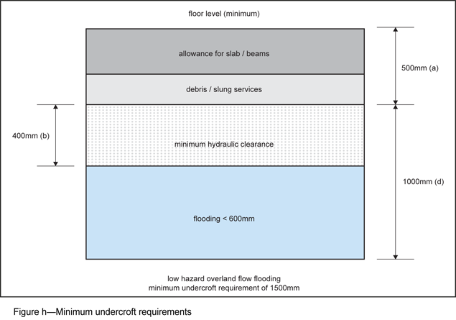

7.3 Building undercroft design and ground treatment
- The undercroft area is to be suitably stabilised and designed to drain freely. This may be accomplished by providing a concrete slab, gabion or rock riprap surface treatment.
- Rock selection is to be based on the velocity or shear stress estimated through the site for design Manning's roughness conditions. A minimum d50 rock size of no less than 200mm is to be used.

7.4 Examples of suitable building undercroft designs
- Figure i, Figure j, Figure k and Figure l provide acceptable examples of ground treatments if a building is suspended over an area affected by overland flow flooding. These examples may also be suitable in fringe flood areas of creek/waterway flooding, such as FPA3 and FPA4, where impacts of development limit the ability to fill.
- The figures below do not suggest or support suspending into the channel or any creek/waterway, or complete enclosure of an overland flow path.
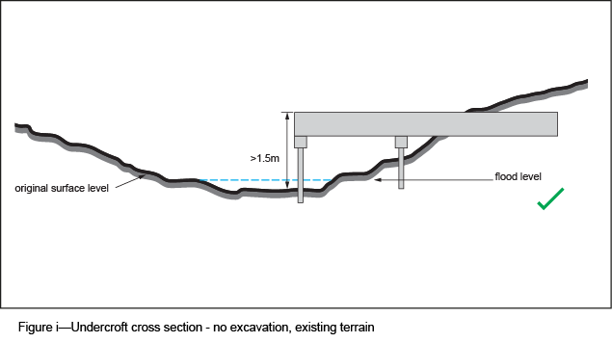
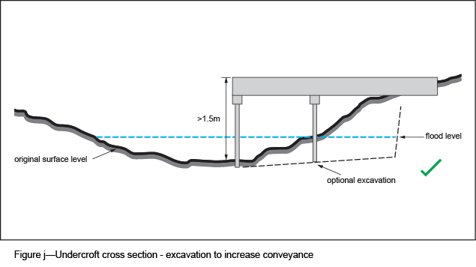
Note—
- undercroft height >1.5m at low point from ground level to finished floor level (or 2m hydraulic hazard is unsafe);
- at least 50% of undercroft area meeting 1.5m height requirement;
- minimum lateral grade of excavated areas of 2% to provide efficient drainage;
- reduction in height allowable on the fringe of the flow path due to maintaining the existing section profile or grade requirement on base of undercroft area;
- base to resist scour by being concreted or rock armoured (i.e. no bare earth);
- no significant increase in flood hazard under structure and a depth X velocity product of no greater than 0.6m2/s (0.4m2/s applies to high risk areas where there is an obvious likelihood of injury or loss of life).
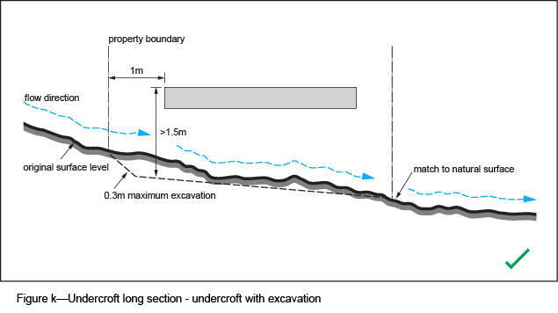
Note—
- undercroft height >1.5m at low point from ground level to finished floor level (or 2m hydraulic hazard is unsafe);
- where excavation is used to obtain the necessary longitudinal clearance a slab cannot be built to boundary and must be set back a minimum of 1m (or as required by the hydraulic analysis) so that any part of the flow transition will not be impeded;
- where excavated, a desirable longitudinal grade of 1% to facilitate drainage;
- base to resist scour by being concreted or rock armoured (i.e. no bare earth).

7.5 Examples of unacceptable building undercroft design
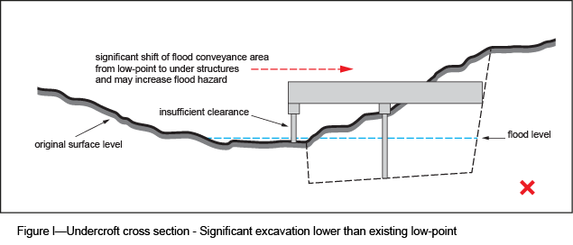
Significant excavation under a structure to achieve the undercroft requirements is not an acceptable outcome as this design:
- shifts the conveyance of floodwaters from primarily outside of the undercroft area to directly under structures by creating a new low point and channel;
- creates adverse flooding impacts by concentration of flows (and potentially increased hydraulic hazard) on down-slope premises;
- concentrates flow and increases the likelihood of debris collection under the structure and associated loading on building structures;
- may cause unsafe hydraulic hazard conditions under the structure where none may have existed before;
- is difficult to match to existing levels at the down-slope boundary and may cause ponding of floodwater;
- creates potential obstruction and insufficient clearance for flows travelling laterally across the flow path;
- results in maintenance access difficulties and occupational health and safety non-compliance.

8 Built form for flood resilience
Editor’s note—The Queensland Government has published a Guideline for the construction of buildings in flood hazard areas which sets out advice for buildings in flood planning areas.

9 Flood risk management

9.1 Flood risk assessment
- The Flood overlay code including Table 8.2.11.3.C set out occasions where a flood risk assessment may be needed to determine the suitability of a land use to the flood hazard or in setting flood immunity levels for specific development types.
- A flood risk assessment is only required if:
- a land use is nominated as requiring a risk assessment to ensure its suitability to the flood hazard; or
- a select group of building types nominated in Table 8.2.11.3.D of the Flood overlay code proposed in a site located in an established area that does not meet the prescribed flood immunity standard for the Brisbane River; or
- addressing the performance outcome of the Flood overlay code where the land use is not compatible with the acceptable outcomes of that code.

9.2 Scope of application
- The flood risk assessment is a formal means of identifying and managing the existing, future and residual risks of flooding. It may be a stand-alone document or incorporated into a flood study.
- A suitably qualified professional consultant is to be engaged to undertake the flood risk assessment in accordance with the framework outlined in AS/NZS 4360:2004 Risk management. Where aspects of the flood risk assessment discuss engineering principles, the flood risk assessment must be jointly undertaken and signed by a Registered Professional Engineer Queensland with expertise in that field of engineering.
- The aim is to ensure that risks, including safety, environmental, social and economic associated with the proposed use are compatible with the flood hazard and level of flood immunity and the risk to people is minimised. For example, a warehouse for the purpose of storing concrete pipes will incur less flood damage losses when compared to a warehouse used to store electrical appliances. The storage of hazardous chemicals may not be an appropriate use given environmental impacts if flooded, even though the economic damages and safety risk may be low or moderate.

9.3 Risk assessment process
- There are instances where the exact use of a development is not known, such as centre activities and industrial activities, and instances where the use is known, such as the lobby of an apartment block. The risk management formulation should cover a range of proposed and likely future uses.
- The flood risk management process is to include the following key elements:
- identification of the stakeholders exposed to or affected by the risk of flooding and their compatibility to the risk and how flood risk to people is managed. For example, residential and special care uses are typically less tolerant to flood risk than industry;
- identification of public and private premises, social systems and environmental elements at risk of flooding, including consideration of extreme flood events;
- identification of all critical electrical services, hazardous storages and other high risk elements;
- estimation of flood risks; that is, the likelihood and consequences of flooding. This evaluation requires a quantitative analysis that uses numerical values, rather than the descriptive scales used in qualitative and semi-quantitative analysis for both consequences and likelihood. The quality of the analysis depends on the accuracy and completeness of the numerical values used;
- consideration should be given to not only building and contents damages from flooding, but the flood compatibility of any activities being conducted on the premises and the economic impacts of downtime during flood recovery on business and employees' economic resilience during a flood;
- assessment of the flood risk and implications up to and in excess of the defined flood event;
- definition of flood risk management strategies is to include:
- the proposed method of perpetuating the restricted use and required mitigation measures through appropriate forms of legal documentation, notation on titles and methods for conveying the risk management data to future owners and leaseholders;
- the procedure to conduct emergency flood management, evacuation and rescue operations including flood emergency management plans.
- Development which proposes a lowering of flood immunity standards through a risk assessment (usually an industrial use) is to ensure the building materials are constructed of flood-compatible materials.

9.4 Issues requiring consideration
A flood risk assessment is to address the following issues:
- number of people likely to be at risk and who may need to be evacuated;
- hazard in larger floods – the flood risk does not stop at the defined flood event so the suitability of a land use must consider the implications of larger floods, particularly in regard to the risk to people;
- flood warning time – within Brisbane the only applicable flooding sources that may have a warning time are the Brisbane River and storm-tide flooding;
- evacuation routes – identify applicable routes, if relied upon, and flood immunity of those routes, and an assessment of the safety of people moving to those routes;
- isolation – potential to have evacuation route cut off early in the flood;
- vertical evacuation – while an important element it cannot be totally relied on and will require an estimation of extreme floods such as the probable maximum flood and isolation issues;
- identify special care uses – the publication Evacuation Planning by Emergency Management Australia (Commonwealth Government 2005) provides a list of special needs groups;
- burden placed on emergency services – while important to allow safe access for emergency services, they cannot be relied on as a solution to egress difficulties and evacuation;
- special care requirements at evacuation destination – uses focused on vulnerable people such as children or elderly and their special requirements for care and the ability of evacuation centres to provide that care;
- length of flood recovery and social and economic impacts;
- hazardous goods, mitigation and associated environmental impacts;
- flood-resilient design – this may include both using flood-compatible materials and building design aspects such as locating the least flood-tolerant uses at the highest development levels;
- impact of increases in rainfall intensity at 2050 and 2100 in regard to safety and property damage;
- in the case of overland flow flooding a severe storm impact assessment being provide in accordance with Queensland Urban Drainage Manual.

9.5 Flood emergency management plans
- A flood emergency management plan is one of the tools used to mitigate the residual risk from flooding.
- A flood emergency management plan could form part of a flood risk assessment, but where relied upon for development, including a condition of development, it is to compromise a stand-alone document.

9.6 Scope of application
Specific land uses or development conditions may require a flood emergency management plan. These are typically land uses that have higher risks from flooding due to the type of use, often involving elderly, children or people with special care or supervision requirements.
The scope of the flood emergency management plan is to include:
- nature and typical size, characteristics and built form of the development;
- asset or use life;
- population characteristics associated with the use such as vulnerable populations, ease of evacuation, number of people;
- scale of investment in the development;
- potential for adverse environmental, social and economic effects from flooding of land uses;
- discretionary visitation (e.g. people easily choose not to go there).

9.7 Issues requiring consideration and information requirements
Where a flood emergency management plan is required, it is to include:
- a plan of development and site showing evacuation routes and assembly areas (where relevant);
- a description of the triggers to activate evacuation plans and other emergency flood management measures;
- a description of relevant signage and proposed locations in the building;
- a list of any procedures required to manage evacuation;
- contact numbers of relevant local emergency services;
- a quantitative assessment of risk and risk-reduction factors, including consideration of extreme flood events up to the probable maximum flood.

10 Requirements for a flood study

10.1 General
Many waterways have flood level information from flood studies, which are shown within the FloodWise Property Report. Use of that information for assigning flood planning levels is acceptable when a development is not modifying the floodplain. This information may not be suitable for developments that modify terrain within, or obstruct parts of the flood planning areas as it may alter flood levels. In addition, site-specific studies are required where impacts of development are being assessed.

10.2 Preparation of a flood study
- A flood study involves hydrological and/or hydraulic assessments where required to estimate catchment flows, flood levels, or demonstrate that the development or any flood mitigation work would not adversely impact on flooding to upstream, downstream or adjacent premises.
- A flood study is to be supervised and certified by a Registered Professional Engineer Queensland with demonstrated expertise in hydrology, hydraulic modelling and stormwater engineering. The flood study is to include where applicable:
- site survey plan showing location of buildings and underground stormwater infrastructure (line and level);
- a catchment plan detailing internal and external drainage catchments and their respective areas;
- the location and details of drainage easements associated with underground drainage, open channel drainage or overland flow paths;
- a scaled drawing showing the hydraulic model layout (cross-sections) or digital elevation model over a cadastral background, also noting details of relevant structures (hydraulic controls);
- scaled drawings showing a comparison of existing and proposed flood inundation extents;
- flood afflux and Manning’s roughness maps when using 2D modelling techniques;
- detailed plans for any proposed waterway structures;
- detailed earthworks plans for any channel works or flow path modifications proposed by the development;
- location of waterway corridors and relevant flood hydraulic hazard areas;
- cross-sections of existing or proposed basins, embankments, spillways and any other structures that may act as hydraulic controls;
- increases in rainfall intensity associated with climate change should be consistent with best practice (Australian Rainfall and Runoff guidelines / Queensland Urban Drainage Manual).

10.3 Choice of hydraulic model
- Hydraulic conveyance is a measure of the flow carrying capacity of a watercourse and is a function of the geometry and surface impedance of that watercourse. The loss of conveyance from obstruction or filling is usually characterised by increases in flood levels upstream.
- Mathematical models are used to assess the impacts on flood flow conveyance when adverse impacts are being assessed such as the HEC-RAS steady/unsteady state hydraulic model or MIKE-11 hydrodynamic model.
- As floodwaters flowing in a watercourse rise during a flood event and overtop banks, a portion of floodwaters is transferred into storage areas of the floodplain where the flow velocities are small in comparison with the main channel. The loss of critical flood storage from obstruction or filling is usually characterised by increases in flow velocities and flood levels downstream. Mathematical models that are appropriate to assess the impacts of flood and flood storage are to be fully dynamic 1D/2D hydraulic models such as MIKEFLOOD, Mike-21, SOBEK and TUFLOW.
- A 2D modelling technique is used where flow paths cannot be adequately represented using 1D modelling techniques, which is often the case with overland flow flooding or where demonstrating the impacts of development on flood storage where compensatory earthworks in creeks/waterways are required.
- The use of a LIDAR survey is acceptable for 2D hydraulic analysis, particularly for areas outside of the subject. However, critical hydraulic controls must be surveyed. If sections of the floodplain contain channels which could be represented by 1D modelling techniques, it is desirable to use an integrated 1D/2D modelling technique if surveyed cross-sections can be integrated into the 2D grid.
- If the survey is converted into a digital elevation model for use in a 2D hydraulic model, the grid size of the 2D model is selected to meet the objectives of the study which may include suitable simulation times, appropriate hydraulic resolution of key areas and flow conditions. A fine grid resolution is not always the most appropriate scale. The adopted grid size is to be justified.
- At a minimum, all 2D flood analysis of existing and developed conditions is to provide drawings/figures in the flood study, including:
- digital elevation model showing any obstructions and blockages;
- existing and design Manning’s roughness;
- flood depth with velocity vectors to visually indicate the conveyance versus storage areas of the floodplain;
- flood afflux to show flood level impacts;
- flood hazard (depth x velocity product) to show areas of safe and unsafe hydraulic hazard.

10.4 Hydrological model assumptions
The report is to justify the basis of the values adopted for the hydrologic modelling parameters used in the analysis, including the following:
- rainfall loss model values;
- sub-catchment fraction imperviousness (development assumptions);
- routing parameters;
- flow velocity and time of concentration estimates;
- Manning’s ‘n’ roughness values in relation to land use;
- structure capacity and hydraulic headloss assumptions (HGL analysis);
- the capacity of culverts considering inlet/outlet control.
Editor’s note—Where consideration of increased rainfall intensity for climate change is required, refer to current advice from the Queensland Government or Australian Rainfall and Runoff guidelines.

10.5 Adverse flood impacts
- Consistent with the requirements of the Flood overlay code, the development is not to cause any adverse flooding with respect to flooding of developed or developable areas, erosion potential, or the general amenity of the area. The applicant should not assume that the downstream drainage will be upgraded at a future date to mitigate any impact from the development.
- An adverse flooding impact includes any significant increase in flood level, flood hazard, or a change in velocity that would increase erosion potential (typically flow velocity in excess of 2m/s).
- The extent of an allowable afflux as a result of development is often variable, depending on the modelling technique, type of land use, flooding type, catchment characteristics and impact on flood storage and ownership of the land affected. However, no increase in level is preferable in all instances otherwise supporting evidence is to be provided justifying any impact.
- Generally larger creek flooding sources and the Brisbane River are not to be impacted by development because impacts are much more likely to extend into many adjacent premises and even a small flood level change may represent significant alterations in floodplain storage.
- Overland flow paths have higher uncertainty and impacts are more likely to be localised within the site.
- In pedestrian areas, the flood afflux may be less relevant than changes to flood hydraulic hazard.
- Where significant diversion of catchment flows from existing conditions occur, adverse impacts associated with flood level changes and hydraulic hazard will need to be considered using a severe storm assessment as identified in Queensland Urban Drainage Manual.

10.6 Assessment for creek/waterway flooding
- All hydraulic studies used to determine the impacts of filling where cumulative impacts are relevant need to use an unsteady flow analysis to estimate the impacts of changes in flood storage.
- Large backwater areas or significant flood storage areas will require the use of 2D hydraulic modelling techniques to adequately assess changes to flood storage.

10.7 Estimating flood planning levels for creeks/waterways
- All hydrologic and hydraulic calculations for waterways or creeks for the purpose of determining ultimate flood levels, easement widths, development fill or building levels are based on the following:
- 1% AEP (and other relevant events) flows;
- Fully developed catchment conditions (ultimate catchment development scenario), including:
- cumulative impacts of filling
- anticipated catchment zone categories and corresponding fraction impervious;
- a fully vegetated waterway corridor using a Manning’s roughness value of 0.15.The high vegetal roughness coefficient assumed is to allow for generally unrestricted planting of vegetation in the future and is to facilitate orderly development by ensuring the development does not constrain other sites or the Council from planting at these densities in the future;
- a Manning’s roughness value of 0.08 is appropriate if a Council-endorsed stormwater management plan, waterway management plan or flood study has identified that full revegetation is not possible due to an unacceptable increase in flood levels, or is not practical (e.g. much of the creek/waterway is open space for recreation);
- using existing or design Manning’s roughness assumptions is only permissible when assessing impacts of development on flood behaviour, such as flood hazard.
Note - When estimating flood planning levels for fully developed catchment conditions (ultimate catchment development scenario), Council accounts for cumulative impacts of filling based on individual catchment characteristics and Brisbane City Plan 2014 provisions. This includes (but is not limited to) restrictions on filling within Flood Planning Areas 1, 2 & 3 (refer to Flood overlay code and Compensatory earthworks planning scheme policy) and/or the waterway corridor (refer to Waterway corridors overlay code).
Note - Flood planning levels calculated for the ultimate catchment scenario should not be less than the levels calculated for existing catchment conditions.

10.8 Assessment for overland flow flooding
Particular care is required when determining flood immunity requirements for buildings affected by overland flow flooding sources because of the high flow velocity that may occur and the substantial hydraulic uncertainty that may occur along such flow paths as a result of fences, retaining walls, structures and landscaping. This may result in situations where the velocity head (energy grade line) is significantly higher than the modelled flood surface level, or possibly higher than the freeboard requirement.

10.9 Estimating flood planning levels for overland flow flooding
- All hydrologic and hydraulic calculations for local flooding for the purpose of determining ultimate flood levels, easement widths, development fill or building levels are based on the following:
- assuming fully developed upslope catchment conditions (ultimate development scenario) for hydrology estimates, including anticipated catchment zone categories and corresponding fractions impervious;
- using a Manning’s roughness ‘n’ of 0.10 to take into account any future planting and garden beds which may occur, ancillary structures such as fences, sheds which may be erected, and any other obstructions which cannot be regulated;
- modelling that includes significant structures such as buildings, as constrictions between such buildings may significantly influence the flood hazard;
- disregarding the effect of fencing on flow diversions (particularly side boundary fencing) if it would lower a building’s flood immunity requirements.
- Using existing or design Manning’s roughness assumptions is only permissible when assessing impacts of development on flood behaviour, such as flood hazard.
Note - Flood planning levels calculated for the ultimate catchment scenario should not be less than the levels calculated for existing catchment conditions.

10.10 Vehicle parking
Relaxation of flood immunity standards for parking may only occur for vehicular accommodation (limited to uncovered short-term car parking bays or unclosed car parking associated with a house) and access area, where there is compliance with the following:
- the maximum flood depth is 300mm in a 1% AEP flood (QUDM section 7.3.15);
- flooding no more frequent than a 10% AEP flood;
- maximum allowable product of velocity in accordance with QUDM section 7.3.15;
- driveways and roads providing egress from the parking area achieve acceptable flood immunity;
- there is minimal chance of vehicles being washed away and blocking stormwater drains, channels and culverts in severe storms greater than the defined flood event. Alternatively, mitigation is provided such as the use of bollards between parking areas and an overland flow path or creek/waterways.

11 Earthworks in a floodplain

11.1 Filling
- Development takes account of existing or created overland flow paths and makes due provision in the design.
- Impacts of filling within an area affected by flooding are assessed by a flood study undertaken by a Registered Professional Engineer Queensland with suitable experience and expertise in undertaking flood studies, stormwater management and drainage infrastructure design.
- Filling does not remove the flood hazard for all floods. It only mitigates the flood hazard for the particular flood immunity for which it is designed. Therefore, filling in areas of unsafe hydraulic hazard requires careful consideration to minimise any unacceptable risk to people in flood events greater than the defined flood event.
- If filling in a waterway corridor, the earthworks comply with the Compensatory earthworks planning scheme policy.

11.2 Interface of development to creeks/waterways
All lot boundaries to a creek/waterway are to provide an interface which is safe and stable during a flood.
- The use of battered interfaces to a waterway corridor is preferred.
- If a retaining wall is necessary, the wall is:
- located on the site;
- clear of flood flows that could cause damage to the wall;
- stepped to allow people egress out of floodwaters.

11.3 Levees
Using levees in a development involving new premises to satisfy flood immunity standards is not appropriate for the following reasons:
- There is no guarantee that the levees will remain with the land.
- Levees are not an intrinsic solution to flooding of the development.
- Levees may be breached or overtopped in extreme storms, which can lead to an increase in flood damage, and subsequently greater potential for damage.
- Levees that overtop in extreme floods can produce a much higher flood hazard to people and structures than if they had not been built in the first place. However, it is accepted that a wall or ramp can be used to provide flood immunity to a basement where it is part of the building or structure;
- Piped drainage through the levee to drain the site may compromise its effectiveness.

