SC6.23 Park management plan planning scheme policy

Contents
1 Introduction
1.1 Relationship to planning scheme
1.2 Purpose

2 Howard Smith Wharves park management plan
2.1 Introduction
2.2 Location
2.3 History
2.4 Vision and intent
2.5 Howard Smith Wharves park management plan precincts
2.5.1 Precincts
2.5.2 Access
2.5.3 Facilities or elements
3 Monier Road Park park management plan
3.1 Introduction
3.2 Location
3.3 Vision and intent
3.4 Monier Road Park park management plan content
3.4.1 Precincts
3.4.2 Access and car parking
3.4.3 Facilities or structures and embellishments
3.4.4 Outdoor lighting
3.4.5 Development size and proximity thresholds
3.4.6 Safe environment

1 Introduction

1.1 Relationship to planning scheme
This planning scheme policy:
- provides guidance or advice about satisfying an assessment benchmark which identifies this planning scheme policy as providing that guidance or advice;
- states a standard for the assessment benchmarks identified in the following table.
Column 1 –  Section or table in the code | Column 2 –  Assessment benchmark reference | Column 3 –  Standard in the planning scheme policy
Community facilities code
Table 9.3.5.3.A | AO29 | All
Outdoor sport and recreation code
Table 9.3.15.3 | AO2 | All
Park code
Table 9.3.16.3 | AO1 | All
Table 9.3.16.3 | AO9.1 | All

1.2 Purpose
- The purpose of the Park management planning scheme policy is to provide:
- guidance on the nature and level of desired uses, activities, facilities and park infrastructure, for specific Brisbane City Council parks and reserves in accordance with the approved park or natural area master or management plan relevant to that park or natural area;
- management plan standards as Park code acceptable outcomes.
- The Council develops individual park or natural area master or management plans with input from a broad range of internal and community stakeholders, ahead of including selected plans into this planning scheme policy.
- The following individual park or natural area master or management plans are covered in this planning scheme policy:
- Howard Smith Wharves park management plan;
- Monier Road park management plan.

2 Howard Smith Wharves park management plan

2.1 Introduction
The Howard Smith Wharves park is included in the Open space zone and the metropolitan zone precinct.

2.2 Location
- The area covered by the Howard Smith Wharves park management plan is identified in Figure a.
- The Howard Smith Wharves park management plan area is located at a junction between the City Centre and the adjacent suburbs of Fortitude Valley and New Farm. This riverfront land is located on the northern shore of the Brisbane River beneath the Story Bridge and opposite Kangaroo Point.
- The Howard Smith Wharves park management plan area includes land bounded by Bowen Terrace, Moray Street, Boundary Street and the Brisbane River. The management plan includes leased areas and berthing facilities within the Brisbane River to the extent that these areas are within the local government boundaries of the Brisbane City Council. The management plan also includes the cliffs located adjacent to Bowen Terrace, as well as the Wilson Outlook Reserve at the corner of Moray Street and Bowen Terrace.

2.3 History
- The Howard Smith Wharves site is a culturally and historically significant site for Brisbane. An understanding of the history of the site is an important context for the Howard Smith Wharves park management plan.
- The Howard Smith Company was established in Brisbane in the 1870s and occupied wharves at the site from the 1890s. While it was originally built as the Brisbane Central Wharves, the existing structures were constructed in the 1930s, when the Queensland Government resumed the site as part of a program to widen the river, to build the Story Bridge and to rebuild the original wharves and sheds as one of the Forgan Smith government’s principal employment-generating projects. The site was then leased by the company (then known as Howard Smith and Co) from the mid 1930s until the early 1960s, and become known as the Howard Smith Wharves.
- Construction of the existing structures on the site began in 1934 and continued through until the early 1940s. During World War II, in 1941 and 1942, five air-raid shelters were constructed below the cliff face.
- The wharves were a hive of activity throughout their use by Howard Smith and Co – one of Australia’s principal nineteenth and early twentieth century coastal shipping companies.
- After Howard Smith and Co moved downstream in the early 1960s, the site was occupied partly by the Water Police, and partly by the Queensland Works Department for storage.
- The site is an important physical, economic and cultural example of the development of Queensland. The remaining wharf buildings provide rare physical evidence of the pre-1940 Port of Brisbane, and the air-raid shelters are the most intact group of such shelters surviving in Brisbane. The site further exemplifies the history of Brisbane as Queensland’s premier port, and the expansion of Brisbane City that has seen port activities shift further downstream.
- The historical structures comprise:
- 3 single-storey storage sheds of timber and sheet metal construction;
- timber decking wharves;
- a 2-storey rendered masonry building originally built as shipping company offices;
- 5 World War II air-raid shelters of reinforced concrete construction;
- masonry Lavatory Building;
- the Story Bridge, in particular, 2 reinforced concrete pylons of the Story Bridge are dominant features of the site located between the storage sheds at the western end of the site.

2.4 Vision and intent
- The vision of the Howard Smith Wharves park management plan is to create a new inner-city metropolitan park that is one of a linear network of riverside parkland destinations, and that features its unique history, access to the Brisbane River and City Centre, and revitalised heritage buildings set amongst the new parkland.
- The intent for the Howard Smith Wharves park management plan is to:
- create a vibrant, accessible urban parkland;
- retain the heritage values and feature historic aspects of Howard Smith Wharves in the design of the parkland;
- allow for a range of passive and active recreation opportunities that activate the park;
- provide public access and circulation to and through the site for cyclists and pedestrians, connecting the New Farm Riverwalk (to be replaced following extensive damage to the structure caused by the January 2011 floods) with the City Centre as well as providing new connections from the lower riverside areas to top of cliff locations to connect with Fortitude Valley and New Farm;
- complement and integrate with any future revitalisation of the Howard Smith Wharves site and any reuse of existing heritage buildings.
  - Howard Smith Wharves park management plan content

2.5.1 Precincts
- The Howard Smith Wharves park management plan area includes the following (refer Figure a) that have different functions as follows.
- Boundary Street entrance area (Precinct 1) – This area contains entrance features and signage, including provision for vehicle entry, car parking, servicing and manoeuvring into the site. This location links with the City Centre Riverwalk, and berthing facilities adjacent to the heritage buildings.
- Heritage buildings A, B, C, E and surrounds (Precinct 2) – Pedestrian access to the river may be provided along wharf or boardwalk structures in front of the existing heritage buildings in this area and berthing facilities can also locate adjacent to the heritage buildings.
- Between heritage building C and heritage building E (Precinct 3) – This area is suited to a lookout, interpretive elements for the bomb shelters, and park facilities, including amenities.
- Eastern end (Precinct 4) – Active and passive recreation areas are contained at the eastern end of the park. This could include rock climbing facilities, stairs and lifts, park facilities and viewing areas.
- Wilson Outlook Reserve (Precinct 5) – Wilson Outlook Reserve could contain viewing platforms, green space, seating and park facilities and the upper cliff area access to the stairs and lift.
- Top of cliff area (Precinct 6) – This area provides viewing platforms and lookouts, park facilities and access to lifts and stairs.

2.5.2 Access
- The Howard Smith Wharves park management plan provides for access for pedestrians and commuter and recreational cyclists to ensure connectivity through the area and to surrounding suburbs. The site performs an important role as part of an integrated movement corridor for pedestrians and commuter and recreational cyclists. Access arrangements for pedestrians and cyclists include (but are not limited to):
- connecting Boundary Street and adjacent city centre areas with the Riverwalk at the eastern end of the park;
- connecting the lower riverside area with upper cliff areas of Bowen Terrace and Moray Street by maintaining the existing pedestrian footpaths (adjacent to the Story Bridge) and providing new lifts and stairs between the upper and lower levels to ensure site access is disability compliant.
Note—A visual analysis is to be provided as part of any proposal for lifts adjoining the cliffs.
- Vehicle access to the lower riverside areas occurs from Boundary Street. Vehicle access and parking are limited to the western end of the park, excluding maintenance and emergency vehicles which may use the whole park.

2.5.3 Facilities or structures
A range of parkland facilities (including buildings and structures) may be provided in the Howard Smith Wharves park including:
- access paths (including walking tracks, footpaths, boardwalks and recreation and commuter bicycle paths) and facilities to and from the parkland;
- ancillary buildings (including storage or maintenance sheds);
- BBQs/picnic facilities (including tables, seating and bins) and areas;
- car parking areas and facilities;
- entry feature(s) and plazas;
- fencing;
- fishing platforms and boating facilities (including ramps, jetties, wharves);
- interpretative walls;
- items of cultural heritage;
- landscape and horticultural structures
- lawns, gardens, planting and landscaped areas;
- lift structures and stairs;
- lighting, including lighting to highlight the landscape values of the cliffs;
- lookout(s) or viewing platforms;
- nest boxes, bird hides, glider poles, bird aviaries;
- parkland shelters and seating;
- play equipment, fitness equipment;
- public artwork/sculptures;
- public toilets and other amenities (including drinking fountains);
- rock climbing area;
- shade/shelter and furniture (including tables and seating);
- signage, noticeboards and display panels containing park related or cultural heritage information;
- small-scale performance spaces/structures;
- water features, including waterfalls;
- wharves and river access.

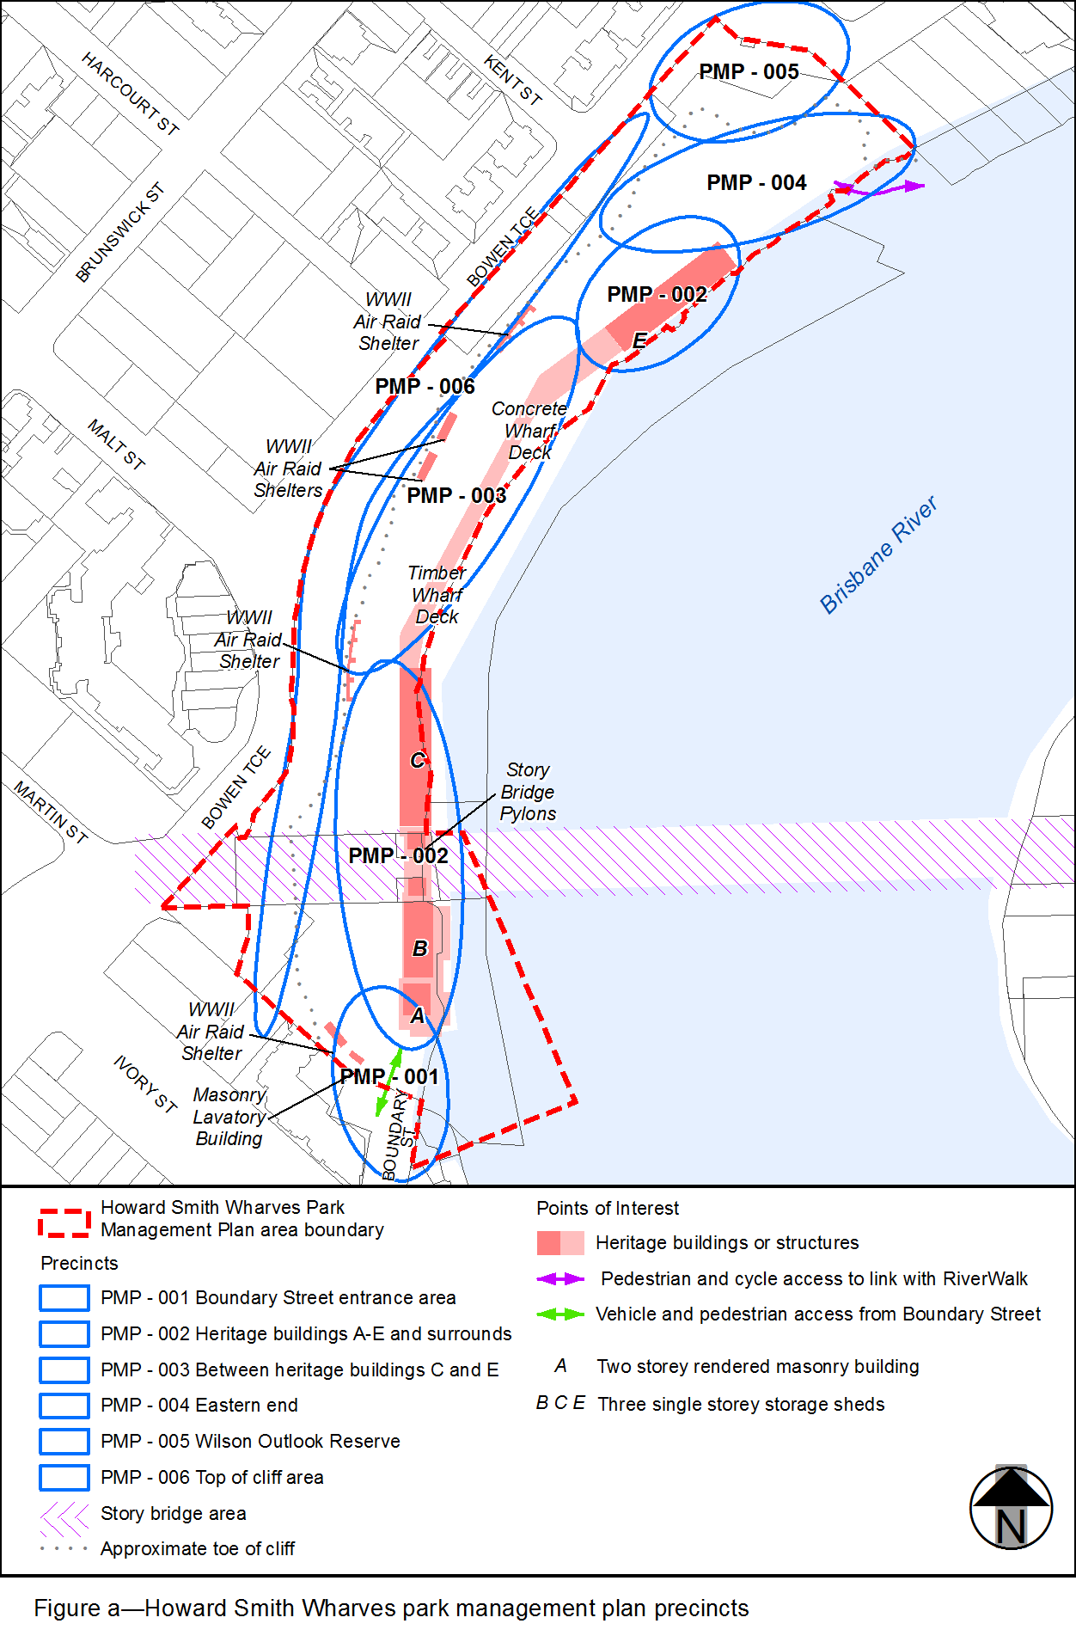

3 Monier Road Park park management plan

3.1 Introduction
The Monier Road Park is included in the District zone precinct in the Sport and recreation zone and the Local zone precinct in the Open space zone.

3.2 Location
- The area covered by the Monier Road Park park management plan is identified in Figure b and applies to land identified as Lots 1 and 2 on RP90070, Lot 3 on SP172176 and Lot 5 on RP44635.
- The Monier Road Park park management plan area is located in Darra in Brisbane's western suburbs. The land is the site of a former landfill which has been rehabilitated for sport and recreation purposes. The land is highly accessible to residents of Darra and the adjoining suburbs of Oxley and Seventeen Mile Rocks via a number of major roads and pedestrian and cyclist connections.
- The Monier Road Park park management plan is bounded by Monier Road to the north, Cardiff Road to the west, open space to the south and low density residential uses to the east and south. A minor waterway bisects the southwest corner of the land, linking to a minor tributary of the Brisbane River west of the site.

3.3 Vision and intent
- The vision of the Monier Road Park park management plan is to provide district level sport and recreation opportunities for residents of Darra and the surrounding suburbs.
- The intent for the Monier Road Park park management plan is to:
- create a vibrant and accessible district level sport and recreation complex for day and evening use;
- provide and range of active recreation opportunities;
- allow for a range of passive and active recreation opportunities that support the park's primary active recreation uses;
- provide environmental buffers between sport and recreation activities and nearby residential dwellings;
- provide land for the provision of overland flow routes and pedestrian and cyclist connections.

3.4 Monier Road Park park management plan content

3.4.1 Precincts
- The Monier Road Park park management plan area includes the following (refer to Figure b) that have different functions as follows.
- Open space/Sport and recreation field (Precinct 1) - This area provides for retention of an existing oval/cricket field within the park and includes provision for an additional oval/sport field. Sport fields may include informal spectator facilities. including shade planting and shelters. Pedestrian links between parking areas and the sport fields may also be provided in this precinct.
- BMX facility (Precinct 2) - This area provides a BMX track and spectator viewing area.
- Vehicular parking and access (Precinct 3) - This area contains the main vehicle entrance to the site and parking located an internal spine road. Supporting infrastructure for the park, including public toilets, club house and amenities buildings may be located in this precinct.
- Open space and recreation area (Precinct 4) - This area contains playground areas and other park facilities.
- Environmental buffers and overland flow (Precinct 5) - This area, predominantly located at the periphery of the land, provides for environmental buffers between sport and recreation activities and nearby residential dwellings. This precinct also provides land required for the provision of overland flow routes and pedestrian and cyclist connections.

3.4.2 Access and car parking
- Vehicle access to the Monier Road Park will be limited to the existing access at the intersection of Monier Road and Hounslow Way. Intersection upgrades which may be required for park access should take into account future plans for the upgrade of Monier Road.
- Pedestrian and cyclist connections to the park shall be provided through improved connections from the park to the local cycleway network;
- Development provides onsite car parking which is compliant with the standards in the Transport, access, parking and servicing planning scheme policy.

3.4.3 Facilities or structures and embellishments
Development is located, designed and constructed to deliver the desired standards of service for public park infrastructure as described in the Priority infrastructure plan.
The following embellishments may also be provided in Precinct 1, Precinct 2, Precinct 3 and Precinct 4 in addition to those embellishments identified within Table 4.5.6.1.4 in the Priority infrastructure plan as appropriate for a sport park within the district zone precinct:
- playground/play space;
- picnic facilities;
- kick-around space;
- barbecues;
- seating;
- paths (pedestrian/cycle);
- dog off leash area;
- skate facility.

3.4.4 Outdoor lighting
Development envisaged by this parks management plan may require the provision of outdoor lighting for evening use which is to comply with:
- AS 4282-1997 Control of the obtrusive effects of outdoor lighting;
- AS 2560-2007 Sports lighting Part 2.3: Specific applications - Lighting for football (all codes);
- AS/NZS 1158 Set:2010 Lighting for roads and public spaces.

3.4.5 Development size and proximity thresholds
Development within the Monier Road Park park management plan may have buildings or structure complying with the following size and proximity thresholds:
- gazebos and shelters with a maximum individual building footprint 60m²
- club, community use, food and drink outlet and environmental facility buildings with a maximum individual footprint of 500m² and no more than 2 storeys;
- outdoor performance stages with a maximum individual building footprint of 150m² and no closer than 50m to land in a zone in the residential zones category or to an existing residential dwelling;
- sport and recreation facilities such as practice nets, skate and BMX facilities no closer than 50m to land in a zone in the residential zones category or to an existing residential dwelling;
- ancillary buildings such as storage or maintenance sheds with a maximum individual building footprint of 120m²;
- public toilets with a maximum individual building footprint of 150m²;
- a maximum combined footprint of 1,000m² for all new and existing buildings and structures or 10% of the park area, whichever is less.

3.4.6 Safe environment
Development within the Monier Road Park park management plan incorporates the key elements of crime prevention through environmental design in its layout, building or structure design, outdoor lighting and landscaping. Refer to Crime prevention through the environmental design planning scheme policy.

