SC6.29 Structure planning planning scheme policy

Contents
1 Introduction
1.1 Relationship to planning scheme
1.2 Purpose

2. Structure plan requirements

3 Preparing a structure plan
3.1 General
3.2 Step 1—Site and context assessment
3.3 Step 2—Identification of constraints
3.4 Step 3—Analysis of site characteristics and constraints and allocation of land uses
3.5 Step 4—Document the structure plan
3.6 Step 5—Level of consultation required for a structure plan

1 Introduction

1.1 Relationship to planning scheme
This planning scheme policy:
- provides information the Council may request for a development application;
- provides guidance or advice about satisfying an assessment benchmark which identifies this planning scheme policy as providing that guidance or advice;
- States a standard for the assessment benchmarks identified in the following table.
Column 1 –  Section or table in the code | Column 2 –  Assessment benchmark reference | Column 3 –  Standard in the planning scheme policy
Coorparoo and districts neighbourhood plan code
Table 7.2.3.10.3.A | PO10 | All
Banyo—Northgate neighbourhood plan code
Table 7.2.2.1.3.A | AO13 | All
Ferny Grove—Upper Kedron neighbourhood plan code
Table 7.2.6.1.3.A | AO2.1 and AO2.2 | All
Lower Oxley Creek north neighbourhood plan code
Table 7.2.12.5.3 | AO4.2 | All
Moggill—Bellbowrie district neighbourhood plan code
Table 7.2.13.6.3 | AO9.2 | All
Mt Gravatt Corridor neighbourhood plan code
Table 7.2.13.10.3.A | PO12 note | All
Table 7.2.13.10.3.A | AO15 | All
The Gap neighbourhood plan code
Table 7.2.20.5.3.A | PO8 note | All
Wynnum Manly neighbourhood plan code
Table 7.2.23.6.3.A | AO1 note | All
Park planning and design code
Table 9.3.17.3 | AO1.1 | All

1.2 Purpose
This planning scheme policy provides guidance on how to prepare a structure plan which is information that may be required to demonstrate compliance with the assessment benchmarks.

2 Structure plan requirements
- A structure plan identifies the major elements of the locality surrounding a development that can impact on the planning and design of the site. It does not constitute an approval for land outside the site, but ensures the continuation of corridors, networks and linkages and allows for this to occur on adjoining premises.
- A structure plan is not an approval and does not authorise work. It primarily:
- identifies how the criteria contained within the various overlays affecting the land have been addressed and how any competing interests have been reconciled when a development application is lodged;
- reconciles how the site will fit into the future development of the surrounding area without compromising the effective and efficient development of those lands.
- The extent of the information contained in a structure plan will depend upon the issues and their resolution, the context of the development in the surrounding area and the number of overlays that impact on the area and the site. The more constrained the site, the greater the level of detail required to justify the development.
- The major components of the development are designed with consideration of this broader context. The structure plan is to be clear about how the proposed development will integrate with the surrounding community and with the existing parks, service and infrastructure networks and the movement system (road network, public transport facilities and pedestrian and cyclist paths) in the area, including as required by the Transport, access, parking and servicing code.
- The scope of a structure plan is tailored to match the scale and likely impact of the proposed development and depends on the nature and extent of the:
- issues associated with the site and the immediate locality surrounding the site, such as land uses, availability of infrastructure, topographical features, significant vegetation, movement systems, natural features, historical features and existing character;
- proposal, its uses, the sequence of development and external impacts such as stormwater quality and quantity management, traffic generation, public transport availability, infrastructure capacity, wildlife corridor linkages and social impacts.
- In addition to the general requirements of a structure plan, an industrial structure plan is to also identify:
- the most appropriate location for different types of industries to minimise land use incompatibilities and conflicts;
- the integration of the site with surrounding development including any necessary buffering;
- that any reconfiguring a lot is appropriate for the intended industry for the locality.

3 Preparing a structure plan

3.1 General
The steps to be followed and information provided when preparing a structure plan are outlined below.

3.2 Step 1 – Site and context assessment
Prior to preparing the structure plan, an assessment of the site and its context is undertaken and a site description of land prepared, supported by a map containing the following features as a minimum:
- topography – contours and levels;
- the existing street network and intersections and future connections (see Table 3.2.1 identifying minor road connections within neighbourhood plan areas required to facilitate efficient movement and connectivity of the local road network), and their treatments and public transport routes and their stops;
- the existing residences and structures (such as pool, tennis court or shed), land uses and approvals on surrounding sites;
- (including the development layout), including the location of nearby schools, shopping centres, employment generators and other community facilities;
- the location of surrounding existing and proposed park network and pedestrian and cyclist paths;
- existing infrastructure.

Table 1—Minor road connections within neighbourhood plan areas
Neighbourhood plan area | Minor road connection description
Bracken Ridge and district neighbourhood plan | Local road connection between Serendipita Street and Serendipita Street  Local road connection between Kyle Street and Belvista Place
Calamvale district neighbourhood plan | Local road connection between Bundabah Drive and Bundabah Drive  Local road connection between Clarence Street and Benhiam Street  Local road connection between Rosella Close and Benhiam Street  Local road connection between Menser Street and Gemview Street  Local road connection between Menser Street and Aster Place  Local road connection between Avondale Crescent and Nottingham Road  Local and neighbourhood road connections within the area bounded by Learoyd Road, Mount Maroon Place, Beaudesert Road and the rail line
Carina—Carindale neighbourhood plan | Local road connection between Woodland Street and Ewer Street
Doolandella neighbourhood plan | Local road connection between Crossacres Street and Redhead Street  Local road connection between Cloverdale Road and Rothburn Street  Local road connection north from Crossacres Street between Rockfield Road and Blunder Road
Ferny Grove—Upper Kedron neighbourhood plan | Detailed Structure Plan identifying the road network is required for undeveloped areas
McDowall—Bridgeman Downs neighbourhood plan | Neighbourhood road connection between Wendon Way and Canopus Street  Neighbourhood road connection between Darien Street and Idonia Street  Neighbourhood road connection between Albany Creek Road and Darien Street/Idonia Street
Mitchelton neighbourhood plan | Local road connection between Samford Road and Evergreen Street
South Brisbane riverside neighbourhood plan | Laneway connection between Ferry Road and Tondara Lane  Laneway connection between Tondara Lane and Victoria Street
Wakerley neighbourhood plan | Local road connection between Tilley Road and Basella Street  Local road connection between Basella Street and Mossvale Drive  Local road connections within the area bounded by Tilley Road, New Cleveland Road and Greencamp Road
Wynnum West neighbourhood plan | Local road connection between Amanda Street and Crawford Road  Local road connection between Marty Street and Templar Street  Local road connection between Evelyn Road and Jillian Place  Local road connection between Shaw Place and Beverley Road  Local road connection between Kianawah Road and Wynnum Road  Local road connections within the area bounded by Kianawah Road, Ropley Road, Evelyn Road and Pinewood Street

3.3 Step 2 – Identification of constraints
Land in the Emerging community zone or Industry investigation zone is generally suitable for development. However some land has values or constraints that will influence the location, form and density of development. As a minimum, values and constraints as identified in any overlays are mapped and considered in the design of the overall development.

3.4 Step 3 – Analysis of site characteristics and constraints and allocation of land uses
- Once the site characteristics and constraints have been identified, they are addressed by the structure plan as recommended by the relevant codes and neighbourhood plans where applicable. In some cases it may be possible to develop all or part of constrained sites carefully and sensitively. Alternative approaches may be required to accommodate development, for example lower development yields or sensitive residential design to ensure the retention of land with environmental or scenic constraint or other values. For other sites, development will not be possible. In many cases, a neighbourhood plan or provisions within codes will articulate whether development is possible, and if so, how it should occur.
- The application must demonstrate integration, namely:
- compatibility of surrounding uses (existing and proposed) with the proposed use/s;
- that consideration has been given to the potential for the development and coordinated and integrated development of adjoining Emerging community zone or Industry investigation zone;
- that the development does not prejudice the development of an adjoining premises by shifting unreasonable costs of infrastructure onto adjoining premises, such as parks, stormwater management facilities, roads and bridges.
- On a smaller site, where it is not possible to include the full range of land uses that support a sustainable community, it is particularly important to demonstrate that the parks are well planned (either on the site, or already approved on adjoining land) and an integrated road network can be achieved.
- If a site is in the Emerging community zone, the structure plan is to demonstrate that the allocation of land uses ensures the following:
- Land is used primarily for residential purposes.
- Residential communities are well serviced and enjoy high amenity by providing for a range of complementary commercial and employment opportunities and community uses and facilities as early as possible. These may include centres, schools, parks, personal services, health care facilities, youth clubs and emergency services.
- Residential development has good access to public transport, local parks, schools, shops and community facilities. As such, these uses must be accommodated in locations that maximise the service they provide to the community and minimise any associated impacts. These uses must be centrally located or highly accessible to their respective catchments and wherever possible to be co-located in or near centres. Uses that are likely to draw significant levels of non-local traffic into residential streets will not be approved unless there is a significant offsetting of community benefit and traffic impacts can be minimised.
- Residential development provides appropriate housing choices for all people and allows residents the opportunity to remain within their neighbourhoods during all stages of their life, with a range of housing choices provided throughout the area. However, houses at low density including conventional and small lot housing should predominate.
- Development does not impinge on the legitimate operation of existing uses and is suitably buffered from incompatible existing uses on the site or on adjacent land.
- In relation to the siting and allocation of specific land uses, the relevant development codes may contain relevant provisions.
- Industrial development may occur in the Industry investigation zone subject to the identification of environmental performance of the development and the mechanism for the provision of infrastructure in the development.
- When allocating industry investigation zoned land for future industrial development, the nature of the industry and the intended industry zone is to align with the separation distances to sensitive zones as detailed in the acceptable outcomes in the Industry code and assessment benchmarks in the Industry zone tables of assessment.
- If a site in the Centre zone or Mixed use zone or for centre activities, the structure plan is to detail the following:
- the mixture and proportion of uses and how these will contribute to economic vitality and the physical environment;
- key site planning and design elements of the development and how these contribute to the overall centre or corridor structure, movement and circulation network and built form character;
- building, open space and landscape siting and how these promote and support:
- economic activity and community service delivery;
- public transport interchange;
- accessibility and connectivity;
- safety and security;
- community use and meeting;
- higher density residential living;
- the character and identity of the centre or mixed use area;
- design for climatic comfort, energy efficiency and subtropical outdoor living.
- the streetscape and public space interface including public and publicly accessible spaces and linkages, active frontages or significant corner treatments;
- development interfaces to the surrounding neighbourhood, adjoining sites and to other buildings or uses within the site to mitigate and manage amenity impacts;
- air or noise impacts on the site and how these will be addressed through use, site planning or building design;
- the existing reduced levels and proposed finished levels for all elements.

3.5 Step 4 – Document the structure plan
- The structure plan design, including land use allocation, movement network design, and open space and park network provision, is to actively promote achievement of the Subdivision code and the intent of any relevant neighbourhood plan.
- The neighbourhood design requirements and any other relevant components of the Subdivision code are to be addressed when preparing the structure plan.
- The structure plan design is to also enable the development to comply with the requirements of all other relevant codes unless specified otherwise by a neighbourhood plan.
- The structure plan is to contain the degree of detail appropriate to the particular development and its circumstance and at a minimum map and report on the following:
- the approximate lot or dwelling yield for each part of the site (density);
- the location of each proposed land use, including where applicable, the extent of facilities proposed such as community facilities, centres, employment and schools;
- how and where broad physical infrastructure is to be provided such as water, sewerage and stormwater;
- the general location and size of parks including corridor linkages and networks and identify the park zone precinct and type that aligns with the intended future function of the site;
- the existing and proposed pedestrian and cyclist paths (refer to Figure c);
- the existing and proposed road network, including level in the hierarchy;
- the existing and proposed public transport routes and stops;
- the proposed staging of development.
- When in map form, the information is to be provided at a maximum scale of 1:2,000 and includes a bar scale and north point. Refer to Figure a and Figure b for examples of structure plan maps for both large and small developments.
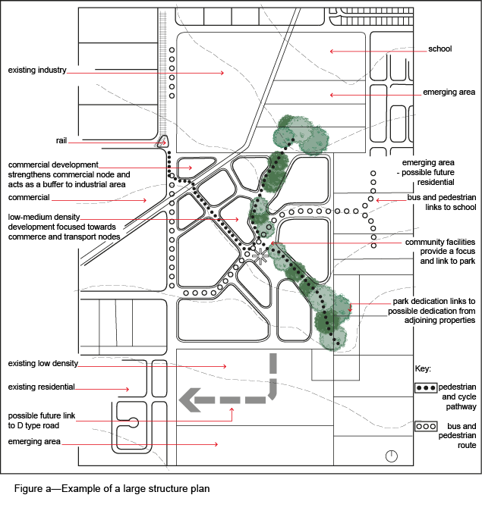
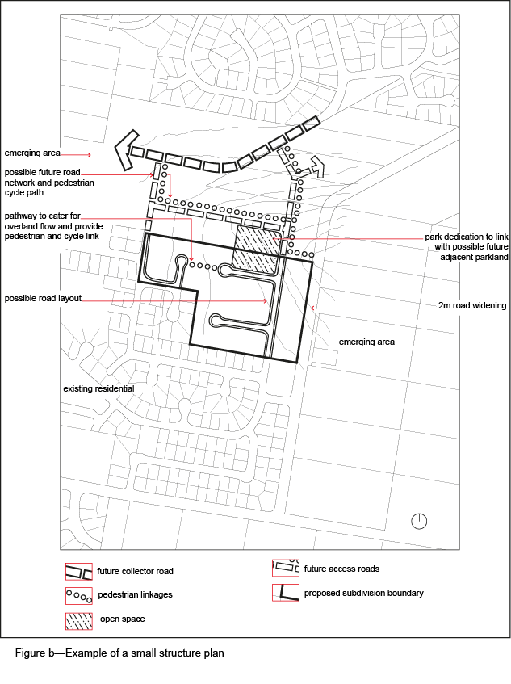
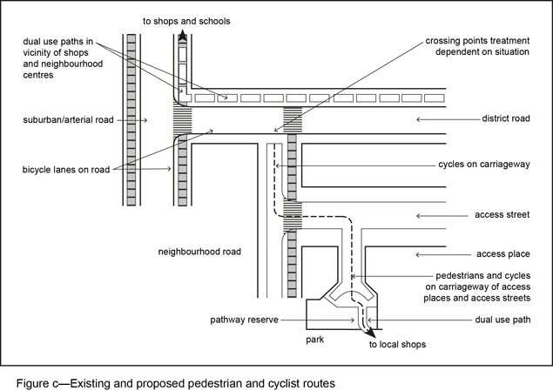

3.6 Step 5 – Level of consultation required for a structure plan
The preparation of a structure plan will entail the level of consultation required for impact assessable development. On smaller sites, this consultation would generally suffice. However, where the site or the proposal entails complex issues, or involves a large site with multiple precincts and land uses, and/or the structure plan is inadequately detailed to facilitate informed public submissions, Council may require additional material and community consultation as part of an information request. Refer to the Consultation planning scheme policy for guidance on community consultation procedures.

