SC6.31 Transport, access, parking and servicing planning scheme policy

Contents
1 Introduction
1.1 Relationship to planning scheme
1.2 Relationship to planning scheme policies and other documents
1.3 Terminology

2 Transport impact assessment
2.1 Guideline for a transport impact assessment report
2.2 Purpose and content of transport impact assessment report

3 Design service vehicle standards
3.1 Design service vehicle selection
3.2 Selection requirements for the type of service vehicle required
3.2.1 Occasional access for service vehicle – Table 1 Column 2
3.2.2 Major road access for service vehicles – Table 1 Column 3
3.2.3 Minor road access for service vehicles – Table 1 Column 4
3.3 Standard number of service bays required
3.3.1 Office
3.3.2 Shopping centre
3.3.3 Short-term accommodation where accommodation hotel or motel

4 Site access design standards
4.1 General
4.2 Location
4.3 Access driveway grades
4.4 External considerations
4.5 Sight distance
4.6 Driveway type
4.6.1 General
4.6.2 Standard driveway selection
4.6.3 Driveways for use by cars only
4.6.4 Driveways for service vehicles
4.7 Surface finish to access driveways
4.8 Provision for queues
4.9 Standards for traffic signs and lines
4.10 Special standards in the City core and City frame
4.11 Special standards for centres
4.12 Rear lot internal access
4.12.1 Residential areas
4.12.2 Non-residential areas

5 Service area design standards
5.1 General
5.2 Location
5.3 Service aisles
5.4 Service areas
5.5 Service bays
5.6 Fuel deliveries
5.7 Standard provisions for queues
5.8 Sight distance
5.9 Gradients
5.10 Height clearance
5.11 Provision for construction

6 Car parking space standards

7 On-site car parking design standards
7.1 General
7.2 Design principles
7.2.1 Mandatory design standards
7.2.2 Desirable design standards
7.3 Location of car parking areas
7.4 Circulation standards within car parking areas
7.4.1 General
7.4.2 Circulation roads
7.4.3 Circulation aisles standards for non-service vehicles
7.4.4 Parking aisle standards
7.4.5 Terminated aisle standards
7.4.6 Turning movement in parking aisle standards
7.4.7 Standards for service vehicle use of aisles
7.4.8 Standard queuing area treatment
7.5 Standard sight distances
7.6 Standard gradients
7.7 Standard height clearance
7.7.1 General standards
7.7.2 Height clearance for disabled user spaces
7.8 Standard car parking space dimensions
7.8.1 Widths of standard parking spaces
7.8.2 Standard length of parking spaces
7.8.3 Fully enclosed garages
7.8.4 Clearance around parking spaces
7.9 Standard provisions for vehicle occupants with a disability
7.10 Standard car park layouts

8 Standard design vehicles and vehicle turning templates
8.1 Design vehicles
8.1.1 Cars
8.1.2 Service vehicles
8.2 Standard vehicle turning templates
8.2.1 Cars
8.2.2 Service vehicles

9 Heavy vehicle standards

10 Pedestrian facilities

11 Cyclist facilities

1 Introduction

1.1 Relationship to planning scheme
This planning scheme policy:
- provides information the Council may request for a development application;
- provides guidance or advice about satisfying an assessment benchmark which identifies this planning scheme policy as providing that guidance or advice;
- states a standard for the assessment benchmarks identified in the following table.
Column 1 –  Section or table in the code | Column 2 –  Assessment benchmark reference | Column 3 –  Standard in the planning scheme policy
Part 8
Active frontages overlay code
Table 8.2.1.3 | PO5 | Section 5; Section 6; Section 7
Commercial character building (activities) overlay code
Table 8.2.7.3 | PO12 note | Section 5; Section 6; Section 7
Table 8.2.7.3 | AO12 | Section 5; Section 6; Section 7
Part 9.3
Centre or mixed use code
Table 9.3.3.3.A | AO21.2 | Section 3; Section 4
Table 9.3.3.3.A | AO39.5 note | Section 6; Section 7
Community facilities code
Table 9.3.5.3.A | AO6 | Section 6; Section 7
Table 9.3.5.3.A | AO7 | Section 6; Section 7
Table 9.3.5.3.A | AO8 | Section 11
Table 9.3.5.3.A | PO18 note | Section 6
Industry code
Table 9.3.12.3.A | AO5 | Section 6
Table 9.3.12.3.A | AO6 | Section 6; Section 7
Table 9.3.12.3.A | AO17 | All
Multiple dwelling code
Table 9.3.14.3.D | Car parking | Section 6; Section 7
Park code
Table 9.3.16.3.A | AO8 | Section 6; Section 7
Rooming accommodation
Table 9.3.19.3 | AO12 | Section 6
Table 9.3.19.3 | AO13 | Section 6
Specialised centre code
Table 9.3.25.3.A | AO8 | Section 6
Table 9.3.25.3.A | AO9 | Section 6; Section 7
Table 9.3.25.3.A | PO27 note | Section 4
Table 9.3.25.3.A | PO28 note | Section 7
Part 9.4
Operational work code
Table 9.4.6.3 | PO1 | All
Subdivision code
Table 9.4.10.3.A | AO3.2 | Section 4
Table 9.4.10.3.A | AO4.1 | All
Table 9.4.10.3.A | AO7.1 | Section 4
Table 9.4.10.3.A | PO10 note | Section 2
Table 9.4.10.3.A | AO10.1 | Section 2
Table 9.4.10.3.A | AO10.3 | Section 4
Table 9.4.10.3.A | AO11.2 | Section 3; Section 4
Table 9.4.10.3.A | AO12.1 | Section 11
Table 9.4.10.3.A | AO17 | Section 4
Table 9.4.10.3.A | AO19 | Section 4
Table 9.4.10.3.A | AO39.2 | Section 4
Transport, access, parking and servicing code
Table 9.4.11.3 | PO1 | All
Table 9.4.11.3 | AO1 | All
Table 9.4.11.3 | AO3.1 | Section 4
Table 9.4.11.3 | AO4.2 | Section 10; Section 11
Table 9.4.11.3 | AO5.1 | Section 11
Table 9.4.11.3 | AO5.2 | Section 11
Table 9.4.11.3 | AO5.5 | Section 11
Table 9.4.11.3 | AO6 | Section 10; Section 11
Table 9.4.11.3 | AO7 | Section 4; Section 7; Section 10; Section 11
Table 9.4.11.3 | AO9.3 | Section 4
Table 9.4.11.3 | AO9.4 | Section 4
Table 9.4.11.3 | PO10 | Section 4
Table 9.4.11.3 | AO11.1 | Section 4
Table 9.4.11.3 | AO11.2 | Section 4
Table 9.4.11.3 | AO12 | Section 6
Table 9.4.11.3 | AO13 | Section 6; Section 7
Table 9.4.11.3 | PO14 note | Section 2; Section 6; Section 7
Table 9.4.11.3 | AO15 | All
Table 9.4.11.3 | AO18 | Section 3
Table 9.4.11.3 | AO19.1 | Section 5
Table 9.4.11.3 | AO19.2 | Section 5
Table 9.4.11.3 | AO19.3 | Section 5
Table 9.4.11.3 | AO20 | Section 9
Table 9.4.11.3 | AO21.1 | Section 9

1.2 Relationship to planning scheme policies and other documents
- The standards in this planning scheme policy supersede all other design standards provided for in a planning scheme policy.
- Where this planning scheme policy is silent, alternative reference sources should be sought in order:
- Austroads Guide to Traffic Engineering Practice;
- DTMR Road Planning and Design Manual;
- AS/NZS 2890 (Set):2009 (use of AS/NZS 2890.1 is only acceptable where called up in this planning scheme policy).
- This planning scheme policy relates to matters dealing with transport, access, parking and servicing. Where figures indicate other elements, these elements are only for context and do not override other applicable provision applicable in the planning scheme or planning scheme policies.

1.3 Terminology
In this planning scheme policy, unless the context or subject matter otherwise indicates or requires, a term has the following meaning:
access driveway: a vehicular access to a site, across a verge between the edge of the road and the property boundary – refer to Figure a

active transport: transport via modes that are clean, green and sustainable, incorporating walking, cycling and wheeled recreational devices

circulation aisle: an aisle performing the dual function of providing access to car parking spaces and providing access to other aisles – refer to Figure a

circulation road: circulation roads which connect entry and exit driveways with circulation and parking aisles and do not provide direct access to parking spaces; they also can provide for traffic circulating between car parking areas – refer to Figure a

design peak parking demands: the greater of the peak-parking demand generated in an annual average week or the 30th highest hourly demand in the year within the Brisbane area and with similar characteristics to the site and similar scales of density

design vehicle: the vehicle type for which development is to make on-site provision as described in this planning scheme policy

driveway: see access driveway

frontage road: a road fronting a development from which an access driveway is gained; developments may have more than one frontage road

high traffic-generating potential: 200vph or more turnover for the total of the existing and proposed development

loading dock: a service area dedicated for loading and unloading of service vehicles

manoeuvring area: a part of a service area adjacent to service bays required by service vehicles to manoeuvre into the bays or to a position beside a loading dock – refer to Figure a

major development: development (total existing and proposed) with a total peak hour vehicle generation rate greater than 25vph

major public transport interchange: a railway station, bus station, ferry terminal or interchange which includes dedicated platforms, docks, bus parking bays, seating and ticketing facilities

occasional access: access by a design vehicle on an infrequent basis, being no more than 1 visit per week

parking aisle: an aisle used by cars to gain access to a parking space – refer to Figure a

queuing area: an area of roadway within the site free from parking and servicing spaces that is available for the storage of vehicles in a queue between the driveway and the first point of conflict; a queuing area ensures that entry vehicles do not queue in the street and exiting vehicles do not conflict with traffic control points in the parking area – refer to Figure a

regular access: access by a design vehicle on a regular or frequent basis, being more than once per week

service aisle: a portion of the roadway within a site that is between the access driveway and the service area; service aisles may form part of the internal circulating road system – refer to Figure a

service area: an area within the site allocated for the manoeuvring, standing, loading or unloading of service vehicles – refer to Figure a

service bay: a parking bay for service vehicles engaged in loading or unloading – refer to Figure a

service vehicle: a vehicle used to supply or remove goods or services to or from a development or used by a tradesperson

sight distance: the distance over which visibility occurs between a driver and an object or between two drivers, at specified heights above the ground

sightline: a straight line of clear view between two objects over which sight distance is measured

transport network: the network including minor and major roads, pedestrian and cycle paths and public transport routes and facilities

veloway: a wide, high-speed commuter bicycle pathway along a major corridor

2 Transport impact assessment

2.1 Guideline for a transport impact assessment report
- A development capable of having a significant adverse impact on the external transport system or the adjacent community, including land uses with high trip-end densities should be accompanied by a report addressing the transport impacts of the development which is prepared by an experienced traffic engineer who is a Registered Professional Engineer Queensland.
- Uses with high trip-end densities include, but are not limited to:
- backpacker hostels (defined as short term-accommodation);
- office buildings and office parks;
- transit centres;
- educational establishments;
- hospitals;
- hotels/motels;
- major indoor and outdoor sport and recreation facilities;
- higher density residential development;
- transit oriented development;
- places of worship;
- industrial developments;
- restaurants;
- retirement villages;
- shopping centres;
- convention centres.
- A transport impact assessment report is required if reconfiguring a lot where:
- the site is more than 1ha in the Emerging communities zone; or
- the site is more than 7,000m2 in the Low density residential zone; or
- the number of lots is 20 or more.

2.2 Purpose and content of transport impact assessment report
- The primary objective of the transport impact assessment report is to demonstrate compliance with all relevant codes.
- A transport impact assessment report includes the following information for the site and the adjacent transport network (streets and intersections) within the sphere of impact of the development:
- An assessment of present traffic operations and safety without the development.
- An assessment of traffic operations and safety for the following scenarios:
- at completion of the development, and if the development is staged, also at each significant stage prior, including a comparison between current traffic arrangements and proposed traffic arrangements and an outline of the works proposed to offset anticipated traffic impacts;
- without the development on a 10 year planning horizon from completion of the development;
- with the proposed and any additional upgrading works proposed in conjunction with the development on a 10 year planning horizon from completion of the project.
Note—Council should be consulted regarding the expected traffic growth rates for assessing the future scenarios.
- A statement describing how the development will provide for safe and convenient movement to, from and within the site.
- A statement describing how the development will facilitate walking and cycling and greater use of public transport in preference to using private motor vehicles for trips to and from the development.
- A statement describing how public transport services and infrastructure will be improved as a result of the development, particularly where relating to indented bus bays and bus shelters.
- A statement describing the measures used to ensure maximum accessibility from the site to public transport, including where future public transport services are envisaged.
- A statement describing the measures used to ensure that through traffic is not introduced into local street systems.
- An assessment of existing parking supply and demand in the vicinity of the development for both on- and off-street parking, and an assessment of the impact of the development on this parking supply and demand.
- A statement describing the appropriate provision for parking in the development based on land use and the potential for trip-making by public transport, or by walking and cycling.
- A statement describing the appropriate provision for on-site bicycle parking facilities.
- A statement describing whether the proposed means of ingress to or egress from the development are adequate and located appropriately according to the road hierarchy.
- An assessment of the provisions made for the loading, unloading, manoeuvring and parking of service vehicles within the development and on the subject site.
- An assessment of refuse storage area/s and demonstration of safe vehicle access for the removal of refuse.
- An assessment of the proposed routes within the development used by service vehicles associated with the development, and the impacts of heavy vehicle movements on these routes.
- An assessment of the potential for integration of access with adjacent development through sharing of common ingress and egress arrangements.
- An assessment of the impacts on public transport, traffic operations and parking as a result of any temporary works required during construction.
- A record of any comments made by the Department of Transport and Main Roads, Translink or any other State planning authority that comply with the rights and powers of these agencies.
- An assessment of the existing and likely future amenity of the surrounding area, and of the potential impacts of the development on that amenity.
- A statement describing all of the assumptions made in the preparation of the report and the design parameters adopted in the technical analysis.
- A statement describing how traffic generation and parking proposed rates (based on gross floor area) are supported by reference to publicly available documents or attaching actual traffic survey data for a similar activity.
- A statement describing how the layout of the development provides for the safe movement of pedestrians and cyclists within the development and to/from the core of the development and the frontage streets, taking into account the location of public transport and pedestrian facilities.
- An assessment of the operation of any security boom gate or card reader and its impact on vehicle queuing on the frontage roads.
- An assessment of traffic signals operation based on existing signal phasing, including impact on adjacent intersections.
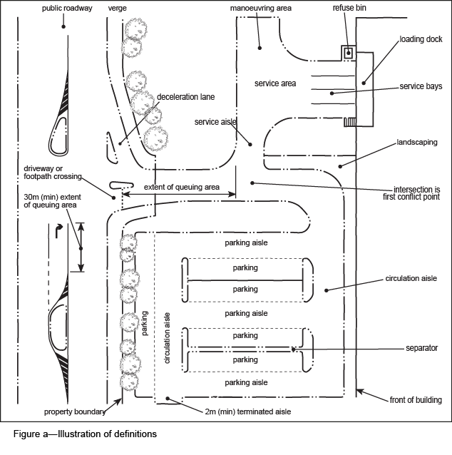

3 Design service vehicle standards

3.1 Design service vehicle selection
- Internal parking bays and road layouts are designed to accommodate the largest service vehicle likely to regularly access the site.
- The standard design service vehicle types are nominated in Table 1 (columns 2, 3 and 4) for each development type.
- The design service vehicle nominated in Column 2 is used for access driveway design, and design of an adequate on-site standing area as described in section 3.2.
- The design service vehicle nominated in columns 3 and 4 is used for design of on-site servicing facilities as described in section 3.2.
- Provision for a service vehicle may be varied from that specified in Table 1, for a development involving multiple uses or activities or for the unique characteristics of a purpose built development.
- Section 7 describes the standards for the design service vehicle types and turning templates to which reference is made in this planning scheme policy.

3.2 Selection requirements for the type of service vehicle required

3.2.1 Occasional access for service vehicle – Table 1 Column 2
- Site access is provided for vehicles that occasionally service a site as part of its normal operation. Examples of this type of servicing are an LRV furniture removal truck at a multi-unit dwelling or an office development. Servicing from this type of vehicle may occur outside of normal operating hours of the facility.
- Provision for servicing by the vehicle type nominated in Column 2 of Table 1 is to ensure that:
- the vehicle can stand wholly contained within the site (clear of the verge);
- occasional reverse manoeuvres by the vehicle are limited to one only, either to or from the site if safe operation can be demonstrated;
- the swept path of the vehicle does not have a greater overall width than the access driveway.

3.2.2 Major road access for service vehicles – Table 1 Column 3
If site access is via a major road, including access via a minor road adjacent to an intersection with a major road, provision is made for servicing by the design vehicle nominated in Column 3 of Table 1 to ensure that:
- the vehicle can enter and leave the site safely in a forward direction. The only exception to this is a refuse collection vehicle servicing a multiple dwelling development on roads other than arterial roads;
- the vehicle can traverse the site on circulation roads and aisles to access service areas;
- the vehicle can manoeuvre on site to allow parking and loading or unloading in a designated service area or bay;
- the Column 2 design vehicle can stand wholly within the site without occupying any designated queue areas or blocking access to more than 50% of car parking spaces;
- the swept path of the Column 2 design service vehicle may cover the overall width of a two-way undivided driveway.

3.2.3 Minor road access for service vehicles – Table 1 Column 4
If site access is via a minor road, on-site manoeuvring and full loading bay provision for the largest design service vehicle is not essential. Therefore, the design service vehicle nominated in Column 4 of Table 1 is used for the design of on-site servicing provisions, in accordance with section 3.2.2, subject to the following:
- the Column 2 design service vehicle can stand wholly contained within the site without occupying any designated queue areas, or blocking access to more than 50% of car parking spaces;
- any on-street manoeuvring by the Column 2 design service vehicle can be limited to safe reversing onto the site in one movement only;
- the swept path of the Column 2 design service vehicle may cover the overall width of a two-way undivided driveway.

Table 1—Development type – Minimum standard design service vehicle
Column 1 – Development type | Design vehicle (Refer Table 20)
 | Column 2 –Access design (occasional access) | Column 3 – Internal design (regular access) – major road | Column 4 – Internal design (regular access) – minor road
Adult store | VAN | VAN | VAN
Agricultural supplies store | LRV | LRV | LRV
Animal keeping where stables | LRV | LRV | LRV
Animal keeping in all other cases | VAN | VAN | VAN
Bar | RCV | RCV | RCV
Brothel | VAN | VAN | VAN
Bulk landscape supplies | AV | MRV | MRV
Car wash | MRV | SRV | SRV
Cemetery | RCV | RCV | RCV
Childcare centre | VAN | VAN | VAN
Club where licensed and equal to or greater than 1,500m2 | AV | RCV | RCV
Club in all other cases | VAN | VAN | VAN
Community care centre | RCV | RCV | RCV
Community residence | VAN | VAN | VAN
Community use | AV | RCV | RCV
Crematorium | RCV | RCV | RCV
Educational establishment where college, university or technical institute | AV | RCV | RCV
Educational establishment in all other cases | COACH | RCV | RCV
Extractive industry | AV | AV | AV
Food and drink outlet | RCV | Refer to Table 3 | Refer to Table 3
Function facility | AV | RCV | RCV
Funeral parlour | RCV | RCV | RCV
Garden centre | AV | AV | AV
Hardware and trade supplies | AV | AV | AV
Health care service | SRV | VAN | VAN
High impact industry | AV | AV | AV
Hospital | AV | RCV | RCV
Hotel | AV | LRV | LRV
Indoor sport and recreation | RCV | RCV | RCV
Low impact industry | AV | AV | AV
Major sport, recreation and entertainment facility | AV | AV | AV
Marine industry | AV | AV | AV
Market | SRV | SRV | SRV
Medium impact industry | AV | AV | AV
Motor sport facility | AV | AV | AV
Multiple dwelling | LRV | RCV | RCV
Nightclub entertainment facility | RCV | RCV | RCV
Office | RCV | Refer to Table 2 | Refer to Table 2
Outdoor sales | AV | AV | AV
Outdoor sport and recreation | RCV | RCV | RCV
Park where in a District zone precinct or where a district park, and where in a Metropolitan zone precinct or where a metropolitan park | COACH | RCV | RCV
Parking station | MRV | SRV | SRV
Place of worship | AV | LRV | LRV
Port service where marina | AV | AV | AV
Port service where ferry terminal | AV | COACH | COACH
Relocatable home park | AV | LRV | LRV
Residential care facility | LRV | LRV | LRV
Retirement facility | LRV | LRV | LRV
Rooming accommodation | RCV | VAN | VAN
Service industry | SRV | Refer to Table 3 | Refer to Table 3
Service station | AV | AV | AV
Shop where liquor store, department store or supermarket | AV | Refer to Table 3 | Refer to Table 3
Shop where discount department store or discount variety stores | LRV
Shop in all other cases | VAN
Shopping centre | AV | Refer to Table 3 | Refer to Table 3
Short-term accommodation where motel | RCV | Refer to Table 4 | Refer to Table 4
Short-term accommodation where accommodation hotel | AV
Short-term accommodation in all other circumstances | SRV | SRV | SRV
Showroom | AV | AV | AV
Special industry | AV | AV | AV
Theatre where concert hall or dance hall | AV | RCV | RCV
Theatre where film studio | AV | LRV | LRV
Theatre in all other circumstances | AV | VAN | VAN
Tourist attraction | COACH | COACH | COACH
Tourist park | COACH | LRV | LRV
Transport depot | AV | AV | AV
Utility installation | LRV | LRV | LRV
Veterinary service | MRV | VAN | VAN
Warehouse where self storage | RCV | RCV | RCV
Warehouse in other circumstances | AV | AV | AV
Wholesale nursery | AV | AV | AV
Note—All large residential developments involving more than 10 units should provide separate service bays or areas.
Note—Areas provided for manoeuvring may include areas nominated as car parking spaces provided it can reasonably be expected that car parking spaces will not be in use at the time of the service vehicle visit. Exceptions to design vehicle requirements may be considered if accompanied with a sound performance-based solution.
Note—Where a use or activity is not described in the above table, requirements are discussed with Council.

3.3 Standard number of service bays required
- The minimum number of on-site service bays provided for office, shop, food and drink outlet and short-term accommodation is shown in Table 2, Table 3 and Table 4.
- A minimum of 1 service bay is provided for the vehicle in columns 3 or 4 for regular access and for the road type in Table 1 for any other use.
- The total number of bays for multi-use developments is determined by the addition of the standard number of bays for the individual development components.
- Large multi-use developments with centralised service vehicle areas may require fewer service bays than the sum of the individual component requirements.
- If fewer service vehicles are proposed, satisfactory operation of the service area is to be demonstrated and supported by a Registered Professional Engineer Queensland.

3.3.1 Office
- Most service vehicles accessing office developments are vans. Provision for vans is positioned near main building entrances and can be in the form of a short-stay layby area. A bay provided for a van is clearly visible from an access driveway or a frontage road and outside a secured area.
- A drop-off and pick-up area is located in the site near to a building entrance. A suitable taxi area is provided in the form of a short-stay layby area. Layby taxi parking spaces are included in the visitor parking calculation.
- If the development incorporates emergency power generating facilities, provision for a LRV fuel delivery vehicle is required.
- Developments exceeding a gross floor area of 1,000m2 provide for access and on-site standing of an LRV such as a furniture removal van. A dedicated service bay is not required for this vehicle.

Table 2—Service bays required for office
Gross floor area (m2) | Service bays required
 | VAN | SRV | MRV | LRV
0–999 | - | 1 | - | -
1,000–2,4999 | 1 | - | 1 | -
2,500–3,999 | 2 | 1 | 1 | -
4,000–5,999 | 3 | 1 | 1 | -
6,000–7,999 | 4 | 1 | 1 | -
8,000–9,999 | 4 | 2 | 1 | -
10,000–14,999 | 4 | 2 | 1 | -
15,000–19,999 | 5 | 2 | 1 | -
20,000–34,999 | 5 | 2 | 2 | -
35,000–49,999 | 5 | 2 | 2 | 1
50,000–64,999 | 6 | 2 | 2 | 1
65,000 and over | 6 | 2 | 3 | 1

3.3.2 Shopping centre
- The following requirements apply to shopping centres:
- Table 3 applies for each individual shop segment comprising the development if each segment is separately serviced, other than via a mall and has a gross floor area more than 200m2.
- The service bays for each segment where practical, are located immediately adjacent to that segment.
- Specialty shops in a shopping centre with a gross floor area less than 200m2 will be grouped together and the gross floor area summed. This total area is treated as a single shop segment for the purposes of applying Table 3 to the extent that such groupings share a common service facility. For this purpose, MRV class vehicles will be provided for in lieu of LRV and AV class vehicles.
- For a shopping centre in the City centre zone precinct of the Principal centre, LRV class vehicle can be substituted for an AV class vehicle as a design vehicle.

Table 3—Service bays required for shop, food and drink outlet or service industry
Gross floor area (m2) | Service bays required
 | VAN | SRV | MRV | LRV | AV
0–199 | - | 1 | - | - | -
200–599 | 1 | - | 1 | - | -
600–999 | 1 | 1 | 1 | - | -
1,000–1,499 | 2 | 1 | 1 | - | -
1,500–1,999 | 2 | 2 | 1 | - | -
2,000–2,799 | 2 | 2 | 2 | - | -
2,800–3,599 | 2 | 2 | 2 | 1 | -
3,600–4,399 | 3 | 2 | 2 | 1 | 1
4,400–6,499 | 3 | 2 | 2 | 1 | 1
6,500–8,499 | 4 | 2 | 2 | 1 | 1
8,500–11,499 | 4 | 3 | 2 | 1 | 1
11,500–14,749 | 5 | 3 | 3 | 1 | 1
14,750–17,999 | 5 | 3 | 3 | 1 | 1
18,000–20,999 | 6 | 3 | 3 | 1 | 1
21,000–23,999 | 6 | 3 | 3 | 2 | 1
24,000–26,999 | 6 | 3 | 3 | 2 | 2
27,000–29,999 | 6 | 3 | 3 | 3 | 2
30,000–32,999 | 7 | 3 | 3 | 3 | 2
33,000–35,999 | 7 | 3 | 4 | 3 | 2
36,000–38,999 | 8 | 3 | 4 | 3 | 2
39,000–41,999 | 9 | 3 | 4 | 3 | 2
42,000 and over | 10 | 3 | 4 | 3 | 2

3.3.3 Short-term accommodation where accommodation hotel or motel
The following applies to short-term accommodation if an accommodation hotel or motel:
- The following provision is made for public areas such as bar, tavern, restaurant, meeting rooms and convention rooms:
- 1 MRV per 6,000m2;
- 1 van per 1,000m2.
- A short-stay layby area is provided for tourist coaches, passenger set down, couriers (vans) and taxis near main building entrances, and is clearly visible from an access driveway or frontage road, and are outside a secured area.
- An accommodation hotel with a large public function area is to consider provision of a site area for the standing of a television relay vehicle.

Table 4—Service bays required for accommodation hotel or motel
No. of rooms | Service bays required
 | VAN | SRV | MRV | LRV
0–199 | 1 | - | 1 | -
200–399 | 1 | - | 1 | 1
400–599 | 1 | 1 | 1 | 1
600 and over | 1 | 2 | 1 | 1

4 Site access design standards

4.1 General
- The configuration of an intersection created by an access driveway satisfies the basic traffic design criteria for all intersections with regard to driver behaviour, safety of pedestrians and vehicle characteristics.
- Treatment of an access is to vary according to its scale and nature such as a minor concrete crossover to a major signalised intersection.
- The number of access driveways for a site is kept to the minimum necessary to allow satisfactory traffic operation for the site.
- One access point (entrance and exit) will be approved for any particular development, except where it can be demonstrated that safety and the traffic operation of the external road system is improved, including pedestrian and cyclist safety, by a design with more than 1 access driveway.
- An access driveway functions to provide access to car parking areas and servicing areas and is located and designed to optimise public safety and convenience.
- A service vehicle is not permitted to manoeuvre within a circulating aisle and is not to create a conflict with other internal traffic. Separating car and service vehicle access may be appropriate, particularly when the volume of service vehicles is significant.
- Development is designed and constructed with all internal traffic circulation on the site. The public road system is not to be used for movements between car parking or servicing areas.
- Development with access from a signalised intersection or roundabout is to dedicate land on the intersection approach for public road to ensure lawful priority of traffic movements under the Transport Operations (Road Use Management) Act 1995 . The amount of land required for road purpose is to be determined by the intersection design and confirmed by the Council.
- If a site has more than 1 road frontage, the primary access must be from the lowest order road, except where the traffic generated by the development would significantly compromise the amenity of a minor road. In some cases, ameliorative works may be required in a minor road to alleviate possible amenity impacts.

4.2 Location
- When determining the location of an access driveway, the following standard design constraints are taken into consideration:
- the characteristics of frontage road (type, traffic volumes, and vertical and horizontal geometry);
- the sight distance requirements;
- the location of intersections, median openings, other driveways, interruption to pedestrian movement on the walkway or bikeway;
- the queue and turn lane lengths at signalised and unsignalised intersections;
- the location of existing above- and below-ground services, bus stops, taxi ranks, loading zones, traffic control devices and significant trees;
- pedestrian and cyclist requirements;
- other Council planning scheme policy requirements, such as landscaping;
- requirements of State transport authorities (if relevant).
- Access to a development is not permitted through bus stops, taxi ranks, pedestrian crossings, pedestrian refuges or traffic control devices.
- An access driveway and its splay is not to protrude across property boundaries, or the projection of such a boundary line to the carriageway, except where joint property access is proposed.
- An access driveway is located as far as possible from an intersection, and other driveways and median openings, except if in a restricted area where it can be demonstrated that safety and operational performance of the transport system are not compromised.
- The minimum distance of an access driveway from an intersection or other feature is specified in Table 5, and is measured from the point at which the frontage property boundaries intersect, disregarding any existing or proposed truncations.

Table 5—Standard driveway location
Type of frontage road for access | Adjacent feature | Minimum separation of minor driveway from adjacent feature
Minor | minor road intersection | 10m from the property boundary of an intersecting road
 | major road intersection | 20m from the property boundary of an intersecting road
 | Median break | 10m from the median nose
 | Adjacent driveway | 3m along the kerb to the edge of driveway
 | Traffic signals | Clear of the queue areas and turning lanes
Major | minor road intersection | 20m from the property boundary of the intersecting road
 | major road intersection | 30m from the property boundary of the intersecting road
 | Median break | 15m from the median nose
 | Adjacent driveway | 15m along the kerb
 | Traffic signals | Clear of the queue areas and turning lanes

4.3 Access driveway grades
The grades of access driveways are to comply with the grades shown on BSD-2021, BSD-2024, BSD-2025 and BSD-2026.

4.4 External considerations
- If access can satisfactorily be provided from a minor road, access is not provided from a major road.
- Access from a major road, where permitted, is restricted to left-in/left-out traffic movements by the construction of a central median which ensures right turns in/out of the site are not possible.
- If all road frontages are of equal classification then the Council is to be consulted in respect of an approved access location option.
- Road widening and resultant land dedication may be necessary for the introduction of a median, deceleration lane, left turn lane or right turn lane for access to a development.
- Median breaks are not provided on major roads to provide ingress to or egress from development sites, unless it is demonstrated that the operation of the road network would not be compromised.
- If it is demonstrated that the operation of the road network would not be compromised by a median break, single median breaks may be used to provide access to more than one contiguous development, by positioning the break opposite a driveway on a common boundary, or via internal access easements.
- If a median break is provided, it is accompanied by an indented right turn lane long enough to accommodate the design 95th percentile queue based on the 10 year design horizon from the opening date.
- A median break is to be considered for a major development where:
- The entrance/exit is such that it can function as a public street with respect to priority controls. Land dedication as road will often be necessary to achieve this.
- The spacing of the major intersections demonstrates safe current and future operations and does not prejudice plans for future major traffic control.
- The disruption to through traffic would be greater without the median break than if no break was provided.
- It can be demonstrated that shared access serving adjoining premises can be provided.
- If a major road does not have a central median, and it is appropriate to permit right turn access, it will be necessary to provide turn lane treatments for both left and right turns into the site, which may require road widening and land dedication. A transport impact assessment and traffic analysis will be required to determine the length of turning lanes. For left or right turn lanes, a minimum length of 60m, consisting of a 30m lane and 30m taper is expected. Refer to BSD-3003.
Note—Notwithstanding any development approval, the Council always maintains the right to construct central medians or close any median break, if it is considered necessary to improve traffic operating conditions on a public road at any time in the future.

4.5 Sight distance
- Safe operation of traffic systems depends critically on adequate visibility (sight distances).
- If a driveway at a major development is configured as an intersection, it is to have sight distances which comply with the requirements of the Safe Intersection Sight Distance in Austroads Guide to Road Design Part 4.
- The minimum sight distance for a driveway is specified in Table 6, and is measured from a point 5m outside the edge of the through carriageway, as shown in Figure b, with an eye height of 1.05m and an object height of 0.60m.
- If design modification such as driveway location and design, or changes to the configuration or level of the external road can be made to allow the minimum sight distance in Table 6, no lesser standard will be considered satisfactory.
- If design modifications cannot provide the sight distances set out in Table 6, lesser sight distances may be considered by the Council, particularly in circumstances of low traffic volumes and familiar users with low potential for distractions, where it can be demonstrated that public safety would not be unreasonably compromised.
- Absolute minimum sight distance standards are specified in Table 7 (eye height of 1.05m and object height of 0.60m), and these are used only where design modification cannot provide greater sight distance.
- If driveways are in locations and situations where it cannot be reasonably assumed that vehicles will stop before attempting to cross or enter the external traffic stream, the minimum dimensions clear of the through carriageway from which sight distances are measured (3m and 4m respectively) is to be increased to 5m.
- To ensure adequate visibility between vehicles on a driveway and pedestrians on the footpath, sight splays are provided at the property boundary as shown in Figure c. This requirement is critical where an obstruction such as a fence or landscaping is likely to obstruct the movement of pedestrians on walkways or cyclists on a bikeway.

Table 6—Standard minimum sight distance for access driveways
Speed environment (kph) | Sight distance (metres)
50 | 90
60 | 110
70 | 125
80 | 145

Table 7—Absolute minimum standards for sight distance for access driveways
Access driveway | Speed environment (kph)
 | 50 | 60 | 70 | 80
Distance for driveways with design two-way peak traffic generations less than 10 per hour, on a minor road, measured from a point 3.5m out from the through carriageway | 50 | 65 | 85 | 105
Distance for driveways with design two-way peak traffic generations less than 100 per hour, measured from a point 5m out from the through carriageway | 70 | 85 | 100 | 115

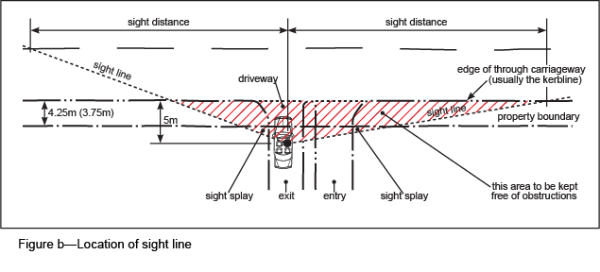
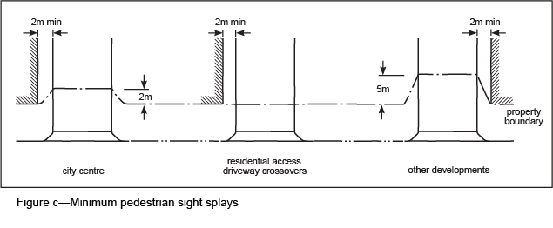

4.6 Driveway type

4.6.1 General
- The type and width of driveway appropriate for a development depends on:
- the volume of traffic generated at that driveway by the development;
- the type of road from which access is sought;
- the existing and predicted future opening day traffic volumes of the road from which access is sought;
- the number of car parking spaces served by the driveway;
- the size and type of the largest vehicle likely to use the driveway on a regular basis (service design vehicle);
- the number of service bays served by the driveway.
- Driveways are constructed in accordance with BSD-2021.
- For a State controlled road, separate design standards are required.

4.6.2 Standard driveway selection
- The driveway type is selected using the following:
- cars only, use Table 8;
- service vehicles only, use Table 9;
- service vehicles and cars, use Table 9.
- Standard driveways are shown in BSD-2021.
- Access for a development that generates significant volumes of traffic and which may cause unacceptable delays and unsafe operating conditions is designed as a channelised intersection controlled by traffic signals or a roundabout in accordance with traffic engineering design standards.

4.6.3 Driveways for use by cars only
- The appropriate driveway for cars only is selected from Table 8.
- Each driveway of a car parking area that has multiple points of access is designed on the basis of the number of spaces effectively served by that driveway. The driveway type is to then to be selected from Table 8.
- Access driveway design is shown on BSD-2021 and BSD-2022 (for a dwelling house).

Table 8—Driveway selection for cars only
Turnover rate of car parking area(1) | Type of road accessed | Type of driveway  Number of spaces in car parking area
 |  | 1–25 | 26–250 | 251–500 | over 500(2)
Low/med | Minor | B1 (3) | B2 | C1 | C3
Low/med | Major | B1 (6m) | C1 | C2 | C3
High | Minor | B1 (7m) | C1 | C2 | C3
High | Major | B1 (7m) | C2 | C3 | C3
Note 1—Low to medium parking turnover rates are likely to be generated by residential, industrial and office developments. High parking turnover rates are likely to be generated by entertainment, public transport, shop, and fast food developments.
Note 2—Car parking areas containing over 500 spaces or generating more than 1,000vpd are assessed for the need of an appropriately designed channelised access intersection, without a driveway crossover.
Note 3—On a minor road, residential (Type A pavement classification) driveways less than the 6m wide are acceptable for streetscape enhancement, provided normal manoeuvring and queuing requirements are satisfied where there are less than 6 car parking spaces, the access driveway may be a type A.

4.6.4 Driveways for service vehicles
- Driveway types for service vehicles are determined according to the turning path requirements of the relevant design vehicle nominated in Column 2 of Table 1. The appropriate driveway is to be selected from Table 9.
- The following also apply to driveway selection for service vehicles:
- if traffic is restricted to left in/left out movements, a Type 2 driveway centre island is used;
- for left turn entry or exit only driveways, the relevant half of a Type C standard driveway is used;
- if the volume of traffic generated by a development contains a substantial proportion of service vehicles and exceeds 500vpd, then a channelised access intersection may be required in place of a standard driveway in accordance with normal traffic engineering guidelines for intersections.

Table 9—Standard driveway selection for service vehicles
Type of driveway
Frontage road | Minor road | Major road | Major road
Generated traffic | N/A | <100vpd | N/A
Nominated design⁽¹⁾ | Driveway type ⁽²⁾ |  | Driveway type ⁽²⁾
VAN | A (6m) |  | C1
C&T | A (6m) |  | C1
SRV | B1 or B2 (6m) |  | C2
MRV | B2 (7m) |  | C2
LRV | B2 (7m) |  | C2
RCV | B2 (6.5m) |  | C2
COACH | B2 (9m) |  | C4
AV | B2 (9m) |  | C4
Notes—
(1) For explanation of design vehicle types, see Table 20.
(2) For explanation of driveway type refer to BSD-2021.

4.7 Surface finish to access driveways
- If pedestrians are to use part of the access driveway to travel along the verge, the surface is to have an acceptable slip and skid resistance standard in accordance with Reference Specification S150 Roadworks.
- Broom-finished concrete, segmental pavers and stencilled concrete surfaces provide a good textured finish and are preferred.
- Exposed aggregate, stamped concrete and similar surfaces are generally not permitted.
- Asphalt surfacing is not permitted except in non-urban areas.

4.8 Provision for queues
- An entry and exit driveway provides for queues of vehicles so that queues do not disrupt traffic operations on a frontage road.
- Queue provisions are measured inside the frontage property boundary of the subject development.
- No reversing of vehicles, particularly service vehicles, is to occur in an area of high pedestrian activity or in an area where the drivers of service vehicles are not able to see approaching or following vehicles.
- No internal intersections or parking manoeuvres are provided for in the defined queue area.
- Entry queues are of primary importance as they have the greatest impact on traffic on the external transport network.
- An exit queue can disrupt internal circulating traffic and consequently block entry lanes.
- Design does not provide for any service vehicle manoeuvring or an intersection of an internal road to occur within the defined queuing area.
- The extent of the design queuing area is a function of a number of factors including:
- the size of the car parking area and the design turnover rates;
- the type and capacity of any access control facility;
- the classification of the frontage road;
- the design of the car parking area beyond the queuing area.
- If there is an entrance control, the boom gate or card reader is to be set back within the site to prevent queuing on to the road. The vehicle queue length is to be a function of the vehicle arrival rate and service rate of the boom gate/card reader.
- Traffic control devices such as raised platforms and speed humps are not installed at the entrance to a development or within the queuing length specified in section 7.4.8.
- The queue requirements shown in Table 10 are used as a guide for driveways without control devices such as boom gates, card readers, roller shutters or pay facilities.
- The minimum standard queue provision for any car parking area is 1 vehicle and a vehicle is assumed to be 6m in length.
- If more than one access is approved to a site, the required queuing distance is distributed among the various accesses according to the expected traffic distribution characteristics of the site.
- The queuing area in car parks using attendant parking that is an accommodation hotel, is at least twice the length of control as that given in Table 10.
- In instances where gates, security gates and security checks are provided at the entrance to a development, the required queuing length is provided between the property boundary and the gate system.
- In addition to the queuing area, sufficient space to enable a car to manoeuvre to turn around and enter the road system in a forward gear is provided in front of any security gates.
- Treatment standards for queuing areas are provided in section 7.4.8.

Table 10—Minimum standard queuing provisions
Car parking area capacity (spaces) | Number of vehicles in entry/exit queue
1–25 | 1
26–50 | 2
51–75 | 3
76–100 | 4
101–150 | 5
151–200 | 6
201–250 | 7
Over 250 | 7 plus 1% of capacity over 250 spaces (rounded upwards)
Takeaway facility/fast food | 10
Drive-in bottle shop | 12

4.9 Standards for traffic signs and lines
- Direction, regulatory, warning and information signs are erected on site to control traffic movements and driver behaviour and to warn of any potential safety hazards.
- Council’s BSD drawings are used to design all traffic signs and pavement markings, whether in a public roadway or on private property.
- For traffic signs and pavement markings not contained in Council’s BSD drawings, using the Queensland Department of Transport and Main Roads Manual of Uniform Traffic Control Devices is recommended.
- If parking spaces have been specially provided for a designated vehicle class or category of user, they are clearly signed to indicate the specific vehicle class or user such as visitor parking, parking for disabled persons, taxis, service area, motorcycles or bicycles. Standard symbolic messages are preferred.
- Advisory parking directional signs are provided to clearly indicate the existence and location of entry and exit points to car parking areas where:
- parking areas are located at the rear of a development;
- access to the car parking area is not from the main frontage road;
- multiple access points serve different car parking areas;
- visitor parking is provided for multi-unit residential developments and is not visible from the frontage road or access driveway;
- ingress or egress is via one-way driveways.

4.10 Special standards in the City core and City frame
- In the City core and City frame, intense office activities call for differing design criteria from those normally required for a suburban development. These environments are typified by the following conditions:
- high pedestrian volumes;
- high use of kerbside space, such as bus stops, taxi ranks, parking and loading zones;
- high level of intersection signalisation, typically at most intersections;
- platooned traffic flows or queue-back from signals;
- higher level of driver alertness;
- lower vehicle speeds.
- Normal design criteria for site access may not be relevant to these conditions and appropriate design standards may reflect the lower vehicle speeds and greater driver alertness.
- Access driveways are not provided within 30m of any signalised intersection and are located in consultation with the Council.
- Shared access arrangements or the amalgamation of smaller lots is preferred to provide acceptable access for new developments and minimal conflicts with pedestrians and cyclists.
- An access for development addresses the vehicle and pedestrian conflict movements and attempts to minimise conflicts and improve safety and priority for pedestrians and cyclists.
- The design of vehicle crossings may consider the grade separation of the driveway to resolve the pedestrian, cyclists and vehicle conflicts.
- A driveway across a walkway or bikeway carrying more than 300 pedestrians or cyclists during the busiest hour of a normal weekday is only provided if it can be satisfactorily demonstrated that pedestrian and cyclist priority and safety will not be threatened.
- The sight distance for an access driveway is in accordance with Figure b and Figure c measured from a point 3m from the edge of the through carriageway.
- Control facilities for car parking areas, such as card readers and ticket machines and associated queuing requirements, must be considered early in the design of the car parking areas, as they are difficult to incorporate once the car parking area is constructed.

4.11 Special standards for centres
- Centres are located throughout Brisbane. A centre may function as a shopping centre, a commercial centre, or a combination of both and other activities. Many centres also include residential development. Centres are typified by the following conditions:
- high pedestrian volumes within the centre and along the external road network;
- external road kerbside space is not generally available for centre car parking or service vehicles;
- multiple accesses are required to accommodate increased traffic volumes;
- development accesses are treated as significant intersections typically requiring dedicated turn lanes and traffic signals based on traffic engineering analysis and design;
- internal traffic speeds are low but congestion levels are high, necessitating elevated driver alertness;
- external traffic speeds are not to compromise the integrity of the road network;
- a centre is to have a high level of bus public transport accessibility provided by on-street bus stops, an on-site or adjacent interchange or a combination of both;
- if a public transport (bus, rail or ferry) interchange is in close proximity to a centre, strong pedestrian and cycling linkages are to be provided;
- kerbside bus stops on a major road are to be indented;
- typically taxi ranks are required on site and near to all major building access points;
- end-of-trip cyclist facilities are provided for staff and convenient cyclist parking is provided for visitors.
- Driveways are separated from adjacent intersections as far as possible, taking into account the length of queues from adjacent intersections.
- A single access point is to be provided for both visitor and service vehicles.
- Separate access points for visitor and service vehicles may be considered if the volume of service vehicles is significant and it can be demonstrated that more than 1 access is required.
- If there is no separate service access, the service area is not located adjacent to the entry point or in a location where manoeuvring will interfere with traffic movements on and off the site.
- Service vehicles, particularly for reversing movements, do not use an internal circulating aisle for visitor or customer vehicles.
- Internal parking areas minimise conflicts with pedestrian and cyclist movements and prioritise pedestrian movements.

4.12 Rear lot internal access

4.12.1 Residential areas
- A rear lot access way for residential development excluding the access driveway on the verge, is to comply with the requirements of Table 11.
- The specified pavement standard does not apply to poor subgrade where the soaked California bearing ratio value is less than 5.
- Alternative asphalt pavement may be suitable in a non-urban area under one or more of the following circumstances:
- the concrete construction is visually intrusive; or
- the cost of concrete construction is prohibitive for the length of driveway under consideration.

Table 11—Internal access requirements for rear residential lots
No of dwelling units | Distance from dedicated road | Easement width | Minimum requirements
1–3 | ≤40m | 3.5m | Grade N25 concrete driveway: 2.5m wide, 125mm thick, F72 reinforcing mesh
4–5 | ≤40m | 4.0m | Grade N25 concrete driveway: 3.1m wide, 125mm thick, F72 reinforcing mesh
≥6 | ≤40m | 6.5m | Grade N25 concrete driveway:5.5m wide, 160mm thick, F82 reinforcing mesh
1–5 | >40m | 6.0m | Grade N25 concrete driveway: 3.1m wide, 125mm thick, F72 reinforcing mesh  Grade N25 concrete passing lanes: 2.0m wide x 6.0m length, 1 in 2 taper at 60m centres  (1) Alternative asphalt driveway: 3.1m wide, nominal traffic loading 1.5 x 104 ESA  (1) Alternative asphalt passing lane: 2.0m wide x 6.0m length, 1 in 2 taper at 60m centres
≥6 | >40m | 6.5m | Grade N25 concrete driveway: 5.5m wide, 160mm thick, F82 reinforcing mesh  (1) Alternative asphalt driveway: 5.5m wide, nominal traffic loading 1.5 x 104 ESA
Note—
If approved by Council, alternative asphalt pavement may be permitted in non-urban areas.
- Provision is to be made for the services of a future dwelling on a rear lot.
- Services for a future dwelling on a rear lot can be provided by:
- an easement wide enough (minimum width of 3.5m) for the services to be placed alongside the driveway, including a single chord truncation at the property alignment; or
- laying conduits under the concrete at the time of construction of the driveway for the services to be threaded through in the future.
- A vehicle crossing from the back of the kerb and channel to the property alignment is to comply with BSD-2021, BSD-2024 and BSD-2025 for multi-unit dwellings and group title access ways.
- A vehicle crossing if there is no kerb and channel, such as in a rural area, is to comply with BSD-2026.
- If an access driveway is trafficked by refuse vehicles, the driveway width is not to be less than 6.5m and is to be constructed to carry a nominal traffic loading of 1.5 x 104 ESA.

4.12.2 Non-residential areas
- A rear lot access way for non-residential development, excluding the access driveway on the verge, is to be provided as an easement with a width of at least an 8m and include a single chord truncation at the property alignment.
- A driveway with a minimum width of 7m is to be provided.

5 Service area design standards

5.1 General
- Facilities for servicing developments are provided on site to ensure loading and unloading activities do not occur on the street where they could compromise the safety and capacity of the public road system.
- The design of service areas is to provide for the operational standards of a service vehicle, including the dimensions and vehicle turning paths in section 8.2.

5.2 Location
- Service areas are located close to service entrances or other building entrances to ensure they are convenient and discourage the use of other areas for loading and unloading.
- Service areas are separated from areas of passenger vehicle or pedestrian and cyclist movement.
- If a service area is located adjacent to a residential use, it is acoustically screened to minimise visibility and noise intrusion.

5.3 Service aisles
- Service aisles are roadways connecting service areas with driveways and form part of the internal circulation road system.
- Standard widths for straight sections of service aisles are to comply with those given in Table 12.
- The width of a curved section is determined by the swept path of the relevant design vehicle and is specified in Table 12.

5.4 Service areas
- The size of a service area is determined by the addition of its components: manoeuvring areas, service bays, loading docks and refuse collection zones.
- Figure d shows the standards necessary for manoeuvring into and out of a loading bay and is suitable for preliminary design purposes.
- Detailed design is to use the turning templates.
- The areas shown in are required unless drive-through servicing facilities are provided.
- If the volume of service vehicle traffic is significant, manoeuvring areas larger than the minimum are to be provided in order to promote easier and more efficient vehicle movements.
- Manoeuvring into a service bay is possible when all other bays are occupied.
- Service and manoeuvring areas are clearly marked with signs and painted pavement markings to encourage correct use and discourage or restrict the parking of non-service vehicles within their boundaries.
- The configuration of the manoeuvring area is to allow the design vehicle to dock or park in a service bay with only one reverse movement.
- If a service vehicle is required to reverse into a loading dock, the design is to maintain the truck driver on the inside of the turning movement as shown in Figure e. This ensures that the truck driver’s view of the loading bay is not obscured by parts of the vehicle or the truck load.
- A service area that necessitates turns through angles greater than 120° at a minimum radii by an articulated or large rigid vehicle can cause tyre, pavement or vehicle structural damage and therefore is to be avoided.

5.5 Service bays
- The service bay dimensions relevant to each design vehicle are specified in Table 12.
- The width dimensions in Table 12 provide approximately 0.5m clearance for each side of a vehicle to allow for cabin door opening, clearance for mirrors and access to load restraints.
- The bay length dimensions in Table 12 provide clearances for access to loads and variations in the overall vehicle size.

5.6 Fuel deliveries
Provision for fuel deliveries for any purpose such as an emergency power plant is to comply with Industry Guidelines for Fuel Systems: Diesel-Powered Emergency Generator Installations (Qld), Petroleum Industry Contractors Association (2004) and AS 1940-2004 The storage and handling of flammable and combustible liquids.
- If a development is designed to accommodate a fuel delivery vehicle on site and the delivery occurs outside building operating times, use of an internal aisle or roadway for parking purposes may be acceptable.
- If a development is designed to accommodate a fuel delivery vehicle on site and the delivery occurs during the operating times of the business, a separate parking bay that can be part of a multi-use area such as a forecourt or public space may be provided.
- A fuel delivery vehicle may be a B-double, a 19m AV or a LRV.

5.7 Standard provisions for queues
- A service vehicle entering a site is not to queue across a walkway or a bikeway or on to a public road.
- Queuing of traffic exiting a site is to be accommodated on the site (minimum requirement: 1 design vehicle).
- Development is designed to prevent manoeuvring and intersections of internal roads within the defined queuing area.
- Internal roads or aisles shared by service vehicles and cars are designed to cater for the queuing requirements of a service vehicle away from any intersection.

5.8 Sight distance
Sight distances for a service vehicle are to comply with the standards in section 4.5, except that the driver’s height of eye is to be greater, depending on the design service vehicle, to a maximum of 2.40m.

5.9 Gradients
- The maximum permissible driveway gradient is determined by the class of vehicle, including cyclists, intended to use the ramp for access in Table 12.
- Changes of surface gradient without a transition are not to exceed an algebraic change of more than 5%.
- If the change of grade is greater than 5%, a grade transition is provided. This is to prevent scraping the underside of a vehicle or structural damage to an articulated vehicle towing connection (refer to Figure f).
- A method of designing a grade transition assumes that the grade change does not exceed 5% (1:20) over a minimum horizontal distance equal to the length of the longest vehicle expected to traverse the site. For example:
- Algebraic change of gradient = 1:8 - 1:20 = 12.5% - 5.0% = 7.5% where >5%. Therefore, adopt intermediate gradient = 7.5% 2 + 5% = 8.75%, or approximately 1:11 over a 6.4m horizontal projection (assuming vehicle length = 6.4m) (refer to Figure g).
- Pavements with transverse gradients exceeding 5% are avoided. While small grades typically up to 5% can be tolerated in service vehicle manoeuvre areas, changes of grade, particularly warping of slabs, are to be carefully considered to avoid unacceptable flexing of vehicles, particularly affecting articulated vehicle couplings.
- The maximum change of grade traversed by car-carrier types of AV is in the order of 2% due to a lower than normal under-carriage clearance.
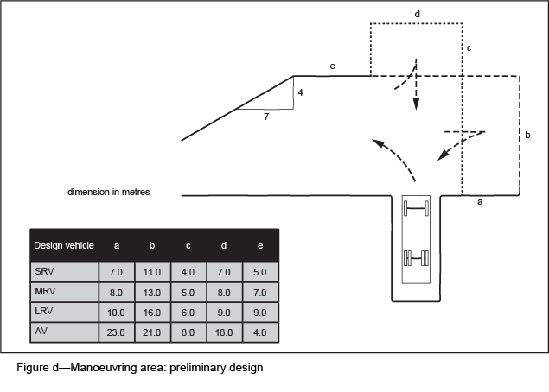
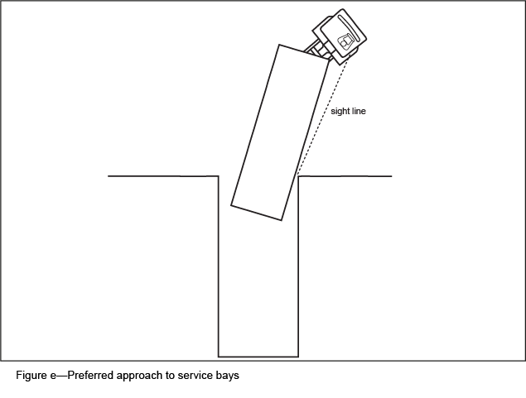

5.10 Height clearance
- The minimum height clearance required for each design vehicle is to comply with the standards in Table 12. The minimum height is appropriately and clearly signed and measured from the floor to the lowest appurtenance on the ceiling such as fire sprinklers, services, lighting fixtures or signs.
- Care is exercised in building design to ensure adequate clearance is retained throughout any grade transition (refer to Figure h). The required height clearance cannot always be simply measured from the floor to the lowest object on the ceiling. The most critical location is where there is a gradient transition at a crest or sag (refer to Figure f, Figure g, Figure h).
- An area of a site where there is a height clearance change is to be clearly signed. Any facility to divert over-height vehicles is clearly signed.
- In some circumstances, streetscape design is to necessitate clear heights less than those specified in Table 12. The Council should be consulted if it appears likely that such circumstances may arise.

Table 12—Standard design dimensions for service aisles and bays
 | Design vehicle⁽¹⁾
 | M/cycle | VAN | C&T⁽⁸⁾ | SRV | MRV | LRV |  | RCV |  | COACH | AV
Minimum service aisle width (m)
- one way |  | 4.5 | 4.5 | 4.5 | 4.5 | 4.5 |  | 4.5 |  | 4.5 | 4.5
- two way |  | 6.5 | 6.5 | 6.5 | 6.5 | 6.5 |  | 6.5 |  | 6.5 | 6.5
Minimum vertical clearance (m)⁽²⁾ |  | 2.3 | 2.3⁽³⁾ | 3.5 | 4.5 | 4.5 |  | 4 |  | 4.5 | 4.5
Minimum bay width (m) loading/standing | 1.5 | 3.0 | 3.5 | 3.5 | 3.5 | 3.5 |  | 3.5 |  | 3.5 | 3.5
Minimum bay length (m) loading/standing | 2.5 | 5.4 | 14.5 | 7.0 | 9.0 | 11.0 |  | 10.5⁽⁵⁾ |  | 13.0 | 19
Platform height (m)⁽⁶⁾ |  | - | - | 0.75–0.9 | 0.95–1.1 | 1.1–1.4 |  | - |  | - | 1.1–1.4
Maximum gradient
- general surface, manoeuvring, aisles, loading bays | 1:20  5% | 1:20  5% | 1:20  5% | 1:20  5% | 1:25  4% |  | 1:25  4% |  | 1:20  5% | 1:25  4% | 1:25  4%
Ramps
- straight |  | 1:6 | 1:6 | 1:8 | 1:10 |  | 1:10 |  | 1:10 | 1:10 | 1:10
- curved ⁽⁷⁾ |  | 1:6 | 1:6 | 1:8 | 1:10 |  | 1:10 |  | 1:10 | 1:10 | 1:10
- queuing area |  | 1:10 | 1:10 | 1:10 | 1:25 |  | 1:25 |  | 1:20 | 1:25 | 1:25
- traffic control point |  | 1:20 | 1:20 | 1:20
Notes—
(1) For an explanation of design vehicle types, see Table 20.
(2) At changes in grade, the required clearance height is maintained at all points (refer to Figure h).
(3) Special trailers, such as horse-floats and caravans, may require greater clearance height.
(4) Operating clearances for refuse trucks are in accordance with Table 3 of the Refuse planning scheme policy.
(5) Dimension is exclusive of bin storage area and loading areas.
(6) Applicable only where the loading dock is provided.
(7) Measured at inside of constructed curve.
(8) C&T = car and trailer (maximum dimensions)
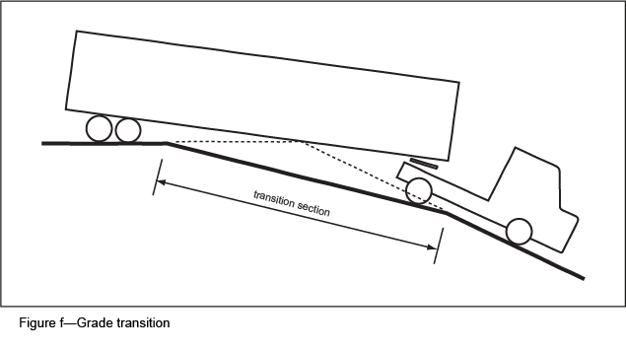
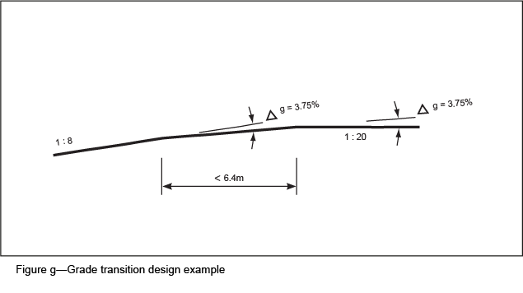
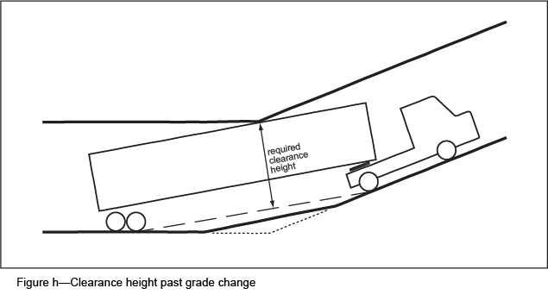

5.11 Provision for construction
- During construction, all construction activities including loading, unloading and storage of materials and equipment are provided for on-site.
- Construction activities are not to impact upon the safe movement of pedestrians and traffic adjacent to the work site.
- If it is not possible to comply with these requirement for major developments and if the site has frontage only to a road with significant pedestrian and traffic movements, a traffic construction management plan is to be prepared in accordance with the Management plans planning scheme policy.
Note—If a footpath or road closure is proposed during the construction stage of a development, a separate application for a 'Footpath closure permit', 'Road closure permit' or 'Work zone' is to be lodged with Council.

6 Car parking space standards
Standards for the provision of car parking for common uses are shown in Table 13 and Table 14. For the purposes of these standards:
- Table 13 is to be read before Table 14;
- the term car space means adequate space for the parking of a medium car, together with provision for access to such space;
- the number shown in Table 13 or Table 14 is the minimum provision unless indicated otherwise in the table;
- if the number of parking spaces calculated in accordance with Table 13 or Table 14 is not a whole number, then the number of spaces provided is the whole number next above the calculated number. Visitor spaces are calculated and rounded up separately;
- if a rate of car parking is not defined in Table 13 or Table 14, the applicant is responsible for providing evidence in support of the amount of car parking proposed;
- in car parks with more than 50 spaces, 2% of the number of spaces required to comply with the requirements of Table 13 and Table 14 are provided as marked and signed spaces for motorcycles, each measuring 2.5m by 1.35m, located immediately adjacent to major pedestrian access points;
- parking spaces for vehicle occupants with a disability are provided at a rate of 1 space per 50 ordinary parking spaces and a minimum provision of 1 space is required;
- for accepted development subject to compliance with identified requirements, if no parking standard is provided in Table 13 or Table 14, no additional parking is required.

Table 13—Car parking standards in specific cases
Use and specific location | Parking standard
Where in the City core identified in Figure a in the Transport access parking and servicing code
Uses other than multiple dwelling, rooming accommodation and short term accommodation | Maximum 1 space per 200m2 gross floor area
Multiple dwelling  Note—Multiple dwellings described as affordable housing, anticipated to accommodate students, accessed through a dual key arrangement, or resulting from conversion from another use (including short term accommodation) still require parking spaces in compliance with these rates for each room that is capable of being used as a dwelling. | Maximum 0.5 space per 1 bedroom dwelling  Maximum 1 space per 2 bedroom dwelling  Maximum 1.5 spaces per 3 bedroom dwelling  Maximum 2 spaces per 4 and above bedroom dwelling  1 visitor space for every 20 dwelling units  Parking may be provided in tandem spaces where 2 spaces are provided for 1 dwelling.  At least 50% of visitor parking is provided in communal areas, and not in tandem with resident parking.
Rooming accommodation, if for a dwelling (other than for on-site management or staff accommodation)  Note—Any part of rooming accommodation that can be defined as a dwelling requires car parking at a rate equivalent to a multiple dwelling | Maximum 0.5 space per 1 bedroom dwelling  Maximum 1 space per 2 bedroom dwelling  Maximum 1.5 spaces per 3 bedroom dwelling  Maximum 2 spaces per 4 and above bedroom dwelling  1 visitor space for every 20 dwelling units  Parking may be provided in tandem spaces where 2 spaces are provided for 1 dwelling.  At least 50% of visitor parking is provided in communal areas, and not in tandem with resident parking.
Rooming accommodation, in all other cases | Maximum 0.25 spaces per room
Short term accommodation | Maximum 0.25 spaces per room, unit or cabin
Where in the City frame identified in Figure a in the Transport access parking and servicing code
Uses other than multiple dwelling, rooming accommodation and short term accommodation | Maximum 1 space per 100m2 gross floor area
Multiple dwelling  Note—Multiple dwellings described as affordable housing, anticipated to accommodate students, accessed through a dual key arrangement, or resulting from conversion from another use (including short term accommodation) still require parking spaces in compliance with these rates for each room that is capable of being used as a dwelling. | Minimum 0.9 spaces per 1 bedroom dwelling  Minimum 1.1 spaces per 2 bedroom dwelling  Minimum 1.3 spaces per 3 or above bedroom dwelling  Minimum 0.15 spaces per dwelling for visitor parking  Parking may be provided in tandem spaces where 2 spaces are provided for 1 dwelling.  At least 50% of visitor parking is provided in communal areas, and not in tandem with resident parking.
Rooming accommodation, if for a dwelling (other than for on-site management or staff accommodation)  Note—Any part of rooming accommodation that can be defined as a dwelling requires car parking at a rate equivalent to a multiple dwelling | Minimum 0.9 spaces per 1 bedroom dwelling  Minimum 1.1 spaces per 2 bedroom dwelling  Minimum 1.3 spaces per 3 or above bedroom dwelling  Minimum 0.15 spaces per dwelling for visitor parking  Parking may be provided in tandem spaces where 2 spaces are provided for 1 dwelling.  At least 50% of visitor parking is provided in communal areas, and not in tandem with resident parking.
Rooming accommodation, in all other cases | Minimum 0.4 spaces per room
Short term accommodation | Minimum 0.5 spaces per room, unit or cabin
Where within 400m walking distance of a dedicated public pedestrian access point of a major public transport interchange, other than where in the City core or City frame identified in Figure a in the Transport access parking and servicing code
Centre activities activity group where in a Principal centre zone, Major centre zone, District centre zone, Neighbourhood centre zone or Mixed use zone | Maximum 5 spaces per 100m2 gross floor area on all levels accessible at-grade from a public street or an on-site car parking area, plus maximum 2 spaces per 100m2 gross floor area on other levels
Rooming accommodation, if for a dwelling (other than for on-site management or staff accommodation)  Note—Any part of rooming accommodation that can be defined as a dwelling requires car parking at a rate equivalent to a multiple dwelling | Minimum 0.9 spaces per 1 bedroom dwelling  Minimum 1.1 spaces per 2 bedroom dwelling  Minimum 1.3 spaces per 3 or above dwelling  Minimum 0.15 spaces per dwelling for visitor parking  Parking may be provided in tandem spaces where 2 spaces are provided for 1 dwelling.  At least 50% of visitor parking is provided in communal areas, and not in tandem with resident parking.
Rooming accommodation, in all other cases | Minimum 0.25 spaces per room
Short term accommodation | Minimum 0.25 spaces per room, unit or cabin plus 1 space for staff per 20 rooms, units or cabins
Other
Centre activities activity group where in a Principal centre zone, Major centre zone, District centre zone, Neighbourhood centre zone or Mixed use zone | Minimum 5 spaces per 100m2 gross floor area on all levels accessible at-grade from a public street or an on-site car parking area, plus 3 spaces per 100m2 gross floor area on other levels
Large format retail activity group, where on land included in the Large format retail zone precinct of the Specialised centre zone | Minimum 3 spaces per 100m2 gross floor area and outdoor display area

Table 14—Car parking standards in all other cases
Use | Parking standard
Adult store | 5 spaces per 100m2 gross floor area
Agricultural supplies store | 3 spaces per 100m2 gross floor area and outdoor display area
Bar | 6 spaces per 100m² gross floor area
Brothel | 2 spaces per bedroom
Bulk landscape supplies | 1 space per 100m2 gross floor area and outdoor display area
Caretaker's accommodation | 1 space per dwelling
Childcare centre | 1 space per 5 children  60% of these spaces are for staff and can be provided in tandem
Club, if licensed and less than 1,500m2 gross floor area | 6 spaces per 100m2 gross floor area
Club, if licensed and equal to or greater than 1,500m2 gross floor area | 40 spaces plus 4 spaces per 100m2 gross floor area
Club, if not licensed | 3 spaces per 100m2 gross floor area
Community care centre | 14 spaces plus 5 spaces per 100m2 gross floor area
Community residence | 1 space per staff
Community use, if a community centre or community hall | 10 spaces per 100 m2 gross floor area
Community use in all other cases | 3 spaces per 100m2 gross floor area
Crematorium | 10 spaces per 100m2 gross floor area
Dual occupancy | 1 space per 1 or 2 bedroom dwelling  2 spaces per 3 or more bedroom dwelling  Parking may be provided in tandem spaces where 2 spaces are provided for 1 dwelling
Dwelling house | 1 space plus 1 space for a secondary dwelling
Dwelling unit | Use standard for multiple dwelling
Educational establishment, if a pre-preparatory, preparatory and primary school, secondary school or special education | 1 space per staff plus 0.1 space per staff for visitors
Educational establishment, if a college, university or technical institute | 1 space per staff plus 0.1 space per staff for visitors  1 space per 10 students
Environment facility, where not in the Open space zone, Sport and recreation zone or Conservation zone | 1 space per staff plus 0.1 space per staff for visitors
Environment facility, where in the Open space zone, Sport and recreation zone or Conservation zone | 1 space per staff plus 0.1 space per staff for visitors where no parking is provided already in that zone or within 200m walking distance of the facility
Food and drink outlet, if less than 400m2 gross floor area, where not in the Open space zone, Sport and recreation zone or Conservation zone | 12 spaces per 100m2 gross floor area and outdoor dining area
Food and drink outlet, where in the Open space zone, Sport and recreation zone or Conservation zone | 6 spaces per 100m2 gross floor area where no parking is provided already in that zone or within 200m walking distance of the outlet
Food and drink outlet, if 400m2 or greater gross floor area | 30 spaces plus 5 spaces per 100m2 gross floor area and outdoor dining area
Function facility | 10 spaces per 100m2 gross floor area
Funeral parlour | 10 spaces per 100m2 gross floor area
Garden centre | 5 spaces per 100m2 gross floor area and outdoor display area
Hardware and trade supplies | 5 spaces per 100m2 gross floor area
Health care service, if less than 200m2 gross floor area | 6 spaces per 100m2 gross floor area
Health care service, if 200m2 or greater gross floor area | 14 spaces plus 5 spaces per 100m2 gross floor area
High impact industry | 2 spaces per tenancy or lot plus 1 space per 100m2 gross floor area
Hospital | 0.5 spaces per bed plus 0.8 spaces per staff
Hotel | 6 spaces per 100m2 gross floor area plus 1 space per short term accommodation room
Indoor sport and recreation, if a gymnasium | 10 spaces per 100m2 gross floor area
Indoor sport and recreation, if squash courts or enclosed tennis courts | 6 spaces per court
Indoor sport and recreation, if indoor cricket or other court game | 20 spaces per court
Indoor sport and recreation, if swimming pool | 15 spaces plus 1 space per 100m2 gross floor area
Indoor sport and recreation, in all other cases | 3 spaces per court or similar or 5 spaces per 100m2 gross floor area
Low impact industry | 2 spaces per tenancy or lot plus 1 space per 100m2 gross floor area
Major sport, recreation and entertainment facility | 1 space per 5 persons to be seated plus 20 spaces per 100m2 other area
Marine industry | 2 spaces per tenancy or lot plus 1 space per 100m2 gross floor area
Market | 6 spaces per 100m2 site area (stalls plus pedestrian circulation)
Medium impact industry | 2 spaces per tenancy or lot plus 1 space per 100m2 gross floor area
Motor sport facility | 1 space per 5 persons to be seated plus 20 spaces per 100m2 other area
Multiple dwelling, if qualifying for a subsidy for aged persons or persons with disabilities under any law | 1 space per 3 dwellings
Multiple dwelling in all other cases  Note—Multiple dwellings described as affordable housing, anticipated to accommodate students, accessed through a dual key arrangement, or resulting from conversion from another use (including short term accommodation) still require parking spaces in compliance with these rates for each room that is capable of being used as a dwelling. | 1 space per 1 bedroom dwelling  2 spaces per 2 bedroom dwelling  2 spaces per 3 bedroom dwelling  2.5 spaces per 4 bedroom dwelling  0.25 spaces per dwelling for visitor parking  Parking may be provided in tandem spaces where 2 spaces are provided for 1 dwelling.  At least 50% of visitor parking is provided in communal areas, and not in tandem with resident parking.
Nightclub entertainment facility | 6 spaces per 100m2 gross floor area
Office | 3 spaces per 100m2 gross floor area
Outdoor sales | 2 spaces per 100m2 gross floor area and outdoor display area
Outdoor sport and recreation, if a swimming pool or other aquatic sport and recreation | 15 spaces plus 1 space per 100m2 site area
Outdoor sport and recreation, if a tennis court | 6 spaces per court
Outdoor sport and recreation, if a ground, such as football, cricket or hockey | 50 spaces per field
Outdoor sport and recreation, if a lawn bowls | 30 spaces per green
Outdoor sport and recreation, if a court game other than tennis | 20 spaces per court
Park, if in the Local zone precinct or a local park | Nil
Park, if in the District zone precinct or a district park, where for informal recreation purposes such as picnic nodes and off-leash areas | 10–20 spaces
Park, if in the District zone precinct or a district park, where for high use purposes such as a district playground | 20–30 spaces plus 2 spaces for minibuses
Park, if in the Metropolitan zone precinct or where a metropolitan park, where for informal recreation purposes | 30–50 spaces plus 2 spaces for buses/coaches
Park, if in the District or Metropolitan zone precinct or a district or metropolitan park, where for sporting purposes | Use standard for outdoor sport and recreation
Park, if not in the Metropolitan, District or Local zone precinct | Maximum 10 spaces unless prescribed in an approved natural area management plan
Place of worship, if fronting a declared public road or including a hall | 10 spaces per 100m2 auditorium and seating area
Place of worship in all other cases | 8 spaces per 100m2 auditorium and seating area
Relocatable home park | 11 spaces per 10 sites plus 1 space per 10 sites for visitors
Research and technology industry | 2 spaces per tenancy or lot plus 1 space per 100m2 gross floor area
Residential care facility | 1 space per 6 beds
Retirement facility | 0.7 spaces per dwelling plus 0.3 spaces per dwelling for visitors and staff
Rooming accommodation, if a boarding house | 1 space per 5 beds plus 1 space for staff
Rooming accommodation, if for a dwelling (other than for on-site management or staff accommodation)  Note—Any part of rooming accommodation that can be defined as a dwelling requires car parking at a rate equivalent to a multiple dwelling | 1 space per 1 bedroom dwelling  1.25 spaces per 2 bedroom dwelling  1.5 spaces per 3 or more bedroom dwelling  0.15 spaces per dwelling for visitor parking  Parking may be provided in tandem spaces where 2 spaces are provided for 1 dwelling.  At least 50% of visitor parking is provided in communal areas, and not in tandem with resident parking.
Rooming accommodation, in all other cases | 0.6 spaces per room
Sales office | 3 spaces per 100m2 gross floor area
Service industry | 5 spaces per 100m2 gross floor area
Service station | 6 spaces per 100m2 gross floor area
Shop | 5 spaces per 100m2 gross floor area
Shopping centre | 5 spaces per 100m2 gross floor area
Short-term accommodation, if dormitory type accommodation  e.g. a backpackers | 1 space per 100m2 gross floor area plus 1 space for a minibus
Short term accommodation, in all other cases | 0.5 spaces per room, unit or cabin plus 0.5 spaces per staff
Showroom | 3 spaces per 100m2 gross floor area
Special industry | 2 spaces per tenancy or lot plus 1 space per 100m2 gross floor area
Theatre | 10 spaces per 100m2 gross floor area
Tourist park | 1 space per 1 site or cabin plus 1 space per 10 sites for visitors plus 0.5 spaces per staff
Transport depot | 2 spaces per tenancy or lot plus 1 space per 100m2 gross floor area
Utility installation | 2 spaces per tenancy or lot plus 1 space per 100m2 gross floor area
Veterinary service | 4 spaces per 100m2 gross floor area
Warehouse | 2 spaces per tenancy or lot plus 1 space per 100m2 gross floor area

7 On-site car parking design standards

7.1 General
- On-site car parking areas are designed to be safe and convenient to use to encourage their use in preference to on-street parking.
- Mandatory design standards (section 7.2.1) satisfy the primary objectives of vehicular and pedestrian safety and are incorporated in all car parking areas.
- Desirable design standards (section 7.2.2) are desirable standards which produce safe and convenient car parking layouts.
- Typical layouts of car parking areas are shown in section 7.10.
- If existing older buildings are being redeveloped, it is recognised that it may not be possible to fully comply with these principles. Any solution proposed is to demonstrate a safe and workable car park layout.
- Motorcycle parking is provided as marked and signed spaces for motorcycles with each measuring 2.5m by 1.35m and is located immediately adjacent to major pedestrian access points.

7.2 Design principles

7.2.1 Mandatory design standards
The following are the mandatory design standards for car park layouts:
- Restrict vehicles to low speeds in the vicinity of pedestrian activity. This is achieved using appropriate road geometry or physical devices designed to limit speed.
- Provide sight distances appropriate for operating speeds in all areas of potential pedestrian and vehicle conflict. In particular, sight distances of at least 2.5 seconds of travel time at the likely prevailing speed are to be provided at all conflict points. This requires splayed corners on structures and the careful treatment of landscaping and sign placement in an area of potential conflict.
- No reversing of vehicles, particularly service vehicles, in areas of high pedestrian, cyclist and vehicle activity.
- On-site traffic congestion does not impact on the external transport system.
- If walls are provided on a circulating ramp, a 3m by 1 chord truncation is required to improve visibility for motorists on the ramp (refer to Figure k)

7.2.2 Desirable design standards
The following are desirable design standards for car park layouts:
- Design for a progressive reduction in speed environment in moving between the road and a parking space.
- Avoid dead-end aisles used by visitors or customers and design for efficient and simple space search patterns.
- Avoid cross-aisle intersections.
- Design for aisles to intersect circulation roads and circulation aisles as near to right angles as possible, as the intersection geometry is unlikely to be satisfactory at angles less than 75°.
- Provide a clearly defined pedestrian network which:
- closely follows demand lines;
- provides for pedestrian movements through car parking areas along aisles rather than across them;
- minimises the potential for vehicular and pedestrian conflict;
- minimises likely vehicle operating speeds and congestion levels at conflict points;
- provides for pedestrian and vehicular queues at conflict points.
- Avoid long straights (longer than 80m) on circulation roadways, and large areas of open car parking which encourage high operating speeds and shortcutting when the car parking area is not full. Separators between parking rows are necessary.
- Restrict the maximum length of parking aisles to 80m, unless additional measures are adopted to ensure vehicle speeds are kept low.
- Within large developments, provide for uncongested public transport and service vehicle movement through the site, without using parking aisles.
- Provide adequate site lighting, and avoid abrupt changes in lighting levels during both day and night operation.
- Provide adequate queuing areas for drive-through facilities that will not block the primary circulation roadways or site access driveways. Occasional queuing in parking aisles is normally of little consequence.
- On-site traffic congestion is not to hinder satisfactory operation of the car parking facility.
- Design of all storage areas, fire escapes, loading areas and refuse collection areas, complies with the requirements of the overall project design.
- Speed humps are not necessary in a well-designed car parking area if speeds are controlled by circulation road and aisle geometry. If speed humps are provided, their profile should be as described in BSD-3216. Speed humps are not located in entry and exit queuing areas, intersection areas, or on curved roadways.
- Where at-grade (footpath level) parking areas are necessary or unavoidable, they are adequately shaded by trees which are selected, planted and maintained to achieve shade coverage of the car park within 10 years of their establishment. Refer to the Planting species planning scheme policy for details of complying species. Shade trees are provided at the ratio of 1 tree for every 6 car parking spaces. One-third of these trees are accommodated in larger unsealed areas rather than planting areas at the corners of car parking spaces.

7.3 Location of car parking areas
- Car parking spaces are located so that they are more convenient for use than alternatives on-street spaces.
- Providing shelter or improved security can increase the attractiveness of on-site parking.
- Access to parking is clearly signed at the street frontage.
- Customer and visitor parking spaces are located closest to building entrances, while employee parking can be relatively more remote.
- Customer and visitor and service vehicle parking spaces are not located inside security fences, behind security doors, in likely outdoor storage areas, in areas used for heavy vehicle manoeuvring, particularly opposite and adjacent to loading doors, or out of sight at the rear of the buildings.

7.4 Circulation standards within car parking areas

7.4.1 General
- Car parking areas are designed based on a hierarchy of internal roadways that range from those primarily providing for vehicle movement, to those primarily providing for access to parking spaces.
- The descending order of roadway importance is: circulation roads, circulation aisles and parking aisles as demonstrated in Figure a.

7.4.2 Circulation roads
- The minimum width of a straight circulation road complies with Table 15.
- Dimensions are measured to nominal kerb faces with a clearance from the nominal kerb face of not less than 0.15m to obstructions higher than 0.15m on a straight roadway. This minimum clearance is increased to 500mm on the outside of a curve or 300mm on the inside of a curve.
- If a median is proposed, it should not be less than 0.6m wide, provided it can be clearly seen, and not less than 1.2m wide if it needs to carry a sign.
- If a circulation road leading from a narrow driveway (less than 6m) is 30m or longer, or the sight distance from one end to the other is restricted, the driveway and circulation road are increased to a minimum of 6m width for at least the first 6m inside the property boundary.
- Passing opportunities are provided at least every 30m on a long driveway.
- If control facilities such as card readers or ticket machines are expected to be installed, the circulation road width is increased by 1.2m to allow for these devices on a median or similar structure.
- Additional turning lanes are provided where necessary in a car parking layout of a high traffic-generating development.
- The dimensions in Table 15 relate to the car access to a car parking area. Greater widths than those specified in Table 15 are provided to accommodate buses or service vehicles where required.
- Curved circulation roads and ramps have the minimum dimensions in compliance with AS/NZS 2890.1:2004 Parking facilities—Off-street car parking – see 'Dimensions of curved roadway and ramps'.
- Two-way curved circulation roads and ramps are separated by a median when the outer kerb radius (dimension Ro in AS/NZS 2890.1:2004 Parking facilities—Off-street car parking) is 15m or less.
- A median is optional on a larger radii curve.

Table 15—Standard minimum widths of straight circulation roads
Type of circulation road | Width of circulation road
One-way, one-lane | 3m <20m  5m if >20m long
One-way, two-lane | 6m
Two-way, one-lane(1) | 5m (up to 25vph)  6.2m (up to 1,000vph)
Two-way, two-lane | 6.5m (101 to 300vph)  7.5m (over 300vph)
Note—
(1) Two-way usage of one-lane circulation roads is permitted in a small low turnover car parking area where it can be demonstrated that:
- the two-way one-lane section is more than 15m from the footpath crossing;
- any congestion generated will not extend onto the street;
- it will operate at a satisfactory level of safety;
- delays produced will not encourage parking in inappropriate locations elsewhere.

7.4.3 Circulation aisles standards for non-service vehicles
- A small low-turnover car parking area typically having less than 50 spaces, two-way circulation aisles may be 6m wide, but in all other design situations they are not to be less than 6.2m wide.
- Circulation aisles are inappropriate in parts of larger car parking areas that have high turnover rates.
- Dimensions are measured to nominal kerb faces with a clearance from the nominal kerb face of not less than 0.15m to obstructions higher than 0.15m on a straight roadway. This minimum clearance is increased to 500mm on the outside of a curve or 300mm on the inside of a curve.

7.4.4 Parking aisle standards
- All parking aisles provide for two-way traffic movement and have a minimum width of 6.2m. In restricted circumstances, this width may be reduced with a corresponding increase in the width of the parking bays (0.4m reduction in aisle width for each 0.1m increase in parking bay width, beyond the widths in Table 15).
- The minimum width of a two-way parking aisle providing access to high turnover spaces is 6.2m.
- The maximum length of a parking aisle is 80m unless provision is made to ensure speeds are minimised.
- One-way parking aisle arrangements are only permitted if it can be satisfactorily demonstrated that a two-way parking aisle arrangement is impracticable, and appropriate design will ensure one-way aisles will only be used for one-way traffic operation.

7.4.5 Terminated aisle standards
Terminated aisles extend 2m or more beyond the last parking space in the aisle to allow for manoeuvres into and out of that parking space, or alternatively an 8m aisle is provided directly behind the last parking space (refer to Figure i).

7.4.6 Turning movement in parking aisle standards
- Two design situations necessitate consideration of turning vehicles: curved roadways and ramps and the provision for turning movements at intersections.
- The standard of design for turning movements depends on the frequency of the likely vehicular conflict between opposing streams of traffic.
- The design standards appropriate for cars are in Figure j.
- Curves and intersections are designed such that turning cars have no need to cross the centre line, whether marked or not, of a circulation road or circulation aisle, or a parking aisle providing access to more than 50 parking spaces.

7.4.7 Standards for service vehicle use of aisles
- If a larger vehicle is expected to use curved and intersecting roadways and ramps or where higher operating speeds are proposed, an appropriate allowance is made by the provision of larger curves and appropriate widths of turning paths, based on the turning templates in section 8.2.
- If a service vehicle is to use an internal road, the minimum aisle width is to be 6.5m and this is to be widened to 7.5m around curves.

7.4.8 Standard queuing area treatment
The following cross-section dimensions are used for a queuing area:
- single queuing lanes are a minimum of 3m wide with at least a 300mm horizontal clearance provided on each side of the lane and an adjoining breakdown lane or strip 2m wide is to be considered on one side of a single queuing lane;
- multiple queuing lanes are a minimum of 2.7m each with at least a 300mm horizontal clearance provided on each side of the queuing area.

7.5 Standard sight distances
- The minimum sight distances within a car park, at all areas of pedestrian and vehicle conflict complies with Table 16.
- The measurement of sight distances is depicted in Figure k.

Table 16—Minimum sight distances at conflict
Location of conflict point | Minimum sight distance
 | For pedestrians | For vehicles
Circulation road | 3.0m | 20m
Circulation aisle | 2.5m | 15m
Parking aisles | 2.0m | 10m
At two-way right angle turns | - | 10m

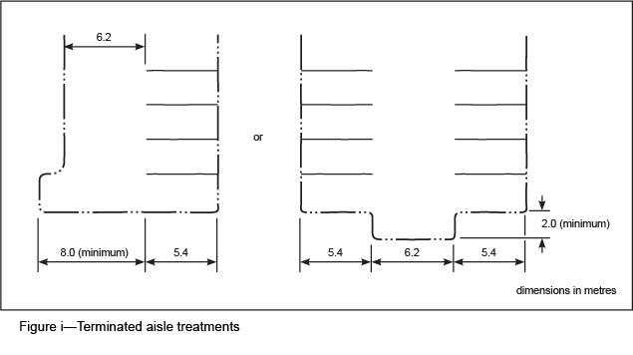
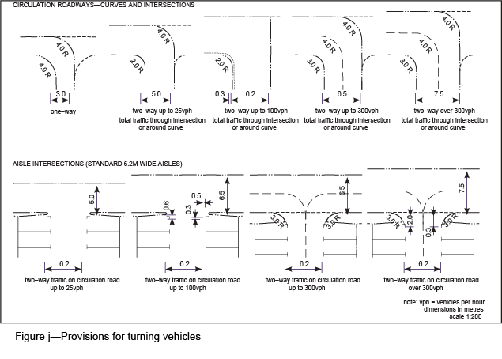
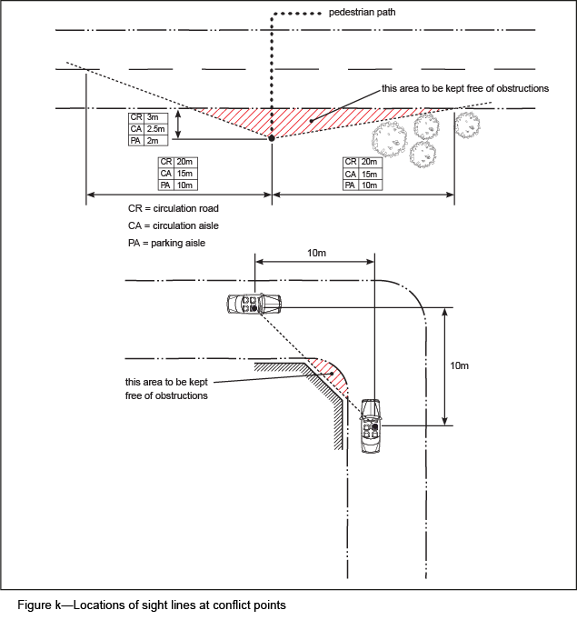

7.6 Standard gradients
- The minimum gradients of car parking areas are defined by drainage requirements and depend on the type of surface and its roughness (refer to AS/NZS 2890.1:2004 Parking facilities—Off-street car parking).
- The maximum gradients are defined by consideration of vehicle performance, user comfort, likely operating speeds and the control of opening car doors and the manoeuvrability of prams, wheelchairs and shopping trolleys.
- The maximum entrance gradients for driveways are set out in BSD-2025 and the maximum gradients for car parking areas are shown in Table 17.
- The gradients are defined as the maximum total gradient incorporating longitudinal and crossfall components.
- The component of the gradient in the car parking area across parking spaces is not to exceed 1 in 20 (5%). If a gradient steeper than this is encountered, some large car doors become difficult to control and minor damage to adjacent car may result.
- For every 5% change in transition gradient, the transition length is to be a minimum of 2m. The transition can be straight or a vertical curve; the latter providing better user comfort. At changes of grade, the required clear height is maintained at all points.
- If transitions and change of grade do not comply with these standards, it is to be demonstrated that the B85 design vehicle (refer to template and method shown in AS/NZS 2890.1:2004 Parking facilities—Off-street car parking) can traverse the aisle or driveway without bottoming out and clear overhead obstructions.
- A vehicle is not permitted to turn on a ramp or on a crest or sag of a crest where driver visibility is poor.

Table 17—Standard maximum gradients in a parking area
Location | Maximum gradient
Parking areas for people with disabilities AS/NZS 2890.6:2009 Parking facilities—Off-street parking for people with disabilities | 1 in 40 (2.5%) both directions
Public car parking area (prams and shopping trolleys likely) consistent with AS/NZS 2890.1:2004 Parking facilities—Off-street car parking and AS 1428.1-2009 Design for access and mobility - General requirements for access—New building work | 1 in 14 (7.1%)
Tenant car parking area in residential building | 1 in 14 (7.1%)
Employee car parking area | 1 in 10 (10%)
Straight circulation road or ramp | 1 in 6 (16.7%)
Curved circulation road or ramp (at inside kerb) | 1 in 6 (16.7%)
Circulation aisle | 1 in 20 (5%)
Ramp or driveway within 6m of a property boundary, traffic control point or marked pedestrian crossing | 1 in 20 (5%)
Uphill queue area | 1 in 12 (8.3%)
Super-elevation on curved roadway or ramp camber | 1 in 12 (8.3%)
Note—Terms used in this table are defined in section 1.3 Terminology and illustrated in Figure a.

7.7 Standard height clearance

7.7.1 General standards
- To permit access for most vehicles expected to use a car parking area, the minimum clear height between the floor and any overhead obstructions is 2.3m.
- The minimum clear height is measured to the lowest appurtenance on the ceiling such as fire sprinklers, services, lighting fixtures and signs.
- The minimum clear height is appropriately and clearly signed.
- If part of the car park has reduced clear heights, arrangements are made to divert higher vehicles within the car parking area.
- The minimum headroom in that part of a car park that has reduced height clearance is no less than 2.1m.
- Reduced height and any alternative route are clearly signed.
- Particular attention is paid to the headroom available at the beginning or end of a ramp, due to the reduced clear height that occurs when a vehicle bridges the change of grade.

7.7.2 Height clearance for disabled user spaces
Car parking spaces reserved for vehicles displaying a disabled person parking permit have a minimum height clearance of 2.5m extending from the open end of the bay to a point not less than 2.16m from the front of the bay. Refer to AS/NZS 2890.6:2009 Parking facilities—Off-street parking for people with disabilities and AS 1428.1-2009 Design for access and mobility - General requirements for access—New building work – see 'Vertical clearance required above car space for people with disabilities '.

7.8 Standard car parking space dimensions

7.8.1 Widths of standard parking spaces
- The standard minimum width of a car parking space is indicated in Table 18 for the identified types of car parking area users.
- The minimum widths are based on considerations of door opening requirements and the frequency of use.
- Parking areas that are shared by different categories of users have spaces of the greatest width required by any of the user types.
- Different car parking areas on the site can provide for different categories of users, provided the user types are adequately and clearly separated. That is an employee car parking area may have narrower spaces than a visitor car parking area on the same site.
- In fully reserved car parking areas, up to 20% of spaces may be small car (50th percentile) spaces, provided such spaces are no smaller than 5m long by 2.3m wide and are appropriately signed as being for small cars only.
- Some spaces, particularly those near entry and exit driveways and where aisle widths are constrained, may need wider (up to 3.5m) to allow satisfactory access to the space, since such spaces can only be practically approached by a vehicle making a minimum radius turn.
- If the side boundary of a space is adjacent to an obstruction greater than 150mm high and placed so as to restrict doors from opening, 0.3m is added to the width of the space.

7.8.2 Standard length of parking spaces
- All angled spaces are not less than 5.4m long.
- Tandem parking spaces (combined length of 10.8m) are not appropriate in visitor or public parking areas, but may be acceptable in the following situations:
- residential developments where both spaces are attached to one dwelling;
- reserved car parking areas where both spaces are allocated to a single tenant.
- Fully enclosed spaces (garages) are 6.0m long to allow for pedestrian access around the vehicle with the garage doors closed.
- Wheel stops can be used, as long as they do not cause parked vehicles to extend into the aisle. They are located 0.5m from the closed end of the parking space, with no obstructions higher than 150mm within the 0.5m overhang area.
- Pedestrian areas are set back at least 1m from the wheel stop face. The area of overhang is not considered to form part of the landscaped area, whatever the surface treatment.
- The normal length of a parallel parking space is 6m, this length being reduced to 5.4m if the space is at the open end of the row of spaces, or increased by 0.3m if closed by a kerb at one end, and by 0.6m if closed by a kerb at both ends. Lengths of parallel parking spaces are depicted in Figure l.
- Vertical clearances required for car spaces for people with disabilities are outlined in AS/NZS 2890.6:2009 Parking facilities—Off-street parking for people with disabilities.

Table 18—Standard minimum widths of car parking space
Class of space | Minimum width of space (m) | User types
1 | 2.4 | Reserved parking with low turnover rates, such as employee car parking areas at and industrial and an office premises
2 | 2.5 | Public car parking areas with low turnover rates, such as the city core car parking areas and sporting venues
3 | 2.6 | Public car parking areas with moderate turnover rates, such as suburban shops and medical centres
 |  | Reserved spaces where passengers and goods are loaded or unloaded, such as tenant car parking area in a residential complex
 |  | Visitor parking at office, industrial and residential premises
4 | 2.7 | Small public car parking areas with high turnover rates (typical duration of stay 30 minutes or less), particularly shopping centres up to 1,000m2 gross floor area, kiss'n'ride areas, fast food stores etc.
5 | 2.4 plus 2.4 shared area | Parking spaces reserved for people with disabilities

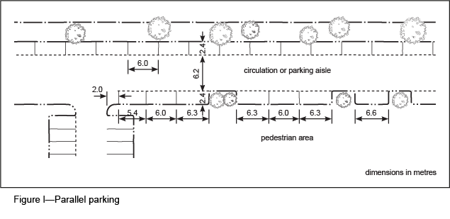

7.8.3 Fully enclosed garages
- For a dwelling house or similar development where a straight entry into a garage is possible, a single garage has minimum internal dimensions of 6m by 3m with a minimum doorway opening of 2.4m.
- If a design vehicle is to turn through 90 degrees from a standard 6.2m wide aisle to enter a single garage, the minimum internal dimensions of the garage are 6m by 3.2m with a minimum doorway opening of 3m. A reduction of doorway and garage widths is considered if the garage is set back a significant distance from the access aisle to provide a greater manoeuvring area in front of the garage that enables the design vehicle to achieve a straighter entry.
- The maximum internal dimension of a single garage is 6m by 4m.
- A double garage with a single opening has a minimum internal dimension of 5.3m(w) by 6m(l) and a minimum doorway opening of 4.2m.
- If a design vehicle movement is to turn 90 degrees from a standard 6.2m wide aisle, the minimum internal dimension is widened as determined by the vehicle turning arch (see section 8).
- Intrusions into a garage area are only allowed in an area shown in Figure m.
- Tandem garages have a minimum internal length of 11.4m.

Table 19—Recommended garage widths for various driveway widths
Width of driveway | Internal garage width
 | Single garage | Double garage
3.0m wide | 4.2m | 7.2m
4.0m wide | 3.8m | 7.0m
5.0m wide | 3.4m | 6.6m
6.2m wide (standard) | 3.0m | 5.3m

7.8.4 Clearance around parking spaces
- All parking spaces are rectangular in shape.
- Intrusion into the rectangular form of the parking space by columns or other structures can occur, provided that such intrusions are at the closed end of the space and within defined limits.
- Additional areas outside the rectangular form are clear of structures to allow for door openings and the turning manoeuvre into the space.
- The allowable intrusions and the additional clearance areas, which may be an unoccupied part of an adjacent space, are shown in Figure m.
- Provision is made for door openings on both sides of the vehicle.
- In permanently reserved long-term employee car parking areas for industrial and office uses, provision may be made for door openings on one side only.

7.9 Standard provisions for vehicle occupants with a disability
- Parking spaces for vehicle occupants with a disability are provided at a rate of 1 space per 50 ordinary parking spaces and a minimum provision of one space is required.
- Provision of parking and general access is made in accordance with the requirements of AS 1428.1-2009 Design for access and mobility - General requirements for access —New building work and AS/NZS 2890.6:2009 Parking facilities—Off-street parking for people with disabilities, particularly for parking space width and location, manoeuvring areas for wheelchairs, gradients, location of stairs, ramps, doorways and signage.
- Multiple dwellings with more than 10 units provide a minimum of 1 visitor car parking space designed and reserved for vehicle occupants with a disability.
- Parking spaces for vehicle occupants with a disability are provided as close as possible to the main entrance to a building.

7.10 Standard car park layouts
Standard car park layouts are shown in Figure n, Figure o, Figure p.

8 Standard design vehicles and vehicle turning templates

8.1 Design vehicles

8.1.1 Cars
- The standard design vehicles used throughout the car parking sections of these guidelines are medium cars.
- A medium car has critical dimensions approximating the 85th percentile dimensions derived from AS/NZS 2890.1:2004 Parking facilities—Off-street car parking, and the research on which it was based.
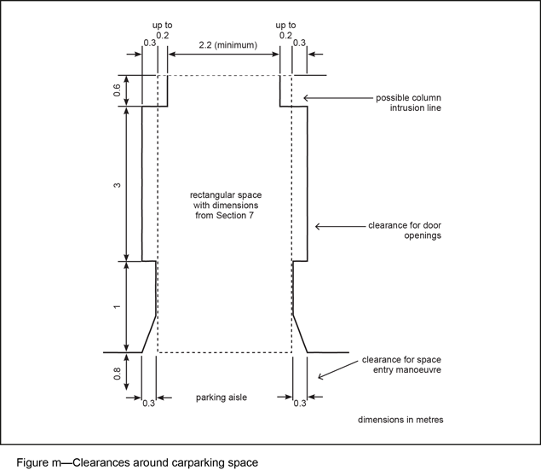
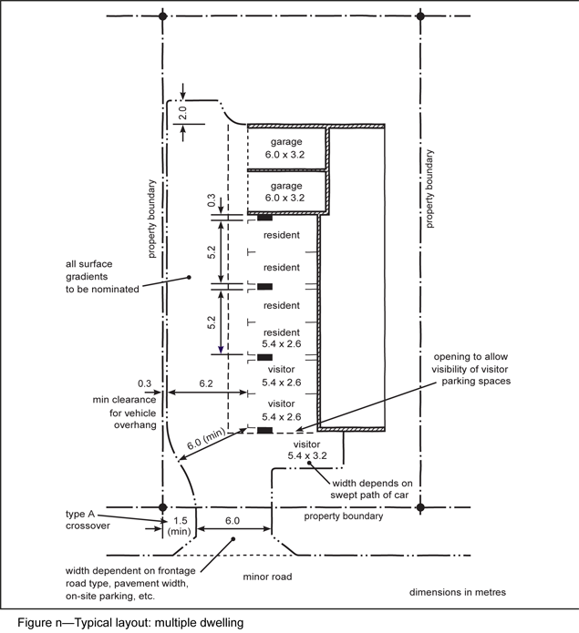
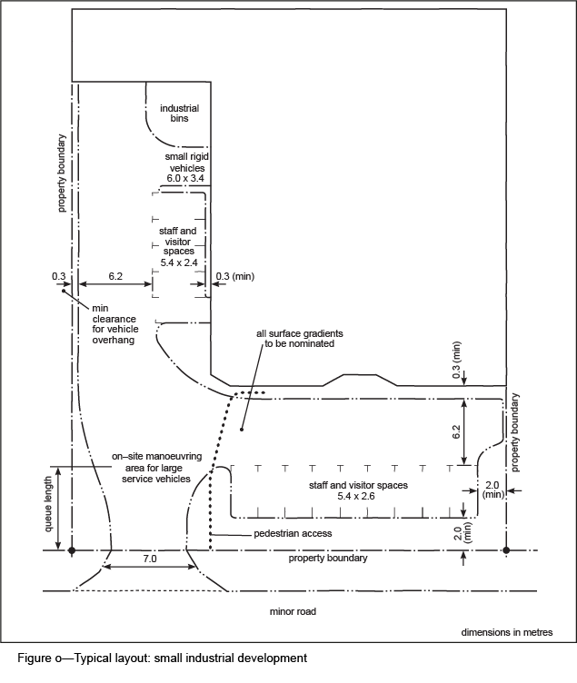
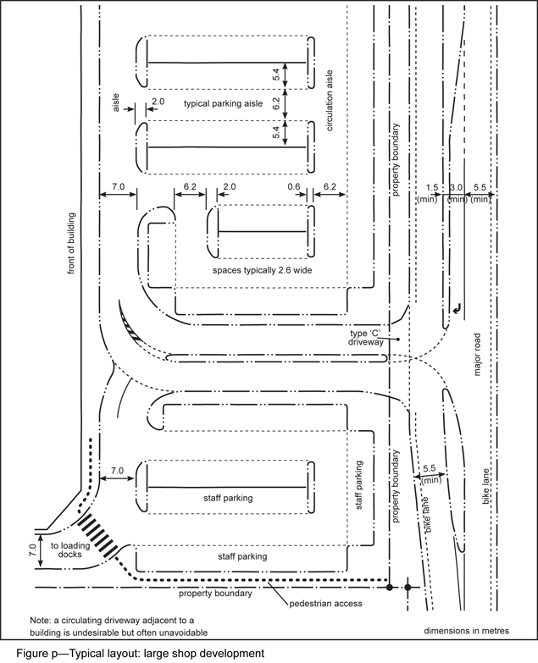

8.1.2 Service vehicles
The origins of the design vehicles selected for use in the service vehicle sections of this planning scheme policy are described in Table 20.

8.2 Standard vehicle turning templates
- Turning templates are used in checking vehicle turning movements in critical locations.
- External roadways and intersections are designed to the appropriate traffic engineering standards.
- There are two standard types of templates:
- manoeuvring templates for movements made at stalling speeds and used for design of service areas;
- turning templates for movements at low speed and used for driveway and internal and external roadway design.
- The minimum template required for an assessment is the 19m AV, largest Council rigid bus, Council refuse truck, a LRV or the medium car.
- If vehicles other than those listed are proposed to service a development, manoeuvring provision is designed using dedicated templates that may already be available for the vehicles or from computer-generated turning paths or from field trials of actual vehicle performance.
- The vehicle paths are inappropriate for design purposes without allowance for 0.5m working clearances in addition to the template curves.
- A minimum horizontal clearance (prescribed below) is provided outside the vehicle extremities when applying the templates to a plan drawing, to demonstrate that vehicles can manoeuvre clear of kerb lines and vertical obstructions. The templates are divided into two sets:
- turning templates for access driveway and access way design. These are based on the swept path of the vehicle at a speed higher than stalling speeds. A clearance for varying vehicle characteristics and driver judgement and skill of 0.5m is allowed when using the templates.
- manoeuvring templates for service area design. These are for manoeuvres undertaken at stalling or minimum speeds. A clearance of 0.3m to all permanent obstructions is allowed when using the templates.

8.2.1 Cars
- Generally the design vehicle is the medium car.
- The relevant turning path templates for medium cars are found in AS/NZS 2890.1:2004 Parking facilities—Off-street car parking and AS 2890.2-2002 Parking facilities—Off-street commercial vehicle facilities. These templates show an additional area required to provide clearance to obstructions.

Table 20—Design vehicles
Design vehicle | Description/type
C&T | Car and trailer, equivalent to AUSTROADS 'Car and Caravan', or similar to the Department of Harbour and Marine 'Car and Boat Trailer'
VAN | A 99.8th percentile vehicle equivalent to the Council's 'large car'
SRV | Small rigid vehicle as in AS 2890.2-2002 Parking facilities—Off-street commercial vehicle facilities, but incorporating a body width of 2.33m
MRV | Medium rigid vehicle equivalent to Council's 8-tonne truck
LRV | Large rigid vehicle described by AS 2890.2-2002 Parking facilities— Off-street commercial vehicle facilities as heavy rigid vehicle
RCV | Industrial refuse collection vehicle
COACH/BCC Bus | Inter-city 12.5m tourist bus from AUSTROADS (see BSD-3005)
AV | 19m articulated vehicle from AUSTROADS
B-double | 26m B-double vehicle on permit specified routes
Over-dimensional vehicles | Vehicles for which special permits are required

8.2.2 Service vehicles
- Provision for service vehicles in office developments is based on the operational requirements of those vehicles. Such requirements are based on vehicle turning paths for which design templates can be derived and are provided. Relevant templates are found in AS 2890.2-2002 Parking facilities— Off-street commercial vehicle facilities and Council-specific templates are in the BSD-3004–3007.
- In situations where complex manoeuvres are required by large vehicles in restricted areas, the designer is to conduct field trials or use computer-generated turning paths to demonstrate the manoeuvring areas required as determined by an experienced traffic engineer who is a Registered Professional Engineer Queensland.

9 Heavy vehicle standards
- A development proposing to operate more than 1 truck daily is to demonstrate how the site is serviced without impacting on the operation of the external transport network, or having significant adverse impact on surrounding streets in respect to structural capacity, amenity and safety, including the need to provide for temporary parking of trucks or trailers on the site.
- Most industrial development is to have the 19m AV as the design vehicle. 19m AVs do not require a permit to operate on a public road.
- Multi-combination vehicles such as 26m B-doubles, over-dimensional vehicles and other special vehicles identified by the Queensland Government agencies are required to operate under a permit system. The truck operator is to obtain the relevant permit to operate their vehicles on specified routes from the Queensland Government. A development proposing to use these permit classes of trucks is to demonstrate how the site is serviced by the vehicle. The applicant is to indicate whether the roads accessing the site have been approved for use by the vehicle classification and permit type.
- Any vehicle accessing a development is to enter and exit the site in a forward direction and all vehicle manoeuvring for all proposed classes of vehicle used on the site is demonstrated.

10 Pedestrian facilities
- On-street and off-street provision of pedestrian facilities associated with new development must achieve fair, safe and equitable access and mobility.
- The existing pedestrian network in proximity to the site is to be taken into account, particularly strategic desire lines and access to key destinations and public transport nodes.
- Access arrangements are to consider all users, particularly the most vulnerable - including the elderly and people with a disability.
- If pedestrians share pathways with cyclists, the paths are a minimum of 3.0m wide. High pedestrian use walkways are a minimum of 2.4m wide.
- Council’s BSD drawings show the preferred design for cyclist and pedestrian facilities.
- Quality end-of-trip facilities such as showers, lockers and change rooms are also important incentives to encourage commuter walking and are provided to comply with Table 21.

11 Cyclist facilities
- In all developments, if ramps are shared between service vehicles, cars and cyclists, particular consideration is given to cyclist safety.
- This includes determination of the gradient, the installation of non-slip surface treatments and clear way-finding and awareness signage and markings along bicycle routes to on-site end-of-trip facilities.
- Non-slip surface treatments are to be installed where a gradient is greater than 1 in 12 or where the floor surface is exposed to the weather.
- Bicycle signage and lines are shown in the Council’s BSD drawings and the Queensland Department of Transport and Main Roads Manual of Uniform Traffic Control Devices.
- End-of-trip facilities such as secure bicycle parking, shower cubicles, change rooms and lockers are co-located and provided to meet the needs of users and to encourage bicycle use.
- Bicycle parking facilities and cyclist facilities are designed and constructed in accordance with Austroads, Part 6a – Bicycles.
- Table 21 provides the minimum on-site cycling facilities and the standards used.
- Bicycle parking facilities are not provided within 1m of a vehicle manoeuvring or parking area.
- In the City core, City frame, centres and growth nodes on selected transport corridors, higher mode share is expected for active travel, and higher levels of facilities and finishes are expected, including, but not limited to, employee bicycle parking incorporated within a building.
- If bike parking is provided in accordance with this planning scheme policy, and the development is located in close proximity to a bikeway or a major public transport interchange, a performance-based solution for reduced car parking may be considered by the Council.
- The internal bicycle facilities and paths are to join the external transport network, including external existing and future bicycle paths in a safe and practical way.

Table 21—Cyclist and pedestrian facilities
Use and user | Standard provision for cyclist and pedestrian facilities
Office or shop with gross floor area exceeding 2,500m2 – for employees | 1 lockable bicycle space per 200m2 gross floor area in an area that is secured or has a high level of casual surveillance  2 lockers per 1 bicycle parking space (to accommodate pedestrian and cyclist demand)  A minimum of 2 shower cubicles with provision for both females and males and an additional 1 shower cubicle with ancillary change rooms per 10 bicycle parking spaces
Office with gross floor area exceeding 2,500m2 – for visitors | 1 lockable bicycle parking space per 500m2 of which is situated close to building entrance in a location that is obvious from the street frontage and has a high level of casual surveillance
Shop with a gross floor area exceeding 2,500m2 – for visitors | 1 lockable bicycle parking space per 200m2 of gross floor area which is situated close to building entrance in a location that is obvious from the street frontage and has a high level of casual surveillance
Office or shop with gross floor area exceeding 1,000m2 (but less than 2,500m2) – for employees | 1 lockable bicycle parking space per 200m2 in an area that is either secure or has a high level of casual surveillance, and minimum of 1 shower cubicle with provision for both females and males  2 lockers per 1 bicycle parking space
Office with gross floor area exceeding 1,000m2 (but less than 2,500 m2) – for visitors | 1 lockable bicycle parking space per 750m2 of gross floor area, or part thereof, which is situated close to the building entrance in a location that is obvious from the street frontage in an area of high casual surveillance
Shop with gross floor area exceeding 1,000m2 (but less than 2,500m2) – for visitors | 1 lockable bicycle parking space per 500m2 of gross floor area of part thereof, which is situated close to the building entrance in a location that is obvious from the street frontage in an area of high casual surveillance
Industry with gross floor area exceeding 5,000m2 – for employees | 1 lockable bicycle parking space per 500m2 gross floor area or 5% of the total vehicle parking spaces (whichever is greater) in an area that is either secure or has a high level of casual surveillance  2 lockers per 1 bicycle parking space  A minimum of 2 shower cubicles with provision for both females and males and an additional 1 shower cubicle with ancillary change rooms per 10 bicycle parking spaces
Multiple dwelling | 1 lockable, covered, bicycle parking space per unit (in either the garage or separate on-site facility)  1 visitor bicycle parking space per 4 units or part thereof
Hostel including off-site student accommodation | 1 lockable bicycle parking space for every 2 rooms
Hospital | 1 lockable, secure bicycle parking space per 15 beds for employees  1 lockable bicycle parking space per 30 beds for visitors in an area of high casual surveillance
Educational establishment | 1 lockable bicycle parking space per 5 pupils over year 4  1 lockable bicycle parking space per 100 full-time students for universities  1 lockable bicycle parking space per 50 full-time students for other educational facilities

