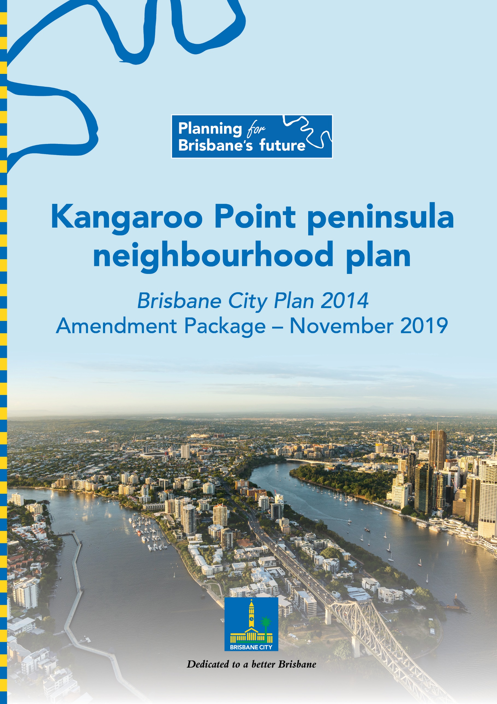

Table of Contents

Part A: Explanatory Notes 3
Glossary 4
Purpose 5
Background 5
What are neighbourhood plans? 5
Community engagement 6
Neighbourhood plan outcomes 7
Amendment summary 18
Part B: Major Amendment v18.00/2020 21
Part 1 Amendment of Part 1 (About the planning scheme) 22
Part 2 Amendment of Part 5 (Tables of assessment) 23
Part 3 Amendment of Part 7 (Neighbourhood plans) 26
Part 4 Amendment of Part 8 (Overlays) 42
Part 5 Amendment of Part 9 (Development codes) 43
Part 6 Amendment of Schedule 2 (Mapping) 44
Part 7 Amendment of Schedule 6 (Planning scheme policies) 48
Part 8 Amendment of Appendix 2 (Table of amendments) 52
Supplement 1—A3 Map Tiles 53

Part A: Explanatory Notes

Glossary

Abbreviation | Term
Council | Brisbane City Council
MCU | Material change of use as defined in the Planning Act 2016
NPP | Neighbourhood plan precinct
the amendment package | Kangaroo Point peninsula neighbourhood plan amendment package
the draft renewal strategy | Kangaroo Point peninsula draft renewal strategy
the neighbourhood plan | Kangaroo Point peninsula neighbourhood plan
the planning scheme | Brisbane City Plan 2014

Purpose

The purpose of these explanatory notes is to provide context to the amendment package, including by outlining key outcomes and the process undertaken to develop the amendment package.

The explanatory notes do not form part of the amendment package.

Background

Council proposes to adopt the amendment package to guide development and coordinate land use in the neighbourhood plan area. The amendment package forms a major amendment to the planning scheme and has been prepared in accordance with Queensland Government requirements.

The amendment package consists of a new neighbourhood plan code for the neighbourhood plan area, revised neighbourhood plan, zone and overlay mapping, and consequential amendments to the planning scheme. Once adopted into the planning scheme, the amendment package will replace the existing neighbourhood plan for Kangaroo Point peninsula.

Council commenced the neighbourhood planning process for Kangaroo Point peninsula in October 2016. The first stage of the process involved preparation of, and community consultation on, the draft renewal strategy. Feedback received on the draft renewal strategy, along with feedback received through the Community Planning Team, was used to inform the second stage of the process, which involved preparation and community consultation on the amendment package. More information about the community engagement process undertaken on the amendment package is outlined in the Community engagement section below.

The amendment package has been prepared in line with the following objectives for the neighbourhood plan area.
- Support growth that provides for the needs of the established residential community and provides leisure and lifestyle opportunities for residents and visitors.
- Facilitate high-quality public realm and streetscape improvements in conjunction with new development.
- Enhance pedestrian and cycle links to parks and the Brisbane River.
- Update planning provisions for the neighbourhood plan area.

What are neighbourhood plans?

Creating a city of neighbourhoods is one of eight principles outlined in Council’s Brisbane’s Future Blueprint.

Council creates neighbourhood plans to guide development in local communities to ensure that each area retains and enhances its own special character and qualities. The neighbourhood plan is the product of technical investigations undertaken by Council, as well as feedback received from the community and other stakeholders over the course of the plan’s preparation.

The existing neighbourhood plan for Kangaroo Point peninsula is more than 20 years old and requires updating. The new neighbourhood plan refines planning provisions to meet the needs of the local community while also maintaining the neighbourhood plan area’s residential character and its landmark heritage and recreation areas.

The neighbourhood plan is a part of Council’s planning scheme. The neighbourhood plan does not duplicate planning provisions that are already contained in the planning scheme (e.g. assessment criteria for overlays), as the neighbourhood plan is a component part of the planning scheme and is not a standalone statutory document.

It is important to recognise that the neighbourhood plan cannot:
- reduce the scale of existing development
- stop already approved development, even if construction has not commenced.

Infrastructure planning for the neighbourhood plan area occurs as part of Council’s Local Government Infrastructure Plan.

Community engagement

Engagement activities for the neighbourhood plan

The neighbourhood planning process for Kangaroo Point peninsula commenced in late 2016 and involved a series of community engagement activities.

The Community Planning Team met three times from November 2016 to October 2017 to provide input to the draft renewal strategy. Engagement on the draft renewal strategy took place from 27 October 2017 to 8 December 2017.

Feedback received on the draft renewal strategy informed preparation of the amendment package.

Engagement on the amendment package took place from 5 October 2018 to 19 November 2018. Council considered feedback received on the amendment package and updated the amendment package in response.

For more information on how Council has addressed community feedback, please refer to the feedback summary reports for both the draft renewal strategy and amendment package. The documents are available for viewing on the project webpage.

Summary of community engagement activities

Table 1 – Community engagement activity summary
Event type | Date | Location | Topic
Community Planning Team | Meeting 1  30 November 2016 | Various | Developing and reviewing the draft renewal strategy
Meeting 2
9 March 2017
Meeting 3
23 October 2017
Draft renewal strategy consultation | 27 October to 8 December 2017 | - | Public consultation and feedback on the draft renewal strategy
Information kiosk | Information kiosk 1  4 November 2017 | Captain Burke Park, Kangaroo Point
 | Information kiosk 2  29 November 2017 | C.T. White Park, Kangaroo Point
Amendment package consultation | 5 October to 19 November 2018 | - | Public consultation and feedback on the amendment package

Neighbourhood plan outcomes

The neighbourhood plan boundary

The Brisbane River, Mowbray Park, Shafston Avenue and the southern boundary of St Vincent’s Private Hospital Brisbane set the boundary for the neighbourhood plan area. The neighbourhood plan area is directly across the river from the City Centre and has approximately three kilometres of Brisbane River frontage.

The neighbourhood plan boundary and precincts are shown in Figure 1.

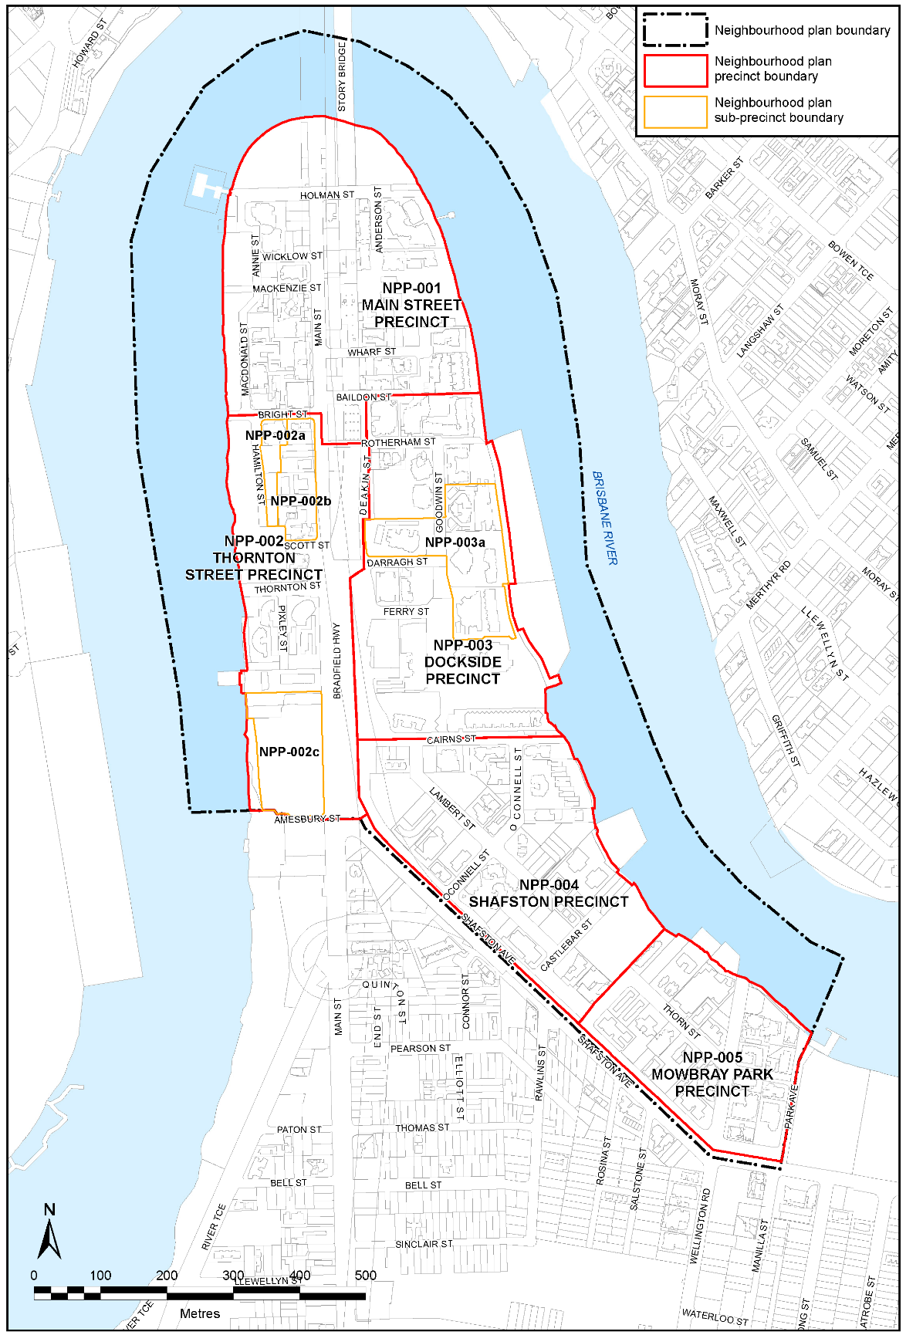
Figure 1—Kangaroo Point peninsula neighbourhood plan boundary and precincts

Precincts

There are five precincts in the neighbourhood plan area:
- Main Street precinct (NPP-001)
- Thornton Street precinct (NPP-002)
  - Bright Street A sub-precinct (NPP-002a)
  - Bright Street B sub-precinct (NPP-002b)
  - St Vincent sub-precinct (NPP-002c)
- Dockside precinct (NPP-003)
  - Dockside core sub-precinct (NPP-003a)
- Shafston precinct (NPP-004)
- Mowbray Park precinct (NPP-005).

Development intent

The intent for development in the neighbourhood plan area is for mid- to high-rise multiple dwellings to predominate, with non-residential uses permitted where they are of a scale that does not negatively affect the amenity enjoyed by residents.

Key areas for change are focused in the Main Street precinct, where Mixed use zoning has been applied over part of the precinct to activate streetscapes and to provide additional commercial services for residents and visitors.

Other changes include the rezoning of land under the Story Bridge and Bradfield Highway from the High density residential zone to the Community facilities zone, to support the use of this land for community purposes over time. Similarly, Community facilities zoning has also been applied to the St Vincent sub-precinct, to better reflect the existing use of this site for community purposes. The Council depot has been included in the Special purpose (Utility services) zone to better reflect the existing use of the site for bridge maintenance purposes.

Key planning outcomes

The amendment package responds to key State-wide, regional and local planning outcomes.

Response to the State Planning Policy July 2017

The amendment package supports the State interests outlined in the State Planning Policy July 2017.

In particular, the amendment package promotes the following State interests.
- Housing supply and diversity – by providing for the development of well-serviced housing on inner-city land.
- Liveable communities – by creating liveable and well-designed communities that support resident wellbeing and enhance quality of life.
- Development and construction – by supporting economic growth through the facilitation of a range of residential and mixed-use development opportunities.
- Cultural heritage – by conserving places of cultural significance and by preserving views to and from the Story Bridge, which is one of Brisbane’s most iconic landmarks.
- Tourism – by supporting lifestyle and leisure opportunities along the Brisbane River as well as tourism experiences associated with the Story Bridge (including retaining views to and from the Story Bridge, as noted above).
- Natural hazards, risk and resilience – by avoiding or mitigating flood and coastal hazard risks to people and property.
- Infrastructure integration – by aligning infrastructure and land use planning.
- Transport infrastructure – by improving active transport connections.

Response to the South East Queensland Regional Plan 2017
The amendment package supports the goals, elements and strategies outlined in the South East Queensland Regional Plan 2017 – ShapingSEQ.

In particular, the amendment package supports the following goals, elements and strategies.
- Goal 1 Grow, Goal 2 Prosper and Goal 3 Connect – by facilitating growth and economic activity in the inner five-kilometre area of regional economic significance.
- Goal 1 Grow and Goal 4 Sustain – by accommodating urban growth in an existing urban area within the Urban Footprint.
- Goal 3 Connect – by prioritising the use of active transport networks in an existing urban area.
- Goal 3 Connect and Goal 5 Live – by planning for high-quality residential development in locations that enjoy good access to public transport, recreation areas and the City Centre.
- Goal 5 Live – by facilitating development that contributes to Kangaroo Point peninsula’s identification as a ‘great place’.

Response to the planning scheme’s Strategic framework

The amendment package is aligned with the Strategic framework of the planning scheme.

Response to local planning outcomes

Kangaroo Point peninsula enjoys convenient access to the City Centre and contains some of Brisbane’s most iconic landmarks, including the Story Bridge, Yungaba Immigration Centre (former) and Shafston House.

The neighbourhood plan area is suitable for increased residential densities and commercial uses, where development maintains views to and from the Story Bridge, and enhances the amenity enjoyed by residents.

The amendment package balances Kangaroo Point peninsula’s existing qualities with its growth potential by ensuring that new development has a desirable bulk and scale and is designed according to subtropical design principles set out in Council’s New World City Design Guide – Buildings that Breathe.

Proposed zone changes

Proposed zoning changes in the neighbourhood plan area are shown in Figure 2.

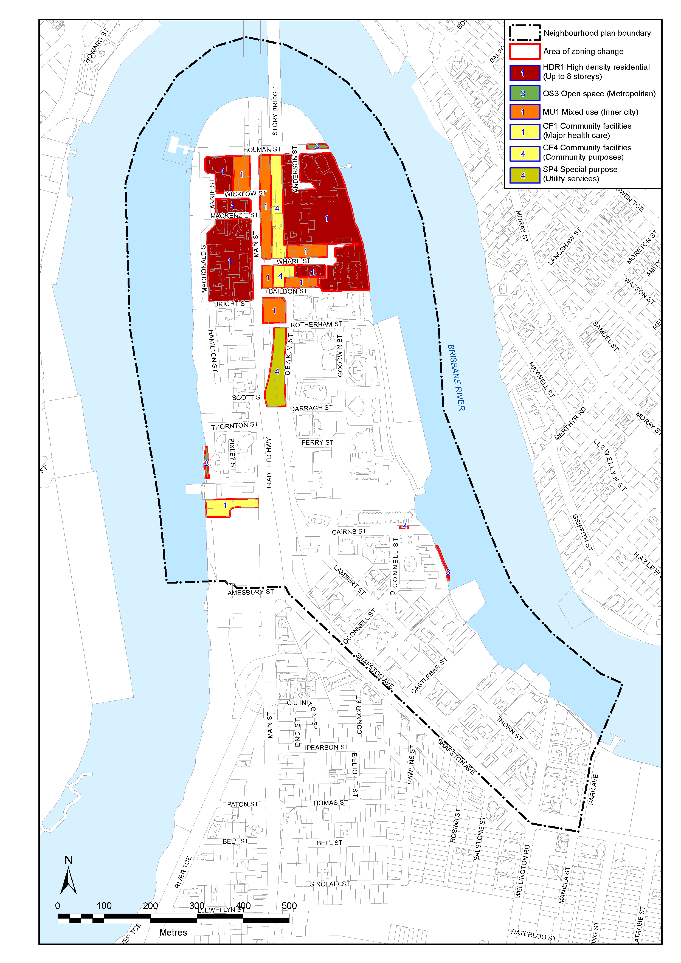

Figure 2—Areas of proposed zoning change

Proposed overlay changes

The amendment package includes changes to the following planning scheme overlays.
- Dwelling house character overlay – to remove properties that are no longer zoned High density residential (see proposed zoning changes in Figure 2 for guidance).
- Heritage overlay – to include two proposed heritage places located at 355 Main Street (the former ‘Travelodge’ building) and the boat shed at 64 Thorn Street.
- Pre-1911 building overlay – to remove properties where pre-1911 buildings are no longer present.
- Significant landscape tree overlay – to include additional significant landscape trees identified throughout the neighbourhood plan area.
- Streetscape hierarchy overlay – to include revised streetscape hierarchy designations throughout the neighbourhood plan area, including locality street advice for part of Main Street.

These changes to overlays are shown in Figure 3 to Figure 7 on the pages that follow.

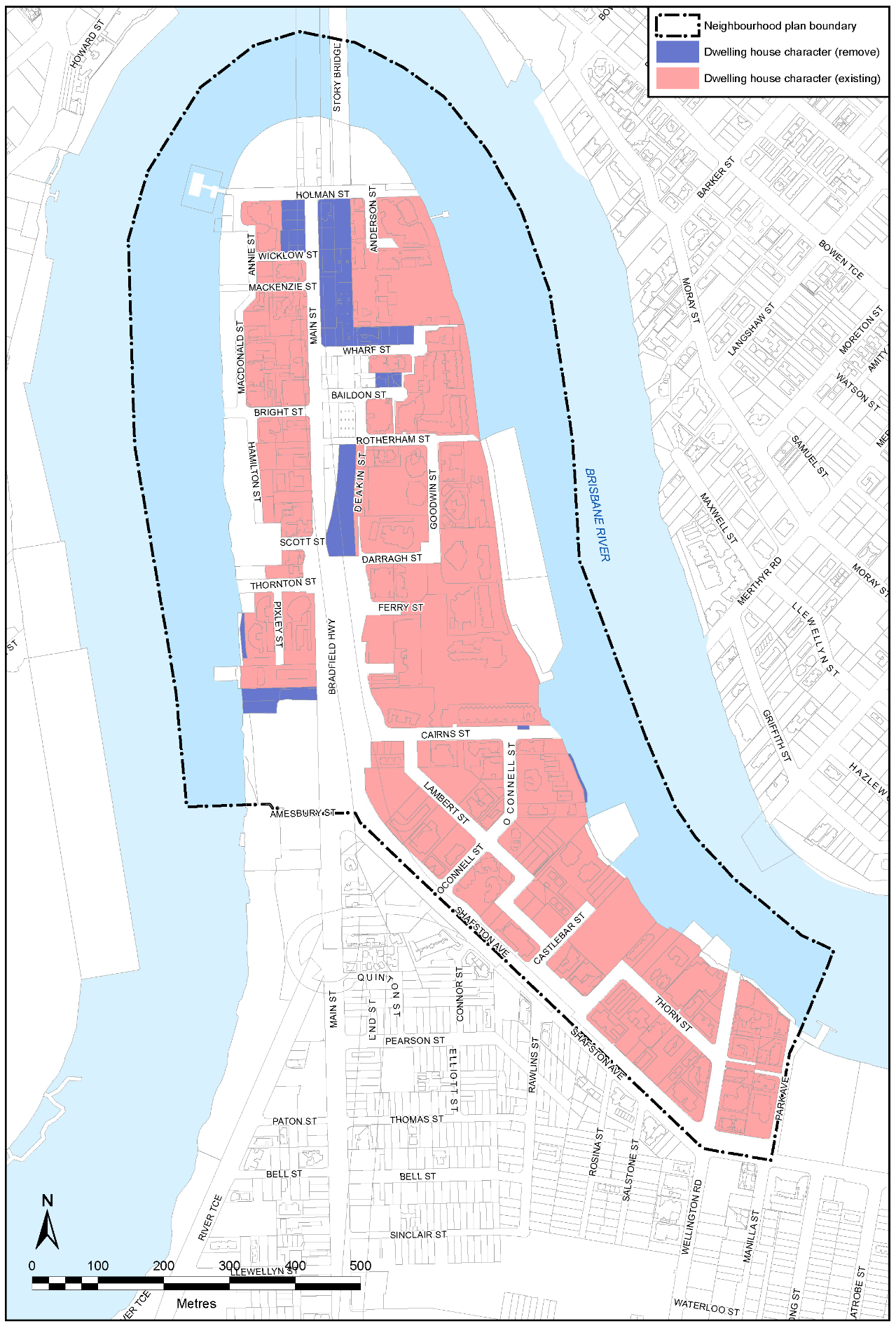
Figure 3—Dwelling house character overlay map

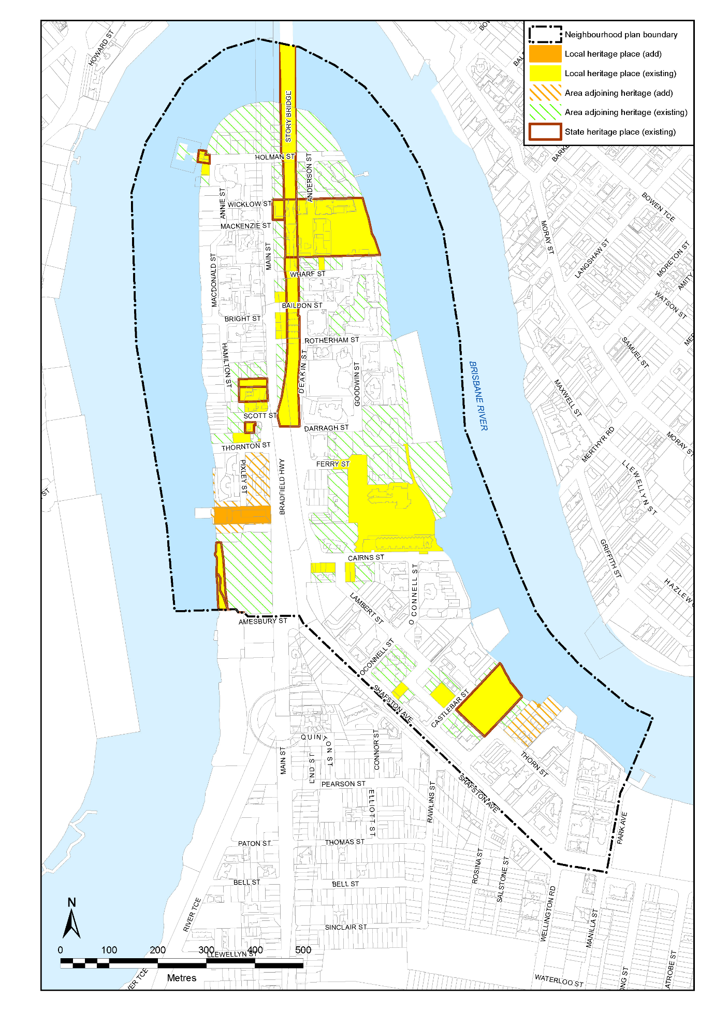

Figure 4—Heritage overlay map

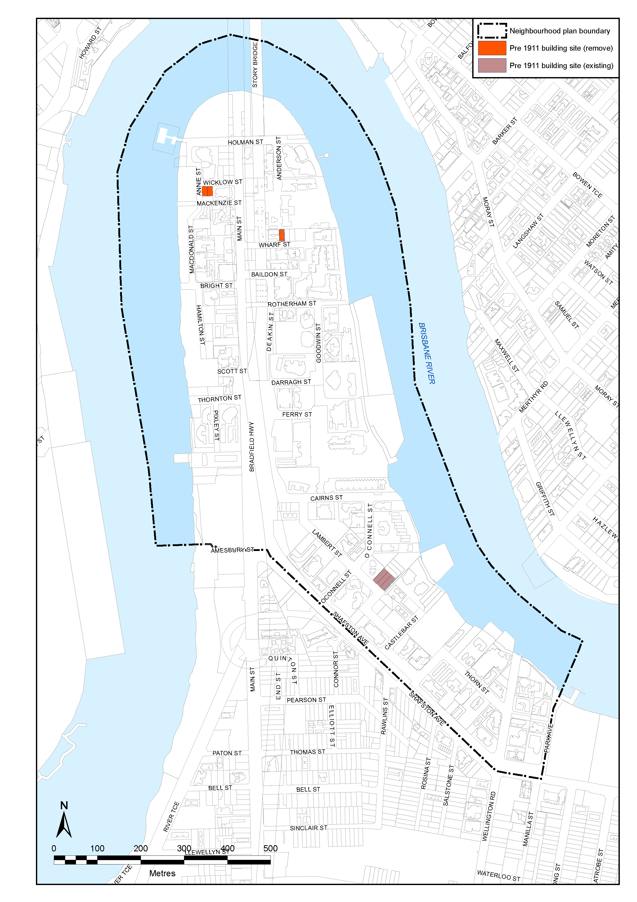

Figure 5—Pre-1911 building overlay map

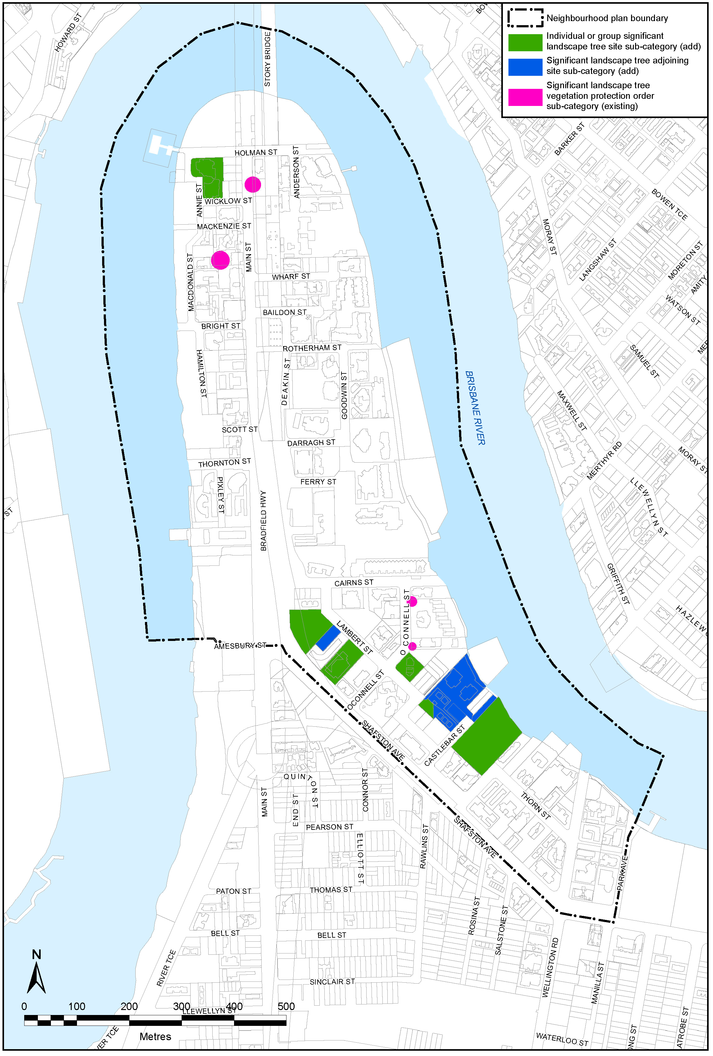

Figure 6—Significant landscape tree overlay map

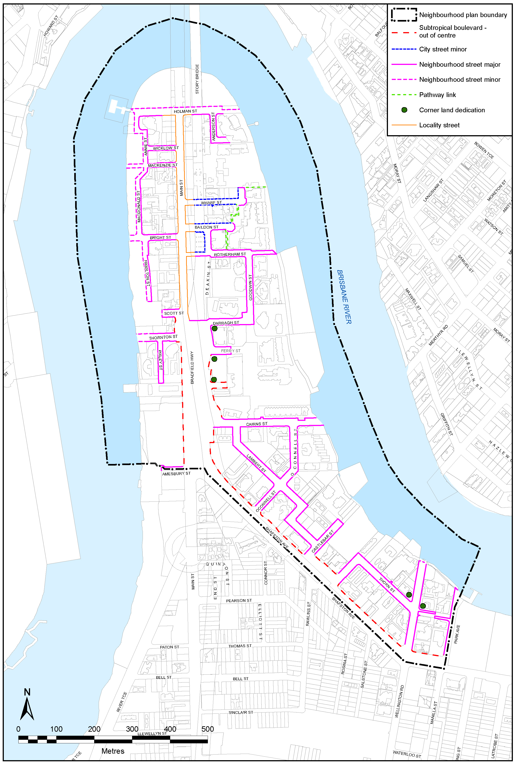

Figure 7—Streetscape hierarchy overlay map

Proposed development code change

The amendment package includes a change to the Transport, access, parking and servicing code to expand the boundary of the City frame area in Figure a—City core and City frame to include all of the neighbourhood plan area. This change is shown in Figure 8.

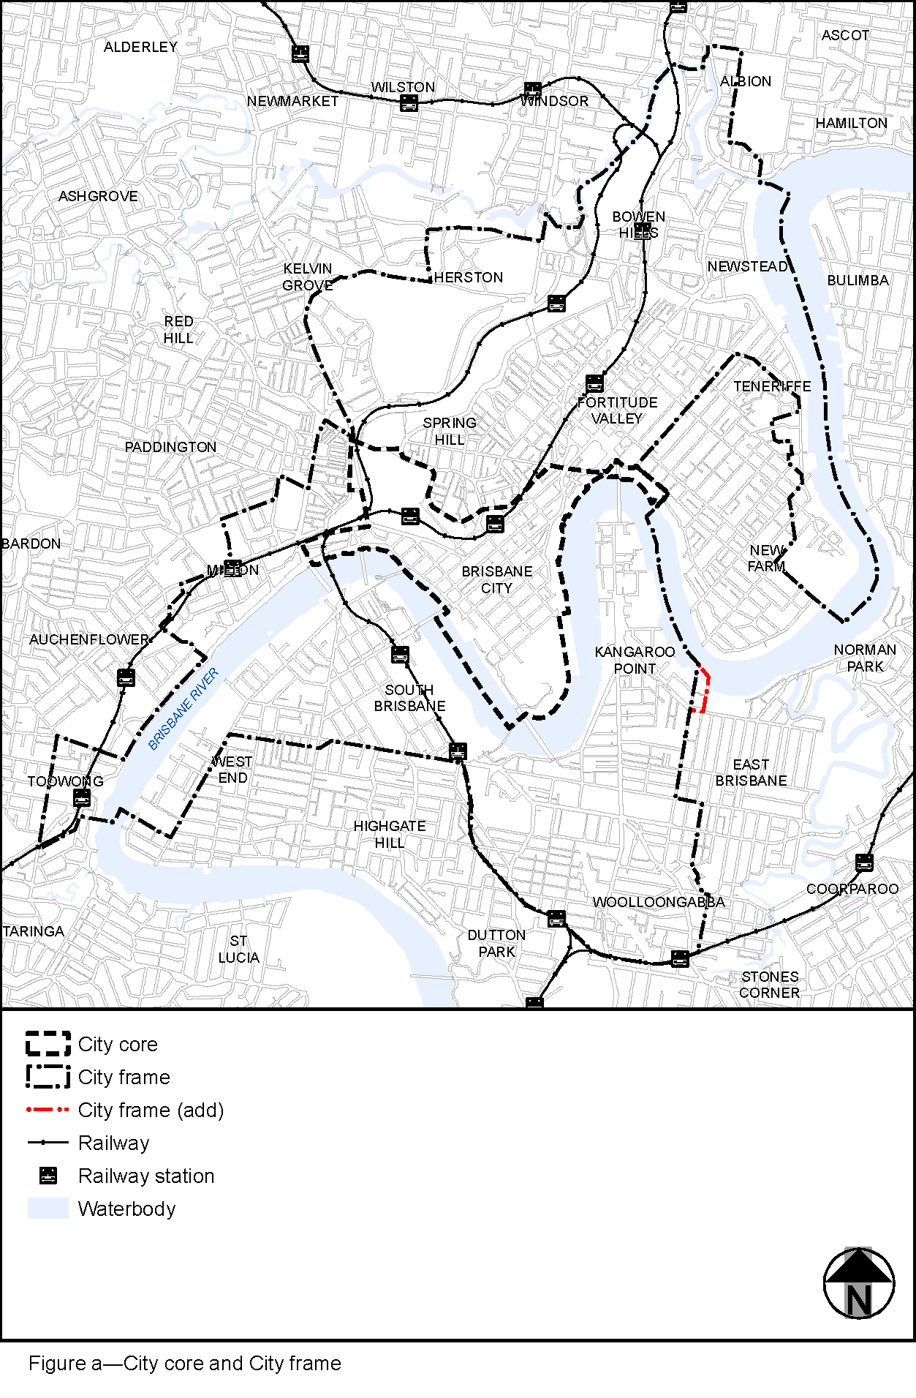

Figure 8—City core and City frame

Amendment summary
Table 2 – Amendment summary
Planning scheme part | Planning scheme reference | Proposed amendment | Part B amendment reference
Part 1  (About the planning scheme) | Section 1.2  Planning scheme components,  Table 1.2.2—Neighbourhood plans precincts and sub-precincts | Replace the existing Kangaroo Point peninsula NPPs with the following precincts:  - NPP-001 Main Street  - NPP-002 Thornton Street  - NPP-002a Bright Street A  - NPP-002b Bright Street B  - NPP-002c St Vincent  - NPP-003 Dockside  - NPP-003a Dockside core  - NPP-004 Shafston  - NPP-005 Mowbray Park. | Part 1.1 (1)
Part 5  (Tables of assessment) | Section 5.9  Categories of development and assessment—Neighbourhood plans,  Table 5.9.32.A—Kangaroo Point peninsula neighbourhood plan: material change of use | Replace the existing MCU categories of development and assessment table for Kangaroo Point peninsula neighbourhood plan with a new MCU categories of development and assessment table. | Part 2.1 (2)
Part 7  (Neighbourhood plans) | Section 7.2  Neighbourhood plan codes,  7.2.11.1 Kangaroo Point peninsula neighbourhood plan code | Replace the existing Kangaroo Point peninsula neighbourhood plan code with a new neighbourhood plan code, including supporting figures. | Part 3.1 (3)
Part 8  (Overlays) | Section 8.2  Overlay codes,  Section 8.2.19  Significant landscape tree overlay code,  Table 8.2.19.3.C—Significant landscape trees in specific locations | Add significant landscape trees identified in the neighbourhood plan area. | Part 4.1 (4)
Part 9  (Development codes) | Section 9.4  Other development codes,  Section 9.4.11 Transport, access, parking and servicing code | Amend Figure a—City core and City frame to include all of the neighbourhood plan area within the City frame area. | Part 5.1 (5)
Schedule 2  (Mapping) | SC2.2 Zone maps,  ZM-001  (Map tile 28) | Amend the zone map tile to include changes to zoning in the neighbourhood plan area. | Part 6.1 (6)
 | SC2.2 Zone maps,  Table SC2.2.1—Zone maps | Reference the amended zone map within the relevant table. | Part 6.1 (7)
 | SC2.3 Neighbourhood plan maps,  NPM-011.1 Kangaroo Point peninsula neighbourhood plan map | Amend the neighbourhood plan map for Kangaroo Point peninsula to reflect changes to precincts and the revised neighbourhood plan area boundary. | Part 6.2 (8)
 | SC2.3 Neighbourhood plan maps,  Table SC2.3.1—Neighbourhood plan maps | Reference the neighbourhood plan map within the relevant table. | Part 6.2 (9)
 | SC2.4 Overlay maps,  OM-004.1  Dwelling house character overlay map  (Map tile 28) | Amend the overlay map to remove properties no longer zoned High density residential. | Part 6.3 (10)
 | SC2.4 Overlay maps,  OM-008.1  Heritage overlay map  (Map tile 28) | Amend the overlay map to identify properties for heritage protection. | Part 6.3 (11)
 | SC2.4 Overlay maps,  OM-016.2  Pre-1911 building overlay map  (Map tile 28) | Amend the overlay map to remove properties that no longer contain buildings built before 1911. | Part 6.3 (12)
 | SC2.4 Overlay maps,  OM-019.1  Significant landscape tree overlay map  (Map tile 28) | Amend the overlay to identify significant landscape trees. | Part 6.3 (13)
 | SC2.4 Overlay maps,  OM-019.2  Streetscape hierarchy overlay map  (Map tile 28) | Amend the overlay to include revised streetscape hierarchy classifications and identify parts of Main Street as a Locality street with specific streetscape treatment standards. | Part 6.3 (14)
 | SC2.4 Overlay maps,  Table SC2.4.1—Overlay maps | Reference the overlay maps within the relevant table. | Part 6.3 (15) to (19)
Schedule 6  (Planning scheme policies) | SC6.16 Infrastructure design planning scheme policy,  Chapter 5 Streetscape locality advice, Table 5.1.2—Locality streets within Neighbourhood plan areas and other locations | Insert new row for Kangaroo Point peninsula streetscape locality advice. | Part 7.1 (20)
 | SC6.16 Infrastructure design planning scheme policy,  Chapter 5 Streetscape locality advice,  Section 5.3 Neighbourhood plans and other locations | Include streetscape locality advice for Kangaroo Point peninsula. | Part 7.1 (21)
Appendix 2  (Table of amendments) | Table AP2.1—Table of amendments | Insert adoption and effective dates, planning scheme version number, amendment type and summary of amendments. | Part 8.1 (22)

Part B: Major Amendment v18.00/2020

It is hereby certified that this is a true and correct copy of Brisbane City Plan 2014 Major Amendment v18.00/2020 made, in accordance with the Planning Act 2016, by Brisbane City Council.

Dyan Currie
Chief Planner
City Planning and Economic Development
City Planning and Sustainability
Brisbane City Council

- Amendment of Part 1 (About the planning scheme)
  - Amendment of section 1.2 (Planning scheme components)
- Section 1.2 Planning scheme components, Table 1.2.2—Neighbourhood plans precincts and sub-precincts
‘
Kangaroo Point peninsula neighbourhood plan | NPP-001: Residential  NPP-002: Community convenience centre  NPP-003: Park  NPP-004: Dockside  NPP-004a: Dockside A  NPP-004b: Dockside A1  NPP-004c: Dockside B1  NPP-004d: Dockside B2  NPP-004e: Dockside B3  NPP-004f: Dockside C1  NPP-004g: Dockside C2  NPP-004h: Dockside D1  NPP-004i: Dockside D2  NPP-004j: Dockside E1  NPP-004k: Dockside E2  NPP-004l: Dockside F  NPP-004m: Dockside G  NPP-004n: Dockside H  NPP-004o: Dockside I
’–
omit, insert:
‘
Kangaroo Point peninsula neighbourhood plan | NPP-001: Main Street  NPP-002: Thornton Street  NPP-002a: Bright Street A  NPP-002b: Bright Street B  NPP-002c: St Vincent  NPP-003: Dockside  NPP-003a: Dockside core  NPP-004: Shafston  NPP-005: Mowbray Park
’.

- Amendment of Part 5 (Tables of assessment)
  - Amendment of section 5.9 (Categories of development and assessment—Neighbourhood plans)
- Section 5.9 Categories of development and assessment—Neighbourhood plans, Table 5.9.32.A—Kangaroo Point peninsula neighbourhood plan: material change of use–
omit, insert:
‘

Table 5.9.32.A—Kangaroo Point peninsula neighbourhood plan: material change of use
Use | Categories of development and assessment |  | Assessment benchmarks
If in the neighbourhood plan area
MCU, if assessable development where not listed in this table | No change |  | Kangaroo Point peninsula neighbourhood plan code
MCU whether or not subsequently listed in this table | Assessable development—Impact assessment
 | If involving a new premises or an existing premises with an increase in gross floor area, where:  - greater than the maximum building height specified in Table 7.2.11.1.3.B of the Kangaroo Point peninsula neighbourhood plan code; or  - greater than the site cover specified in Table 7.2.11.1.3.G of the Kangaroo Point peninsula neighbourhood plan code |  | The planning scheme
If in the Main Street precinct (NPP-001), where in the Mixed use zone
Bar | Assessable development—Code assessment
 | If on a site fronting the eastern side of Main Street, where located between Wharf Street and Holman Street | Kangaroo Point peninsula neighbourhood plan code  Centre or mixed use code  Prescribed secondary code
Garden centre | Assessable development—Impact assessment
 | - |  | The planning scheme
Hardware and trade supplies | Assessable development—Impact assessment
 | - |  | The planning scheme
Showroom | Assessable development—Impact assessment
 | - |  | The planning scheme
Hotel | Assessable development—Code assessment
 | If involving an existing premises with an increase in gross floor area, where additional gross floor area is no greater than 200m2 |  | Kangaroo Point peninsula neighbourhood plan code  Centre or mixed use code  Prescribed secondary code
If in the Main Street precinct (NPP-001), the Thornton Street precinct (NPP-002), the Mowbray Park precinct (NPP-005), where in the High density residential zone and with frontage to Main Street or Park Avenue
Food and drink outlet | Assessable development—Code assessment
 | If involving a new premises or an existing premises with an increase in gross floor area, where:  - gross floor area is no greater than 100m2;  - the use is located at street level |  | Kangaroo Point peninsula neighbourhood plan code  Centre or mixed use code  Prescribed secondary code
Office | Assessable development—Code assessment
 | If involving a new premises or an existing premises with an increase in gross floor area, where:  - gross floor area is no greater than 100m2;  - the use is located at street level |  | Kangaroo Point peninsula neighbourhood plan code  Centre or mixed use code  Prescribed secondary code
Shop | Assessable development—Code assessment
 | If involving a new premises or an existing premises with an increase in gross floor area, where:  - gross floor area is no greater than 100m2;  - the use is located at street level |  | Kangaroo Point peninsula neighbourhood plan code  Centre or mixed use code  Prescribed secondary code
If in the Dockside precinct (NPP-003)
Food and drink outlet | Accepted development, subject to compliance with identified requirements
 | If involving an existing premises with no increase in gross floor area, where complying with all acceptable outcomes in section A of the Centre or mixed use code |  | Not applicable
 | Assessable development—Code assessment
 | If involving an existing premises with no increase in gross floor area, where not complying with all acceptable outcomes in section A of the Centre or mixed use code |  | Centre or mixed use code—purpose, overall outcomes and section A outcomes only
 | If involving a new premises or an existing premises with an increase in gross floor area, where total gross floor area is no greater than 250m2 for any individual tenancy |  | Kangaroo Point peninsula neighbourhood plan code  Centre or mixed use code  Prescribed secondary code
Indoor sport and recreation | Assessable development—Code assessment
 | - |  | Kangaroo Point peninsula neighbourhood plan code  Indoor sport and recreation code  Prescribed secondary code
Outdoor sport and recreation | Assessable development—Code assessment
 | - |  | Kangaroo Point peninsula neighbourhood plan code  Outdoor sport and recreation code  Prescribed secondary code
Shop | Accepted development, subject to compliance with identified requirements
 | If involving an existing premises with no increase in gross floor area, where complying with all acceptable outcomes in section A of the Centre or mixed use code |  | Not applicable
 | Assessable development—Code assessment
 | If involving an existing premises with no increase in gross floor area, where not complying with all acceptable outcomes in section A of the Centre or mixed use code |  | Centre or mixed use code—purpose, overall outcomes and section A outcomes only
 | If involving a new premises or an existing premises with an increase in gross floor area, where total gross floor area is no greater than 250m2 for any individual tenancy |  | Kangaroo Point peninsula neighbourhood plan code  Centre or mixed use code  Prescribed secondary code
’.

- Amendment of Part 7 (Neighbourhood plans)
  - Amendment of section 7.2 (Neighbourhood plan codes)
- Section 7.2 Neighbourhood plan codes, 7.2.11.1 Kangaroo Point peninsula neighbourhood plan code–
omit, insert:
‘

7.2.11.1 Kangaroo Point peninsula neighbourhood plan code
- 7.2.11.1.1 Application
  - This code applies to assessing a material change of use, reconfiguring a lot, operational work or building work in the Kangaroo Point peninsula neighbourhood plan area if:
    - assessable development where this code is an applicable code identified in the assessment benchmarks column of a table of assessment for a neighbourhood plan (section 5.9); or
    - impact assessable development.
  - Land in the Kangaroo Point peninsula neighbourhood plan area is identified on the NPM-011.1 Kangaroo Point peninsula neighbourhood plan map and includes the following precincts:
    - Main Street precinct (Kangaroo Point peninsula neighbourhood plan/NPP-001);
    - Thornton Street precinct (Kangaroo Point peninsula neighbourhood plan/NPP-002):
      - Bright Street A sub-precinct (Kangaroo Point peninsula neighbourhood plan/NPP-002a);
      - Bright Street B sub-precinct (Kangaroo Point peninsula neighbourhood plan/NPP-002b);
      - St Vincent sub-precinct (Kangaroo Point peninsula neighbourhood plan/NPP-002c);
    - Dockside precinct (Kangaroo Point peninsula neighbourhood plan/NPP-003):
      - Dockside core sub-precinct (Kangaroo Point peninsula neighbourhood plan/NPP-003a);
    - Shafston precinct (Kangaroo Point peninsula neighbourhood plan/NPP-004);
    - Mowbray Park precinct (Kangaroo Point peninsula neighbourhood plan/NPP-005).
  - When using this code, reference should be made to section 1.5, section 5.3.2 and section 5.3.3.
Note—The following purpose, overall outcomes, performance outcomes and acceptable outcomes comprise the assessment benchmarks of this code.
Note—This neighbourhood plan includes a table of assessment with variations to categories of development and assessment. Refer to Table 5.9.32.A, Table 5.9.32.B, Table 5.9.32.C and Table 5.9.32.D.
Note—The preparation of an Urban context report, in accordance with Table 7.2.11.1.3.C, will assist in demonstrating how development achieves the outcomes of this neighbourhood plan. Preparation of an Urban context report is required for development in the Mixed use zone, as well as development in any other zone where proposed building height exceeds 10 storeys.
Note—Council’s Independent Design Advisory Panel may be invited to provide advice on development, to facilitate high-quality development, in accordance with the provisions of the Independent design advisory panel planning scheme policy.
Editor’s note—Council’s New World City Design Guide – Buildings that Breathe sets out the vision, design elements and best practice case studies to guide subtropical building design in Brisbane. Development is actively encouraged to incorporate these design elements and embrace the city’s subtropical climate.
Editor’s note—The Kangaroo Point peninsula draft renewal strategy sets out the vision for the neighbourhood plan area and, among other things, provides useful background information to the intended use and operation of the Bridge undercroft area identified in Figure a. Refer to sub-strategy 2C and Catalyst Project 1 of the draft renewal strategy for more information.
- 7.2.11.1.2 Purpose
  - The purpose of the Kangaroo Point peninsula neighbourhood plan code is to provide finer grained planning at a local level for the Kangaroo Point peninsula neighbourhood plan area.
  - The purpose of the Kangaroo Point peninsula neighbourhood plan code will be achieved through overall outcomes including overall outcomes for each precinct of the neighbourhood plan area.
  - The overall outcomes for the neighbourhood plan area are:
    - The Story Bridge is an important city landmark that visually dominates the neighbourhood plan area and is highly visible to and from nearby public vantage points.
    - A pedestrian and cyclist bridge connects Kangaroo Point peninsula to the City Centre, significantly enhancing active transport movement networks.
    - Development does not exceed building heights specified in the neighbourhood plan unless there is an overwhelming community need for the development at that greater building height within the neighbourhood plan area and views to and from the Story Bridge are preserved.
    - Development is designed to take advantage of Brisbane’s subtropical climate and delivers high-quality architectural and landscape design that enhances amenity in the neighbourhood plan area.
    - Development facilitates safe and convenient public pedestrian access to community facilities, recreational facilities and open spaces, including the Brisbane River.
  - Main Street precinct (Kangaroo Point peninsula neighbourhood plan/NPP-001) overall outcomes are:
    - The Main Street precinct (Kangaroo Point peninsula neighbourhood plan/NPP-001) is predominantly residential, and includes some commercial, community and recreational uses.
    - Development has a built form that is subordinate to the Story Bridge, and preserves views to and from the Story Bridge and Bradfield Highway deck.
    - Development promotes Main Street’s revitalisation as an active high street and Inner City destination through a combination of street level non-residential activation, visible front entrances and high-quality streetscape design.
    - Development in the Mixed use zone has a scale and form that is compatible with the residential character and amenity of the precinct, and is set back from Main Street to accommodate subtropical planting and shaded outdoor spaces that complement Main Street’s existing landscape character.
    - Development incorporating a rooftop bar is located in the Mixed use zone, where located on a site fronting the eastern side of Main Street, between Wharf Street and Holman Street.
  - Thornton Street precinct (Kangaroo Point peninsula neighbourhood plan/NPP-002) overall outcomes are:
    - The Thornton Street precinct (Kangaroo Point peninsula neighbourhood plan/NPP-002) includes a mix of residential and community facility uses that support the precinct’s role as an established residential community, and a location for significant health services.
    - Development preserves views to and from the Story Bridge and Bradfield Highway deck.
    - Development provides well-spaced towers that are sited and designed to maintain the openness of street vistas with adequate spacing between buildings to allow for light penetration, air circulation, and privacy.
    - Development complements the heritage and landscape qualities of the precinct, and presents a human-scale frontage to the street.
    - Development provides publicly accessible pedestrian connections to join Main Street, Amesbury Street and Pixley Street.
  - Dockside precinct (Kangaroo Point peninsula neighbourhood plan/NPP-003) overall outcomes are:
    - The Dockside precinct (Kangaroo Point peninsula neighbourhood plan/NPP-003) includes a mix of residential, retail, recreation and publicly accessible open space areas.
    - Development for non-residential purposes enhances the public realm and activates streetscapes and public walkways.
    - Development maintains sight lines between buildings to the Brisbane River and between Goodwin Street and Cairns Street, and reinforces the tower in landscaped plaza development form that contributes to the precinct’s unique character and high level of residential amenity.
    - Development maintains the function of existing open space and recreation areas and public walkways, and retains the dock as an iconic feature of the precinct.
  - Shafston precinct (Kangaroo Point peninsula neighbourhood plan/NPP-004) overall outcomes are:
    - The Shafston precinct (Kangaroo Point peninsula neighbourhood plan/NPP-004) accommodates predominantly multiple dwelling uses.
    - Development provides well-spaced towers that are sited and designed to maintain the openness of street vistas with adequate spacing between buildings to allow for light penetration, air circulation, and privacy.
  - Mowbray Park precinct (Kangaroo Point peninsula neighbourhood plan/NPP-005) overall outcomes are:
    - The Mowbray Park precinct (Kangaroo Point peninsula neighbourhood plan/NPP-005) accommodates predominantly multiple dwelling uses.
    - Development provides well-spaced towers that are sited and designed to maintain the openness of street vistas with adequate spacing between buildings to allow for light penetration, air circulation, and privacy.
    - Development on a site fronting Park Avenue has an increased setback from the street boundary to establish a landscape buffer between buildings and Mowbray Park.

- 7.2.11.1.3 Performance outcomes and acceptable outcomes

Table 7.2.11.1.3.A—Performance outcomes and acceptable outcomes
Performance outcomes | Acceptable outcomes
General
PO1  Development is of a height that achieves the intended outcome for the neighbourhood plan, improves the amenity of the neighbourhood plan area, contributes to a cohesive streetscape and built form character and is:  - consistent with anticipated density and assumed infrastructure demand;  - aligned with community expectations about the number of storeys to be built;  - proportionate to and commensurate with the utility of the site area and frontage width;  - designed to avoid a significant and undue adverse amenity impact to adjoining development.  Note—Development that exceeds the intended number of storeys or building height can place disproportionate pressure on the transport network, public space or community facilities in particular.  Note—Development that exceeds the maximum building height may interrupt public view corridors identified in Figure d and may diminish the prominence of the Story Bridge as a city landmark. | AO1  Development complies with the building height specified in Table 7.2.11.1.3.B—Maximum building height.  Note—Neighbourhood plans will mostly specify a maximum number of storeys where zone outcomes have been varied in relation to building height. Some neighbourhood plans may also specify height in metres. Development must comply with both parameters where maximum number of storeys and height in metres are specified.
PO2  Development in the River edge transition area presents a low-scale built form to the river. | AO2  Development in the River edge transition area has a building height no greater than 4 storeys.  Note—The River edge transition area is any part of a site shown in Figure a as being subject to the River edge transition area which is located no more than 40m landward from the level of the highest astronomical tide.
PO3  Development is of a scale and form that contributes to a cohesive streetscape and built form character and is:  - consistent with anticipated density and assumed infrastructure demand;  - designed to avoid a significant and undue adverse amenity impact to adjoining development;  - sited and designed to enable existing and future buildings to be well separated from each other to allow for light penetration, air circulation between buildings, and the preservation of views, vistas and resident privacy;  - designed to respect the existing built form of properties identified in the Commercial character building overlay, Heritage overlay, or Pre-1911 building overlay;  - designed so as to not interfere with the maintenance of the Story Bridge;  - designed to provide subtropical planting that contributes to the landscape character of the neighbourhood plan area.  Note—Development that is over-scaled for its site can result in an undesirable built form that significantly reduces amenity and streetscape character. | AO3.1  Development is setback in accordance with:  - where in the High density residential zone, Table 7.2.11.1.3.D—High density residential zone boundary setback requirements; or  - where in the Mixed use zone, and where on a site with a frontage to Main Street, Table 7.2.11.1.3.E—Mixed use zone boundary setback requirements.
AO3.2
Development achieves building separation in accordance with Table 7.2.11.1.3.F—Minimum building separation requirements.
AO3.3
Development has a site cover in accordance with Table 7.2.11.1.3.G—Maximum site cover requirements.
PO4  Development ensures that the roofs of buildings overlooked from the Story Bridge present an interesting and tidy roofscape not marred by the placement of unenclosed mechanical plant and utility structures.  Note—For the purposes of this performance outcome, mechanical plant and utility structures does not include solar panels, or rooftop gardens. | AO4  No acceptable outcome is prescribed.
PO5  Development may include a supermarket where there is a community need and economic need for the supermarket and it is consistent with the overall outcomes for the relevant precinct. | AO5  No acceptable outcome is prescribed.
PO6  Development preserves views to and from the Story Bridge, including the Bradfield Highway deck, as identified in Figure d. | AO6  No acceptable outcome is prescribed.
If in the Main Street precinct (Kangaroo Point peninsula neighbourhood plan/NPP-001), where in the Mixed use zone
PO7  Development for a large format, high traffic generating use, including garden centre, hardware and trade supplies, and/or showroom, is not located in the precinct due to the constraints of the local road network and the potential for adverse impacts on residential amenity. | AO7  No acceptable outcome is prescribed.
PO8  Development includes a podium that frames the public realm, contributes to the vibrancy of the street and reinforces Main Street as an active high street.  Editor’s note—Refer to Figure f for guidance in achieving this performance outcome. | AO8.1  Development has a maximum podium height of 2 storeys, or 8m, whichever is lower.
AO8.2
Development incorporates non-residential uses at street level.
AO8.3
Development incorporates landscaping and communal space on top of the podium.
PO9  Development provides building articulation and design elements that address adjacent buildings and maintain high levels of amenity on adjoining sites. | AO9  Development does not present a blank wall to adjoining properties in the:  - Community facilities zone; or  - High density residential zone; or  - Heritage overlay; or  - Pre-1911 building overlay.
PO10  Development:  - provides pedestrian connections between Main Street and the Bridge undercroft area identified in Figure a;  - is designed to provide sight lines from Main Street to the Story Bridge deck and undercarriage;  - maintains open and direct sight lines through the Bridge undercroft area between Baildon Street and Holman Street, as identified in Figure a.  Editor’s note—Refer to Figure f for guidance in achieving this performance outcome. | AO10  No acceptable outcome is prescribed.
If in the Thornton Street precinct (Kangaroo Point peninsula neighbourhood plan/NPP-002)
PO11  Development complements the heritage and landscape qualities of:  - C.T. White Park;  - St Mary’s Anglican Church;  - Kangaroo Point cliffs. | AO11  No acceptable outcome is prescribed.
PO12  Development provides publicly accessible pedestrian connections to join Main Street, Amesbury Street and Pixley Street. | AO12  No acceptable outcome is prescribed.
PO13  Development does not adversely impact the preferred siting, design and delivery of a pedestrian and cyclist bridge to the City Centre. | AO13  No acceptable outcome is prescribed.
If in the Dockside precinct (Kangaroo Point peninsula neighbourhood plan/NPP-003)
PO14  Development maintains the function of areas identified in Figure e, being:  - Dockside square and Dockside walkway as safe and well-connected public pedestrian and cyclist access areas;  - Dockside green space as an open landscaped area;  - Dockside dock as an historical landmark with opportunities for river access;  - Dockside sport and recreation area for leisure, sport and recreation activities. | AO14  No acceptable outcome is prescribed.
PO15  Development:  - maintains open and direct sight lines between Cairns Street and Goodwin Street, and from Deakin Street to the Brisbane River, as identified in Figure e;  - provides pedestrian connections between Goodwin Street and the riverside portion of the Dockside walkway area. | AO15  No acceptable outcome is prescribed.
PO16  Development for non-residential purposes:  - maintains a high level of residential amenity;  - addresses the Dockside square and Dockside walkway areas identified in Figure e;  - enhances the public realm. | AO16  No acceptable outcome is prescribed.

Table 7.2.11.1.3.B—Maximum building height
Development | Maximum building height
If in the Main Street precinct (Kangaroo Point peninsula neighbourhood plan/NPP-001)
All development | Development has a maximum building height that does not exceed the maximum building height contours in Figure b
If in the Thornton Street precinct (Kangaroo Point peninsula neighbourhood plan/NPP-002), where not in the Community purposes zone precinct of the Community facilities zone
Development of a site less than 800m2 where not in a sub-precinct | 8 storeys
Development of a site 800m2 or greater where not in a sub-precinct | 15 storeys
Development in the Bright Street A sub-precinct (NPP-002a) | 12 metres
Development in the Bright Street B sub-precinct (NPP-002b) | Development has a maximum building height that does not exceed the maximum building height depicted in Figure c
Development in the St Vincent sub-precinct (NPP-002c) | 10 storeys
If in the Dockside precinct (Kangaroo Point peninsula neighbourhood plan/NPP-003), where not in the Community facilities zone
Development of a site less than 800m2 | 8 storeys
Development of a site 800m2 or greater but less than 1,200m2 | 12 storeys
Development of a site 1,200m2 or greater where not in the Dockside core sub-precinct (NPP-003a) | 15 storeys
Development of a site 1,200m2 or greater where in the Dockside core sub-precinct (NPP-003a) | 20 storeys
If in the Shafston precinct (Kangaroo Point peninsula neighbourhood plan/NPP-004)
Development of a site less than 800m2 | 8 storeys
Development of a site 800m2 or greater | 15 storeys
If in the Mowbray Park precinct (Kangaroo Point peninsula neighbourhood plan/NPP-005)
Development of a site less than 800m2 | 8 storeys
Development of a site 800m2 or greater | 12 storeys
Note—Maximum building height in the Main Street precinct is the height contours in the contour-based building height control area depicted in Figure b.
Note—Maximum building height in the Bright Street B sub-precinct is derived using the calculation method depicted in Figure c.
Editor’s note—Use of the Virtual Brisbane 3D model may assist in demonstrating compliance with building height controls in the Main Street precinct and Bright Street B sub-precinct.

Table 7.2.11.1.3.C—Urban context report
Content | Scope (and format)
Site characteristics | Demonstrate how the site’s constraints and attributes have been considered in the design of the development.
Cityscape and built form | Demonstrate how the development:  - provides a site-responsive built form taking into account site characteristics and form of surrounding development, including the relationship with other buildings in terms of setbacks, privacy, light and air;  - provides a contextually responsive built form taking into account site location within Kangaroo Point peninsula;  - impacts on views to and from the Story Bridge;  - impacts on broader views across the cityscape and of the city skyline;  - exhibits outstanding architectural merit.
Streetscape | Demonstrate how the development impacts on and contributes to the streetscape and street functioning, in terms of:  - building height, setbacks and design;  - street level activation, including proportion of glazing and openings;  - footpath width, continuity and design.
Heritage, landmarks, natural assets, views and vistas | Demonstrate how the development:  - respects the streetscape and public realm context and setting of nearby heritage buildings and places, landmarks and natural assets, including the Story Bridge, Yungaba Immigration Centre (former), Evans Deakin Dry Dock (former), and Shafston House;  - maintains or creates views from public vantage points to heritage places, landmarks and natural assets, and across public realm.
Public realm, connections, attractors and movement network | Demonstrate how the development:  - respects, enhances, expands and/or connects to adjoining and nearby public realm;  - maintains and enhances pedestrian permeability, including to major attractors and the wider movement network.
Subtropical climate | Demonstrate how the development design incorporates orientation, shading, outdoor spaces, natural ventilation, landscaping and articulation to reduce heat loading, protect from weather, optimise natural light and support outdoor lifestyles.
Note—The Urban context report provides a formal means for developers, architects and designers to clearly articulate how the development successfully responds to the site, its context and climate. This report should comprise plans, diagrams, perspectives, 3D modelling (including use of the Virtual Brisbane 3D model to test development options) and supporting design rationales to demonstrate how the proposal achieves the outcomes of this neighbourhood plan.
Editor’s note—Council’s New World City Design Guide – Buildings that Breathe sets out the vision, design elements and best practice case studies to guide subtropical building design in Brisbane. Development is actively encouraged to incorporate these design elements and embrace the city’s subtropical climate.

Table 7.2.11.1.3.D—High density residential zone boundary setback requirements
Site | Minimum boundary setback (m)
 | Front/street |  | Rear |  | Side
 | To balcony | To wall | To balcony | To wall
Where in the Main Street precinct and the site does not contain a landscape buffer identified in Figure a | 3 | 4 | 4 | 6 | 4
Where not in the Main Street precinct and the site does not contain a landscape buffer identified in Figure a | 4 | 6 | 6 | 8 | 6
Where not in the Main Street precinct and the site contains a landscape buffer identified in Figure a | 6 | 8 | 6 | 8 | 6

Table 7.2.11.1.3.E—Mixed use zone boundary setback requirements
Development | Minimum boundary setback (m)
 | Front/ street | Side | Rear | Where affected by the Regional infrastructure corridors and substations overlay | Where adjoining land in the High density residential zone (measured from common boundary) | Where adjoining land in the Pre-1911 building overlay (measured from common boundary)
Where on a site with a frontage to Main Street
For the part of the building up to 8m | 2 | 0 | 0 | Development is set back further where required in accordance with the Regional infrastructure corridors and substations overlay | 4 | 2
For the part of the building above 8m | 4 | 4 | 4 |  | 6 | 4

Table 7.2.11.1.3.F—Minimum building separation requirements
Precinct and building height | Minimum building separation (m)
If in the Main Street precinct, for the part of the building above 8m building height | 8
If not in the Main Street precinct, for the part of the building less than 15 storeys | 12
If not in the Main Street precinct, for the part of the building 15 storeys and above | 20
Note—Building separation means the shortest distance, measured horizontally, between the outermost projection of a building and the outermost projection of an adjoining building.

Table 7.2.11.1.3.G—Maximum site cover requirements
Zone | Maximum site cover
If in the Mixed use zone, where fronting Main Street | 65% where above 8m building height
If in the High density residential zone, where in the Main Street precinct | 65%
If in the High density residential zone, where not in the Main Street precinct | 45%

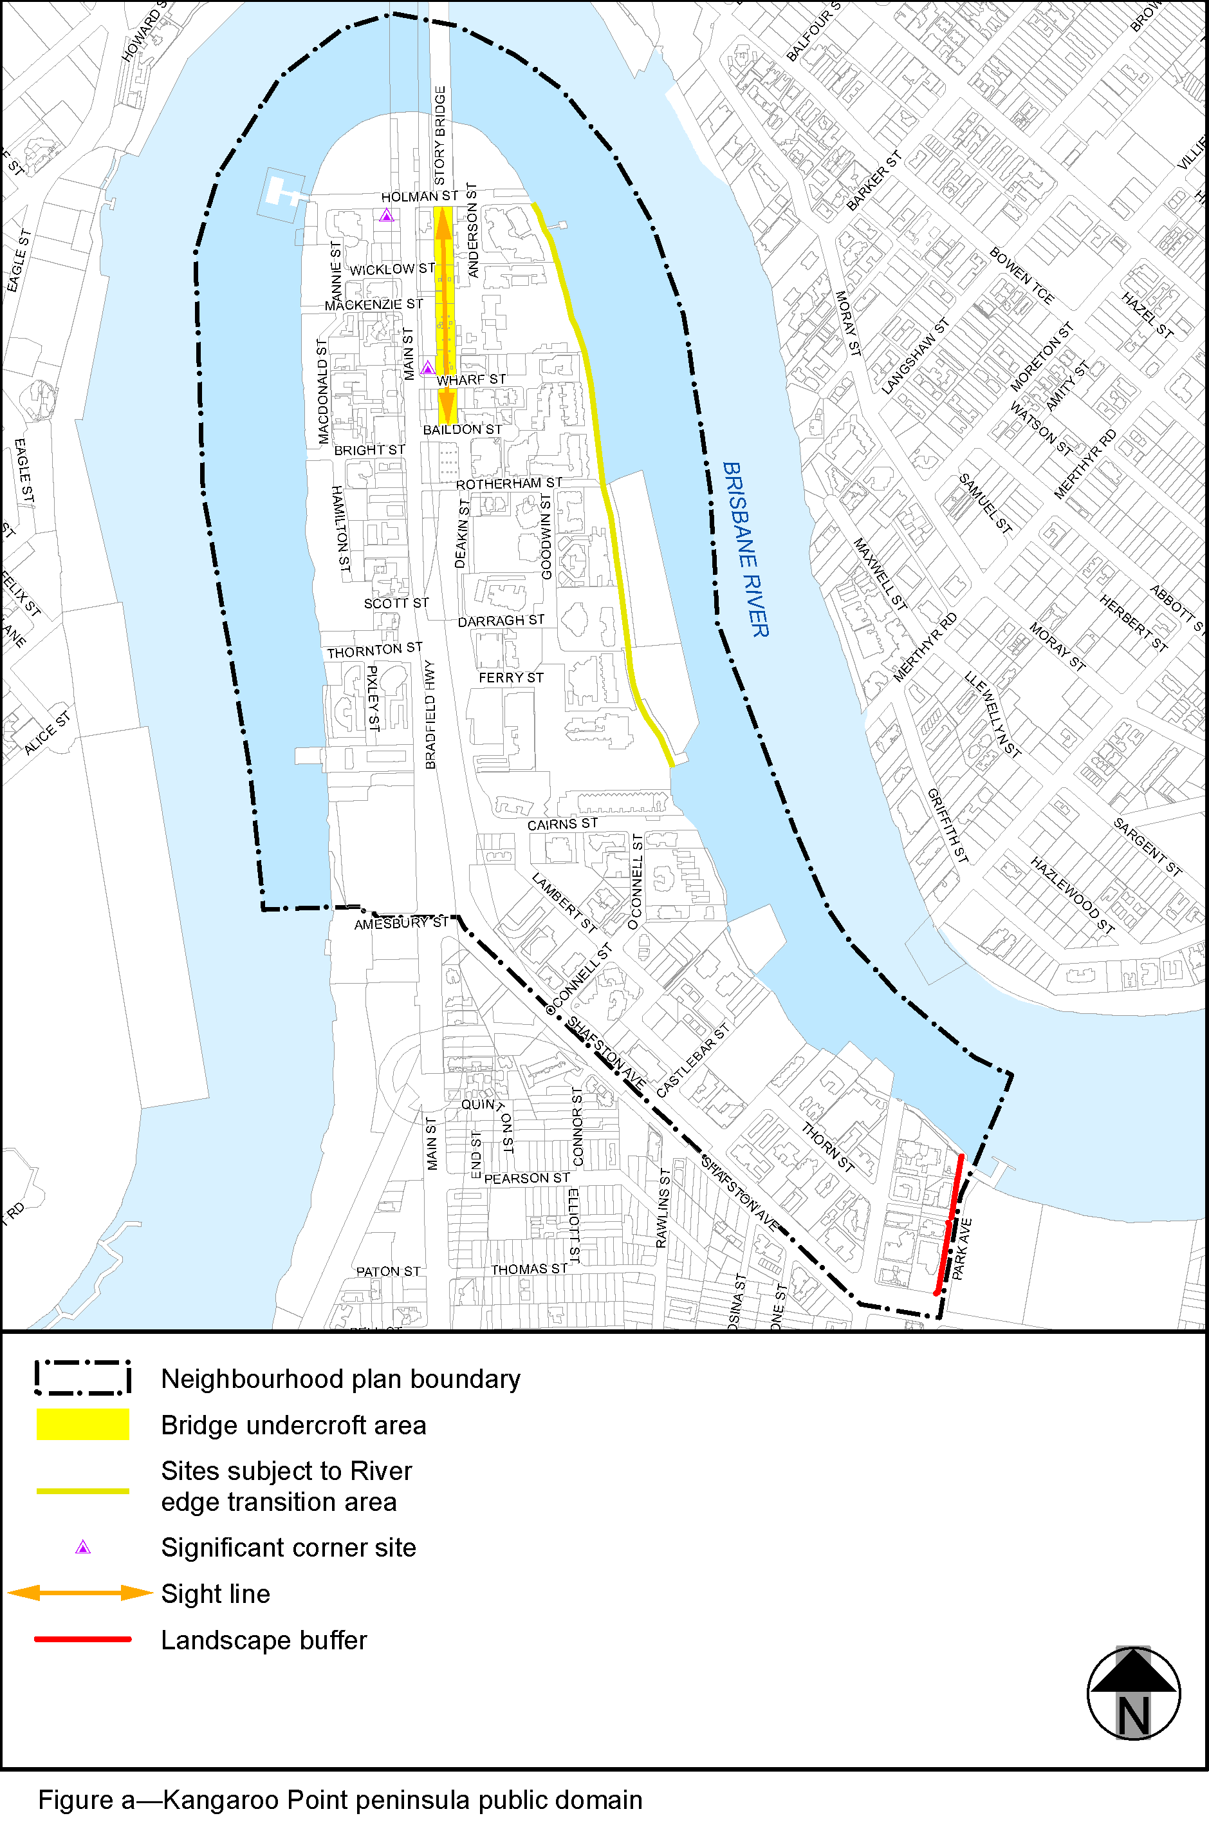
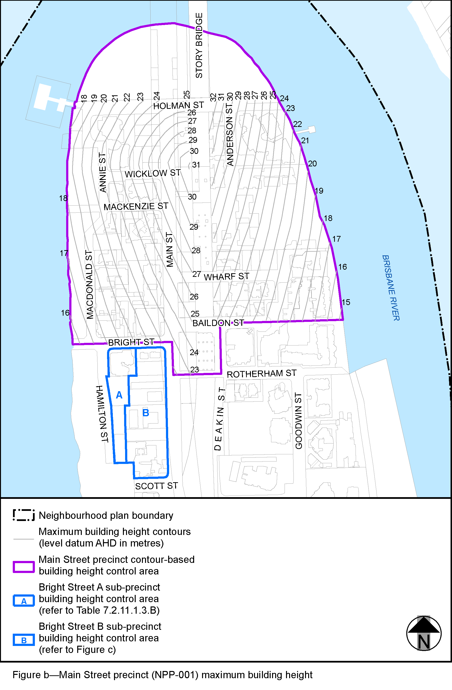
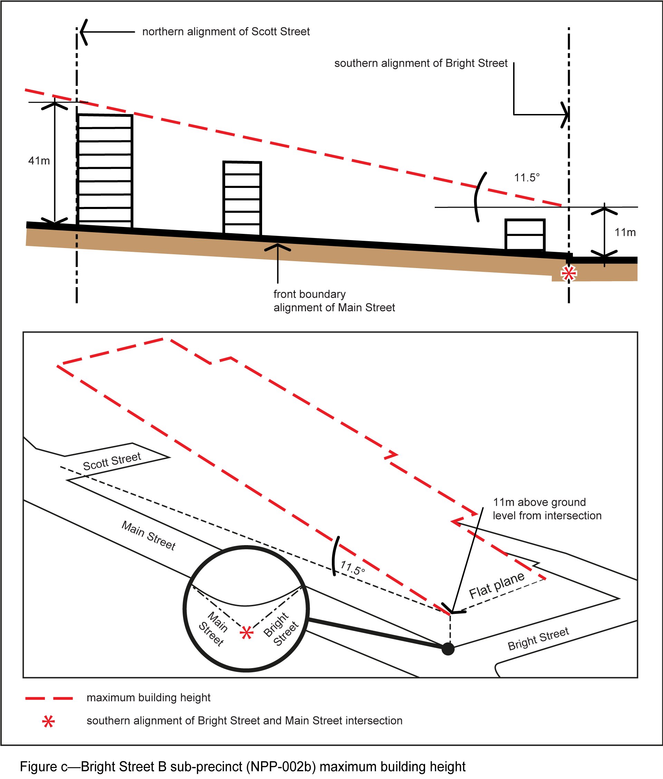

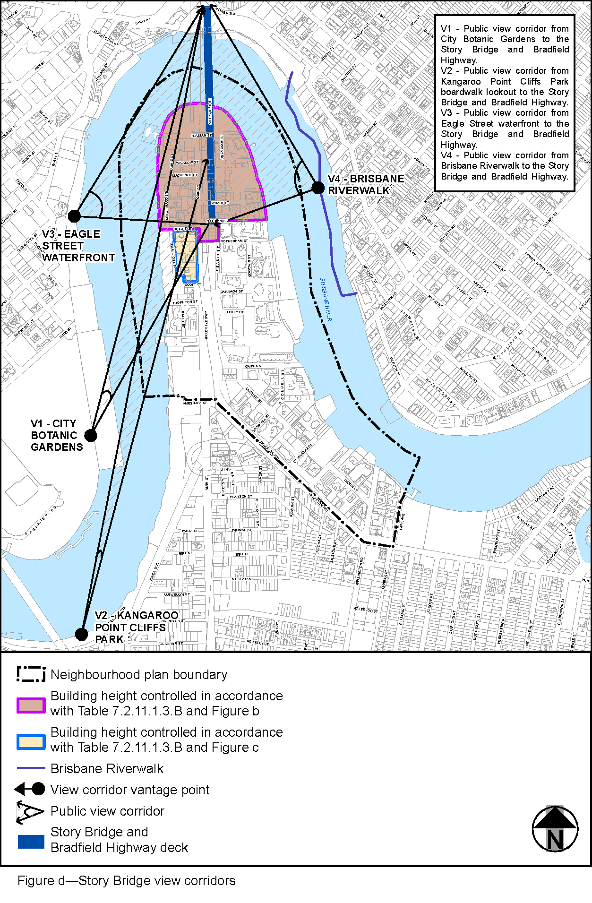
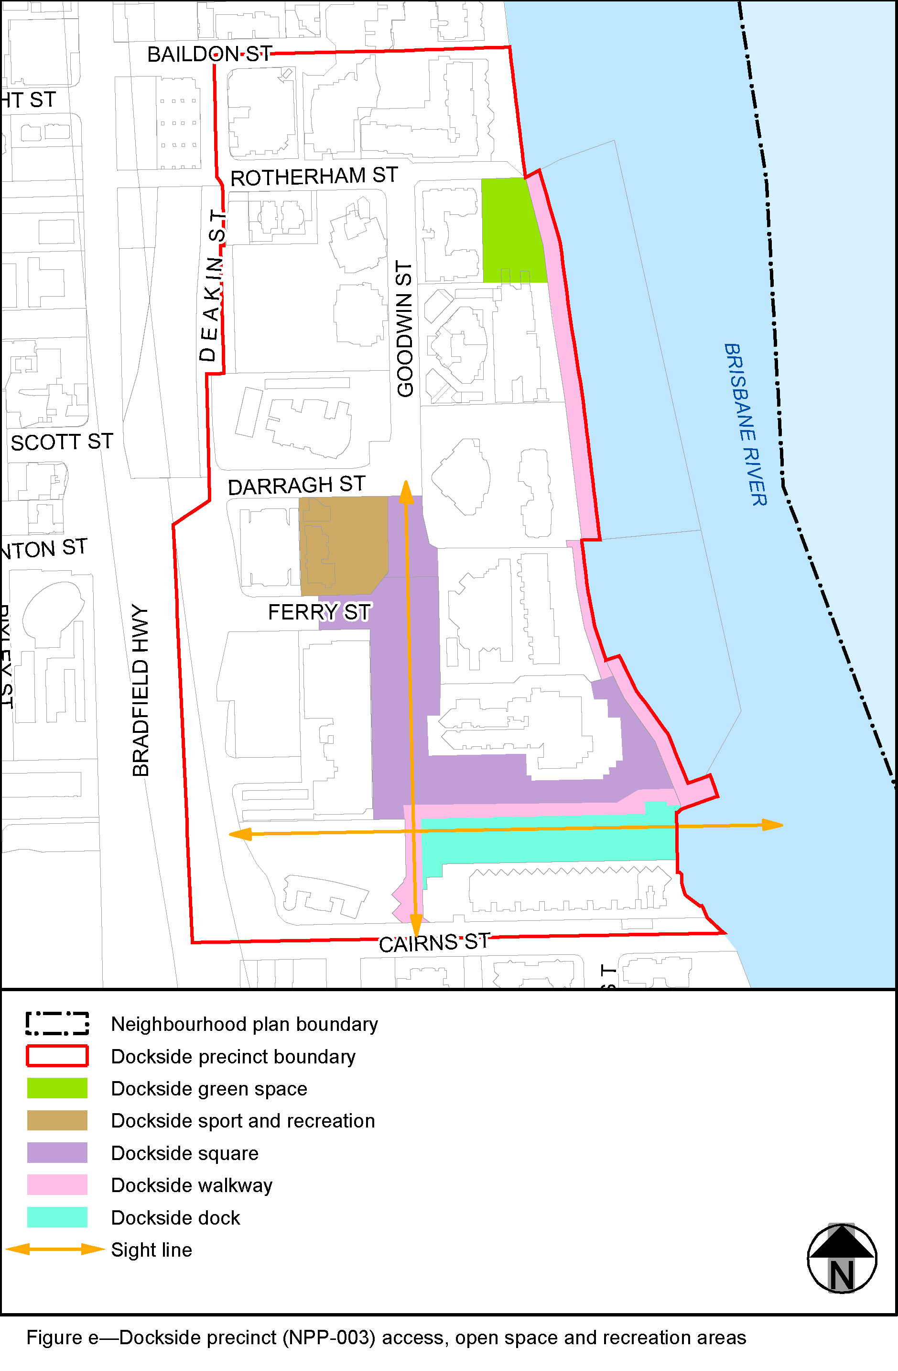

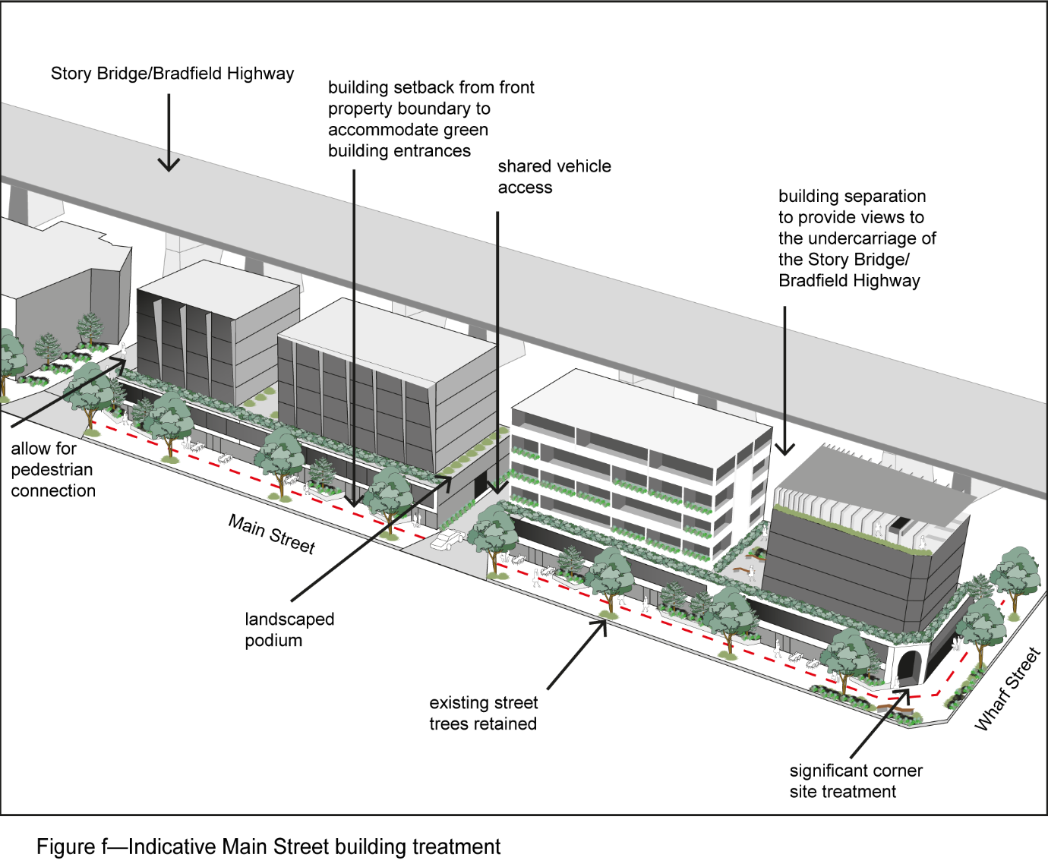
’.

- Amendment of Part 8 (Overlays)
  - Amendment of section 8.2 (Overlay codes)
- Section 8.2.19 Significant landscape tree overlay code, Table 8.2.19.3.C—Significant landscape trees in specific locations–
insert before Kelvin Grove:
‘
Kangaroo Point peninsula
Group of mature trees and exotic trees | 23 Castlebar Street (various locations on campus grounds) | L10 RP135198
3 x Delonix regia poinciana | 98 Holman Street (front of property) | L0 and 1 to 43 BUP105155
Araucaria bidwillii bunya pine | 21 Lambert Street (front of property) | L36 SP190816
3 x Ficus superba deciduous fig | 57 Lambert Street (along Shafston Avenue frontage) | L0 and 1 to 44 BUP12106
Ficus benjamina weeping fig | 90 Lambert Street (corner of Lambert Street and O’Connell Street) | L0 and 1 to 17 BUP1537
Araucaria bidwillii bunya pine  Grevillea robusta silky oak  Castanospermum australe Moreton Bay chestnut | 112 Lambert Street (front corner and rear garden) | L2 RP94412
’.

- Amendment of Part 9 (Development codes)
  - Amendment of section 9.4 (Other development codes)
- Section 9.4.11 Transport, access, parking and servicing code, Figure a—City core and City frame–
omit, insert:
‘
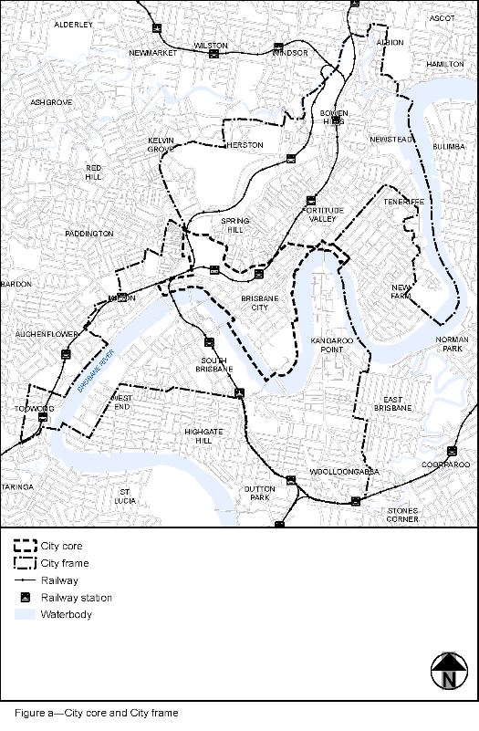
’.

- Amendment of Schedule 2 (Mapping)
  - Amendment of Schedule 2.2 (Zone maps)
- Schedule 2 Mapping, SC2.2 Zone maps, ZM-001 (Tile 28)–
omit, insert:
SC2.2 Zone maps, ZM-001 (Tile 28)–refer to Supplement 1a.

- Schedule 2 Mapping, SC2.2 Zone maps, Table SC2.2.1—Zone maps–
insert after Gazettal date, 29 November 2019:
‘
Not applicable | ZM-001 | Zoning map  Map tile 28 | 28 February 2020
’.

  - Amendment of Schedule 2.3 (Neighbourhood plan maps)
- Schedule 2 Mapping, SC2.3 Neighbourhood plan maps, NPM-011.1 Kangaroo Point peninsula neighbourhood plan map–
omit, insert:
NPM-011.1 Kangaroo Point peninsula neighbourhood plan map–refer to Supplement 1b.

- Schedule 2 Mapping, SC2.3 Neighbourhood plan maps, Table SC2.3.1—Neighbourhood plan maps–
‘
NPM-011.1 | Kangaroo Point peninsula neighbourhood plan map | 30 June 2014
’–
omit, insert:
‘
NPM-011.1 | Kangaroo Point peninsula neighbourhood plan map | 28 February 2020
’.

  - Amendment of Schedule 2.4 (Overlay maps)
- Schedule 2 Mapping, SC2.4 Overlay maps, OM-004.1 Dwelling house character overlay map (Map tile 28)–
omit, insert:
OM-004.1 Dwelling house character overlay map (Map tile 28)–refer to Supplement 1c.

- Schedule 2 Mapping, SC2.4 Overlay maps, OM-008.1 Heritage overlay map (Map tile 28)–
omit, insert:
OM-008.1 Heritage overlay map (Map tile 28)–refer to Supplement 1d.

- Schedule 2 Mapping, SC2.4 Overlay maps, OM-016.2 Pre-1911 building overlay map (Map tile 28)–
omit, insert:
OM-016.2 Pre-1911 building overlay map (Map tile 28)–refer to Supplement 1e.

- Schedule 2 Mapping, SC2.4 Overlay maps, OM-019.1 Significant landscape tree overlay map (Map tile 28)–
omit, insert:
OM-019.1 Significant landscape tree overlay map (Map tile 28)–refer to Supplement 1f.

- Schedule 2 Mapping, SC2.4 Overlay maps, OM-019.2 Streetscape hierarchy overlay map (Map tile 28)–
omit, insert:
OM-019.2 Streetscape hierarchy overlay map (Map tile 28)–refer to Supplement 1g.

- Schedule 2 Mapping, SC2.4 Overlay maps, Table SC2.4.1—Overlay maps–
insert before OM-005.1, Extractive resources overlay map (all tiles, other than where specified below), 30 June 2014:
‘
OM-004.1 | Dwelling house character overlay map  Map tile 28 | 28 February 2020
’.

- Schedule 2 Mapping, SC2.4 Overlay maps, Table SC2.4.1—Overlay maps–
insert before OM-009.1, Industrial amenity overlay map (all tiles, other than where specified below), 30 June 2014:
‘
OM-008.1 | Heritage overlay map  Map tile 28 | 28 February 2020
’.

- Schedule 2 Mapping, SC2.4 Overlay maps, Table SC2.4.1—Overlay maps–
insert before Q, intentionally left blank:
‘
OM-016.2 | Pre-1911 building overlay map  Map tile 28 | 28 February 2020
’.

- Schedule 2 Mapping, SC2.4 Overlay maps, Table SC2.4.1—Overlay maps–
insert before OM-019.2, Streetscape hierarchy overlay map (all tiles, other than where specified below), 30 June 2014:
‘
OM-019.1 | Significant landscape tree overlay map  Map tile 28 | 28 February 2020
’.

- Schedule 2 Mapping, SC2.4 Overlay maps, Table SC2.4.1—Overlay maps–
insert before OM-020.1, Traditional building character overlay map (all tiles, other than where specified below), 30 June 2014:
‘
OM-019.2 | Streetscape hierarchy overlay map  Map tile 28 | 28 February 2020
’.

- Amendment of Schedule 6 (Planning scheme policies)
  - Amendment of Schedule 6.16 (Infrastructure design planning scheme policy)
- Schedule 6 Planning scheme policies, SC6.16 Infrastructure design planning scheme policy, Chapter 5 Streetscape locality advice, Table 5.1.2—Locality streets within Neighbourhood plan areas and other locations–
insert before 5.3.12, Intentionally blank – as no Neighbourhood plans beginning with ‘L’:
‘
5.3.11 | 5.3.11.2 | Kangaroo Point peninsula
’.

- Schedule 6 Planning scheme policies, SC6.16 Infrastructure design planning scheme policy, Chapter 5 Streetscape locality advice, Section 5.3 Neighbourhood plans and other locations, 5.3.11.2 Kangaroo Point peninsula–
insert:
‘

5.3.11.2 Kangaroo Point peninsula
- 5.3.11.2.1 Location and extent
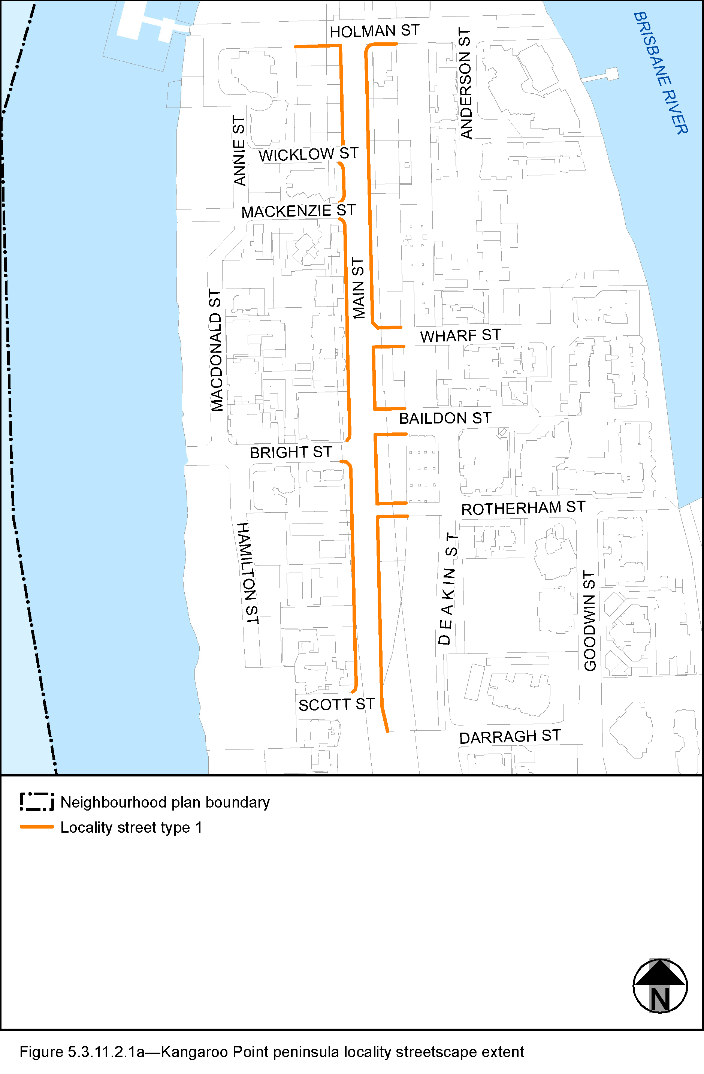
  - The Locality Street in the Kangaroo Point peninsula neighbourhood plan area is indicated on the Kangaroo Point peninsula locality streetscape extent map in Figure 5.3.11.2.1a.
  - All streetscape works occurring within the locality streets indicated in Figure 5.3.11.2.1a must comply with the character specified in this document.
  - Streetscapes outside these areas may be developed in keeping with this character, at the discretion of the developer and subject to Council approval.

- 5.3.11.2.2 Standard footway elements and materials
  - These locality guidelines are to be read in conjunction with Chapter 3 – Road corridor design of the Infrastructure design planning scheme policy.
  - Footway upgrades are to include new surfacing, new or reinstated kerb and channel, driveways, pedestrian kerb crossings, tactile markers, roof water drainage line connections, service pit lids, street trees, garden beds, furniture and pedestrian lighting applicable to the streetscape type.
  - The scope, layout and detail of the footway upgrades are to be agreed on a site by site basis through the development assessment process.
- 5.3.11.2.3 Streetscape hierarchy
- 5.3.11.2.3.1 Streetscape types overview
  - The locality streets within the Kangaroo Point peninsula neighbourhood plan area are exceptions to the standard streetscape hierarchy.
  - The streetscape type and specifications for locality streets in this area are outlined in Table 5.3.11.2.3.1A and shown in Figure 5.3.11.2.1a.

Table 5.3.11.2.3.1A—Streetscape types and specifications
Component | Locality Street Type 1 in the Kangaroo Point peninsula neighbourhood plan area
Verge width | 3.75m as a minimum
Description | Full width pavement
Unobstructed pavement width | 2.4m as a minimum
Paving materials | Exposed Aggregate Concrete uses:  - type: Standard Portland Grey concrete;  - supplier: Hanson (code 10043620), Boral or approved equivalent;  - colour: 'Victoria Falls' (90% ‘Blue Heeler’ 10% ‘Winter Brown’).
Tactile markers  (consistent with BSD-5218) | Type: Concrete tactile paver  Supplier: Chelmstone, Urbanstone or approved equivalent  Colour: CCS ‘Voodoo’
Driveways | Exposed aggregate to match footpath
Trees | Trees are planted in garden beds or tree grates.  Street trees include:  - medium and small crown trees to be planted at minimum 2m spacing, if within garden beds, or minimum 6m spacing outside of garden beds;  - large crown feature trees to be planted at minimum 10m centres.  Distance:  - all tree centrelines are 750mm from the nominal face of the kerb and a minimum of 600mm from the edges of the pavement.  Layout:  - trees planted in a single row at the rear of kerb;  - to be planted as singles and in pairs or clusters;  - at full development the trees should form a continuous canopy for shade.  Promote the health and long-term viability of the existing mature fig trees:  - located in the eastern verge on Main Street between Holman Street and Wharf Street;  - located in the eastern verge on Main Street south of Rotherham Street.  Where possible, retain existing healthy mature trees of approved species (refer to section 3.7.5 Design standards for street tree planting), or appropriate alternatives.
Garden beds – located adjacent kerb | A garden bed located adjacent to the kerb has a:  - 1.5m minimum spacing between garden beds;  - maximum length of 10m;  - layout and length to accommodate car parking and other kerbside allocation.
Garden beds – minimum widths | 1.2m
Furniture | All furniture is to be located outside of the unobstructed pavement area.

- 5.3.11.2.4 Planting
- 5.3.11.2.4.1 Street trees
  - Street trees are permitted and section 3.7.5 Design standards for street tree planting sets out the approved street tree species.
  - Each street has a minimum of two approved street tree species to encourage variety and diversity within the precinct.
  - The chosen large or medium crown trees should, at full development, have the capacity to create a near continuous canopy along and across Main Street.
  - Where two or more street trees are required on the same development frontage, a mixture of the appropriate species as listed in section 3.7.5 Design standards for street tree planting is required.
’.

- Amendment of Appendix 2 (Table of amendments)
  - Amendment of Appendix 2 (Table of amendments)
- Appendix 2 Table of amendments, Table AP2.1—Table of amendments–
insert after vxx.00/20xx:
‘
19 November 2019 (adoption) and 28 February 2020 (effective) | v18.00/2020 | Major and minor | Major amendment to planning scheme (2.3A.4 of MAALPI);  Minor amendment to planning scheme policy (Schedule 1, Section 6 b) of MGR)  Refer to Amendment v18.00/2020 for further detail.
’.

Supplement 1—A3 Map Tiles

