7.2.1.5 Aspley district neighbourhood plan code

7.2.1.5.1 Application
- This code applies to assessing a material change of use, reconfiguring a lot, operational work or building work in the Aspley district neighbourhood plan area if:
assessable development where this code is an applicable code identified in the assessment benchmarks column of a table of assessment for a neighbourhood plan (section 5.9); or
impact assessable development.
- Land in the Aspley district neighbourhood plan area is identified on the NPM-001.5 Aspley district neighbourhood plan map and includes the following precincts:
- Aspley centre precinct (Aspley district neighbourhood plan/NPP-001);
Aspley centre residential precinct (Aspley district neighbourhood plan/NPP-002);
Caravan park precinct (Aspley district neighbourhood plan/NPP-003);
Western residential precinct (Aspley district neighbourhood plan/NPP-004);
Reservoir precinct (Aspley district neighbourhood plan/NPP-005);
Robinson Road centre precinct (Aspley district neighbourhood plan/NPP-006).
- When using this code, reference should be made to section 1.5, section 5.3.2 and section 5.3.3.
Note—The following purpose, overall outcomes, performance outcomes and acceptable outcomes comprise the assessment benchmarks of this code.
Note—This neighbourhood plan includes a table of assessment with variations to categories of development and assessment. Refer to Table 5.9.5.A, Table 5.9.5.B, Table 5.9.5.C and Table 5.9.5.D.

7.2.1.5.2 Purpose
- The purpose of the Aspley district neighbourhood plan code is to provide finer grained planning at a local level for the Aspley district neighbourhood plan area.
- The purpose of the Aspley district neighbourhood plan code will be achieved through overall outcomes including overall outcomes for each precinct of the neighbourhood plan area.
- The overall outcomes for the Aspley district neighbourhood plan area are:
- The Aspley centre is reinforced as a northern gateway to Brisbane. The centre continues to be the main focus for the district’s retail, commercial and community services. The centre layout and design promotes a legible and safe pedestrian environment.
The existing caravan parks are maintained as providers of a significant amount of affordable housing and short-term accommodation for tourists.
Development along Cabbage Tree Creek and Little Cabbage Tree Creek provides park linkages adjoining waterways which allow for public access. Good public road frontage to these parks enables public access to the park and safety for park users.
Development is of a height, scale and form which is consistent with the amenity and character, community expectations and infrastructure assumptions intended for the relevant precinct, sub-precinct or site and is only developed at a greater height, scale and form where there is both a community need and economic need for the development.
- Aspley centre precinct (Aspley district neighbourhood plan/NPP-001) overall outcomes are:
- The Aspley precinct centre provides a modern gateway to Brisbane which will be enhanced by the consolidation of landscaping to clearly define the precinct. The character and legibility of the precinct will be enhanced by:
- recognising the values of the waterways;
- clearly defining pathways to and through the centre;
- consolidating access and parking in the centre.
A public space close to public transport and centre activities will act as an informal community gathering place.
- Aspley centre residential precinct (Aspley district neighbourhood plan/NPP-002) overall outcome is:
- Residential development is of a low–medium density given the precinct’s proximity to the Aspley centre precinct and associated public transport and waterway recreational opportunities. Multiple dwellings are not accommodated in the Low density residential zone.
- Caravan park precinct (Aspley district neighbourhood plan/NPP-003) overall outcome is:
- The caravan parks continue to operate and provide a significant amount of affordable housing and short-term accommodation for tourists for the district in locations with good access to public transport and centre activities and provide the use of:
- Alpha – 110 sites;
- Aspley Acres – 255 sites;
- Caravan Village – 152 sites.
- Western residential precinct (Aspley district neighbourhood plan/NPP-004) overall outcomes are:
- This precinct is to undergo a gradual transition from rural land and other uses to a residential community.
Well-integrated residential development protects the waterway and environmental values of Little Cabbage Tree Creek.
- Reservoir precinct (Aspley district neighbourhood plan/NPP-005) overall outcomes are:
- The Aspley Reservoir and lands located on Lawrence Road and Milne Hill reservoir and lands located on Hamilton Road, are retained for their water storage and supply facility functions and for their parkland values in terms of bushland, scenic landscape and passive recreation.
Milne Hill reservoir continues to form part of the dryland environmental corridor that links Chermside Hills Reserve to the Raven Street Reserve.
- Robinson Road centre precinct (Aspley district neighbourhood plan/NPP-006) overall outcome is:
- Development layout and design, including building height, landscaping and facade treatments ensure that expansion of the Robinson Road centre precinct respects the residential setting and improves the pedestrian environment.

7.2.1.5.3 Performance outcomes and acceptable outcomes

Table 7.2.1.5.3.A—Performance outcomes and acceptable outcomes
Performance outcomes | Acceptable outcomes
General
PO1  Development is of a height, scale and form that achieves the intended outcomes for the precinct, improves the amenity of the neighbourhood plan area, contributes to a cohesive streetscape and built form character and is:  - consistent with anticipated density and assumed infrastructure demand;  - aligned to community expectations about the number of storeys to be built;  - proportionate to and commensurate with the utility of the site area and frontage width;  - designed so as not to cause a significant and undue adverse amenity impact to adjoining development;  - sited to enable existing and future buildings to be well separated from each other and to not prejudice the development of an adjoining site.  Note—Development that exceeds the intended number of storeys or building height can place disproportionate pressure on the transport network, public space or community facilities in particular.  Note—Development that is over-scaled for its site can result in an undesirable dominance of vehicle access, parking and manoeuvring areas that significantly reduce streetscape character and amenity. | AO1  Development complies with the number of storeys and building height in Table 7.2.1.5.3.B.  Note—Neighbourhood plans will mostly specify a maximum number of storeys where zone outcomes have been varied in relation to building height. Some neighbourhood plans may also specify height in metres. Development must comply with both parameters where maximum number of storeys and height in metres are specified.
If in a Major environmental/waterway corridor
PO2  Development enhances the major environmental/waterway corridors as indicated in Figure a and Figure b. | AO2.1  Development where the waterway has been piped underground on the Hypermarket site and at 9 Gayford Street, Aspley, provides a landscape feature consisting of low-growing plants and some large trees incorporated through the parking station, which references the original location of Little Cabbage Tree Creek.  Note—It is not intended that the creek be reinstated above-ground.
AO2.2
Development of sites in the Western residential precinct adjoining Little Cabbage Tree Creek provides locally occurring native vegetation of at least two groupings:
- where each grouping is a minimum area of 1% of the site;
- within at least 60m of the main road frontage such as Albany Creek Road.
PO3  Development provides for a safe walking and cycling route and a recognisable entry to the linear park along the Major environmental/waterway corridors. | AO3  Development provides a 4.5m widening of the access strip along the eastern boundary of 80 Albany Creek Road, Aspley.
If in the Aspley centre precinct (Aspley district neighbourhood plan/NPP-001)
PO4  Development makes a positive contribution toward the legibility of the centre in terms of defining the Aspley centre precinct, its network of public spaces, roads and car parking. | AO4  Development complies with the following:  - Figure a;  - a minimum 2m wide key pedestrian spine is provided linking the shops on the eastern side of Gympie Road to the Hypermarket (west of Gayford Street), with landscape nodes that provide weather protection every 15m along the walkway;  - any development of the Hypermarket site contributes to the establishment of a controlled crossing, such as traffic signals, to improve safety for pedestrians and provide a better linkage with the strip shopping along Gympie Road;  - on-site tree planting contributes to a boulevard effect along Gympie Road and Gayford Street;  - landscaping nodes are provided as landmark features at the identified locations;  - development of the Hypermarket site and 9 Gayford Street provides a shared use path linking Cabbage Tree and Little Cabbage Tree creeks;  - vehicular access points, parking and circulation driveways are consolidated or designed to allow for future consolidation, particularly for businesses fronting Gympie Road;  - the internal road layout in large sites is legible and safe having regard to elements such as paving treatments, landscaping and signage;  - shade is increased in large parking areas such as Hypermarket and Christies Centre;  - any redevelopment of the Hypermarket site improves pedestrian access to the adjoining retirement facility;  - the 2 bunya pine trees near the intersection of Albany Creek Road and Maundrell Terrace are retained as natural visual markers of the location of the Aspley centre precinct.
PO5  Development is a focus for community activities such that the further development of the Hypermarket site provides an informal community gathering place close to the bus stop, including landscaping, shade and seating that will provide a comfortable environment. | AO5  No acceptable outcome is prescribed.
If in the Caravan park precinct (Aspley district neighbourhood plan/NPP-003)
PO6  Development provides:  - pedestrian and cycle access along Cabbage Tree Creek to the Aspley centre precinct;  - a walking and cycling route through the site which links Cabbage Tree Creek to locations in the Aspley centre precinct (Aspley district neighbourhood plan/NPP-001) such as the Hypermarket site in accordance with Figure a.  - locally occurring native vegetation along the edge of these paths. | AO6  No acceptable outcome is prescribed.
If in the Western residential precinct (Aspley district neighbourhood plan/NPP-004)
PO7  Development for residential uses is integrated with the surrounding community in terms of park, road layout, shared use paths and landscaping. | AO7  Development is consistent with Figure b.
PO8  Development along Albany Creek Road and Trouts Road provides high-quality streetscape outcomes for future residents. | AO8  Development provides a 4m native vegetation buffer along the road frontages, of which 2m is located in front of the fence.
If in the Robinson Road centre precinct (Aspley district neighbourhood plan/NPP-006)
PO9  Development achieves the following:  - provides a safe and comfortable pedestrian environment into and within the Robinson Road centre precinct;  - the Robinson Road centre precinct contributes positively to the visual amenity of the surrounding area, including an enhanced northern aspect to improve the visual amenity for adjoining residential and educational uses;  - landscaping softens the appearance of the buildings and parking station;  - building heights maintain a building scale consistent with adjoining residential. | AO9  Development complies with the following:  - Figure c;  - a pedestrian path is provided linking the supermarket with the shops fronting Wilmah Street;  - landscaping is enhanced and maintained along the road frontages;  - the identified significant trees are retained;  - on the northern aspect of the centre, the building is articulated and has shaded walls by measures such as awnings, eaves and landscaping;  - landscaping is enhanced along the northern boundary and in the parking area;  - refuse areas are screened from adjoining uses.

Table 7.2.1.5.3.B—Maximum building height
Development | Building height  (number of storeys) | Building height (m)
If in the Robinson Road centre precinct (Aspley district neighbourhood plan/NPP-006)
Development of a site in the maximum building height area shown in Figure c | 1 | Not specified

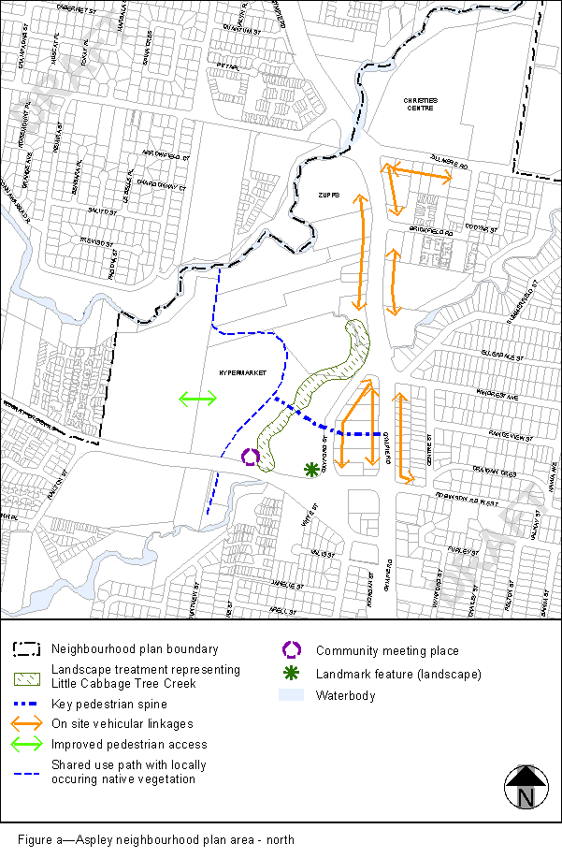
View the high resolution of Figure a–Aspley neighbourhood plan area (PDF file size is 207Kb)
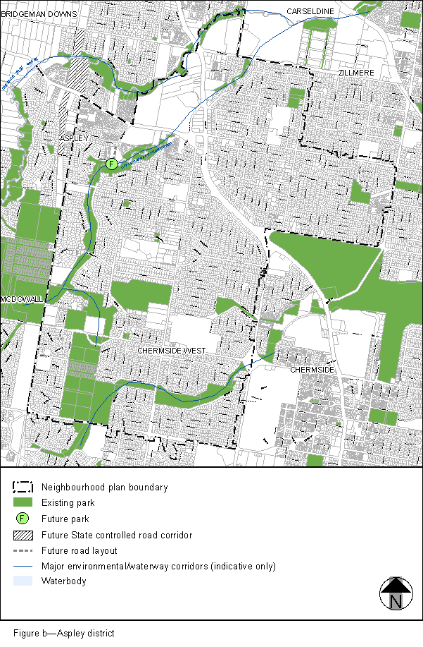
View the high resolution of Figure b–Aspley district (PDF file size is 401Kb)
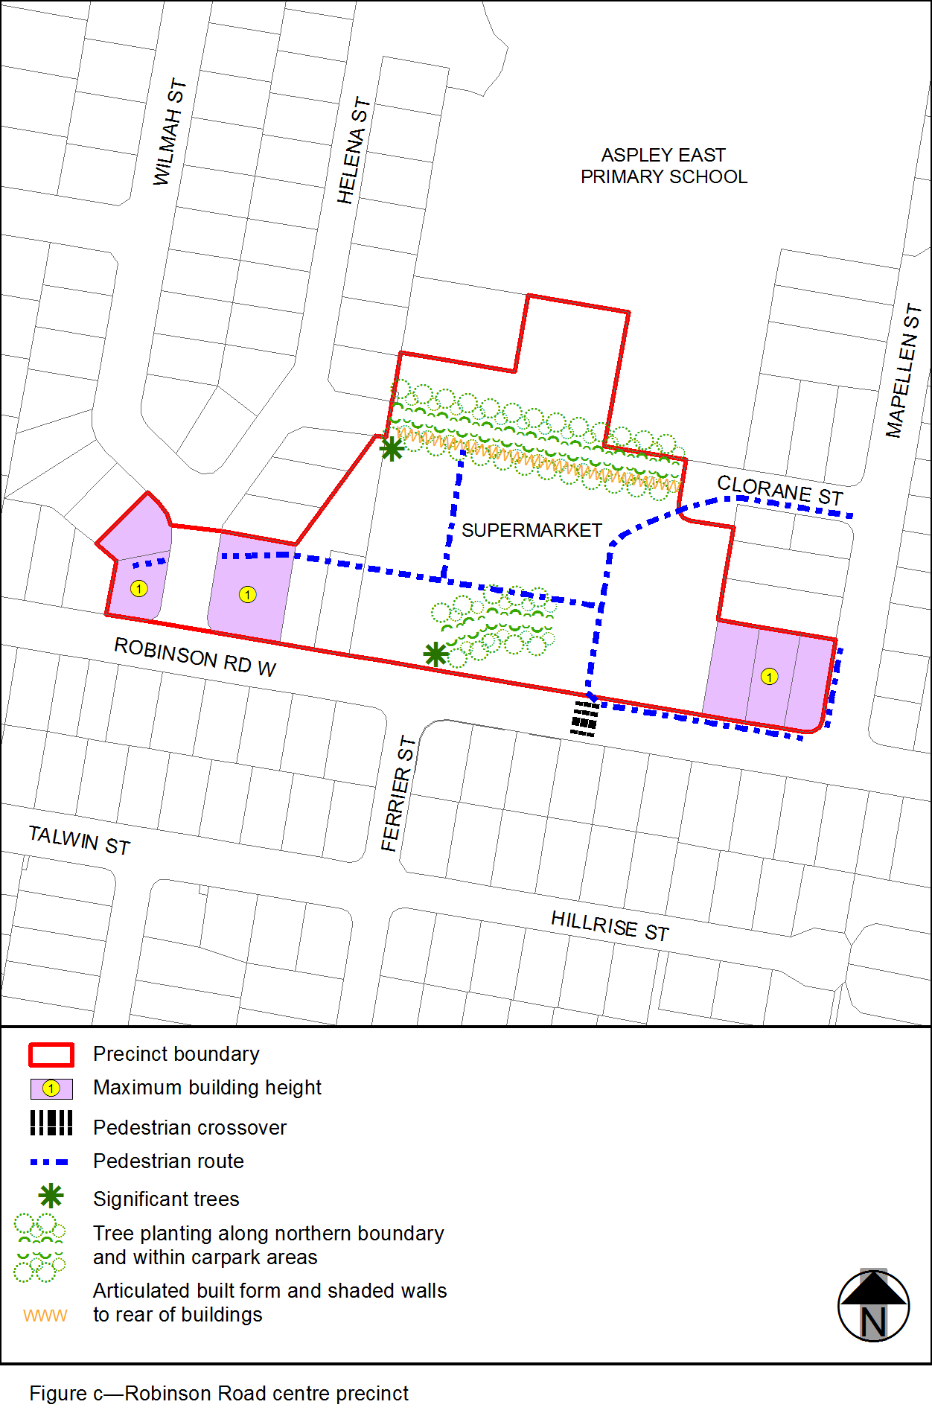
View the high resolution of Figure c–Robinson Road centre precinct (PDF file size is 72Kb)

