7.2.3.7 City Centre neighbourhood plan code

7.2.3.7.1 Application
- This code applies to assessing material change of use, reconfiguring a lot, operational work or building work in the City Centre neighbourhood plan area if:
- assessable development where this code is an applicable code identified in the assessment benchmarks column of a table of assessment for a neighbourhood plan (section 5.9); or
- impact assessable development;
- Land in the City Centre neighbourhood plan area is identified on the NPM-003.7 City Centre neighbourhood plan map and includes the following precincts:
- Retail precinct (City Centre neighbourhood plan/NPP-001);
- Quay Street precinct (City Centre neighbourhood plan/NPP-002):
- Quay Street north sub-precinct (City Centre neighbourhood plan/NPP-002a);
- Quay Street south sub-precinct (City Centre neighbourhood plan/NPP-002b);
- Queen’s Wharf precinct (City Centre neighbourhood plan/NPP-003);
- River precinct (City Centre neighbourhood plan/NPP-004);
- Howard Smith Wharves precinct (City Centre neighbourhood plan/NPP-005);
- When using this code, reference should be made to section 1.5, section 5.3.2 and section 5.3.3 in Part 5.
Note—The following purpose, overall outcomes, performance outcomes and acceptable outcomes comprise the assessment benchmarks of this code.
Note—This neighbourhood plan includes a table of assessment with variations to categories of development and assessment. Refer to Table 5.9.17.A, Table 5.9.17.B, Table 5.9.17.C and Table 5.9.17.D.
Editor’s note—The preparation of an Urban context report in accordance with Table 7.2.3.7.3.B will assist in demonstrating how the proposal achieves the outcomes of this neighbourhood plan.
Note—Council’s Independent Design Advisory Panel may be invited to provide advice on development, to facilitate high quality development, in accordance with the provisions of the Independent design advisory panel planning scheme policy.
Editor’s note—The New World City Design Guide - Buildings that Breathe sets out the vision, design elements and best practice case studies to guide new development. Development is actively encouraged to incorporate these design elements and embrace the city’s subtropical climate.
Note—Development height and high-rise construction may be subject to restrictions in accordance with the Airports (Protection of Airspace) Regulations 1996.
Editor's note—The Queen’s Wharf precinct is covered by the Queen’s Wharf Brisbane priority development area which Economic Development Queensland is responsible for planning under the Economic Development Act 2012.
Editor's note—Part of the neighbourhood plan area is covered by the Albert Street Cross River Rail priority development area which Economic Development Queensland is responsible for planning under the Economic Development Act 2012.
Note—The ‘street building’ comprises all levels of a building below which a set back tower commences. Refer to Figure b for guidance.
Note—The building height transitions and percentage of deep planting provisions as identified in the Multiple dwelling code do not apply within this neighbourhood plan area.
Note—The podium heights, building height transitions, land use mix restrictions, active frontage-primary and active frontage-secondary provisions as identified in the Centre or mixed use code do not apply within this neighbourhood plan area.
Note—The acceptable outcomes for car parking located above ground level or for a multistorey or podium car park in the Centre or mixed use code do not apply within this neighbourhood plan area.
Note—Restrictions on the use of security barriers to manage visitor or customer parking as identified in the Centre or mixed use code do not apply within this neighbourhood plan area.

7.2.3.7.2 Purpose
- The purpose of the City Centre neighbourhood plan code is to provide finer grained planning at a local level for the City Centre neighbourhood plan area.
- The purpose of the City Centre neighbourhood plan code will be achieved through the overall outcomes.
- The overall outcomes for the City Centre neighbourhood plan area are:
- The City Centre supports a mix of uses, where the principal business and administration functions are complemented by retailing, entertainment, education, community and cultural facilities, tourism and residences.
- The City Centre accommodates high density development to make the most of public transport infrastructure and good access to shops, public space and community facilities.
- The built form within the City Centre responds to its site characteristics and context, including the cityscape and streetscape. Development reinforces the distinct qualities of a close-knit city grid and well-spaced buildings along the river’s edge.
- Development is located and designed to maintain or improve views and vistas from the public realm to the Brisbane River and Story Bridge, the Botanic Gardens and major public spaces, to City Hall, Customs House, General Post Office, St John’s Cathedral, St Stephen’s Cathedral, Central Station and to other landmark and heritage buildings.
- The close-knit street grid at the heart of the city centre is maintained, with street buildings that occupy most of the site framing and activating the public realm at street level with layered, permeable and subtropical facades.
- Along the river’s edge, development is spaced and landscaped to maximise views and public access to the river, and maximise penetration of light and breezes into the city centre.
- The street level is highly walkable and pedestrian-oriented with fine-grain tenancies of active uses addressing the street. The visual and physical impact of vehicles and servicing on the pedestrian environment is minimised.
- Modern towers each contribute to the city’s distinctive skyline and provide elevated outdoor spaces. Towers are sited to maintain the openness of street vistas with adequate spacing between buildings to allow for light penetration, air circulation, views and vistas, and privacy, particularly for residential towers.
- Each development is unique and provides an innovative and contextual design that is tailored to its individual circumstances and is appropriate to its context. While designed to accommodate growth that realises the development potential of the site and makes efficient use of City Centre land, development:
- protects the amenity of adjoining development, public realm and parks;
- respects heritage, important landmarks and significant views and vistas;
- fits responsively into the streetscape and riverscape;
- positively contributes to the overall city skyline.
- Development responds to the broad range of market demands, including diverse tenancy sizes that provide small, flexible, and innovative incubator spaces for small businesses.
- Development is designed to take advantage of Brisbane’s subtropical climate and delivers high-quality, subtropical architecture of outstanding merit. Buildings, public realm and landscape are open, engaging and green, with shaded spaces and opportunities to interact with the street, and contribute to Brisbane’s identity and lifestyle.
- Development on sites over 3000m² showcase buildings that are open, inviting, laden with landscape, embody an outdoor lifestyle and deliver public spaces, art and active street edges that integrate with the grain of the City Centre.
- Development maintains and enhances a well-connected and accessible public realm network that links attractions.
- Wide, sheltered, tree-lined footpaths provide for the comfortable movement of pedestrians. Footpaths are complemented by laneways, alleys and arcades that are flanked by active uses and provide a fine-grain network of connections to retail, employment, transport, public spaces and the river’s edge to relieve pressure on streets in peak hours and provide additional opportunities for economic activity and social interaction.
- Development is located and designed to enhance the accessibility and integration of existing and future public transport passenger facilities.
- Retail precinct (City Centre neighbourhood plan/NPP-001) overall outcomes are:
- A continuous frontage of fine-grain, pedestrian-oriented, and highly permeable retailing and active uses maximises pedestrian amenity and convenience.
- The Queen Street Mall is the focus of the city’s retail heart with a streetscape that conveys to shoppers and tourists that this is a major specialist retailing, service and entertainment location with a built form that maintains a high level of public amenity.
- Development maintains and respects the historic built form along the Queen Street Mall.
- Development supports and integrates with an upgraded Queen Street bus station.
- Active and pedestrian-friendly retail frontages and wide footpaths make it easy, safe and comfortable to walk along Edward Street, Elizabeth Street and Adelaide Street.
- Permeable ground storeys, a high proportion of food and drink outlets and landscaping create a subtropical outdoor dining experience along Albert Street.
- Quay Street precinct (City Centre neighbourhood plan/NPP-002) overall outcomes are:
- Development in the Quay Street north sub-precinct (City Centre neighbourhood plan/NPP-002a) will contain buildings of a lower scale that relate to Petrie Terrace and are commensurate with the sub-precinct’s city fringe location.
- Development in the Quay Street south sub-precinct (City Centre neighbourhood plan/NPP-002b) will contain buildings with a scale consistent with the prevailing built form and heights along Coronation Drive and commensurate with the site’s characteristics.
- The precinct will comprise short-term accommodation, local shops, services and restaurants that will activate adjoining streets and E.E. McCormick Place.
- Pedestrian connections are created to connect the precinct with the heart of the city centre and surrounding neighbourhoods.
- Queen’s Wharf precinct (City Centre neighbourhood plan/NPP-003) overall outcomes are :
- The precinct will accommodate integrated development that attracts visitors and investment with world-class, sustainable urban design and architecture that regenerates the riverfront and incorporates new and enhanced public spaces.
- Development preserves and celebrates heritage buildings and renews this historic part of the City Centre with fine-grain retail along a pedestrian-focused William Street.
- Pedestrian connections are created to reconnect the city centre to the precinct and the river.
- River precinct (City Centre neighbourhood plan/NPP-004) overall outcomes are:
- The precinct is one of Brisbane’s premier dining and recreation precincts, showcasing the waterfront to residents, workers and tourists 24 hours a day, seven days a week.
- The river edge is enhanced as a generous and unified urban public space for pedestrians and cyclists, diners and visitors.
- High density waterfront development optimises the amount of public space at ground level, creating a sense of openness and space for pedestrians. New and improved spaces between buildings provide open visual and physical connections from the city grid to the river and beyond. Landscaping is used to create subtropical towers in a riverside garden setting.
- A multi-layered river edge provides for river activities at the water level, a waterfront promenade at the lower level, publicly accessible and active low-rise tenancies at the middle level, and well-spaced towers that are set back from the river at the upper level.
- Howard Smith Wharves precinct (City Centre neighbourhood plan/NPP-005) overall outcomes are:
- The precinct will comprise a combination of new development and adaptation of heritage buildings and structures in an urban parkland setting.
- A vibrant, accessible, riverside recreation precinct is created comprising a mix of riverside parkland, open space, plazas, leisure-oriented uses and commercial uses.
- The heritage values of the precinct are retained, including the Howard Smith Wharves, Story Bridge, World War II Air Raid Shelters and cliffs.
- A complementary mix of uses are provided at defined locations, including shops, restaurants, bars, sport and recreation uses, community facilities, office and short-term accommodation uses that attract visitation and generate activity, promote recreation and leisure, and facilitate safe access and use throughout the precinct.
- New development is at a scale and location that integrates with the parkland and reflects the intended emphasis on heritage values and public access provision.
- Public access and circulation is provided for cyclists and pedestrians to and through the site, connecting the Riverwalk with the City Centre as well as providing new connections from the lower riverside areas to top of cliff locations to connect with Fortitude Valley and New Farm.

7.2.3.7.3 Performance outcomes and acceptable outcomes

Table 7.2.3.7.3.A—Performance outcomes and acceptable outcomes
Performance outcomes | Acceptable outcomes
SECTION A: CITY CONTEXT & SUBTROPICALITY
PO1  Development is designed to respond to its site characteristics, context and setting within the City Centre, including cityscape, streetscape, public realm, heritage places, surrounding buildings, natural assets and movement networks.  Development design exhibits outstanding architectural merit, and development with a tower contributes positively to the city’s skyline. | AO1  No acceptable outcome is prescribed.  Editor’s note—The preparation of an Urban context report in accordance with Table 7.2.3.7.3.B will assist in demonstrating how the proposal achieves the outcomes of this neighbourhood plan.  Note—Council’s Independent Design Advisory Panel may be invited to provide advice on development, to facilitate high quality development, in accordance with the provisions of the Independent design advisory panel planning scheme policy.  Editor’s note—The New World City Design Guide - Buildings that Breathe sets out the vision, design elements and best practice case studies to guide new development. Development is actively encouraged to incorporate these design elements and embrace the city’s subtropical climate.
PO2  Development exhibits best practice subtropical design and presents a highly landscaped environment, including:  - landscaping and outdoor spaces that make the most of Brisbane’s subtropical climate, while mitigating heat;  - landscaped subtropical spaces and water features on ground levels, roofs, balconies, terraces, and edges of buildings. | AO2  Development provides landscaped outdoor spaces equivalent to a minimum 30% of the site area.  Note—Outdoor space does not include spaces where more than 70% of the perimeter is enclosed, or balconies that are less than 12m².
PO3  Development exhibits best-practice climate-responsive design, including orientation, to mitigate heat and reduce the need for mechanical heating, cooling and lighting. | AO3  No acceptable outcome is prescribed.
SECTION B: BUILT FORM
If on a site over 3000m² , where not within the Quay Street precinct (City Centre neighbourhood plan/NPP-002) or Howard Smith Wharves precinct (City Centre neighbourhood plan/NPP-005)
PO4  Development is of a quality that makes a significant contribution to the vitality and image of the City Centre.  Development includes provision of a significant amount of publicly accessible space, or major public linkages or connections, or new or improved public infrastructure or facilities, that enhance the functioning of the City Centre and its public realm. | AO4  No acceptable outcome is prescribed.
PO5  Development is of a scale and design that:  - contributes to a cohesive streetscape and built form character;  - does not cause significant and undue adverse amenity impacts to adjoining properties or prejudice their development;  - is sited and designed to enable existing and future buildings to be well separated from each other to allow for light penetration, air circulation, views, vistas and privacy. | AO5.1  No acceptable outcome is prescribed in relation to building height and gross floor area.
AO5.2
Development ensures the maximum tower site cover is in accordance with Table 7.2.3.7.3.C.
If on a site with a primary street frontage of less than 20m, where a site not over 3000m²
PO6  Development is of a scale and design that:  - contributes to a cohesive streetscape and built form character;  - is consistent with the anticipated density and assumed infrastructure demand;  - is proportionate to and commensurate with the utility of the site area and frontage width;  - does not cause significant and undue adverse amenity impacts to adjoining development;  - is sited and designed to enable existing and future buildings to be well separated from each other and to not prejudice the development of adjoining sites. | AO6.1  Development ensures the maximum building height is in accordance with Table 7.2.3.7.3.C.
AO6.2
Development ensures tower levels (being all levels from which a set back tower commences) have minimum setbacks in accordance with Table 7.2.3.7.3.E.
If a site with a primary street frontage of 20m or greater, where a site not over 3000m²
PO7  Development is of a scale and design that:  - makes efficient use of City Centre land by accommodating high density development;  - contributes to a cohesive streetscape and built form character;  - is consistent with the anticipated density and assumed infrastructure demand;  - is proportionate to and commensurate with the utility of the site area and frontage width;  - does not cause significant and undue adverse amenity impacts to adjoining properties or prejudice their development;  - is sited and designed to enable existing and future buildings to be well separated from each other to allow for light penetration, air circulation, views, vistas and privacy, particularly for residential towers. | AO7  Development ensures the maximum building height and tower site cover is in accordance with Table 7.2.3.7.3.C.  Note—Specific site cover outcomes apply in the Howard Smith Wharves precinct (City Centre neighbourhood plan/NPP-005) - refer to precinct provisions.
If on a site with a primary street frontage of 20m or greater, where not within the Howard Smith Wharves precinct (City Centre neighbourhood plan/NPP-005)
PO8  Tower levels are set back from boundaries to provide spacing between buildings to protect privacy, views and vistas.  Minimum side and rear setbacks ensure that existing and future buildings are well separated to optimise light penetration and air circulation through the cityscape so that each building contributes positively to the overall amenity of the city.  Tower shape and setbacks reduce the visual width and scale of the building and provide variation, contributing positively to the streetscape and city skyline. | AO8.1  Development ensures tower levels (being all levels from which a set back tower commences where involving a street building, or all levels where a tower in plaza) have minimum setbacks in accordance with Table 7.2.3.7.3.E.
AO8.2
Development truncates and curves tower corners and creates an alternative shape to a typical square or rectangle parallel to the site boundaries.
If on a site where not within the Howard Smith Wharves precinct (City Centre neighbourhood plan/NPP-005)
PO9  Development ensures that the separation of buildings within a site is sufficient to:  - provide residential amenity, including access to natural light, sunlight and breeze;  - provides visual privacy via site planning and design without a reliance on fixed screening;  - create a streetscape and cityscape that is consistent with the spacing of towers in the vicinity. | AO9  Development ensures the minimum separation between towers (being all levels from which a set back tower commences where involving a street building, or all levels where a tower in plaza) within a site is 10m.
If on a site where not fronting the ‘mall street frontage’ in the Retail precinct (City Centre neighbourhood plan/NPP-001), within the River precinct (City Centre neighbourhood plan/NPP-004), or the Howard Smith Wharves precinct (City Centre neighbourhood plan/NPP-005)
PO10  Development includes a street building that reinforces the close-knit city grid, frames the public realm and is consistent with the street setbacks of neighbouring buildings.  The street building height contributes to the vibrancy of the street, and is compatible with adjoining heritage buildings and reinforces the prevailing streetscape character. | AO10.1  No acceptable outcome is prescribed for street building setbacks.  Note—Street building setbacks are determined in response to the Urban context report.  AO10.2  Development has a maximum street building height of:  - 10.5m where in the Quay Street precinct (City Centre neighbourhood plan/NPP-002);  - 20m in all other locations.
SECTION C: STREETSCAPE AND PUBLIC SPACE
PO11  Development incorporates a street building with a facade treatment that is designed to:  - address and activate the street and any adjacent publicly accessible space with a high level of permeability, landscaping, shade and shelter;  - contribute to an attractive streetscape;  - create a smooth transition from indoors to outdoors;  - respond to the subtropical climate by opening up to the elements while providing shade and comfort. | AO11  Development of the street building incorporates:  - balconies, openings and louvres to create a high degree of permeability that allow building occupants to overlook the street and any adjacent publicly accessible space;  - outdoor spaces that allow building occupants to access open air;  - vertical landscaping, awnings and shade structures, and articulation that provide shade and shelter for pedestrians on the street and the building.  Refer to Figure a and Figure b for guidance.
PO12  Development at ground storey of all buildings and in the street building above ground storey, comprises occupiable spaces, creates an active facade and contributes to the vibrancy of the street and any adjacent publicly accessible space. | AO12.1  Development of the ground storey of all buildings (street building or tower in plaza) is for active uses.
AO12.2
Development of the street building above ground storey is for occupiable commercial or residential uses (not car parking, storage, plant or equipment).
PO13  Development at ground storey contributes to the role of the City Centre as a focus for vibrant commercial activity and community life through:  - footpath space that caters for pedestrian movement and amenity, including congregation at intersections and destinations;  - strong physical and visual integration between the ground storey and the adjoining verge to support high levels of pedestrian movement and activity;  - provision of a high-quality streetscape in accordance with the specifications of the Infrastructure design planning scheme policy  - intensive activation of the ground storey with active uses and a well-defined frontage with siting and treatment which supports continuity of streetscape, pedestrian activity and interaction. | AO13  Development of the ground storey of all buildings includes:  - a built form addressing the street with a setback that facilitates a footpath with a minimum width of 5m;  - provision, construction and embellishment of a footpath in accordance with the specifications of the Infrastructure design planning scheme policy;  - lighting to publicly accessible areas, including the underside of awnings;  - a minimum floor-to-ceiling ground storey height of 4.2m;  - clear glazing for a minimum of 50% of the frontage up to awning height.
PO14  Development provides:  - continuous weather protection to pedestrians along all street frontages except where inconsistent with an existing heritage building;  - awnings at a height that provides weather protection to pedestrians, aligns with adjoining awnings and respects heritage building facades. | AO14  Development provides awnings along the full length of all street frontages in accordance with Figure b and Figure d.  Note—In all other respects the requirements of the Centre or mixed use code apply to the design of awnings.
PO15  Development on a ‘Mall street frontage’ or ‘Retail street frontage’ as identified on Figure c:  - creates a fine-grain frontage made of tenancies with narrow frontage, high quality finishes and detailed facades, providing a sense of human scale;  - provides an architectural treatment that maintains and enhances the architectural rhythms of neighbouring heritage buildings or the prevailing streetscape character. | AO15  No acceptable outcome is prescribed.
PO16  Development at the ground storey provides tenancies and pedestrian entrances at intervals and of a width consistent with the scale of frontages in the streetscape or the intended function of the street, to create an active, fine-grain and permeable frontage to the street. | AO16.1  Development of the ground storey of frontages indicated as ‘Mall street frontage’, ‘Retail street frontage’ or ‘Dining street frontage’ on Figure c, provides at least one tenancy or one pedestrian entry/exit per 15m of building frontage.
AO16.2
Development of the ground storey of all other frontages provides an average of at least one tenancy or one pedestrian entry/exit per 30m of building frontage.
PO17  Development locates parking in basements unless the location of significant city-wide infrastructure or geotechnical issues mean basement parking is unachievable.  Development designs the ground storey and lower levels of the building to create an attractive pedestrian environment and provide casual surveillance of the adjoining streets and public spaces. | AO17  Development locates all car parking below the ground level.
PO18  Development locates vehicle crossovers away from pedestrian-oriented streets. The design of vehicular access, on-site servicing and parking does not compromise the walkability or activation of the street frontage, and opportunities for co-location of servicing and parking openings within single buildings and/or with adjoining developments is maximised.  On smaller sites, development minimises the impact of servicing requirements on the streetscape and frontage continuity by utilising smaller refuse vehicles and frequent refuse collection, enabling smaller service entries.Where no on-site service vehicle access is provided, on-street loading and refuse collection does not compromise the walkability or activation of the street frontage.  Development ensures that the location and design of features such as vehicular access, refuse collection, fire access and control room and building services are not a dominant element of any streetscape. | AO18.1  Development on a site with a primary street frontage of less than 20m ensures:  - no new vehicle crossovers are created from the relevant frontage;  - where no vehicle crossover currently exists or where an existing crossover is removed, any new on-site parking and service vehicle access is provided either from a laneway or another site, if a shared driveway and access arrangement is established.
AO18.2
Development on a frontage identified as ‘mall street frontage’, ‘retail street frontage’ or a ‘dining street frontage’ on Figure c does not provide vehicle access from that street frontage where the site also has access to another street frontage or to a laneway.
AO18.3
Development provides basement parking that enables joint use of access driveways by utilising or providing connections between adjoining buildings, usually at the highest basement level.
AO18.4
Development has a maximum of one vehicle access per site (including where amalgamating properties’ access is consolidated to one point, or where shared access arrangement) with:
- a maximum crossover width of 7m, or 5m on a site with a primary street frontage of less than 20m;
- a maximum opening height of 4.5m, or 4m on a site with a primary street frontage of less than 20m.
PO19  Development supports pedestrian access to publicly accessible spaces and the increases the activation and passive surveillance of these spaces. | AO19  Development on a site adjoining a publicly accessible space provides direct pedestrian access to that space and bounds the space with publicly accessible and active uses.
PO20  Development ensures the capacity, convenience, attractiveness and comfort of fine-grain pedestrian permeability through the City Centre is maintained or enhanced and that any views along pedestrian connections to the river and significant landmarks and buildings are retained or created. | AO20.1  Development maintains all existing privately owned links, arcades and alleys, as identified on Figure e and Figure j.
AO20.2
Where existing links are open to the sky they are maintained in this state.
AO20.3
Development provides new arcades and pedestrian paths as identified on Figure e.
PO21  Development for an arcade:  - provides public access and connection to facilitate direct, convenient, comfortable and safe access through developments to key destinations;  - has a strong street presence and clear entries;  - has active frontages and uses along its length, with a high level of physical and visual permeability;  - has high-quality finishes and materials;  - addresses public safety. | AO21  Development for an arcade identified on Figure e:  - has active frontages with operable openings providing physical and visual permeability for the majority of its length;  - has a minimum section of 25m² including a 3.2m minimum wide strip exclusively dedicated to pedestrian movement and clear of all obstruction during hours of operation of the use;  - has a minimum floor-to-ceiling ground storey height of 4.2m;  - creates a fine-grain frontage comprised of tenancies with narrow frontages and finely detailed facades, providing a sense of human scale;  - provides lighting and shelter, and  - is in accordance with Figure f.  Note—In all other respects the requirements of the Centre or mixed use code apply to the design of arcades.
PO22  When on a site containing an alley, as identified on Figure j, development:  - retains and enhances the alley or provides a new alley space of equivalent size and function;  - provides pedestrian access into the alley during hours of operation of the use;  - frames the alley with active frontages and uses;  - integrates or reconfigures any required servicing or access function of the alley to maximise pedestrian amenity;  - maintains any adjacent heritage buildings or elements visible from the alley;  - integrates the alley with any adjoining arcade. | AO22  No acceptable outcome is prescribed.
PO23  Development does not impinge upon an equal choice of sunlight or shade at lunchtime in winter months in King George Square, Queen’s Gardens, Anzac Square and Post Office Square. | AO23  Development does not increase the extent to which sunshine is blocked between noon and 2pm on 21 June from King George Square, Queen’s Gardens, Anzac Square and Post Office Square.
PO24  Development provides artwork of a capital city quality, commensurate with the status and scale of the proposed development and site, and is designed:  - as an integral part of the project design;  - to be conceptually relevant to the City Centre;  - to enhance the interest and vitality of the City Centre;  - to enhance the quality of life, cultural tourism and point of difference in the marketplace;  - to reflect and respond to the cultural values of the community;  - to promote local character in a planned and informed manner. | AO24  No acceptable outcome is prescribed.  Note—The Infrastructure design planning scheme policy provides information to assist in conceptualising artwork that is sited and designed in a contextually responsive manner.
PO25  Development safely integrates artwork with the development’s design response to the public realm and is visually accessible. | AO25.1  Development locates artwork in the public realm, positioned on the site to be fully accessible and observed at all times.
AO25.2
Development maintains pedestrian and vehicular movement and safety that is not compromised by the artwork.
PO26  Development provides high-quality lighting that enlivens the cityscape at night and reinforces the building’s daytime and night-time presence. | AO26  Development incorporates creative lighting into publicly accessible spaces, facades and building tops.
SECTION D: RESIDENTIAL
Additional requirements if involving multiple dwellings or short-term accommodation
PO27  Development for multiple dwellings accommodates a range of dwelling sizes that allows for a diversity of household types. | AO27  Development for multiple dwellings provides no more than 80% of dwellings as studio or one bedroom units.
PO28  Development providing air conditioning ensures that it is an integral part of the building design and does not result in units that visually, acoustically or climactically detract from the building or its use. | AO28  Development does not provide individual air conditioning units on balconies or external walls.
SECTION E: LOCATION-SPECIFIC
PO29  Development maintains and enhances the setting and visual and physical connections between Central Station and St Stephen’s Cathedral, by;  - protecting the view and public connections across and through Anzac Square and Post Office Square to the St Stephen’s Cathedral and General Post Office from Central Station and Ann Street;  - maintaining the open and low-scale context and setting of Central Station, the General Post Office and St Stephen’s Cathedral. | AO29  No acceptable outcome is prescribed.
PO30  Development of, and surrounding, Central Station and Roma Street Station:  - creates pedestrian connections between the station and the surrounding streets and public spaces;  - creates high quality public spaces to celebrate and support these major gateways to the City Centre;  - respects the heritage values of the station and surrounding buildings. | AO30  No acceptable outcome is prescribed.
PO31  Development adjoining Roma Street Parklands, between Parkland Boulevard, College Road and Countess Street enhances the parkland setting, by:  - having a building height that is consistent with existing building heights along Parkland Boulevard and transitions down to the lower scale of Petrie Terrace and Spring Hill;  - maintaining views and vistas between Petrie Terrace, Spring Hill, Roma Street Parklands and the city centre;  - providing pedestrian and cycle paths that connect with surrounding streets and neighbourhoods. | AO31  No acceptable outcome is prescribed.
PO32  Development maintains or improves the visual prominence of St John’s Cathedral by:  - protecting views and vistas along Ann Street to the Cathedral;  - protecting views to the Cathedral across Cathedral Square from Turbot and Wharf Streets and their intersection;  - respecting and having regard to the context and setting of the Cathedral and surrounding heritage buildings;  - maintaining the public function of and the connections across Cathedral Square;  - retaining the very low scale and intensity of development of Cathedral Square. | AO32  No acceptable outcome is prescribed.
PO33  Development maintains or improves views and vistas from the public realm to the Brisbane River and Story Bridge, to the City Botanic Gardens and major public spaces, and to other important landmark and heritage buildings. | AO33  No acceptable outcome is prescribed.
PO34  Development at the north-west corner of the intersection of Queen Street with George Street incorporates:  - a distinctive development that opens up the connection between Reddacliff Place and Queen Street Mall  - enhanced movement and visibility at the ground plane and lower levels  - a new arcade will improve connectivity with Burnett Lane, revealing the heritage fabric of the building at 62 Queen Street and creating a new small-scale space for public activity  - a street building that is open and permeable, enhancing the open and active character of the Queen Street Mall  - a slender tower of outstanding architectural merit, that is consistent with the skyline of development fronting George Street, creating a visual focal point, guiding people to this key intersection that intersects the retail area of Queen Street with the administrative area of George Street. | AO34  No acceptable outcome is prescribed.
PO35  Development ensures the function and purpose of the retail and mall streets is maintained and enhanced with a high level of visual interest and interface created between pedestrians and the ground storey tenancies. | AO35.1  Development of the ground storey fronting a ‘retail street frontage’ as identified on Figure c provides clear glazing for a minimum of 60% of the frontage up to awning height in accordance with Figure d.
AO35.2
Development of the ground storey fronting a ‘mall street frontage’ as identified on Figure c provides clear glazing for a minimum of 80% of the frontage up to awning height in accordance with Figure d.
PO36  Development ensures the function of dining streets is maintained and enhanced to:  - provide a high level of visual and physical permeability;  - create subtropical outdoor dining spaces with significant landscaping;  - blur the distinction between indoor and outdoor spaces. | AO36  Development of the ground storey fronting a ‘dining street frontage’ as identified on Figure c provides:  - a street building interface and subtropical semi-outdoor dining spaces adjacent to the footpath in accordance with Figure d;  - a minimum 60% of the frontage as operable openings.
SECTION F: RETAIL PRECINCT
If in the Retail precinct (City Centre neighbourhood plan/NPP-001)
PO37  Development ensures vehicle access and increased vehicle movements do not adversely impact on pedestrian safety and retail amenity. | AO37  Development ensures no net increase in the number of vehicle access points or car parking spaces on any site in the block bounded by George, Elizabeth, Edward and Adelaide Streets.
PO38  Development ensures awnings reinforce the highly visible retail function of street buildings, while respecting the context of and streetscape continuity created by any adjoining heritage buildings. | AO38  Development provides awnings with a maximum height of 5.2m or to align with adjoining awnings on a heritage building, whichever is the lower.
PO39  Development of the Myer Centre site:  - provides an active frontage to and enhances pedestrian permeability and connectivity to Elizabeth Street;  - facilitates the creation of a new mid-block crossing across Elizabeth Street;  - enhances access to the Queen Street Busway Station;  - facilitates upgrades to enhance the amenity and functioning of the Queen Street Busway Station. | AO39  No acceptable outcome is prescribed.
If in the Retail precinct (City Centre neighbourhood plan/NPP-001), where fronting a ‘mall street frontage’ as identified on Figure c
PO40  Development is of a scale and design that:  - is conducive to a pedestrian-friendly shopping and entertainment precinct;  - achieves a continuous and uniform streetscape that maintains a continuity of retail frontage and street building facades;  - ensures street buildings are of a height that maintains continuity with adjoining street building heights;  achieves a high degree of pedestrian amenity that is not impacted unduly by overshadowing or adverse wind impacts;  - maintains a pleasant open streetscape, with a high degree of visibility to the sky above street building level;  - sets back any levels above the street building a sufficient distance to:  - not visually overbear or impose on open public and pedestrian areas;  - ensure the scale and character of the street building is the prevailing built form;  - maximise vistas up and down the street. | AO40  Development ensures:  - the street building is built to the alignment to the ‘mall street frontage’ (indicated on Figure c);  - the maximum height of a street building with a ‘mall street frontage’ is no greater than, or matches, the height of the adjoining or closest heritage building also fronting the mall street frontage;  - the minimum setback for any tower above the street building is in accordance with Table 7.2.3.7.3.E;  - the maximum height of any tower in the ‘mall tower area’ (indicated on Figure h) including the street building and ground storey is in accordance with Table 7.2.3.7.3.C
PO41  Development ensures the perception of mall areas as a 24-hour, seven days a week shopping precinct, and associated day and night activity, design atmosphere, theme and amenity is enhanced. | AO41  Development of the ground storey, if involving alterations to the facade of a building or creation of a new facade:  - provides clear glazing of the frontage;  - ensures no blank walls, roller shutters, security grills, grates or small panel concertina doors are visible from the mall.
PO42  Development contributes to creating a high-quality, safe and active urban space. | AO42.1  Development utilises pre-finished, high-quality and sufficiently durable materials and finishes on the building frontage that withstand being in the public realm.
AO42.2
Development provides shopfronts that are detailed in a manner to avoid potential for injury to the public.
PO43  Development ensures the retail focus of the mall is enhanced. | AO43.1  Development provides at least the same amount of retail floor space as existed prior to that development.
AO43.2
Development for non-retail uses, including banks, are not located in the ground storey.
PO44  Development ensures ground storey tenancies have a strong visual connection with the mall areas and facilitate a high level of pedestrian convenience and safety. | AO44.1  Development provides a retail frontage that is uninterrupted by foyers and entrances to other non-retail uses.
AO44.2
Development provides access into buildings that is safe, convenient and minimises potential obstructions.
AO44.3
Development ensures that tenancy layout will not result in queuing into the public realm or obstruction to pedestrian movement.
PO45  Development retains late 19th century and early 20th century buildings.  Street building design complements the traditional character of these buildings and reinforces the traditional streetscape of the mall areas. | AO45  Street building design:  - retains original facade detailing of buildings built in 1946 or earlier;  - exhibits a level of design detailing that unites and complements adjoining and nearby building facades;  - does not detract from or diminish the significance of heritage places in the mall;  - ensures any alteration to a building facade respects the appearance of other buildings or structures in or fronting the mall.
SECTION G: QUAY STREET PRECINCT
If in the Quay Street precinct (City Centre neighbourhood plan/NPP-002)
PO46  Development in Quay Street north sub-precinct (NPP-002a) has a height and density commensurate with the city fringe location of the site, topography, prevailing lot sizes and the capacity of local streets and infrastructure.  Development in Quay Street south sub-precinct (NPP-002b) has a height and density consistent with the prevailing scale along Coronation Drive, and commensurate with site area and capacity of local streets and infrastructure. | AO46  Development is in accordance with the maximum building height and tower site cover in Table 7.2.3.7.3.C.
SECTION H: QUEEN’S WHARF PRECINCT
If in the Queen’s Wharf precinct (City Centre neighbourhood plan/NPP-003)
PO47  Development comprises world-class architecture and subtropical design. | AO47  No acceptable outcome is prescribed.
PO48  Development preserves and enhances the setting of heritage buildings and places. | AO48  No acceptable outcome is prescribed.
PO49  Development revitalises and activates the riverfront, enhances Riverwalk, better connects the City Centre to the riverfront and creates new public spaces of a quality commensurate with their capital city setting. | AO49  No acceptable outcome is prescribed.
SECTION I: RIVER PRECINCT
If in the River precinct (City Centre neighbourhood plan/NPP-004)
PO50  Development:  - maximises the public space at ground level to provide access and views to the river from surrounding streets;  - ensures open, inviting and publicly accessible places predominate along the river edge with open plaza spaces linking the city grid to the Riverwalk, and seamlessly connects these with adjoining publicly accessible spaces. | AO50  Development:  - ensures a maximum site cover of 70% (total of towers and low-scale tenanted spaces);  - provides publicly accessible space at ground level outside of the building footprint;  - locates and configures buildings and publicly accessible space in a manner that can accommodate emergency vehicle access;  - ensures access and views to the river from surrounding streets and from the Riverwalk to significant landmarks.  Refer to Figure a for guidance.  Note—Maximum tower site cover specified in Table 7.2.3.7.3.C also applies.
PO51  Development provides:  - low-level and well-spaced ground storey tenancies that activate the Riverwalk and create wide and active public spaces and connections to the river;  - towers set back a sufficient distance from the Riverwalk to not dominate the public realm, allow sunlight penetration and a sense of space, and to ensure a broad publicly accessible frontage to the river. | AO51  Development on premises adjoining the river has a:  - maximum building height of 12m, measured from the finished level of Riverwalk, within 5m of the high water mark;  - maximum building footprint of 50% within 10m of the high water mark.  - Refer to Figure g for guidance.
PO52  Development located along the riverfront, contributes to the provision of Riverwalk as a 24-hour publicly accessible and continuous link from Howard Smith Wharves to the City Botanic Gardens and the Bicentennial Bikeway at Boomerang Street, that:  - provides a variety of opportunities for recreation and rest;  - integrates with riverfront tenancies;  - establishes a high degree of pedestrian amenity though tree planting, furniture, lighting, balustrade, pavement treatment and public art. | AO52  Development adjoining the river delivers a Riverwalk that:  - is dedicated to Council;  - provides a minimum overall corridor width of 10m and unobstructed pavement width of 6m;  - is in accordance with the specifications of the Infrastructure design planning scheme policy.
PO53  Development located on the river provides generous publicly accessible links and spaces that connect the street and pedestrian networks with the river. | AO53  Development on premises adjoining the river provides pedestrian connections between the Riverwalk, adjoining riverfront properties, arcades, other public spaces and the street network that are publicly accessible at all times and with a minimum width of 6m.
PO54  Development in proximity to the river includes a ground storey that is for publicly accessible non-residential uses that activate the riverfront. | AO54  Development within 60m of the river contains only non-residential uses at ground storey and lower levels, that provide an active interface with adjoining publicly-accessible spaces.
SECTION J: HOWARD SMITH WHARVES PRECINCT
If in the Howard Smith Wharves precinct (City Centre neighbourhood plan/NPP-005)
PO55  Development provides a mix of uses (including commercial uses) that complements the parkland setting of the precinct by:  - creating uses which generate activity and promote visitation;  - promoting recreation and leisure uses;  - encouraging casual surveillance, access and use to enhance safety. | AO55.1  Development provides a diversity of uses generating activity at different times of the day.
AO55.2
Development locates active uses at the ground storey of buildings in building locations 1 and 2 and in heritage buildings A, B, C and E shown on Figure i.
AO55.3
Development provides short-term accommodation only in building locations 1 and 2 on Figure i.
AO55.4
Development of office uses, where located at ground storey, comprises no more than 30% of the ground storey gross floor area in any one building.

PO56  Development provides public open space comprising parkland, accessible riverside areas, open space between buildings, plazas and other complementary public access and recreation areas. | AO56.1  Development ensures new buildings and structures are located in building locations 1 and 2 shown on Figure i.
AO56.2
Development ensures areas not occupied by new or existing buildings and structures are developed into publicly accessible passive and active open space and parkland.
PO57  Building footprints are limited in area and location to maintain the open space and heritage character of the precinct.  Building scale and bulk:  - reflects the precinct’s location in the City Centre;  - shall not exceed the height of the cliffs adjacent to building location 1 on Figure i;  - maintains the dominance of the Story Bridge at this location;  - complements the presence and setting of the surrounding heritage buildings, World War II air raid shelters, cliffs and Story Bridge;  - maximises land for public purposes including parkland, open space, accessible riverside areas, plazas and other complementary public access and recreation areas. | AO57.1  Development ensures the maximum total site cover of the ground storey of all buildings is limited to a maximum of 10% of the total existing site area (comprising Lot 2 on SP 190806, Lot 3 on SP 190810, Lots 2, 3 and 4 on RP 64991, Lot 4 on RP 52849 and Lot 4 on SP 128032) and is located within building locations 1 and 2 shown on Figure i.  Note—Site cover for the purposes of this acceptable outcome is the area contained by the outermost projection of a building or fixed structure at ground storey.
AO57.2
Development in building location 1 on Figure i ensures:
- the maximum building heights (excluding public lift and stair access structures) for areas 1.1, 1.2 and 1.3 shown on Figure i are in accordance with Table 7.2.3.7.3.C;
- area 1.1 contains stepping of the total building height to reflect the changing level of the footpath on its northern side;
- area 1.3 is to be occupied by an open structure to allow views to the heritage air raid shelter and amenities block at the Boundary Street end of the site.
AO57.3
Development in building location 2 on Figure i ensures the maximum building height is in accordance with Table 7.2.3.7.3.C.
PO58  Development of any new building(s) and structure(s) is sited to retain heritage values and allow for:  - views from and to the cliffs, Story Bridge and wharves;  - public appreciation of the heritage places;  - servicing the eastern part of the precinct;  - public access throughout the precinct. | AO58.1  Development of new buildings or structures in building location 1 on Figure i provides minimum setbacks in accordance with Table 7.2.3.7.3.F.
AO58.2
Development in building location 2 on Figure i ensures that:
- minimum building setbacks are provided in accordance with Table 7.2.3.7.3.F;
- buildings adjoin the timber and concrete wharf deck at ground storey level and provide activation to adjoining public spaces;
- buildings may cantilever over the timber wharf deck by no greater than 1.5m for those storeys at or above RL9m. (Pylons or building support structures are not to be provided onto the timber wharf deck).
PO59  Development ensures building(s) or structures are designed to:  - integrate with the existing landscape through design, materials and colours;  - avoid imitating the historic detail of the heritage buildings and structures;  - retain the prominence and distinctiveness of the Story Bridge;  - provide a strong connection between indoor and outdoor uses;  - provide spaces that are flexible in use. | AO59  No acceptable outcome is prescribed.
PO60  Development ensures lift and stair structures are located to provide access between the riverside areas of the site and the top of the cliffs, and located to retain the heritage and landscape values of the site. | AO60  No acceptable outcome is prescribed.
PO61  Development ensures car parking is unobtrusive and integrated with the development. | AO61  Development locates car parking below ground level or, where car parking is located above ground level it is located in building location 1 as shown on Figure i.
PO62  Development retains the cultural heritage values of the precinct. | AO62.1  Development retains, conserves and interprets existing heritage buildings and structures.
AO62.2
Works to allow for adaptive reuse of the heritage buildings are consistent with the Burra Charter, best practice for conservation of heritage places, and includes retention of their evidence of use, wear and patination of age.
AO62.3
Development retains and integrates the World War II air raid shelters into the site design in a way that allows for their appreciation by the public.
AO62.4
Development retains the timber wharf deck.
AO62.5
Development provides public access to the river’s edge on the timber and concrete wharf decks.
PO63  Development ensures the heritage office building and sheds (heritage buildings A, B, C and E shown on Figure i) are stabilised, preserved and adapted for compatible uses. | AO63.1  Development provides public access to the wharves.
AO63.2
Development provides public riverfront access adjacent to heritage buildings A, B, C and E shown on Figure i.
AO63.3
Development may provide boat berthing facilities adjacent to heritage buildings A, B, C and E shown on Figure i.
PO64  Development provides public access through the site for pedestrians and cyclists in the following locations:  - between Boundary Street and the Riverwalk;  - between the top of the cliffs to the lower riverside areas of the precinct (connecting Fortitude Valley, New Farm and surrounding suburbs to the riverside areas and the City Centre).  Development maintains and, where possible, enhances the function and role of cycle access through the site. | AO64.1  Development provides disability compliant public lifts and/or stairs between the riverside areas of the site to the top of the cliffs in the following locations:  - at or near building location 1 shown on Figure i (the lift may be integrated with the new buildings);  - at or near the south-eastern end of the riverside park area (adjacent to Wilson Outlook Reserve).
AO64.2
Development of public access structures (such as lifts and stairs) are integrated within the precinct.
AO64.3
Development of cycle paths ensures the width of all paths complies with the Transport, Access, Parking and Servicing planning scheme policy.
AO64.4
Development of shared pedestrian and cyclist paths include the following appropriate treatments:
- contrasting pavement surfaces;
- adequate signage;
- bollards;
- lighting;
- street furniture;
- landscaping.
PO65  Development optimises public access to the River (except where existing heritage buildings or structures prevent direct access). | AO65  No acceptable outcome is prescribed.
PO66  Development of vehicular access, parking and servicing allows for:  - safe pedestrian and cyclist access through the site;  - minimal impacts on the provision and operation of the public open space;  - ongoing vehicular access to building location 2 and building E on Figure i, and the eastern end of the site. | AO66.1  Development locates vehicle access to building location 1 shown on Figure i as near as practicable to Boundary Street.
AO66.2
Development provides vehicle access and circulation for:
- general vehicle access from the Ivory Street end of the precinct to Building 1 on Figure i;
- circulation design and traffic management devices are provided to enable vehicle access for taxis, tourist minibuses, emergency and service vehicles to the balance of the precinct.

Table 7.2.3.7.3.B Urban context report
Content | Scope (and format)
Site characteristics | To demonstrate how the site’s constraints and attributes have been considered in the design of the development.
Cityscape and built form | To demonstrate how the development:  - provides a site-responsive built form taking into account site characteristics and form of surrounding development, including relationship with other buildings in terms of setbacks, privacy, light and air;  - provides a contextually responsive built form taking into account site location within the City Centre (e.g. core, garden edge, river edge, gateway);  - impacts on broader views across the cityscape and of the city skyline;  - exhibits outstanding architectural merit.
Streetscape | To demonstrate how the development impacts on and contributes to the streetscape and street functioning, in terms of:  - street building height, setbacks and design;  - ground level activation, including proportion of glazing and openings;  - awning heights and continuity;  - footpath width, continuity and design.
Heritage, landmarks, natural assets, views and vistas | To demonstrate how the development:  - respects the streetscape and public realm context and setting of nearby heritage buildings and places, landmarks and natural assets;  - maintains or creates views and vistas from public vantage points, including from the city grid to the river, to heritage places, landmarks and natural assets, and across public realm.
Public realm, connections, attractors and movement network | To demonstrate how the development:  - respects, enhances, expands and/or connects to adjoining and nearby public realm;  - maintains and enhances river access;  - maintains and enhances pedestrian permeability, including to major attractors and the wider movement network.
Subtropical climate | To demonstrate how the development design incorporates orientation, shading, outdoor spaces, natural ventilation, landscaping and articulation to reduce heat loading, protect from weather, optimise natural light and support outdoor lifestyles.
Editor’s note—The Urban context report provides a formal means for developers, architects and designers to clearly articulate how the development successfully responds to the site, its context and climate. This report should comprise plans, diagrams, perspectives, 3D modelling (including use of the Virtual Brisbane 3D model to test development options) and supporting design rationales to demonstrate how the proposal achieves the outcomes of this neighbourhood plan.
Editor’s note—The New World City Design Guide - Buildings that Breathe sets out the vision, design elements and best practice case studies to guide new development. Development is actively encouraged to incorporate these design elements and embrace the city’s subtropical climate.

Table 7.2.3.7.3.C Maximum building height and maximum tower site cover
Site | Maximum building height | Maximum tower site cover
Where not within the Quay Street precinct (City Centre neighbourhood plan/NPP-002) or Howard Smith Wharves precinct (City Centre neighbourhood plan/NPP-005)
Where on a site of over 3000m² | - | 45%  for non-residential towers where utilising transferable site area, or where achieving all the sustainable development criteria in Table 7.2.3.7.3.D, TSC can be increased up to a maximum 50% of the original site area
Where on a site with a primary street frontage of less than 20m and not more than 3000m² | 12 storeys | -
Where on any other site not described above | - | 45% for residential towers  for residential towers on sites over 1500m², where utilising transferable site area, or where achieving all the sustainable development criteria in Table 7.2.3.7.3.D, TSC can be increased up to a maximum 50% of the original site area  50% for non-residential towers  for non-residential towers, where utilising transferable site area, or where achieving all the sustainable development criteria in Table 7.2.3.7.3.D, TSC can be increased up to a maximum 55% of the original site area
Within the ‘mall tower area’ (indicated on Figure h) | 30 storeys | As described above, determined by site dimensions
Where within the Quay Street precinct (City Centre neighbourhood plan/NPP-002)
Where in the Quay Street north sub-precinct 2a | 8 storeys | -
Where on a site of 1200m² or less in the Quay Street south sub-precinct 2b | 8 storeys | -
Where on a site of over 1200m² in the Quay Street south sub-precinct 2b | 20 storeys | 40% where development is greater than 8 storeys in height (applies to all tower storeys)
Where within the Howard Smith Wharves precinct (City Centre neighbourhood plan/NPP-005)
Where for development of a site identified in building location 1 in Figure i | Not to exceed the height of the cliffs at any point, being RL23m and RL26.79m | Note – refer to precinct acceptable outcomes in Table 7.2.3.7.3.A for site cover outcomes.
Where for development of a site identified in building location 1, area 1.1 in Figure i | RL26.5m or 22.5m/7 storeys above ground level (whichever is the lesser and ensuring the height of the cliffs is not exceeded)  A minimum distance of 5m in plan or elevation to the underside of the Story Bridge deck
Where for development of a site identified in building location 1, area 1.2 in Figure i | RL15.9m or 11.9m/4 storeys above ground level (whichever is the lesser)
Where for development of a site identified in building location 1, area 1.3 in Figure i | RL12m or 8m/3 storeys above ground level (whichever is the lesser)
Where for development of a site identified in building location 2 in Figure i | RL21m or 17m/4 storeys above ground level (whichever is the lesser)
Note—Maximum building height includes the ground storey and all street building and tower storeys above ground level.
Note—Tower site cover (TSC) is:
- the combined average area of the 10 largest storeys of each building (being the full area of any storey located wholly or partially above 20m above ground level) as a portion of the original site area;
- calculated as the area bounded by the outside of the external wall, including balconies but excluding projections.
Note—Where a tower includes both non-residential and residential uses, the maximum TSC for non-residential uses is applicable.
Note—Transferable site area (TSA) can be used in certain circumstances (shown above) to theoretically expand the site area to achieve an increase in TSC equivalent up to an additional 5% of the original site area. For example, if the original site is 2000m² and the TSC is 45%, then 200m² of TSA could be used to increase the maximum tower site cover to 990m². The maximum TSC that could be achieved with additional TSA would be 1000m² which equates to 50% of the original site area. Acceptable outcomes for tower setbacks must still be achieved.
Note—Street building setbacks are not specified in the neighbourhood plan but are determined in response to the Urban context report.

Table 7.2.3.7.3.D Sustainable development criteria
Criteria | Residential | Non-residential
Star Rating | 5 star Green Star: Design and as Built (or equivalent rating system) | 6 star Green Star: Design and as Built (or equivalent rating system)
Outdoor space | 150% of the site area | 70% of the site area
Note—Outdoor space does not include spaces where more than 70% of the perimeter is enclosed, or balconies that are less than 12m².
Editor’s note—Compliance with the Star rating (or equivalent rating system) criteria will generally be demonstrated by a Design certified rating to be provided at the time of assessment and an As Built certified rating to be provided upon completion as a condition of development.

Table 7.2.3.7.3.E Minimum tower setbacks
Site | Minimum street setback | Minimum side setback | Minimum rear setback
where not within the Howard Smith Wharves precinct (City Centre Neighbourhood plan/NPP-005)
If on a site with a primary street frontage of less than 20m, where a site not over 3000m² | 3m | 3m, or  5m for residential components if the windows of habitable rooms are oriented towards that boundary |  | 5m, or  8m for residential components
If on a site with a primary street frontage of 20m or greater | 3m | 5m, or  8m for residential components if the windows of habitable rooms are oriented towards that boundary |  | 5m, or  8m for residential components
where fronting a ‘mall street frontage’ as identified on Figure c | 20m from the ‘mall street frontage’ | As described above, determined by site dimensions

Table 7.2.3.7.3.F Minimum building setbacks in the Howard Smith Wharves precinct (City Centre neighbourhood plan/NPP-005)
Development | Setbacks (m)
Development of a site identified in building location 1 in Figure i | 5m to World War II air raid shelters;  17m to heritage buildings A, B and C shown on Figure i;  30m horizontal distance between the part of any new building directly underneath the Story Bridge and the Story Bridge pylons.
Development of a site identified in building location 2 in Figure i | 15m to the toe of the cliffs;  10m to the World War II air raid shelters;  10m between buildings.

Table 7.2.3.7.3.G Sites allocated transferable site area
Name and address | Real property description | Transferable site area
Former Moon’s Building  43 Adelaide Street | Lots 1 and 2 and 3 (part) on RP747 | 1,009m²
Desmond Chambers  303–309 Adelaide Street | Lot 2 on RP886 and  Lot 1 on RP910 | 106m²
Former Castlemaine Perkins Building  418 Adelaide Street | Lots 11 and 12 on B32461 | 1,686m²
Former McLennan and Co /  Queensland Machinery Co Warehouse  142 Albert Street | Lot 9 on B118233 | 1,031m²
Perry House  167 Albert Street | Lot 54 on RP890830 | 946m²
William Cairncross Building  188–196 Albert Street  and former OK Building  117 Queen Street | Lot 1 (part) on SP140690 and  Lot 10 (part) on RP516 | 975m²
Former Queensland Deposit Bank  245 Albert Street | Lot 3 on RP707 | 45m²
Shell House  301–309 Ann Street | Lot 77 on B123422 and  Lot 1 on RP158095 | 1,315m²
Former St Luke’s Church  10 Charlotte Street | Lot 2 on RP618 | 377m²
Former John Mills Himself Building  40 Charlotte Street | Lot 2 on RP614 | 346m²
Charlotte House  45 Charlotte Street | Lot 514 on B118215 | 951m²
Former F.H. Faulding Warehouse  168 Charlotte Street | Lot 2 on RP41710 | 283m²
Spencers Building  47 Edward Street | Lots 2 and 3 on RP56903 | 207m²
Spencers Building  51 Edward Street | Lot 1 on RP56903 | 207m²
Youngs Building  93–103 Edward Street | Lots 2 and 3 on RP1042 and  Lots 1 and 2 on RP46753 | 2,085m²
Former Henry Box and Son –  Coachbuilders Building  104 Edward Street | Lot 2 on RP628 | 392m²
Victory Hotel  127 Edward Street | Lot 1 (part) on RP191653 | 1,256m²
The Exchange Hotel  131 Edward Street | Lot 1 (part) on B12348 | 1,267m²
Former Edwards Dunlop Building –  The Catholic Centre  149 Edward Street | Lot 1 on RP41710 and  Lot 20 on B12348 | 1,426m²
Hotel Embassy  178 Edward Street | Lot 25 (part) on RP178618 | 738m²
People’s Palace  308 Edward Street | Lot 31 on B123422 | 638m²
Former Queensland Teachers’ Union Building  81 Elizabeth Street | Lot 1 on RP607 | 222m²
Former John Bell Warehouse  151 Elizabeth Street | Lot 51 (part) on RP890812 | 295m²
Heckelman’s Building  171 Elizabeth Street | Lot 2 on RP845929 | 915m²
Tara House  179 Elizabeth Street | Lot 5 on B12349 | 944m²
Former Telecommunications House –  Commercial Travellers Association Building  283 Elizabeth Street | Lot 2 on RP143070 | 115m²
Walker Building  129 George Street | Lot 2 on SL11288 | 90m²
Sutton House  133 George Street | Lot 1 on SL11288 | 101m²
Treasury Hotel  175 George Street | Lots 3 to 6 on RP530 | 215m²
Treasury Chambers and St Francis House and Symons Building  181–191 George Street  (40 Elizabeth Street) | Lot 1 (part) on RP883066  Lot 2 on RP530 and  Lots 1 to 4 on RP532 | 411m²
Grosvenor Hotel  320 George Street | Lot 1 on RP217755 | 714m²
J.P.C. (Jenyns Patent Corset) Building  327 George Street | Lot 6 on RP847 | 86m²
Former Grosvenor Hotel and  Duncalfe and Co extension  332 George Street | Lots 2, 4 and 5 on RP776 | 337m²
Duncalfe and Co Building  338 George Street | Lots 1 and 5 on RP778 | 310m²
McDonnell and East Building  414 George Street | Lot 1 on SP148948 | 1,722m²
Langley's Building  440 George Street | Lots 1 and 2 on RP857991 | 583m²
Former Royal Bank of Queensland  458–460 George Street | Lots 1 and 2 on RP88494 | 218m²
TransContinental Hotel  468–482 George Street | Lot 1 on RP51625  Lot 1 on RP85358 and  Lot 2 on B361 | 983m²
Former Baby Clinic  51 Herschel Street | Lot 4 on B361 | 147m²
HB Sales Building  125 Margaret Street | Lot 2 on RP1076 | 1,106m²
Wenley House – Jewell's Building  20–28 Market Street | Lot 1 on RP197742 and  Lots 1 to 4 on RP179235 | 1,169m²
Mooney's Building  130 Mary Street | Lot 504 on B118215 | 1,070m²
Former Perkins Wine and Spirit Store  138 Mary Street | Lot 505 on B118215 | 1,144m²
Westpac Bank Building – Bank of NSW Building  33 Queen Street | Lot 2 on RP52526 | 942m²
ANZ Bank – Trustees Chambers  43 Queen Street | Lot 1 on RP52526 | 740m²
Former Colonial Mutual Chambers  62 Queen Street | Lot 3 on B3153 | 100m²
Palings Building  86 Queen Street | Lot 1 on RP722 | 271m²
Former Rutter and Sons Building  114 Queen Street | Lot 21 on B3153 | 93m²
Former Love's Auction Mart  116 Queen Street | Lot 12 on B118211 | 268m²
Former Edwards and Chapman Building  120 Queen Street | Lots 13,14 and 23 on B3513 | 407m²
Former Gaujard and Elson Building  125 Queen Street | Lot 5 on RP516 | 78m²
Former Beak House  127 Queen Street | Lots 1 to 4 on RP517 | 70m²
Brisbane Arcade  160 and 166 Queen Street/117 Adelaide Street | Lots 1 to 4 on RP671 | 2,086m²
National Mutual Building – Metway Chambers  295–299 Queen Street | Lots 4 and 5 on B353 | 275m²
National Australia Bank – Queensland National Bank  308 Queen Street | Lots 8 to 10 on RP46027 | 2,286m²
Former RACQ Buildings  470 Queen Street | Lot 2 on RP1102 and  Lot 2 on RP1103 | 595m²
Hotel Orient  558–560 Queen Street | Lots 12 and 13 on RP864104 | 152m²
Former Drysdales Chambers  580 Queen Street | Lot 101 (part) on RP170326 | 568m²
King George Chambers  154–158 Roma Street | Lot 1 (part), Lot 2 (part) and  Lot 3 (part) on RP84756 | 1,712m²
Turbot House  65 Turbot Street | Lot 9 on RP 847 and  Lot 9 on RP853 | 86m²
Note—Table 7.2.3.7.3.G indicates the original allocation of TSA and may include TSA that is no longer available to be used. Council maintains a transferable site area register that records:
- the description of any site from which Council has approved any transferable site area;
- the quantity of the transferable site area;
- the description of the site to which any of the transferable site area has been added.
Refer to the register for the most current allocations affecting a site.
Note—If conservation of a heritage place is certain, the Council may approve the allocation of the transferable site area stipulated in Table 7.2.3.7.3.G, where not less than 50m², at the request of the owner of the heritage place. This area may be transferred to another site within the neighbourhood plan area for the purpose of calculating the extent of tower site cover that may be carried out on that site, provided:
- the acceptable outcomes for tower setbacks are achieved;
- the primary street frontage is 20m or greater;
- the site is not located within the Quay Street or Howard Smith Wharves precincts; and
- the development application is lodged with Council by 29 January 2027.
In determining whether or not to approve the allocation of transferable site area, the Council will have regard to the specific context of the site and the capacity of the site to accommodate the additional development to achieve the outcomes of the neighbourhood plan.
Note—Where a heritage place has been substantially developed, destroyed or has deteriorated beyond reasonable repair, the Council will not approve the use of its transferable site area on any site. Once transferable site area has been used to obtain a development approval on a site it cannot be transferred to another site.
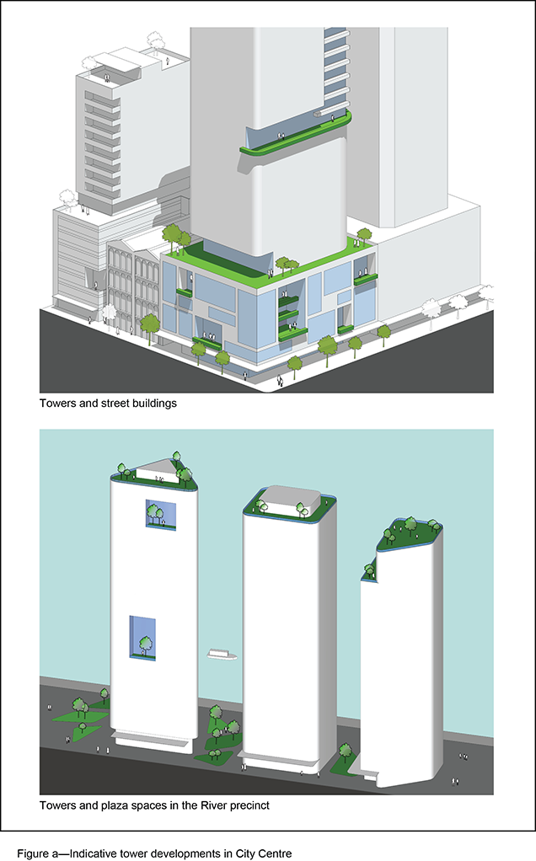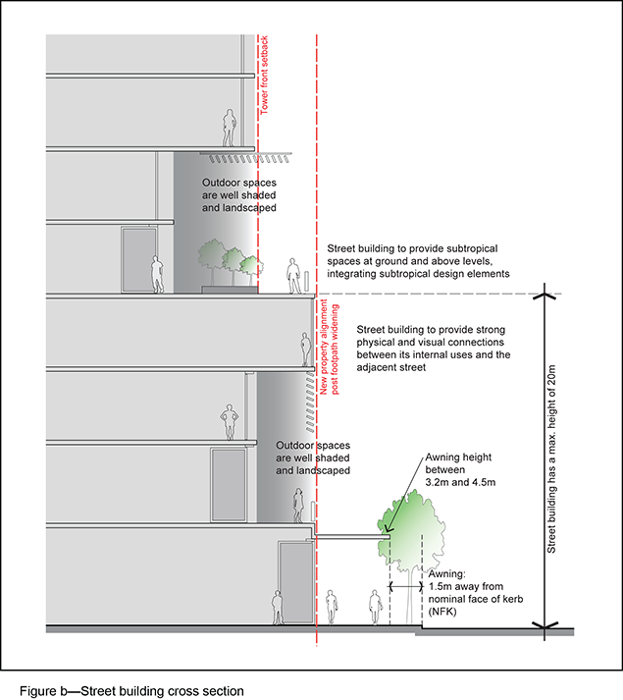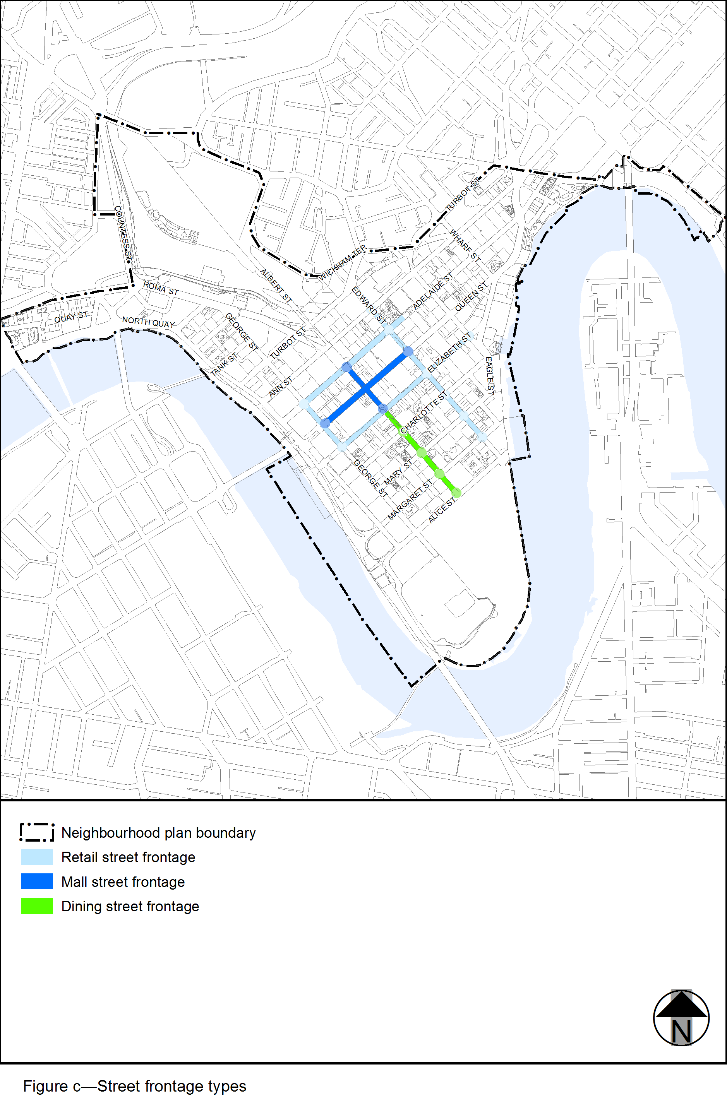 View the high resolution of Figure c–Street frontage types (PDF file size is 379Kb) 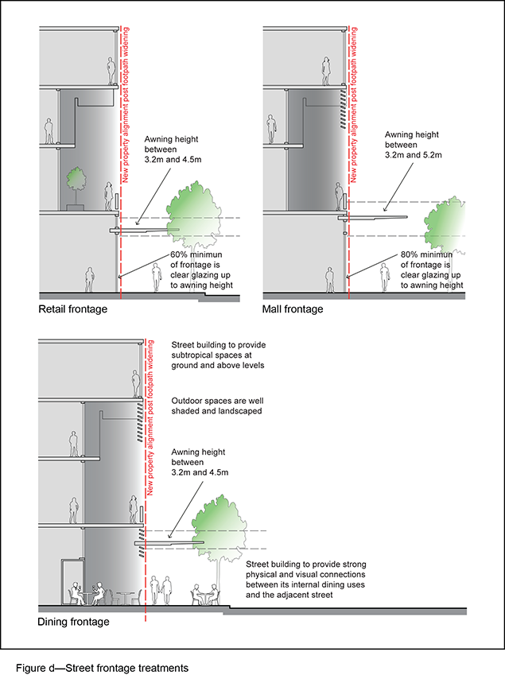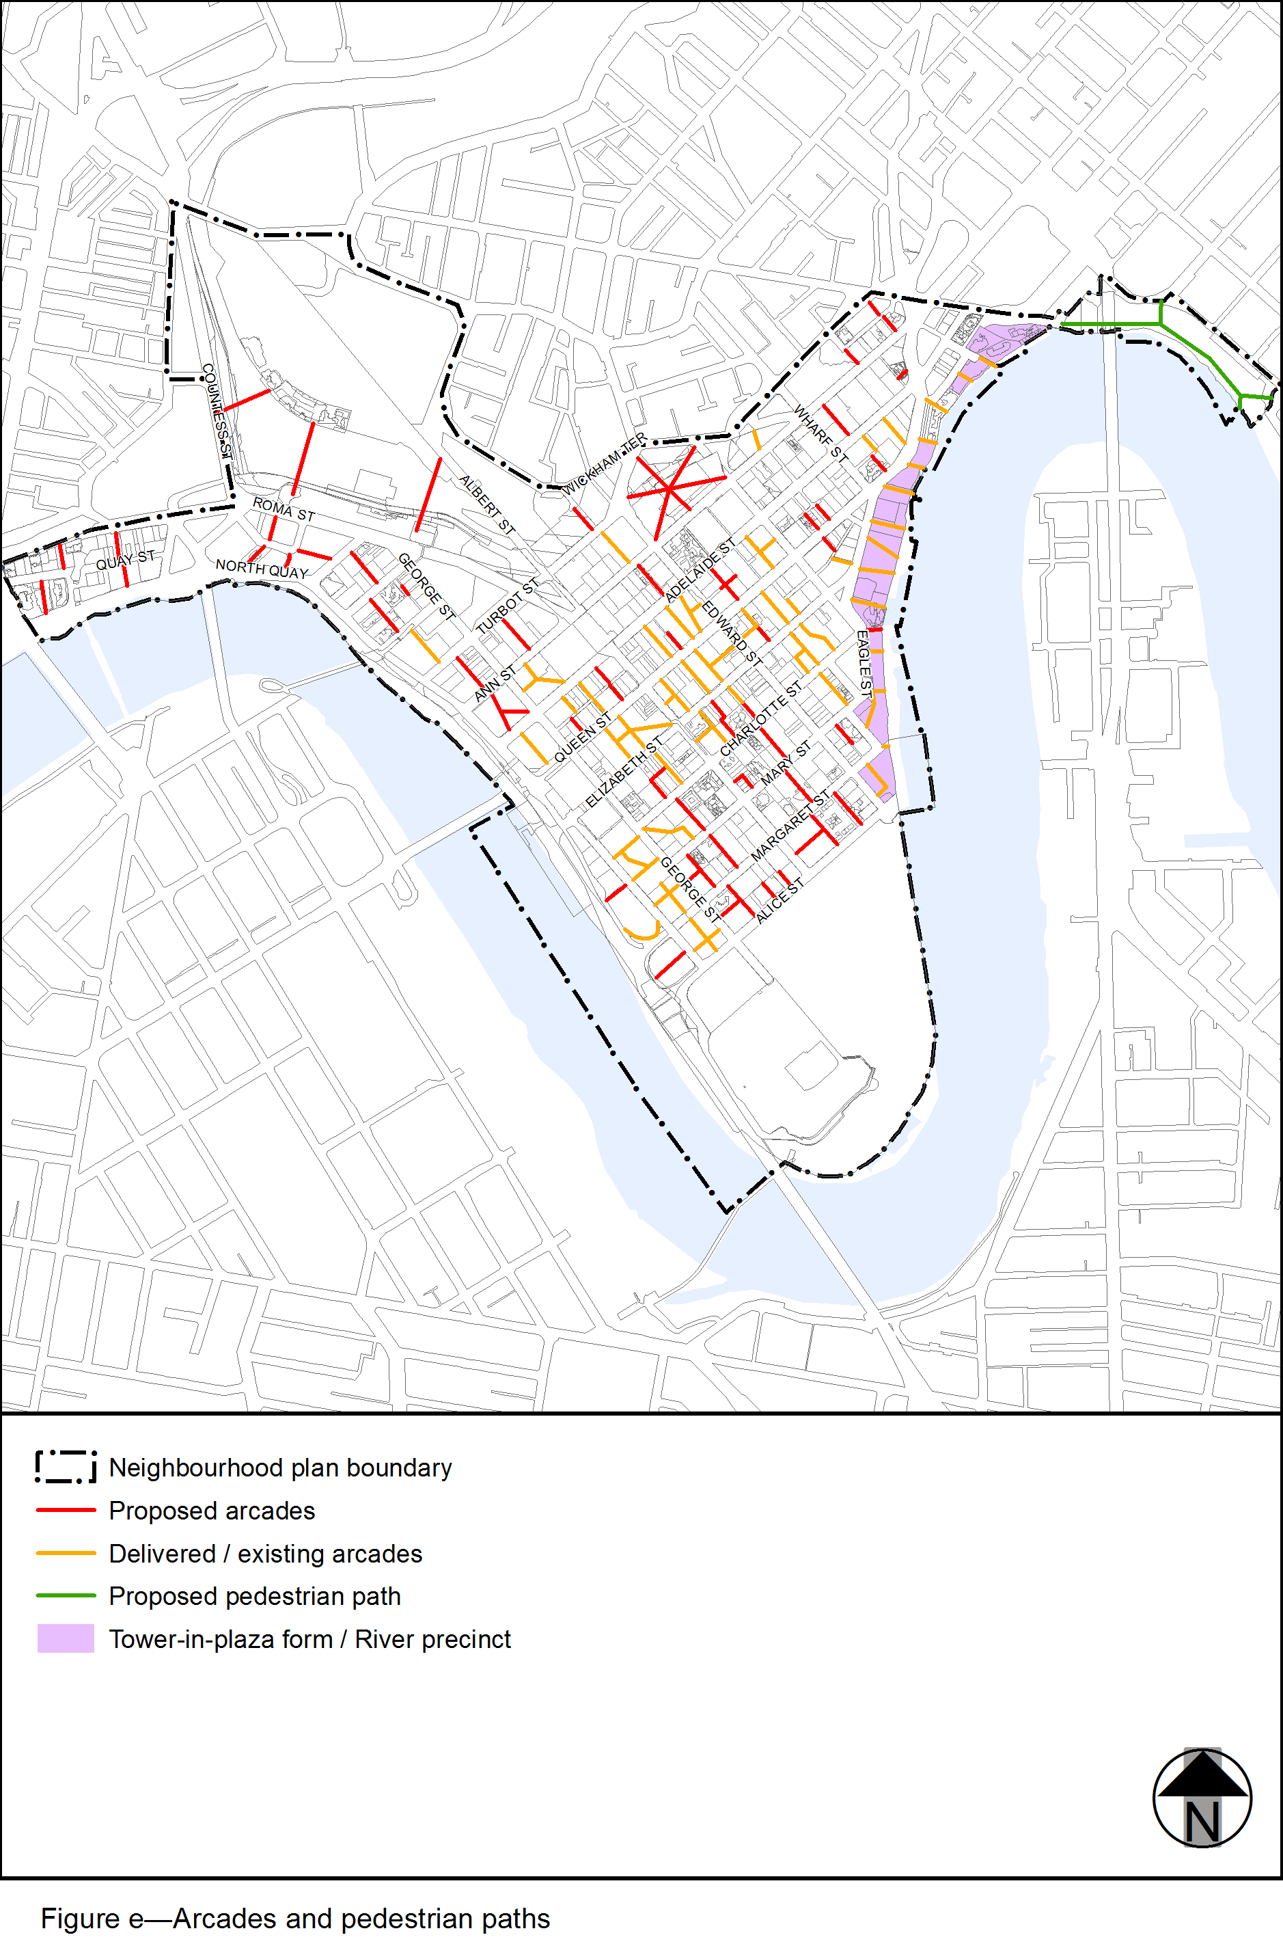 View the high resolution of Figure e–Arcades and pedestrian paths (PDF file size is 490Kb) 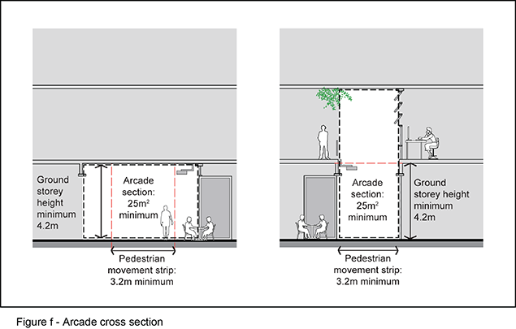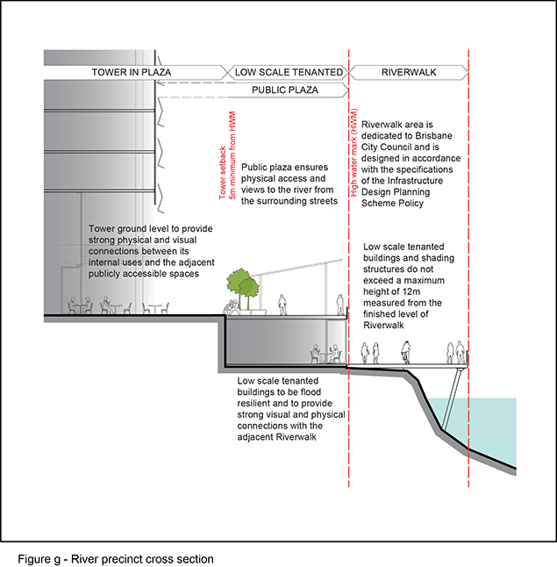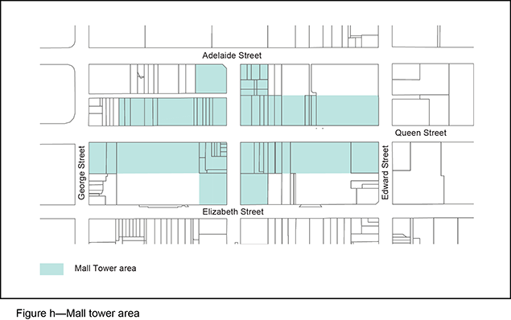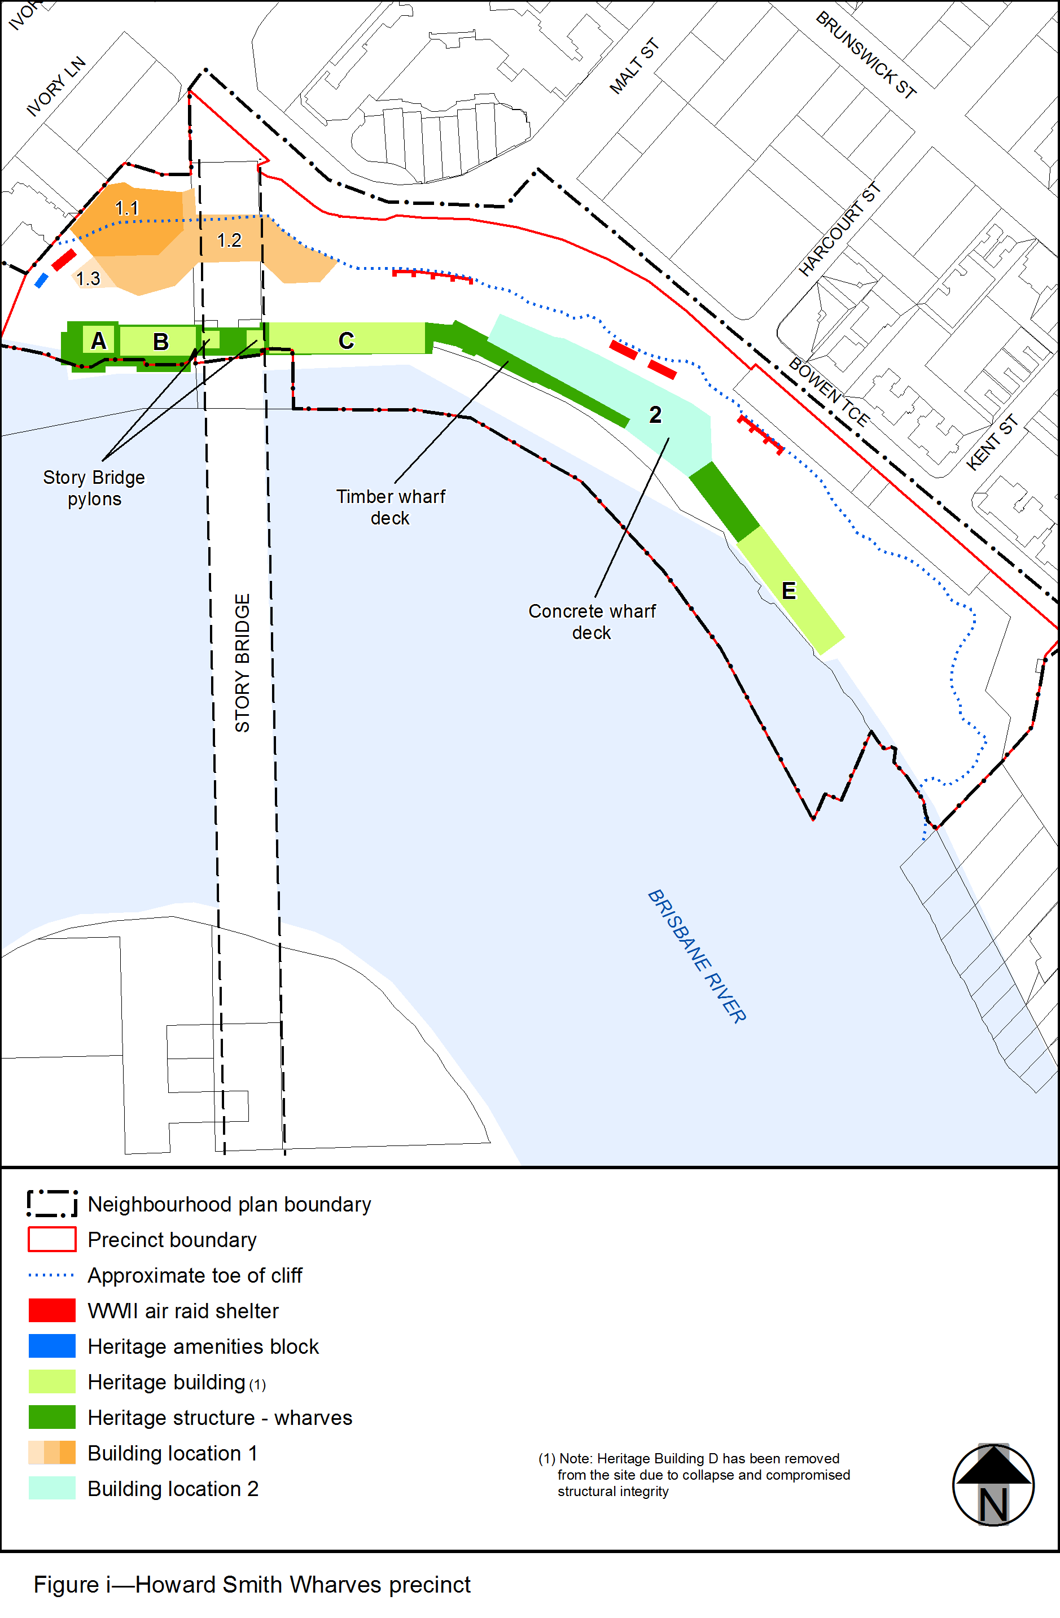View the high resolution of Figure i–Howard Smith Wharves precinct (PDF file size is 213Kb) 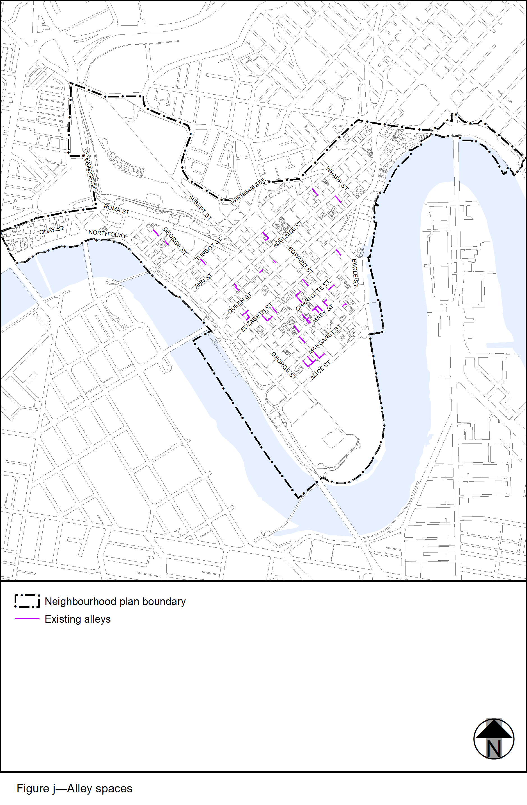View the high resolution of Figure j–Alley spaces (PDF file size is 485Kb)

