7.2.6.4 Fortitude Valley neighbourhood plan code

7.2.6.4.1 Application

1. This code applies to assessing a material change of use, reconfiguring a lot, operational work or building work in the Fortitude Valley neighbourhood plan area:
2. assessable development where this code is an applicable code identified in the assessment benchmarks column of a table of assessment for a neighbourhood plan (section 5.9); or
3. impact assessable development.
4. Land in the Fortitude Valley neighbourhood plan area is identified on the [NPM-006.4 Fortitude Valley neighbourhood plan map](http://www.brisbane.qld.gov.au/planning-building/planning-guidelines-tools/brisbane-city-plan-2014/city-plan-2014-mapping) and includes the following precincts:
5. Gotha Street precinct (Fortitude Valley neighbourhood plan/NPP-001);
6. Valley heart precinct (Fortitude Valley neighbourhood plan/NPP-002);
7. Special context area sub-precinct (Fortitude Valley neighbourhood plan/NPP-002a);
8. Valley gateway precinct (Fortitude Valley neighbourhood plan/NPP-003);
9. Light Street hill precinct (Fortitude Valley neighbourhood plan/NPP-004);
10. James Street precinct (Fortitude Valley neighbourhood plan/NPP-005);
11. Water Street precinct (Fortitude Valley neighbourhood plan/NPP-006).
12. When using this code, reference should be made to section 1.5, section 5.3.2 and section 5.3.3.

Note—The following purpose, overall outcomes, performance outcomes and acceptable outcomes comprise the assessment benchmarks of this code.

Note—This neighbourhood plan includes a table of assessment with variations to categories of development and assessment. Refer to Table 5.9.28.A, Table 5.9.28.B, Table 5.9.28.C and Table 5.9.28.D.

7.2.6.4.2 Purpose

1. The purpose of the Fortitude Valley neighbourhood plan code is to provide finer grained planning at a local level for the Fortitude Valley neighbourhood plan area.
2. The purpose of the Fortitude Valley neighbourhood plan code will be achieved through overall outcomes including overall outcomes for each precinct of the neighbourhood plan area.
3. The overall outcomes for the neighbourhood plan area are:
4. Fortitude Valley is a nationally recognised destination catering for a multitude of people and uses. The rich tapestry of new and old buildings, streets and lanes, cultures and character make it distinctly ‘The Valley’.
5. Renewal of Fortitude Valley focuses on promoting its vital role in the growth and economy of the city by providing both a supportive commercial function to the City Centre and ensuring the cultural heritage of the area, in the Special context area sub-precinct (Fortitude Valley neighbourhood plan/NPP-002a) in particular, is maintained and enhanced.
6. Growth demonstrates balanced social, economic and environmental outcomes and complements Fortitude Valley’s social, cultural and heritage diversity.
7. Development strengthens the role of the Valley heart precinct (Fortitude Valley neighbourhood plan/NPP-002) as a major entertainment, cultural, heritage, retail and business centre serving both the inner north-eastern suburbs and a city-wide catchment. The mix of uses strengthens both the day and night-time economies of Fortitude Valley.
8. Development supports the growth of more-intensive mixed use retail, cultural, commercial uses and residential activity, between and along the north–south corridors of Ann Street, Wickham Street and McLachlan Street and along St Pauls Terrace.
9. James Street is supported as a lifestyle node, together with small-scale business along surrounding streets such as Robertson Street.
10. Development carefully transitions to lower intensity residential activity at the interface with the residential neighbourhoods of New Farm, Light Street hill and Spring Hill.
11. Entertainment activities are focused within the Special entertainment area cores as shown in Figure a and provide for and encourage a variety of live music, nightclub entertainment facilities and other music venues into Fortitude Valley.
12. Noise attenuation to reduce the intrusion of amplified music from both existing and future venues is required in all new residential development, and noise attenuation requirements must be satisfied when designing new entertainment venues. In special entertainment areas, residents will expect ambient noise levels to be relatively higher both inside and outside of residences, due to their proximity to entertainment venues.

Note—A Special entertainment area is taken to be a special entertainment precinct for the purposes of the [Local Government Act 2009](http://www.legislation.qld.gov.au/Acts_SLs/Acts_SL_L.htm). A special entertainment area may cover more than 1 precinct.

1. Development is of a height, scale and form which is consistent with the amenity and character, community expectations and infrastructure assumptions intended for the relevant precinct, sub-precinct or site and is only developed at a greater height, scale and form where there is both a community need and an economic need for the development.
2. Development protects and enhances Fortitude Valley’s special heritage and character through the retention, refurbishment and re-use of heritage places and character buildings. New development will favour the retention of existing buildings, sensitively integrate infill development with heritage places, reflect and complement Fortitude Valley’s character and maintain the prominence of landmark sites and vistas.
3. Development reinforces the varied and diverse architecture and urban form that distinguishes Fortitude Valley from the CBD and other parts of Brisbane, through innovative building construction, architecture and urban design that reflects the creative and heritage values of Fortitude Valley and is responsive to each site’s specific shape, size, context and setting.
4. The quality and quantity of public spaces is improved through new and enhanced urban commons (including railway capping plazas), small-scale spaces, arcades, streetscape treatments and corner land dedication at significant corner sites that enhance recreational and pedestrian movement opportunities. Widened footpaths and active frontages reinforce street amenity and safety. Development will also support inter-suburban connections for pedestrians and cyclists to move easily through the plan area.
5. A range of community facilities and services that cater for local residents and those of surrounding suburbs support social inclusiveness. New community facilities will be encouraged, particularly around established clusters at Brunswick Street East and Church Street.
6. Gotha Street precinct (Fortitude Valley neighbourhood plan/NPP-001) overall outcomes are:
7. This precinct accommodates higher densities with a diverse range of uses that support the function of the City Centre and Valley heart, whilst respecting the existing sense of place and maintaining views to heritage places.
8. Retail and commercial uses activate the ground storey along Wickham Street and maintain the existing fine-grain retail character that defines this entry to Fortitude Valley.
9. Valley heart precinct (Fortitude Valley neighbourhood plan/NPP-002) overall outcomes are:
10. Development of a high architectural quality reinforces the role of the Valley heart as a key commercial, retail and entertainment centre.
11. The precinct’s proximity to the Fortitude Valley station supports higher densities and a wide range of uses. Development enhances pedestrian access to the station, and provides additional pedestrian links. Development extends along and over the railway corridor, where it enhances station access, railway operations, and the provision of public space. Refer to Figure b.
12. Development on the southern side of Constance Street between Alfred Street and Wickham Street makes a positive contribution to Fortitude Valley’s public domain by capping the railway corridor with a new pedestrian entrance to the railway station; footpath widenings and publicly accessible space. Refer to Figure b.
13. Site amalgamation and development adjoining the rail corridor between Gipps Street and Brunswick Street is encouraged to enable a development intensity that can support capping the rail corridor with new public space. Refer to Figure b.
14. Major retail and commercial development is located in the vicinity of the Brunswick Street and Chinatown malls and the Fortitude Valley Railway station. Food and beverage services are focused on the malls, reinforcing their role as regional attractions, with active, pedestrian-focused uses at lower levels. Cafes, restaurants and other pedestrian‑generating uses are located along the streets that connect Wickham Street with Ann Street.
15. Entertainment uses (including clubs and live music venues) are focused within the special entertainment area core. Short-term accommodation is encouraged in this area, where all residential uses are designed to mitigate higher levels of ambient noise.
16. Development in the Special context area sub-precinct (Fortitude Valley neighbourhood plan/NPP-002a):
17. enhances the cultural heritage of the area through preservation of the distinctive and fine-grain character;
18. is responsive to the setting of heritage places, and protects and enhances views towards them.
19. Valley gateway precinct (Fortitude Valley neighbourhood plan/NPP-003) overall outcomes are:
20. This precinct serves as a northern gateway to the city. It contains a mix of high-quality commercial, retail display, residential, recreational and community uses.
21. Streetscapes are of high quality with wide footpaths and significant street planting, particularly along Ann Street and Wickham Street.
22. The greatest intensities and heights of development are concentrated along and between the major routes of Ann Street and Wickham Street, whilst maintaining existing heritage elements.
23. Building heights reinforce the respective roles of St Paul’s Terrace and McLachlan Street as major boulevards, with smaller scale businesses and residential uses throughout the remainder of the precinct.
24. Pedestrian-generating uses, such as food and drink outlets (cafes and restaurants), are located along the streets that connect Wickham Street and Ann Street.
25. Development along Montpelier Road maintains views between Light Street hill and Bowen Hill and provides an active frontage to the street, with retail uses at ground level.
26. Light Street hill precinct (Fortitude Valley neighbourhood plan/NPP-004) overall outcomes are:
27. The precinct contains a significant group of 19th century timber cottages that testify to the early history of the area. The refurbishment of existing traditional character buildings is desirable and any infill development in the [Character residential zone](http://www.brisbane.qld.gov.au/planning-building/planning-guidelines-tools/brisbane-city-plan-2014/city-plan-2014-mapping) is required to reinforce this.
28. Within this precinct, residential, office and community uses are supported. Commercial uses are encouraged along the south–west end of Prospect Street via fine-grain infill development and re-use of buildings.
29. James Street precinct (Fortitude Valley neighbourhood plan/NPP-005) overall outcomes are:
30. The precinct contains a mix of commercial, retail, residential and recreational uses, providing a transition between the retail, business and entertainment-oriented precincts surrounding Ann Street and Wickham Street and the predominantly residential area of New Farm.
31. Development reinforces the commercial and retail frontages to Brunswick Street and Commercial Road and enhances the city-wide lifestyle role of the James Street node.
32. The view to St. Patrick’s Church from James Street is preserved.
33. This precinct supports a range of building heights, depending on the zoning and location of a site.
34. Water Street precinct (Fortitude Valley neighbourhood plan/NPP-006) overall outcomes are:
35. The Water Street precinct provides for medium-scale mixed use development, with an emphasis on multiple dwellings. As such, new music venues and other noise-generating uses are inappropriate.
36. Given the precinct’s proximity to Royal Brisbane Hospital and the RNA Showgrounds, it is an appropriate location for short-term accommodation.
37. Existing commercial and small-scale shops may continue to consolidate along Brunswick Street. However, shop uses other than those serving a local service function are not intended to permeate throughout the precinct. Other non-residential activities may locate away from Brunswick Street only where their impacts are suitably mitigated.

7.2.6.4.3 Performance outcomes and acceptable outcomes

Table 7.2.6.4.3.A—Performance outcomes and acceptable outcomes

|  |  |
| --- | --- |
| Performance outcomes | Acceptable outcomes |
| General | |
| PO1  Development is of a height, scale and form that achieves the intended outcome for the precinct, improves the amenity of the neighbourhood plan area, contributes to a cohesive streetscape and built form character and is:   1. consistent with the anticipated density and assumed infrastructure demand; 2. aligned to community expectations about the number of storeys to be built; 3. proportionate to and commensurate with the utility of the site area and frontage width; 4. designed to avoid a significant and undue adverse amenity impact to adjoining development; 5. sited to enable existing and future buildings to be well separated from each other and to avoid affecting the potential development of an adjoining site.   Note—Development that exceeds the intended number of storeys or building height can place disproportionate pressure on the transport network, public space or community facilities in particular.  Note—Development that is over-scaled for its site can result in an undesirable dominance of vehicle access, parking and manoeuvring areas that significantly reduce streetscape character and amenity.  Note—Maximum gross floor area provisions do not apply within centres in the Fortitude Valley neighbourhood plan area. | AO1.1  Development involves the re-use and refurbishment of existing buildings that contribute to the built form character and context of the immediate area. |
| AO1.2  Development complies with the number of storeys and building height in Table 7.2.6.4.3.B.  Note—Neighbourhood plans will mostly specify the maximum number of storeys where zone outcomes have been varied in relation to building height. Some neighbourhood plans may also specify the height in metres. Development must comply with both parameters where maximum number of storeys and height in metres are specified. |
| AO1.3  Development has a maximum podium height in accordance with Table 7.2.6.4.3.C. |
| PO2  Development of residential floor-to-ceiling heights facilitates natural ventilation and allows space for ceiling fans. | AO2  Development provides a minimum residential floor-to-ceiling height of 2.7m with an average floor-to-floor height of 3m. |
| PO3  Development setbacks are sufficient to ensure a building:   1. protects important views and vistas; 2. does not dominate the street or other spaces; 3. does not prejudice the development of an adjoining site; 4. enables existing and future buildings to be appropriately separated from each other to allow light penetration, air circulation and privacy and ensures windows are not built out by adjoining buildings; 5. creates attractive and viable small-scale spaces at the rear of buildings that also functions as a secondary light and ventilation source. | AO3  Development in the centres zone category or the Inner city zone precinct of the Mixed use zone:   1. if above the podium, has a 3m frontage setback unless located in the Special context area sub-precinct (Fortitude Valley neighbourhood plan/NPP-002a); 2. ensures any part of a building above the podium has a maximum site coverage of 60%, and a maximum horizontal dimension of 50m; 3. has a minimum rear boundary setback to the podium of: 4. 5m; or 5. 3m where no openings; or 6. 10m for residential components if the windows of habitable rooms are orientated towards that boundary; 7. if adjoining a zone in the Residential zones category, has a minimum boundary setback to the podium of 3m at that side boundary; 8. if above the podium, has a minimum side setback of 3m, and a minimum rear setback of 5m, where the minimum setback for residential components is 10m if the windows of habitable rooms are orientated towards that boundary.   Note—Where the new development adjoins a heritage place, the appropriate building setback will be determined case by case having regard to the views, vistas and context of the heritage place.  Note—In a zone in the [Residential zones](http://www.brisbane.qld.gov.au/planning-building/planning-guidelines-tools/brisbane-city-plan-2014/city-plan-2014-mapping) category the setbacks in the relevant residential zone code apply. |
| PO4  Development of a new building or addition:   1. is designed to address all elevations, with front, rear and side elevations displaying a high level of articulation and high-quality materials and finishes; 2. has a vertical articulation of building form and mass with proportions compatible with the height, scale and setting of the building; 3. is designed to address the skyline and silhouette with a high level of architectural design treatment and articulation when over 5 storeys in height; 4. is orientated to and with active uses fronting streets, urban commons (including railway capping plazas), small-scale spaces and arcades.   Note—Council’s Independent design advisory panel may be invited to provide advice on proposals in accordance with the provisions of the Independent design advisory panel planning scheme policy. | AO4  No acceptable outcome is prescribed. |
| PO5  Development improves pedestrian movement and amenity by dedicating and constructing footpaths to a width that is appropriate to the scale and function of the street, as identified in the Infrastructure design planning scheme policy. | AO5.1  Development with a frontage to a footpath build out street as indicated in Figure c constructs footpath build outs and in accordance with the specifications of the Infrastructure design planning scheme policy. |
| AO5.2  Development:   1. may have minor basement levels extending into the footpath area to the extent identified in Table 5.3.3.2.2A in Chapter 5 of the Infrastructure design planning scheme policy where located and constructed in accordance with the specifications of the Infrastructure design planning scheme policy; 2. contains the basement within a volumetric lot and the basement does not in any circumstances extend beyond the original property boundary.   Note—Where new development adjoins a heritage place, the appropriate width of any widening and building setback will be determined case by case having regard to the heritage place and the street function. |
| PO6  Development on a significant corner site provides a prominent visual reference and contribution to the neighbourhood’s public realm by:   1. accommodating high levels of pedestrian movement at the corner and enhancing the pedestrian experience; 2. emphasising the corner setting through building form, expression, silhouette, scale, materials and landscaping; 3. reinforcing a sense of arrival to the neighbourhood plan area, precinct or sub-precinct through marking a node, an intersection or connection point in the neighbourhood; 4. respecting the prominence of any adjoining or nearby heritage places, traditional character buildings or local landmarks; 5. where a land dedication is required: 6. accommodating a deep-planted large feature tree within the dedication area; 7. providing a building envelope that acknowledges and respects the presence of the large feature tree canopy. | AO6.1  Development is designed to emphasise the corner setting and provides:   1. building entries on both street frontages; or 2. a single main entry at the corner. |
| AO6.2  Development on a site greater than3,000m2 provides an inverted corner land dedication in the locations indicated as significant corner sites in Figure c and in accordance with the Road corridor design chapter of the Infrastructure design planning scheme policy.  Note—This is a locally specific outcome complementing the requirements of the neighbourhood plan section of either the Multiple dwelling code or the Centre or mixed use code. |
| AO6.3  Development provides deep-planted feature trees, seating and public art in the corner land dedication area in accordance with the specifications of the Infrastructure design planning scheme policy. |
| AO6.4  Development of all parts of a building including the basement are kept outside of the corner land dedication area. |
| PO7  Development of the ground and podium levels of the building exhibit a human-scale, fine grain and architectural interest, having regard to the characteristics of adjoining development, supporting outdoor lifestyles and engaging with the public realm. | AO7.1  Development of the lower 3 storeys of the building include:   1. variations in plan shape and vertical profile; 2. awnings and sun-protection devices; 3. balconies orientated to the street; 4. operable elements within the facade; 5. elements of a finer scale than the main structural framing; 6. display windows, showcases or public art. |
| AO7.2  Development ensures that street frontage and built form reflect the original lot widths and maintain the pattern of dominant architectural features. |
| PO8  Development:   1. is closely integrated with the street environment, with built form and uses that activate the frontage and generate pedestrian traffic; 2. at ground and podium levels abutting footpaths suits the nature and character of the street and provides: 3. an activated, pedestrian-friendly and human-scale facade; 4. a strong visual and physical connection to internal and external spaces; 5. a gradual transition between public street and semi-public and/or private outdoor or building spaces; 6. a subtropical urban design and built form; 7. a permeable edge to the street, which creates both a visual widening of the street section and an amenable edge to pedestrian movement; 8. useable outdoor/semi-outdoor spaces that support outdoor lifestyles and engage with the public realm.   Note—Within the Special context area sub-precinct (Fortitude Valley neighbourhood plan/NPP-002a), a more traditional and urban streetscape will predominate with a well-defined (such as less gradual and less permeable) transition between the public and private realms. | AO8.1  Development provides active uses at ground and podium levels, with windows and doors that allow for activity, visual connection and surveillance of streets, urban commons including railway capping plazas, small-scale spaces and arcades. |
| AO8.2  Development provides pedestrian entrances at least every 20m along the street frontages. |
| AO8.3  Development provides foyers that:   1. occupy a minimal proportion and subordinate part of the site frontage; 2. are open to the public domain; 3. contain activities and spaces that attract people such as reception desks, seating areas, cafes, shopfront galleries and display spaces. |
| A08.4  Development implements either an outdoor room, forecourt or landscape transition at the street frontage as illustrated in Figure d, Figure e, Figure f and Figure g.  Note—A landscape or an outdoor room transition with soft landscape, is not suitable in the Special context area sub-precinct (Fortitude Valley neighbourhood plan/NPP-002a). |
| PO9  Development provides awnings:   1. along busy pedestrian routes; 2. at gathering and waiting points such as bus stops. | AO9.1  Development provides awning cover where shown in Figure c.  Note—In locations not indicated in Figure c, the appropriateness of and design of awnings will be determined case by case. |
| AO9.2  Development provides awnings that do not include posts within the footpath. |
| A09.3  Development provides awnings that extend from the face of the building and are set back from inside the kerb line by:   1. 2.5m on a subtropical boulevard; or 2. 1.5m on all other streets.   Note—In all other respects, the awning is provided in accordance with the Centre or mixed use code. |
| Public domain | |
| PO10  Development on a significant site makes a significant contribution to the public realm by providing major new public spaces.  Note—Significant sites include sites identified for urban commons, railway cappings or small-scale spaces in Figure b and other development sites where the site area exceeds 5,000m2. | AO10.1  Development provides new urban commons in each of the following circumstances:   1. as part of a development where the site includes an area identified as an urban common in Figure b; 2. as part of a development where the site area exceeds 5,000m2. |
| AO10.2  Development provides new urban commons in accordance with any notation in Figure b or otherwise a minimum of 600m2 exclusive of vehicle movement areas. |
| AO10.3  Development of new railway cappings provides public space improvements such as a plaza in accordance with the locations and extent identified in Figure b. |
| AO10.4  Development provides new small-scale spaces in the locations identified in Figure b. |
| PO11  Development of a site containing an existing urban common including a railway capping plaza, small-scale space or arcade either:   1. retains and enhances the existing space; or 2. provides a new space of at least equal size and function. | AO11  No acceptable outcome is prescribed. |
| PO12  Development provides public spaces:   1. comprising: 2. urban commons including railway capping plazas which: 3. are publicly accessible recreational spaces that provide a high standard of amenity and include shade trees, lighting, shelter and seating; 4. are predominantly open to the sky and are focused on informal public use, with only limited formal activities such as outdoor dining; 5. are enhanced by public art and include infrastructure for events; 6. small-scale spaces which are publicly accessible entertainment and pedestrian areas that include lighting, shelter and infrastructure for temporal art installations; 7. that have equitable access, and that are well integrated with any adjoining arcades and incorporate crime prevention through environmental design principles; 8. that are generally bounded by active uses and have a strong street presence that signifies the space is publicly accessible. | AO12  No acceptable outcome is prescribed. |
| PO13  Development:   1. creates an integrated and continuous cross-block pedestrian network that facilitates safe, logical and direct access to centres of activity, public transport facilities, urban commons (including railway capping plazas) and small-scale spaces; 2. for an arcade has a strong street presence that signifies that they are publicly accessible; 3. provides active and pedestrian-friendly uses along the edges to create activity in the arcade and contribute to crime prevention through environmental design. | AO13.1  Development provides arcades:   1. in the locations identified in Figure b; 2. on sites running from street to street within an indicative location for an arcade identified in Figure b. |
| AO13.2  Development ensures the design of new, or enhancement of existing, arcades is in compliance with the specifications of the Infrastructure design planning scheme policy. |
| PO14  Development:   1. supports and facilitates pedestrian and cycle movement along the inter-suburban connections indicated in Figure b; 2. supports the safe movement of pedestrians across streets at ground level and through a network of arcades, laneways and small-scale spaces that align with existing and proposed street crossings; 3. incorporates a pavement treatment and building frontage that is conducive to footpath dining, except along subtropical boulevards and streets within the special context area excluding malls, where new footpath dining is not suitable due to high volumes of traffic or narrow and congested footpaths; 4. provides street furniture and landscaping in the public domain in accordance with the Infrastructure design planning scheme policy. | AO14  No acceptable outcome is prescribed. |
| Car parking, access and servicing | |
| PO15  Development provides:   1. buildings that are designed to accommodate useable floor space (not car parking) that genuinely activates and surveys the streetscape; 2. vehicle entrances, servicing and parking designed and located to: 3. minimise disruption to building frontages, the pedestrian environment, and reduce the visual impact on the street environment; 4. maximise pedestrian movement, comfort and safety in areas of high pedestrian usage by reducing pedestrian and vehicular conflict. | AO15.1  Development locates parking areas underground or behind the building at ground level only and car parking is not provided in a podium. |
| AO15.2  Development does not provide vehicular access from a principal frontage where:   1. laneway or secondary frontages are available; 2. new service lanes can be created. |
| AO15.3  Development only provides 1 vehicle access point to each site, vehicle entrances are minimised in height and width, and shared use of vehicle access points are used where possible. |
| AO15.4  A development’s driveway crossovers maintain the integrity, quality and primacy of footpaths. |
| AO15.5  Development in the Special context area sub-precinct (Fortitude Valley neighbourhood plan/NPP-002a) ensures that service vehicle openings are no wider than 3m and no higher than 3.5m, to allow entry to a vehicle 3m in height. |
| If in the Valley heart precinct (Fortitude Valley neighbourhood plan/NPP-002), where in the Special context area sub-precinct (Fortitude Valley neighbourhood plan/NPP-002a) | |
| PO16  Development:   1. makes a positive contribution to the existing streetscape, with podium heights, building frontages, awnings and architectural treatments that respond to the prevailing heights, lot patterns, building rhythms and architectural features of the heritage places and character buildings within the streetscape, as shown in Figure h; 2. has tenancy widths that reflect those in the character streetscape and create regular pedestrian entrances to facilitate activity at ground level; 3. is set back on upper levels above the podium to reduce visual impact of new development on the streetscape and to maintain views towards landmark heritage places; 4. maintains the visual significance of the McWhirter’s, Walton’s and Judith Wright Centre buildings within the streetscape.   Note—A character streetscape analysis is to be prepared for development within the special context area that demonstrates compliance with this performance outcome. | AO16.1  Development provides average tenancy widths to the street that are no greater than the average tenancy widths of the adjoining 2 properties either side of the site. Refer to Figure h. |
| AO16.2  Development ensures that buildings are built to the street alignment at the podium levels. |
| AO16.3  Development provides a maximum podium height in accordance with Table 7.2.6.4.3.C and otherwise aligns with the prevailing parapet level of heritage and character buildings. Refer to Figure h. |
| AO16.4  Development provides a minimum 6m building setback from tower above the podium to street frontage not including arcades or small-scale spaces. |
| AO16.5  Development provides an awning height and angle which matches any adjoining awning on a character building and reflects any stepping of awning height along the character streetscape. |
| AO16.6  Development provides a minimum rear boundary setback to the podium of:   1. 5m; or 2. 3m where no openings; or 3. 10m for residential components if the windows of habitable rooms are orientated towards that boundary. |
| AO16.7  Development provides a minimum boundary setback to tower (above the podium) of:   1. 3m to the side boundary; 2. 5m to the rear boundary; 3. 10m for residential components if the windows of habitable rooms are orientated towards that boundary. |
| AO16.8  Development of any part of the building above the podium (the tower) has a maximum site cover of 60%, and a maximum horizontal dimension of 50m. |
| PO17  Development reflects the material palette and character of the existing built fabric, with a rougher and grittier aspect to the architecture in contrast with that of the CBD. | AO17  Development uses building materials which:   1. are self-finished; 2. patina well with age; 3. display a tactile finish, such as face brick, stone, off-form unpainted/coloured/stained concrete or metals such as zinc and copper. |
| If in the Valley heart precinct (Fortitude Valley neighbourhood plan/NPP-002) | |
| PO18  Development enhances the amenity and attraction of the Chinatown and Brunswick Street malls. | AO18  Development provides day and night animation and promotes the theme, atmosphere and amenity of the malls through:   1. retail and other active uses fronting the mall; 2. mall-level tenancies that provide visual interest at all hours with transparent roller or shutters security grills; 3. ensuring that in the Chinatown Mall any alterations to the building facade promote the oriental design and theme of the mall; 4. ensuring that in the Brunswick Street Mall, any alterations to the building facade respect the scale, form and rhythm of the heritage places and streetscapes fronting the mall. |
| PO19  Development provides vehicular access and loading for non-residential uses that is located to minimise the use of St Pauls Terrace. | AO19  No acceptable outcome is prescribed. |
| If in the James Street precinct (Fortitude Valley neighbourhood plan/NPP-005) | |
| PO20  Development protects significant views and vistas towards St Patrick’s Church and grounds. | AO20  Development siting, configuration and design do not impinge on the significant view of St Patrick’s Church and grounds from James Street identified in Figure b. |
| If in the Water Street precinct (Fortitude Valley neighbourhood plan/NPP-006) | |
| PO21  Development provides vehicular access and loading for non-residential uses that are located to minimise the use of Brunswick Street. | AO21  No acceptable outcome is prescribed. |
| If in the special entertainment area | |
| If in the special entertainment area core identified in Figure a and involving a material change of use for a bar, club, hotel, indoor sport and recreation, nightclub entertainment facility, or food and drink outlet (restaurant) | |
| PO22  Development is designed and constructed to achieve an amplified music noise level at 1m external to any point of the premises of:   1. in core area A, not greater than LCeq,T 80dB and LLeq,T 73dB in any one-third octave band between and including 31.5Hz and 125Hz; 2. in core area B, not greater than LCeq,T 88dB for approved activities before 11.30pm, and LCeq,T 65dB and LLeq,T 55dB in any one-third octave band between and including 31.5Hz and 125Hz, for approved activities after 11.30pm.   Note—Operating noise levels for the above activities will be determined by the Amplified Music Venue Permit in accordance with the [Amplified Music Venues Local Law 2006.](http://www.dlg.qld.gov.au/local-government/local-laws-online.html) | AO22  Development does not involve amplified music that is audible external to the premises. |
| PO23  Development, located in the same building as, or that has a wall within 5m of a caretaker’s accommodation, dwelling house, hotel, multiple dwelling or short-term accommodation ensures the building is designed and constructed to achieve an amplified music noise level of:   1. not greater than LLeq,T 43dB in any one-third octave band between and including 31.5Hz to 125Hz in a bedroom not associated with the development; 2. not greater than LLeq,T 45dB in any one-third octave band between and including 31.5Hz to 125Hz in a living room not associated with the development.   Note—Operating noise levels for the above activities will be determined by the Amplified Music Venue Permit in accordance with the [Amplified Music Venues Local Law 2006.](http://www.dlg.qld.gov.au/local-government/local-laws-online.html) | AO23  Development located in the same building as, or that has a wall within 5m of a caretaker’s accommodation, dwelling house, multiple dwelling or short-term accommodation does not involve amplified music that is audible in a bedroom not associated with the development. |
| If in the special entertainment area (core or buffer) and involving material change of use for a caretaker’s accommodation, dwelling house or centre activities where a hotel, multiple dwelling or short-term accommodation | |
| PO24  Development ensures:   1. bedrooms and living rooms are designed, located and constructed to protect occupants from existing or future amplified music noise that may arise from premises outside the building; 2. a building is designed and constructed to achieve a minimum reduction in sound pressure level between the exterior of the building and the bedroom or living room, of: 3. LLeq,T 25dB at 63Hz where in special entertainment area core area A or buffer area A; 4. LLeq,T 20dB at 63Hz where in special entertainment area core area B or buffer area B; 5. LLeq,T 18dB at 63Hz for short-term accommodation where a backpackers in a special entertainment area core area or buffer area. | AO24  No acceptable outcome is prescribed. |
| PO25  Development located in the same building as, or that has a wall, within 5m of a bar, club, hotel, indoor sport and recreation, nightclub entertainment facility or food and drink outlet (restaurant) ensures:   1. bedrooms and living rooms are located, designed and constructed to protect occupants from amplified music noise being transmitted through a wall, floor or ceiling; 2. the building is designed and constructed to achieve an amplified music noise level of: 3. not greater than LLeq,T 43dB in any one-third octave band between and including 31.5Hz to 125Hz in a bedroom; 4. not greater than LLeq,T 45dB in any one-third octave band between and including 31.5Hz to 125Hz in a living room; 5. not greater than LLeq,T 45dB in any one-third octave band between and including 31.5Hz to 125Hz in a bedroom or living room for short-term accommodation where a backpackers. | AO25  Development is not located in the same building as, and the use does not have, a wall within 5m of centre activities where a bar, club, hotel, indoor sport and recreation, nightclub entertainment facility or food and drink outlet (restaurant). |

Table 7.2.6.4.3.B—Maximum building height

|  |  |  |  |  |  |  |  |
| --- | --- | --- | --- | --- | --- | --- | --- |
| Development | Building height (number of storeys) | | | | | | |
| Site frontage | Site frontage of less than 20m | Site frontage of 20m or greater | | | | | |
| Site area | Less than 500m2 | 500m2 or greater but less than 1,000m2 | 1,000m2 or greater but less than 1,500m2 | 1,500m2 or greater but less than 2,000m2 | 2,000m2 or greater but less than 3,000m2 | 3,000m2– or greater but less than 5,000m2 | 5,000m2 or greater |
| If in the Gotha Street precinct (Fortitude Valley neighbourhood plan/NPP-001) | | | | | | | |
| Any development in this precinct | 4 | 4 | 10 | 15 | 25 | 25 | 25 |
| If in the Valley heart precinct (Fortitude Valley neighbourhood plan/NPP-002), where outside the Special context area sub-precinct (Fortitude Valley neighbourhood plan/NPP-002a) | | | | | | | |
| Any development in this precinct | 4 | 10 | 12 | 15 | 25 | 30 | 30 |
| If in the Valley heart precinct (Fortitude Valley neighbourhood plan/NPP-002), where in the Special context area sub-precinct (Fortitude Valley neighbourhood plan/NPP-002a) | | | | | | | |
| Any development in this precinct | 3 | 5 | 10 | 15 | 25 | 30 | 30 |
| If in the Valley gateway precinct (Fortitude Valley neighbourhood plan/NPP-003) | | | | | | | |
| Any development in this precinct | 4 | 10 | 12 | 15 | 15 | 15 | 20 |
| If in the Valley gateway precinct (Fortitude Valley neighbourhood plan/NPP-003), where fronting Montpelier Road | | | | | | | |
| Any development in this precinct | 4 | 4 | 8 | 8 | 8 | 8 | 8 |
| If in the Light Street hill precinct (Fortitude Valley neighbourhood plan/NPP-004), where in the [Character residential zone](http://www.brisbane.qld.gov.au/planning-building/planning-guidelines-tools/brisbane-city-plan-2014/city-plan-2014-mapping) | | | | | | | |
| Any development in this precinct | 2 | 2 | 2 | 2 | 2 | 2 | 2 |
| If in the Light Street hill precinct (Fortitude Valley neighbourhood plan/NPP-004), where in the Up to 3 storeys zone precinct of the [Low–medium density residential zone](http://www.brisbane.qld.gov.au/planning-building/planning-guidelines-tools/brisbane-city-plan-2014/city-plan-2014-mapping) | | | | | | | |
| Any development in this precinct | 3 | 3 | 3 | 3 | 3 | 3 | 3 |
| If in the Light Street hill precinct (Fortitude Valley neighbourhood plan/NPP-004), where in the [Mixed use zone](http://www.brisbane.qld.gov.au/planning-building/planning-guidelines-tools/brisbane-city-plan-2014/city-plan-2014-mapping) | | | | | | | |
| Any development in this precinct | 4 | 4 | 5 | 5 | 5 | 5 | 5 |
| If in the James Street precinct (Fortitude Valley neighbourhood plan/NPP-005), where in the [Mixed use zone](http://www.brisbane.qld.gov.au/planning-building/planning-guidelines-tools/brisbane-city-plan-2014/city-plan-2014-mapping) | | | | | | | |
| Any development in this precinct | 4 | 4 | 6 | 6 | 8 (12 storeys fronting Commercial  Road) | 8 (12 storeys fronting Commercial  Road) | 8 (12 storeys fronting Commercial  Road) |
| If in the James Street precinct (Fortitude Valley neighbourhood plan/NPP-005), where fronting Arthur Street or within the Up to 3 storeys precinct of the [Low–medium density residential zone](http://www.brisbane.qld.gov.au/planning-building/planning-guidelines-tools/brisbane-city-plan-2014/city-plan-2014-mapping) | | | | | | | |
| Any development in this precinct | 3 | 3 | 3 | 3 | 3 | 3 | 3 |
| Water Street precinct (Fortitude Valley neighbourhood plan/NPP-006) | | | | | | | |
| Any development in this precinct | 4 | 4 | 6 | 6 | 8 | 8 | 8 |

Note—Maximum building height is determined by the number of storeys, rather than metres.

Note—The site must meet both the site area and street frontage criteria to achieve the maximum building height. Where the site area and street frontage criteria provide for different building heights, the lesser of the heights applies.

Table 7.2.6.4.3.C—Maximum podium height

| Development | Podium height |
| --- | --- |
| If in the Valley heart precinct (Fortitude Valley neighbourhood plan/NPP-002), where outside the Special context area sub-precinct (Fortitude Valley neighbourhood plan/NPP-002a) | |
| Any development in this precinct | 5 storeys |
| If in the Valley heart precinct (Fortitude Valley neighbourhood plan/NPP-002), where in the Special context area sub-precinct (Fortitude Valley neighbourhood plan/NPP-002a) | |
| Development of a site on:  Brunswick Street between St Pauls Terrace and Wickham Street  The north-western side of Wickham Street between Gipps Street and Brunswick Street  The south-eastern side of Ann Street between Winn Street and Morgan Street  The block bounded by Wickham Street, Constance Street, Ann Street and Ballow Street | 3 storeys |
| Development of a site on the block bounded by Wickham Street, Duncan Street, Ann Street and Gipps Street | 4 storeys |
| Development of a site on all other areas | Aligns with the prevailing parapet level of heritage and character buildings |
| If in the James Street precinct (Fortitude Valley neighbourhood plan/NPP-005) | |
| Development of a site within the Inner city zone precinct of the [Mixed use zone](http://www.brisbane.qld.gov.au/planning-building/planning-guidelines-tools/brisbane-city-plan-2014/city-plan-2014-mapping) | 3 storeys |
| If in the Valley Gateway precinct (Fortitude Valley neighbourhood plan/NPP-003) | |
| Development of a site where adjoining or fronting the Light Street hill [Character residential zone](http://www.brisbane.qld.gov.au/planning-building/planning-guidelines-tools/brisbane-city-plan-2014/city-plan-2014-mapping) | 3 storeys |
| Development of a site in all other areas | 4 storeys |
| If in the Light Street hill precinct (Fortitude Valley neighbourhood plan/NPP-004) | |
| Development of a site within the Inner city zone precinct of the [Mixed use zone](http://www.brisbane.qld.gov.au/planning-building/planning-guidelines-tools/brisbane-city-plan-2014/city-plan-2014-mapping) | 3 storeys |
| If in the Gotha Street precinct (Fortitude Valley neighbourhood plan/NPP-001) | |
| Any development in the precinct | 4 storeys |
| If in the Water Street precinct (Fortitude Valley neighbourhood plan/NPP-006) | |
| Any development in the precinct | 3 storeys |

Note—Podium heights are not applicable in the [Low–medium density residential zone](http://www.brisbane.qld.gov.au/planning-building/planning-guidelines-tools/brisbane-city-plan-2014/city-plan-2014-mapping) and [Character residential zone](http://www.brisbane.qld.gov.au/planning-building/planning-guidelines-tools/brisbane-city-plan-2014/city-plan-2014-mapping).

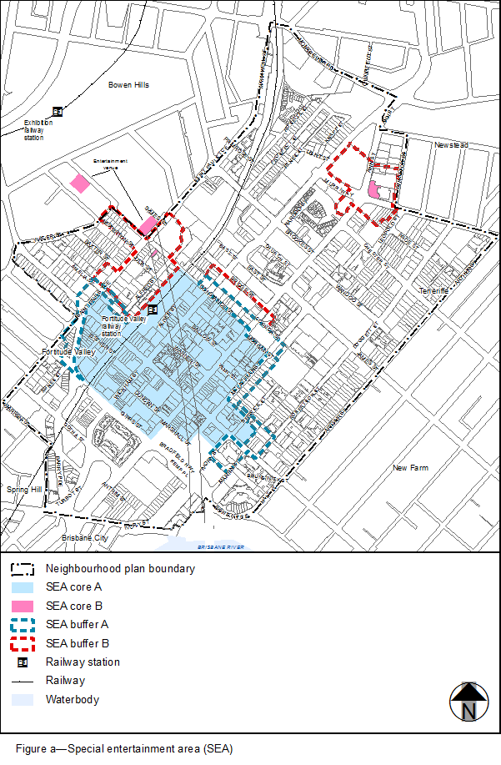

View the high resolution of [Figure a–Special entertainment area](http://eplan.brisbane.qld.gov.au/New%20City%20Plan%20QPP/Part%2007%20-%20Local%20plans/Spatial%20Maps/FigureA_Fortitude_Valley.pdf) (PDF file size is 633Kb)

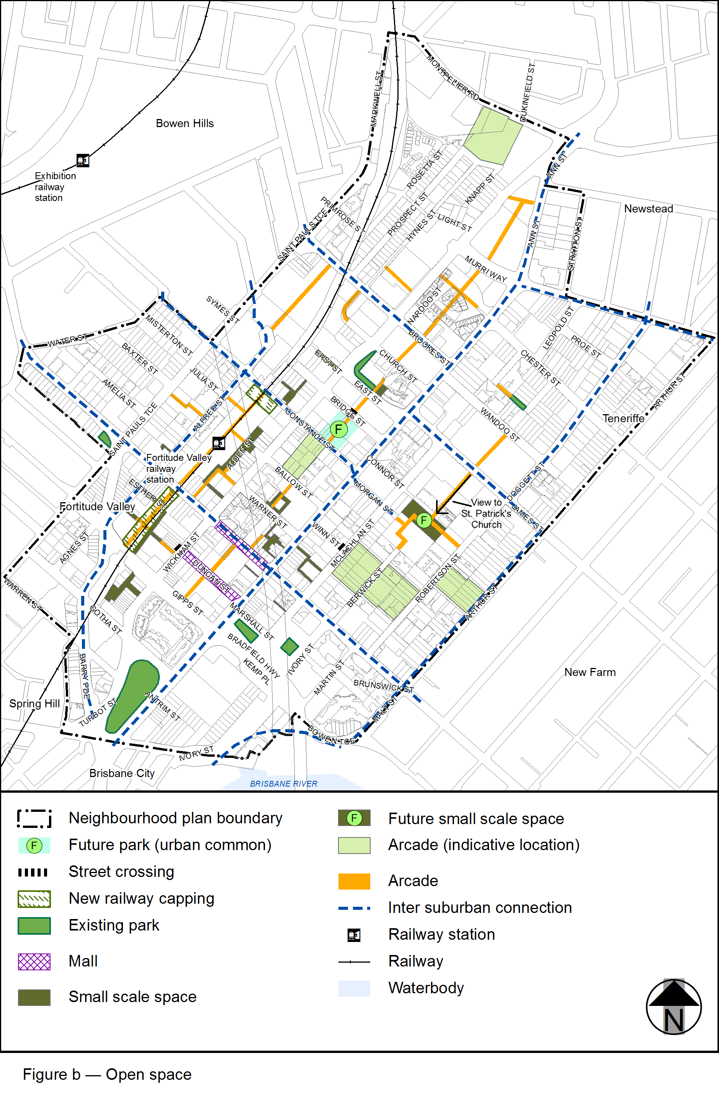

View the high resolution of [Figure b–Open space](http://eplan.brisbane.qld.gov.au/New%20City%20Plan%20QPP/Part%2007%20-%20Local%20plans/Spatial%20Maps/FigureB_Fortitude_Valley.pdf) (PDF file size is 620Kb)

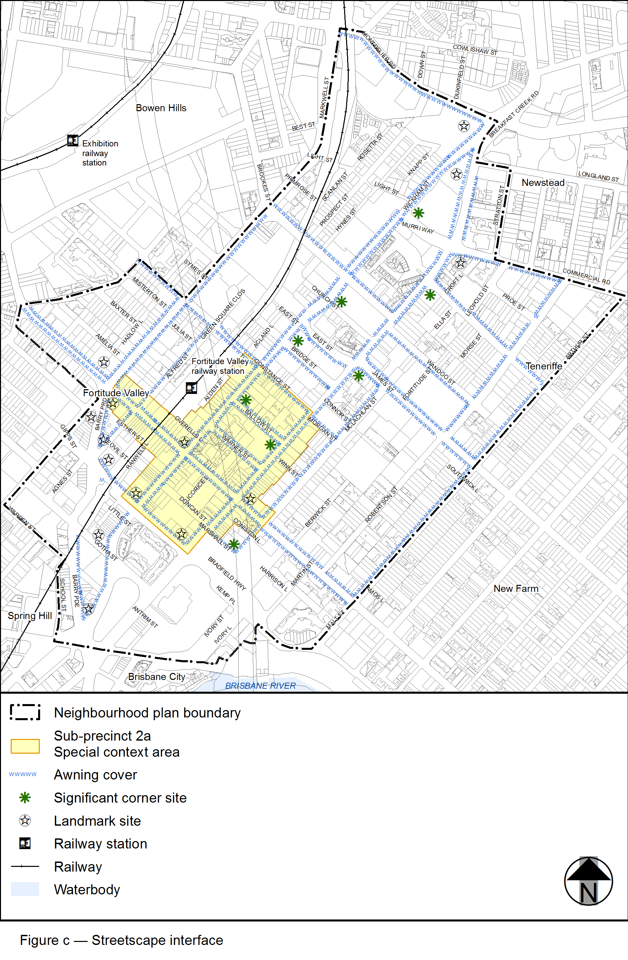

View the high resolution of [Figure c—Streetscape interface](http://eplan.brisbane.qld.gov.au/New%20City%20Plan%20QPP/Part%2007%20-%20Local%20plans/Spatial%20Maps/FigureC_Fortitude_Valley.pdf) (PDF file size is 639Kb)



