7.2.9.2 Ithaca district neighbourhood plan code

7.2.9.2.1 Application
- This code applies to assessing a material change of use, reconfiguring a lot, operational work or building work in the Ithaca district neighbourhood plan area if:
- assessable development where this code is an applicable code identified in the assessment benchmarks column of a table of assessment for a neighbourhood plan (section 5.9); or
- impact assessable development.
- Land in the Ithaca district neighbourhood plan area is identified on the NPM-009.2 Ithaca district neighbourhood plan map and includes the following precincts:
- Butterfield Street precinct (Ithaca district neighbourhood plan/NPP-001):
- Butterfield Street a sub-precinct (Ithaca district neighbourhood plan/NPP-001a);
- Butterfield Street b sub-precinct (Ithaca district neighbourhood plan/NPP-001b).
- Ballymore precinct (Ithaca district neighbourhood plan/NPP-002);
- Bishop Street precinct (Ithaca district neighbourhood plan/NPP-003);
- Guthrie Street precinct (Ithaca district neighbourhood plan/NPP-004);
- Brewery precinct (Ithaca district neighbourhood plan/NPP-005);
- Enoggera Terrace precinct (Ithaca district neighbourhood plan/NPP-006);
- Rosalie village precinct (Ithaca district neighbourhood plan/NPP-007);
- Hillside character precinct (Ithaca district neighbourhood plan/NPP-008).
Editor's note—Part of the neighbourhood plan area is covered by the Herston Quarter priority development area which Economic Development Queensland is responsible for planning under the Economic Development Act 2012.
- When using this code, reference should be made to section 1.5, section 5.3.2 and section 5.3.3.
Note—The following purpose, overall outcomes, performance outcomes and acceptable outcomes comprise the assessment benchmarks of this code.
Note—Hillside areas are steeper residential areas containing traditional character housing and significant ridgelines. Hillside character is derived from the relationship of buildings to their physical setting. Traditional character housing built following an historic subdivision pattern and located on well-treed hillsides results in a unique character of important visual significance in the local context.
Note—This neighbourhood plan includes a table of assessment with variations to categories of development and assessment. Refer to Table 5.9.31.A, Table 5.9.31.B, Table 5.9.31.C and Table 5.9.31.D.

7.2.9.2.2 Purpose
- The purpose of the Ithaca district neighbourhood plan code is to provide finer grained planning at a local level for the Ithaca district neighbourhood plan area.
- The purpose of the Ithaca district neighbourhood plan code will be achieved through overall outcomes of the neighbourhood plan area.
- The overall outcomes for the neighbourhood plan area are:
- Identified character housing and significant character streetscapes are maintained;
- A mix of housing densities and types serve the needs of the community;
- Multiple dwellings are not accommodated in the Low density residential zone.
- Hillside character is retained and enhanced through sympathetic development that minimises visual impact within its visual catchment;
- The ecological and recreational values of Ithaca and Enoggera creeks are protected;
- The neighbourhood plan area will capitalise on its strategic location by developing businesses and low impact industrial activities that support the City Centre and its fringe, or are associated with key facilities in the area, such as the Royal Brisbane and Women’s Hospital;
- Expansion of the hospital, medical school and research activities into the nearby residential areas is not consistent with the outcomes sought by the neighbourhood plan code;
- The industrial zoned land at Milton provides industrial support functions for the City Centre and its fringe;
- Business or retail activities on industrial zoned land at Milton are not consistent with the outcomes sought by the neighbourhood plan code unless they have a justifiable nexus with the surrounding industrial activities;
- Community facilities on privately owned land, including Ballymore and the Broncos Leagues Club, are protected to ensure the ongoing provision of a range of venues for the pursuit of sporting, recreational, community and cultural activities; Opportunities for new community facilities and services are encouraged.
- Significant views and vistas are to be protected;
- Development proposed in visually prominent locations such as major ridgelines and hilltops is designed to achieve minimal visual impact;
- Development forms that require cut and fill and disturbance of vegetation are not consistent with the outcomes sought by the neighbourhood plan code;
- Development is of a height, scale and form which is consistent with the amenity and character, community expectations and infrastructure assumptions intended for the relevant precinct, sub-precinct or site and is only developed at a greater height, scale and form where there is both a community need and an economic need for the development.
- Butterfield Street precinct (Ithaca district neighbourhood plan/NPP-001) overall outcomes are:
- Development enhances public access to Enoggera Creek and provides walking and cycling paths along the creek linking with Butterfield Street;
- Attractive pedestrian environments are provided along the Enoggera Creek with quality landscaping;
- Building envelopes are set back from the Enoggera Creek with elevations stepped towards Butterfield street;
- Development in the Butterfield Street a sub-precinct (Ithaca district sub-precinct neighbourhood plan/NPP-001a):
- supports non-residential uses that have a close nexus with the Royal Brisbane and Women’s Hospital complex provided relevant amenity and site flooding issues are satisfactorily addressed.
- Development in the Butterfield Street b sub-precinct (Ithaca district sub-precinct neighbourhood plan/NPP-001b):
- may comprise higher intensity mixed uses to co-exist with hospital uses, provided relevant amenity and site flooding issues are satisfactorily addressed.
- Ballymore precinct (Ithaca district neighbourhood plan/NPP-002) overall outcomes are:
- Any alterations to the existing sporting facilities that result in an increase in capacity and/or intensity do not adversely affect the surrounding community;
- Further expansion of sporting facilities within the waterway corridor is minimised.
- Bishop Street precinct (Ithaca district neighbourhood plan/NPP-003) overall outcomes are:
- Bishop Street continues to provide an important industrial support function for the City Centre and its fringe;
- Business and commercial activities that do not have a direct link with the industrial precinct are not considered consistent with this outcome;
- Redevelopment of properties adjoining Enoggera Creek provides land for a park along the waterway corridor and contributes land for a walking and cycling link between Bishop Street and the creek.
- Guthrie Street precinct (Ithaca district neighbourhood plan/NPP-004) overall outcomes are:
- As the precinct is in proximity to Given Terrace and commercial and public transport facilities, low–medium density residential uses are consistent with the outcomes sought;
- New development forms respectful relationships with its immediate neighbours and surrounding neighbourhood, consistent with its strategic location.
- Brewery precinct (Ithaca district neighbourhood plan/NPP-005) overall outcomes are:
- This precinct contains a purpose-built brewery of cultural heritage significance. The brewery is a Brisbane icon and a well-known landmark of the city, with a great physical presence within the locality. Any loss of the cultural heritage values of the site would be a significant iconic loss to the city and inconsistent with the outcomes sought in this precinct. As such, a range of associated subordinate cultural and tourism activities are encouraged to protect and enhance this value;
- The following range of subordinate cultural and tourism activities are consistent with the outcomes sought in the precinct:
- tourist attraction where tour centre and/or museum catering exclusively for cultural heritage associated with the brewery;
- food and drink outlet where catering exclusively for tour centre and/or museum visitors or brewery employees;
- shop retailing exclusively brewery products or memorabilia;
- club for brewery employees.
- Medium impact industry uses where for brewery purposes is consistent with the outcomes sought for the precinct.
- Enoggera Terrace precinct (Ithaca district neighbourhood plan/NPP-006) overall outcomes are:
- Enoggera Terrace is maintained as an intact street containing a substantial range of early and historic buildings, the rarity of which contributes to the uniqueness of this precinct;
- Special area 1 – Musgrave Road, is a visually prominent site and represents a gateway into Enoggera Terrace. Development in special area 1 – Musgrave Road:
- addresses its corner location, its setting adjacent to a heritage place and its landmark value at the head of an historic street;
- features centre activities that whilst limited in size and intensity, contribute to a locally prominent commercial node at this part of Enoggera Terrace;
- employs quality contemporary architecture respectful of its setting and context rather than replicative design;
- features low rise mixed uses incorporating multiple dwellings and a small component of centre activities at a scale consistent with the outcomes sought for this special area.
- Special area 2 – Skate Arena, contains a purpose-built theatre of cultural heritage significance, which has great physical presence within the locality. Development in Special area 2 – Skate Arena:
- retains the site’s cultural heritage and landmark value;
- comprises an adaptive re-use featuring quality contemporary architecture respectful of its setting and context rather than replicative design;
- contains multiple dwellings within the existing building footprint at a scale consistent with the outcomes sought for this special area;
- retains the Enoggera Terrace facade.
- Given the lack of on-street parking and the preference for site access from Mannion Street rather than Enoggera Terrace, high traffic-generating uses are not consistent with the outcomes sought for special areas 2 and 3;
- Special area 3 – 78 Enoggera Terrace, contains a church building that has been used successfully for a variety of activities since its original purpose was discontinued. Despite the small allotment size, adaptive re-use of the existing structure for small-scale non-residential uses or a multiple dwellings is consistent with the outcomes sought in the special area.
- Rosalie village precinct (Ithaca district neighbourhood plan/NPP-007) overall outcome is:
- Given Rosalie village’s popularity as a food and drink outlet precinct, car parking bays other than those associated with an on-site residential use are to be made available for public use outside normal business hours. Any variation of parking requirements for a non-residential uses must be consistent with the outcomes sought in this precinct where available parking in perpetuity is achieved;
- In the event of the Rosalie Kindergarten ceasing operations, re-use of the existing structure for low impact centre activities may be appropriate. Relaxation of car parking requirements may be appropriate where the provision of parking would compromise the nature of the heritage place.
- Hillside character precinct (Ithaca district neighbourhood plan/NPP-008) overall outcomes are:
- Hillside character is maintained, retained and enhanced through sympathetic development that minimises visual impact within its visual catchment;
- Development along major ridgelines in the precinct contributes to a consistent rhythm and sense of scale along the ridgeline when viewed from the surrounding visual catchment;
- Residential development in particular, provides and/or incorporates:
- the appearance of traditional character houses uniformly spaced and stepped across well-treed hillsides;
- compatible building height, bulk and proportions;
- construction methods, such as posts or piers, that minimise the amount of alteration to site topography.

7.2.9.2.3 Performance outcomes and acceptable outcomes

Table 7.2.9.2.3.A—Performance outcomes and acceptable outcomes
Performance outcomes | Acceptable outcomes
Building height
PO1  Development is of a height, scale and form that achieves the intended outcome for the precinct, improves the amenity of the neighbourhood plan area, contributes to a cohesive streetscape and built form character and is:  - consistent with the anticipated density and assumed infrastructure demand;  - aligned to community expectations about the number of storeys to be built;  - proportionate to and commensurate with the utility of the site area and frontage width;  - designed to avoid a significant and undue adverse amenity impact to adjoining development;  - sited to enable existing and future buildings to be well separated from each other and to avoid affecting the development potential of adjoining sites.  Note—Development that exceeds the intended number of storeys or building height can place disproportionate pressure on the transport network, public space or community facilities in particular.  Note—Development that is over-scaled for its site can result in an undesirable dominance of vehicle access, parking and manoeuvring areas that significantly reduce streetscape character and amenity. | AO1  Development complies with the number of storeys and building heights in Table 7.2.9.2.3.B.  Note—Neighbourhood plans will mostly specify a maximum number of storeys where zone outcomes have been varied in relation to building height. Some neighbourhood plans may also specify height in metres. Development must comply with both parameters where maximum number of storeys and height in metres are specified.
If in the Butterfield Street precinct (Ithaca district neighbourhood plan/NPP-001)
PO2  Development contributes toward the natural value of Enoggera Creek and the recreation needs of the local community by providing land for park purposes along Enoggera Creek that can accommodate a shared walking and cycling path and riparian rehabilitation. | AO2  Development ensures land within the waterway corridor or within 10m of the creek banks, whichever is greater, is dedicated to Council.
PO3  Development provides emergency site access from any residential development during floods. | AO3.1  Development in the Butterfield Street a sub-precinct (Ithaca district neighbourhood plan/NPP-001a) does not contain a residential component.
AO3.2
Development for residential purposes in the Butterfield Street b sub-precinct (Ithaca district neighbourhood plan/NPP-001b) achieves flood-free emergency access in a defined flood event to Butterfield Street.
PO4  Development preserves land adjoining Enoggera Creek for public use and buildings reinforce the creek corridor by providing:  - pedestrian links;  - high-quality, attractive building elevations that are orientated toward a corridor park;  - above-ground elevations and landscape treatments that are attractively designed to reduce tall blank areas to the corridor park and public pedestrian links. | AO4.1  Development on sites adjacent to Enoggera Creek provides a corridor park between the waterway corridor and the high water mark or 12m in width, whichever is greater.
AO4.2
Development provides a public walking and cycling path along the entire creek edge at no cost to the Council and designed in compliance with the Infrastructure Design planning scheme policy.
AO4.3
Development involving basement walls that face the landscaped public access ways to the corridor park incorporate a variety of landscaping and transitional elements for the entire length and width of the boundary setback.
AO4.4
Development ensures that building elevations orientated to the corridor park incorporate windows, parking areas or activity areas that overlook the corridor park.
AO4.5
Development provides opportunities for passive surveillance over the corridor park and pedestrian links.
PO5  Development provides parking that achieves a balance between controlling congestion and providing sufficient short- term parking to keep the anticipated commercial components of the precincts viable and service the needs of other users of the site’s facilities. | AO5  Development provides access, parking and servicing in accordance with the requirements of the Transport, access, parking and servicing code, with the following exceptions:  - for residential development, the number of car parking spaces does not exceed 1.5 spaces per dwelling unit;  - the number of car parking spaces does not exceed 1 space per 30m2 of gross floor area for non-residential uses.
If in the Butterfield Street precinct (Ithaca district neighbourhood plan/NPP-001), where in the Butterfield Street a sub-precinct (Ithaca district neighbourhood plan/NPP-001a)
PO6  Development maximises building setbacks to the corridor park and steps back building heights from the creek frontage. |  |  | AO6.1  Development has a maximum site cover of 75%.
AO6.2
Development has a maximum plot ratio of 150% of the site area.
AO6.3
Development has a maximum building height of 3 storeys and 10.5m.
AO6.4
Development of a building has a setback of 5m from the corridor park.
AO6.5
Development has a minimum front setback of 5m.
If in the Butterfield Street precinct (Ithaca district neighbourhood plan/NPP-001), where in the Butterfield Street b sub-precinct (Ithaca district neighbourhood plan/NPP-001b)
PO7  Development maximises building setbacks to the corridor park and steps back building heights from the creek frontage. |  |  | AO7.1  Development has a maximum site cover of 75%.
AO7.2
Development has a maximum plot ratio of 250% of the site area.
AO7.3
Development has a minimum front setback for basements of 2m.
AO7.4
Development has a minimum front setback above basement level of 8m.
AO7.5
Development may have front balconies protruding a maximum of 3m into the building setback.
If in the Ballymore precinct (Ithaca district neighbourhood plan/NPP-002)
PO8  Development contributes towards the natural value of Enoggera Creek and the recreation needs of the local community by providing land for park purposes along Enoggera Creek capable of accommodating a shared walking and cycling path and riparian rehabilitation. |  |  | AO8  Development ensures land within the waterway corridor or within 10m of the creek bank, whichever is greater, is dedicated to Council.
PO9  Development involving any substantial extensions to the existing sporting facility does not adversely impact on the surrounding residential community. |  |  | AO9  Development does not result in significant adverse community impacts that cannot be satisfactorily mitigated.  Note—This is demonstrated in a social health impact assessment report and management plan prepared in accordance with the Social and health impact assessment planning scheme policy and Consultation planning Scheme Policy.
PO10  Development of sites adjoining Enoggera Creek must provide a safe and convenient pedestrian and cyclist path between Bishop Street and Enoggera Creek and accommodate riparian rehabilitation. |  |  | AO10  A pedestrian/cyclist link is provided in accordance with the Bicycle network overlay code.
If in the Bishop Street precinct (Ithaca district neighbourhood plan/NPP-003)
PO11  Development of sites adjoining Enoggera Creek contributes to the natural value of the creek and the recreation needs of the local community. |  |  | AO11  Development on sites adjacent to Enoggera Creek provides a corridor park to be dedicated to the Council, comprising land within the waterway corridor or 8m from the top of the bank, whichever is greater.
PO12  Development of sites adjoining Enoggera Creek locates active on-site recreation areas so they overlook the adjoining park. |  |  | AO12  Development locates on-site recreation areas along the rear property boundary.
If in Special area 1 – Musgrave Road
PO13  Development ensures that building size, bulk and intensity of centre activities within the mixed use development is consistent with the locality and does not diminish the dominance of the adjacent heritage place. |  |  | AO13.1  Development has a maximum gross floor area of 75% the site area.
AO13.2
Development has a minimum of 65% of the total gross floor area which is used for residential purposes.
PO14  Development does not compromise the functions of the local road hierarchy. |  |  | AO14  Development does not provide vehicle access from Musgrave Road or Enoggera Terrace.
PO15  Development:  - contributes to a pedestrian-friendly commercial node on Enoggera Terrace;  - does not have parking that dominates street frontages. |  |  | AO15  Development is built to the Enoggera Terrace frontage and incorporates an awning over the footpath.
If in Special area 2 – Skate Arena
PO16  Development is consistent with the bulk and scale of the existing structure and conserves the cultural heritage values of the heritage place. |  |  | AO16.1  Development has a gross floor area that does not exceed the gross floor area of the existing structure.
AO16.2
Development is contained within the existing building envelope.
PO17  Development does not compromise the functions of the local road hierarchy. |  |  | AO17  Development does not provide vehicular access from Enoggera Terrace.
If in the Hillside character precinct (Ithaca district neighbourhood plan/NPP-008)
Development pattern and form
PO18  Development for residential purposes must be compatible with traditional character house scale and designed and sited to retain and reinforce the predominant development pattern and form of:  - separate allotments, whether or not the site area exceeds predominant lot sizes in the area or the site is an amalgamation of allotments;  - buildings of a traditional character house scale uniformly spaced and consistently stepped across well treed hillsides when viewed from the visual catchment;  - the design and scale of elevation and building form of the rear of extended or new buildings must consider the views of the building from surrounding areas, and the impact of the proposal on properties at the rear of the premises. |  | AO18.1  Development has a building footprint, boundary setbacks and siting in relation to adjoining development that reflects the predominant development pattern and form of development in the area.
AO18.2
Development of buildings feature orthogonal plan forms with outside walls aligned to those on adjoining allotments or within the development.
Building height, scale and proportions
PO19  Development for a residential purpose has a height, scale and proportions compatible with traditional character houses when viewed from the visual catchment. |  | AO19.1  Development of buildings are designed to appear as a series of separate blocks, each of a size and scale similar to that of a traditional character house, using either physical separation or:  - significant recesses and projections of the exterior wall plane;  - articulation through steps in the horizontal plane of the roof;  - roof geometry incorporating significant variety, such as pitched roofs of minimum 27.5º pitch;  - elevation and roof treatment using a variety of materials, colours and finishes compatible with traditional character houses to achieve the appearance of separate blocks;  - landscaped areas to achieve the appearance of separate blocks, and include trees capable of deep planting and growing to roof height.
AO19.2
Development has building heights exceeding the prescribed acceptable outcome only where:
- use of traditional character elements or site responsive construction methods has resulted in non-compliance with the prescribed acceptable outcome;
- any additional building height or storeys are incorporated into a building form appearing to comply with the prescribed acceptable outcome, such as outcomes where 2-storey development is prescribed and a third storey is incorporated into a roof space area.
Note—Site-responsive construction methods, such as posts or piers, minimise the amount of alteration to site topography. Traditional character elements are pitched roofs of a minimum 27.5 o pitch.
AO19.3
Development has a site cover exceeding the prescribed acceptable outcome only where the development is designed to reduce building bulk in accordance with AO19.1.
AO19.4
Development has eaves heights that reflect the predominant development pattern and form of development in the area:
- along undulating ridgelines;
- horizontally across hillsides;
- vertically down hillsides.
AO19.5
Development above ground level does not have a uniform elevation treatment longer than 10m, without variation, articulation or openings.
PO20  Development must be designed, sited and landscaped to minimise the impact of incompatible building bulk, maintain and enhance the traditional character and built form of this precinct in terms of building:  - bulk, form and scale;  - eaves heights;  - elevation treatment;  - construction materials;  - by using quality contemporary architecture respectful of its setting;  - development along ridgelines must not dominate the skyline and must be designed and sited to contribute to a consistent rhythm and sense of scale along the ridgeline when viewed from the visual catchment. |  | AO20  No acceptable outcome is prescribed.
PO21  Development along ridgelines does not dominate the skyline and is designed and sited to contribute to a consistent rhythm and sense of scale along the ridgeline when viewed from the visual catchment. |  | AO21  No acceptable outcome is prescribed.
Landscape character, physical setting and topography
PO22  Development minimises impacts to existing significant vegetation and provides replacement vegetation on the site of advanced size and maturity where significant vegetation is removed. |  | AO22  Development:  - designs and sites buildings or other structures, driveways and hard-stand areas to maximise the retention of vegetation on the site;  - replaces significant vegetation removed as a result of the development with vegetation of advanced size and maturity that contributes to the special character of the area.  Note–Trees featuring a trunk diameter width of 250mm or greater measured at 1m above ground level are considered significant vegetation. Advanced size and maturity is vegetation of 100L minimum stock size planted in sufficient quantity to achieve a total canopy area of 50% of the removed vegetation when mature.
PO23  Development must be designed and sited to retain or reinforce the landscape character and physical setting of the locality, and to break up building bulk and buildings must appear to be uniformly sited on well–treed hillsides and consistently spaced along major ridgelines. |  | AO23.1  Development provides communal open space and ground storey private open space required for residential development is provided at a minimum dimension of 5m.
AO23.2
Development ensures that boundary setbacks are a minimum of:
- 6m to the rear boundary;
- 12m to the rear boundary on sites steeper than 1 in 8 gradient (long axis from the front boundary to rear boundary of the site);
- 6m to any adjoining site’s front or rear boundary in the case of rear allotments.
AO23.3
Development comprising a carport, car parking space or other structures associated with a multiple dwelling is not located in the setback area.
Note—In the case of corner lots, the rear boundary is that boundary which abuts other rear boundaries.
PO24  Development, including buildings or other structures, driveways and hard-stand areas, must be designed and sited to minimise cut-and-fill disturbance on the site and to soften visual impact. |  | AO24.1  Development incorporates:  - foundation systems that minimise disturbance to the landscape, such as post-and-pier type foundations;  - slab-on-ground foundations only on those parts of a site with gradients less than 1 in 8 and where cut and fill is minimal;  - benching, cut and fill, or construction of retaining walls of a minor nature only (i.e. fill does not exceed 1m and/or the combined height of any retaining wall and fence does not exceed 2m) and is designed so it is not noticeable after construction has been completed;  - driveways and hard-stand areas only on those parts of a site with gradients less than 1 in 4.
AO24.2
Development provides retaining walls that are set back from any boundary and are stepped, terraced and landscaped.
Public domain
PO25  Development provides long term infrastructure for the land for community facilities network to meet the recreational needs of residents and workers. |  | AO25  Development protects land for community facilities in the general location specified in Figure b and in accordance with the Long term infrastructure plans.

Table 7.2.9.2.3.B—Maximum building height
Precinct/sub-precinct | Building height  (number of storeys) | Building height (m)
If in the Butterfield Street a sub-precinct (Ithaca district neighbourhood plan/NPP-001a)
Any development in this precinct | 3 | 10.5
If in the Butterfield Street b sub-precinct (Ithaca district neighbourhood plan/NPP-001b)
Any development in this precinct | 10 | Not specified
If in the Enoggera Terrace precinct (Ithaca district neighbourhood plan/NPP-006), where in the Special area 1 – Musgrave Road
Any development in this precinct | 2 | 9.5
If in the Hillside character precinct (Ithaca district neighbourhood plan/NPP-008)
Any development in this precinct | 2 | 9.5

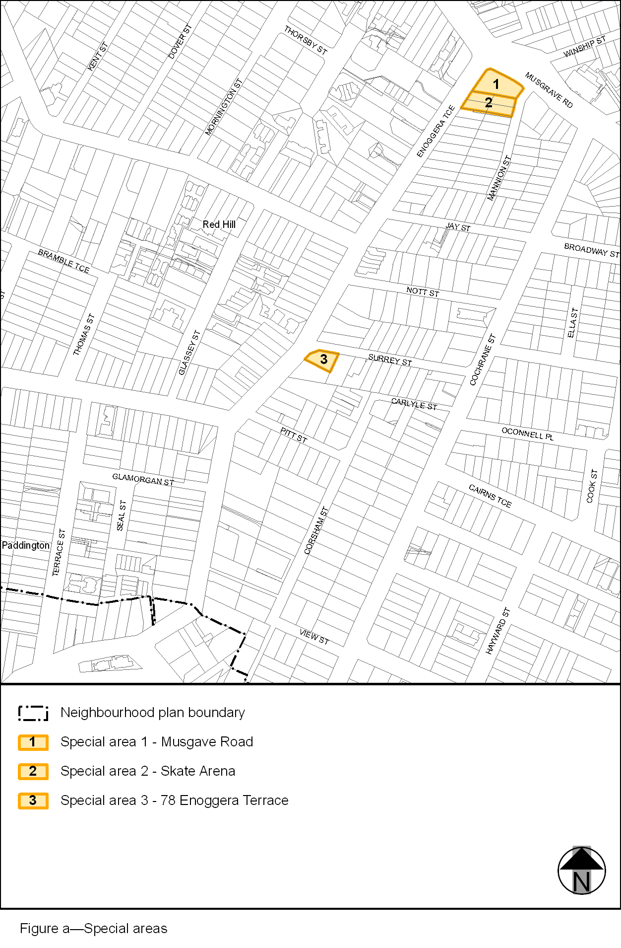
View the high resolution of Figure a–Special areas (PDF file size is 158Kb)
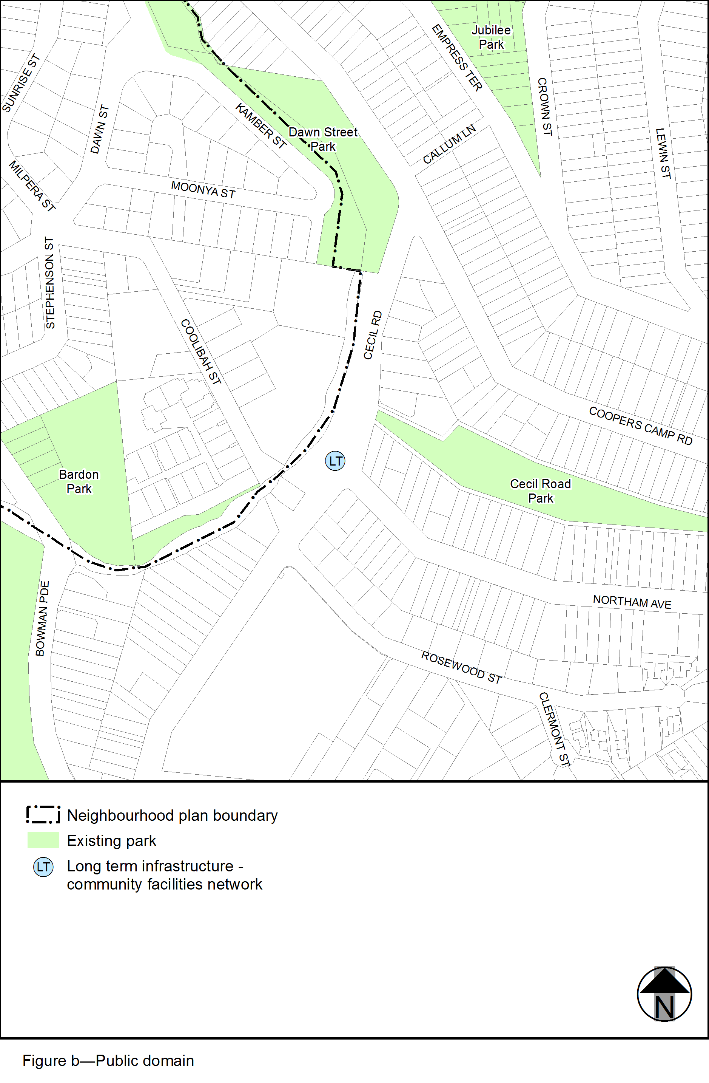
View the high resolution of Figure b–Public domain (PDF file size is 121Kb)

