7.2.23.3 Western gateway neighbourhood plan code

7.2.23.3.1 Application
- This code applies to assessing a material change of use, reconfiguring a lot, operational work or building work in the Western gateway neighbourhood plan area if:
- assessable development where this code is an applicable code identified in the assessment benchmarks column of a table of assessment for a neighbourhood plan (section 5.9); or
- impact assessable development.
- Land in the Western gateway neighbourhood plan area is identified on the NPM-023.3 Western gateway neighbourhood plan map and includes the following precincts:
- Sumner precinct (Western gateway neighbourhood plans/NPP-001);
- Wacol institutional precinct (Western gateway neighbourhood plans/NPP-002);
- Wacol industrial precinct (Western gateway neighbourhood plans/NPP-003);
- Inala precinct (Western gateway neighbourhood plans/NPP-004);
- Carole Park/Ellen Grove precinct (Western gateway neighbourhood plans/NPP-005).
- When using this code, reference should be made to section 1.5, section 5.3.2 and section 5.3.3.
Note—The following purpose, overall outcomes, performance outcomes and acceptable outcomes comprise the assessment benchmarks of this code.
Note—This neighbourhood plan includes a table of assessment with variations to categories of development and assessment. Refer to Table 5.9.69.A, Table 5.9.69.B, Table 5.9.69.C and Table 5.9.69.D.

7.2.23.3.2 Purpose
- The purpose of the Western gateway neighbourhood plan code is to provide finer grained planning at a local level for the Western gateway neighbourhood plan area.
- The purpose of the Western gateway neighbourhood plan code will be achieved through overall outcomes including overall outcomes for each precinct of the neighbourhood plan area.
- The overall outcomes for the neighbourhood plan area are:
- The Western gateway district provides a base for major industrial development and accommodates a diverse residential community.
- The area exhibits well-integrated living, working and recreation areas and is supported by high-quality transport links, retail and commercial facilities.
- The Inala Civic Centre is to remain the major community and retail focus for the Western gateway area.
- New shopping facilities complement the services provided by the older centres.
- Major institutional uses in the Wacol institutional precinct (Western gateway neighbourhood plan/NPP-002) preserve areas of regional environmental significance and the rural character.
- Areas identified as subject to scenic constraints are recognised.
- An accessible network of green spaces focused on environment and waterway corridors, natural area corridors and desirable parkland is developed throughout the area. These green spaces contain valuable bushland areas and public parks, and offer a wide range of recreational opportunities.
- Multiple dwellings are not accommodated in the Low density residential zone, including where in a precinct.
- Sumner precinct (Western gateway neighbourhood plans/NPP-001) overall outcomes are:
- Industrial development remains the dominant form of development in this precinct.
- A green space link (desirable parkland, environment and waterway corridor) is established to correct the catchments of Jindalee Creek and Bullockhead Creek.
- Wacol institutional precinct (Western gateway neighbourhood plans/NPP-002) overall outcomes are:
- Future development within this area ensures the preservation of the area’s environmental and cultural significance.
- Areas of significant rural amenity, biodiversity and other open space values are to remain in their current state or be developed for low-intensity rural or open-space uses.
- Low impact industrial and commercial activities are to be consolidated around the intersection of Wacol Station Road and the Ipswich Motorway.
Note—This precinct is to contain a variety of significant government facilities. Primary responsibility for the management of these facilities and surrounding lands rests with a number of Queensland Government agencies.
- Wacol industrial precinct (Western gateway neighbourhood plans/NPP-003) overall outcomes are:
- Showroom development in the vicinity of the intersection of Blunder Road and the Ipswich Motorway is consistent with the outcomes sought.
- Inala precinct (Western gateway neighbourhood plans/NPP-004) overall outcomes are:
- This precinct remains primarily a residential area supported by a range of retail, recreation and community facilities.
- New residential areas east of Blunder Road are integrated with the existing urban area.
- Community activities are focused on the Inala Civic Centre, maintaining its role as the main retail and commercial focus for Inala and the surrounding suburbs.
- Mixed use development in the District centre zone and Low-medium density residential zone clustered around the Inala Civic Centre is consistent with the outcomes sought.
- Carole Park/Ellen Grove precinct (Western gateway neighbourhood plans/NPP-005) overall outcomes are:
- Carole Park is to remain predominantly a residential area.
- Initiatives to broaden the range of housing forms and to reduce the concentration of public housing in Carole Park are consistent with the outcomes sought for the precinct.
- Development in Ellen Grove supports significant biodiversity values (as shown on the Biodiversity areas overlay). Development within the precinct must be sensitively located, designed and constructed to minimise adverse impacts on these biodiversity values.

7.2.23.3.3 Performance outcomes and acceptable outcomes

Table 7.2.23.3.3—Performance outcomes and acceptable outcomes
Performance outcomes | Acceptable outcomes
If in the Sumner precinct (Western gateway neighbourhood plan/NPP-001)
PO1  Development contributes to open space corridors connecting the Jindalee Creek and Bullock Head Creek catchments. | AO1  Development provides an open space corridor along the eastern and southern boundaries of the former QCL site to connect under the Centenary Highway. The indicative width of this corridor is 20m. Hydraulic, ecological and visual landscape investigations may be required to determine the appropriate width in a particular location.
If in the Wacol institutional precinct (Western gateway neighbourhood plan/NPP-002)
PO2  Development, particularly for government facilities, must proceed according to an approved structure plan. | AO2  Development in areas of regional environmental and scenic significance are:  - retained in public ownership and designated as parkland or reserves;  - linked by habitat areas and ecological corridors and are not required to be publicly accessible.
PO3  Development provides for a publicly accessible corridor along the Brisbane River. | AO3  Development provides the publicly accessible corridor at an indicative width of 120m from the top of the Brisbane River high bank. Hydraulic, ecological and visual landscape investigations may be required to determine the approximate width in a particular location.  Site design should prevent adjoining proposals from having a detrimental effect on the visual landscape of these lands.
Public domain
PO4  Development provides long term infrastructure for the land for community facilities network to meet the recreation needs of residents and visitors. | AO4  Development protects land for community facilities in the general location specified in Figure a and in accordance with the Long term infrastructure plans.

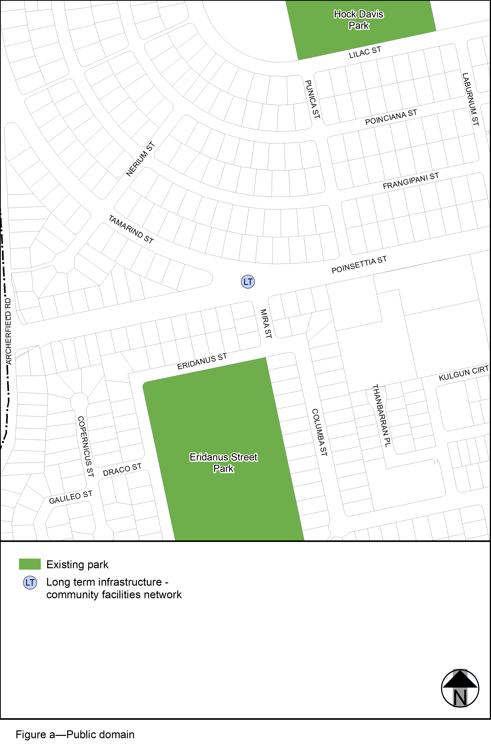View the high resolution of Figure a– Public domain (PDF file size is 122Kb)

