7.2.23.7 Wynnum West neighbourhood plan code

7.2.23.7.1 Application
- This code applies to assessing a material change of use, reconfiguring a lot, operational work or building work in the Wynnum West neighbourhood plan area if:
- assessable development where this code is an applicable code identified in the assessment benchmarks column of a table of assessment for a neighbourhood plan (section 5.9); or
- impact assessable development.
- Land in the Wynnum West neighbourhood plan area is identified on the NPM-023.7 Wynnum West neighbourhood plan map.
- When using this code, reference should be made to section 1.5, section 5.3.2 and section 5.3.3.
Note—The following purpose, overall outcomes, performance outcomes and acceptable outcomes comprise the assessment benchmarks of this code.
Note—This neighbourhood plan includes a table of assessment. Refer to Table 5.9.73.A, Table 5.9.73.B, Table 5.9.73.C and Table 5.9.73.D.

7.2.23.7.2 Purpose
- The purpose of the Wynnum West neighbourhood plan code is to provide finer grained planning at a local level for the Wynnum West neighbourhood plan area.
- The purpose of the Wynnum West neighbourhood plan code will be achieved through overall outcomes.
- The overall outcomes for the neighbourhood plan area are:
- Development creates functional and integrated communities.
- Land subject to development constraints, character or environmental values specified in Figure a in this neighbourhood plan code or shown on an overlay map is protected from inappropriate development in order to maintain its character, and natural and ecological significance.
- Residential development in a potential development area identified in Figure a provides for a mix of housing types, styles and densities, in particular:
- low density residential – dwelling houses: contains predominantly dwelling houses at a yield of 11 dwellings per hectare;
- low density residential – dwelling houses and multiple dwellings: contains a mix of dwelling houses and multiple dwellings at a yield of 16 dwellings per hectare;
- low–medium density residential: contains a mix of mostly established dwelling houses and multiple dwellings at a yield of 23 dwellings per hectare.
Note—Densities and yields are to be calculated excluding parts of the site that are not within a potential development area. These include areas with development constraints or character or environmental values identified in overlay maps. Yields and maximum gross floor area for multiple dwellings and dual occupancy are to be calculated across the potential development area including all access ways and roads respectively.
- Multiple dwellings are not accommodated in the Low density residential zone, including where in a potential development area.
- No further subdivision or intensification of development occurs on low-lying land identified in Figure a fronting Wynnum Road, ensuring the unimpeded passage of overland stormwater flows through the precinct and the maintenance of acceptable traffic levels on Wynnum Road.
- The caravan park fronting Manly Road is retained to preserve its role in providing affordable housing for the local area.
- Development in the industry area fronting Wondall Road creates a landmark seen from the road frontage, and is designed to respond to Robinson Park and increase casual surveillance.
- Development of the Wondall Road frontage of the Marching Girls Association land comprises non-residential uses and acts as a buffer between existing residences and the nearby industrial area.

7.2.23.7.3 Performance outcomes and acceptable outcomes

Table 7.2.23.7.3—Performance outcomes and acceptable outcomes
Performance outcomes | Acceptable outcomes
If for multiple dwellings in a potential development area, where not in the Low density residential zone
PO1  Development for multiple dwellings must be designed to integrate with the surrounding neighbourhood and street network. | AO1.1  Development for multiple dwellings in the low density residential – dwelling houses potential development area does not exceed 15% of the site area, excluding areas identified as waterway corridors in the Waterway corridor overlay map, habitat areas and ecological corridors as shown in Figure a, or as park identified in the Local government infrastructure plan.
AO1.2
Development has a minimum lot size and frontage for multiple dwellings as follows:
- 800m2 and 20m respectively in the low density residential – dwelling houses and multiple dwellings potential development area;
- 600m2 and 17m respectively in the low–medium density residential potential development area.
Note–Refer to Figure a for potential development areas.
If involving development in the low-lying land fronting Wynnum Road area and where the Stormwater code is applicable
PO2  Development, including on-site access to Wynnum Road, does not impede the existing overland flow of stormwater to the detriment of neighbouring houses. | AO2  Development incorporates on-site overland flow paths secured by the dedication of drainage easements to the Council.
If involving development in a neighbourhood centre
PO3  Development in a neighbourhood centre supports and consolidates the established network of centres in the area. | AO3  Development of the neighbourhood centre at the intersection of Evelyn Road and Kianawah Road as shown in Figure a has a maximum gross floor area of 1,500m2.
If involving development in the Habitat areas and ecological corridors (public)
PO4  Development must protect biodiversity and landscape values and provide access along the public corridor. | AO4  Development that includes land within the habitat areas and ecological corridors (public) as identified in Figure a ensures that:  - the land is rehabilitated and stabilised in accordance with an approved rehabilitation plan;  - land is transferred to the Council for public ownership and included in the Conservation zone;  - a road with a shared use (pedestrian and cyclist) path in an adjoining 6m wide verge is constructed within the Potential development area.

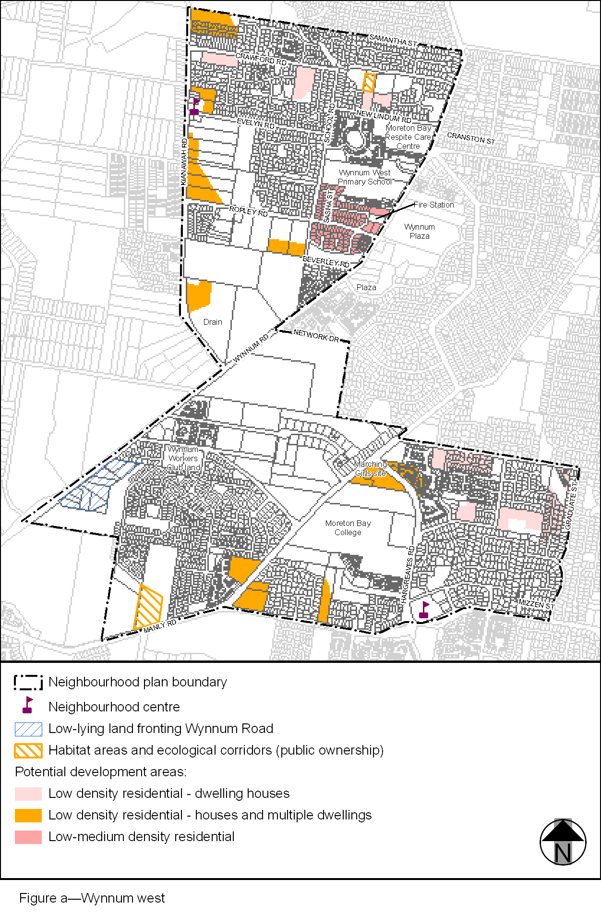
View the high resolution of Figure a–Wynnum west (PDF file size is 272Kb)

