5.3.13.1 Milton station

5.3.13.1.1 Location and extent
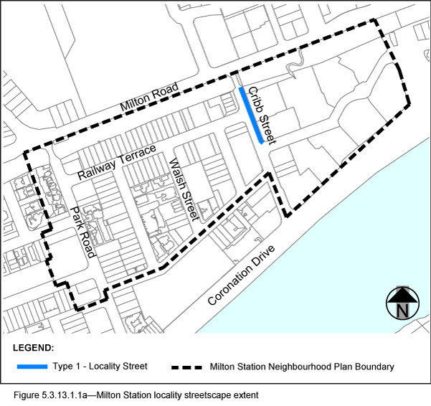
- The Locality Streets in the Milton Station Neighbourhood Plan area are indicated on the Streetscape hierarchy overlay map and on Figure 5.3.13.1.1a.
- All streetscape works occurring within the Locality Streets indicated in Figure 5.3.13.1.1a, must comply with the character specified in this document.
- Streetscapes outside these areas may be developed in keeping with this character, at the discretion of the developer and subject to Council approval.

5.3.13.1.2 Standard footway elements and materials
- These locality guidelines are to be read in conjunction with Chapter 3 – Road corridor design of the Infrastructure design planning scheme policy.
- Footway upgrades are to include new surfacing, new or reinstated kerb and channel, driveways, pedestrian kerb crossings, tactile markers, roof water drainage line connections, service pit lids, street trees, garden beds, furniture and pedestrian lighting applicable to the streetscape type.
- The scope, layout and detail of the footway upgrades are to be agreed on a site by site basis through the development assessment process.

5.3.13.1.3 Streetscape hierarchy

5.3.13.1.3.1 Streetscape types overview
- The locality streets within the Milton Station Neighbourhood Plan area are exceptions to the standard streetscape hierarchy.
- The streetscape type and specifications for locality streets in this area are outlined in Table 5.3.13.1.3.1A and shown in Figure 5.3.13.1.1a.
- Refer to Figure 5.3.13.1.3a for footway detail.

Table 5.3.13.1.3.1A - Streetscape type and specifications
Specifications | Locality Street in Milton Station Neighbourhood Plan area
Verge Width | As existing.
Unobstructed Pavement width | 2.4m
Description | Provide a footway in accordance with the detail shown in Figure 5.3.13.1.3a.
Paving materials | Asphalt
Tactile Paving  (consistent with BSD-5218) | Type: Concrete tactile paver  Supplier: Chelmstone, Urbanstone or approved equivalent  Colour: CCS 'Pewter'
Driveways | None.
Street Trees | No additional trees.  Promote the health and long term viability of the existing stand of mature fig trees, located on private land just inside the street frontage property boundary.
Garden Beds | Variable width (refer to Figure 5.3.13.1.3.a)
Furniture | None.

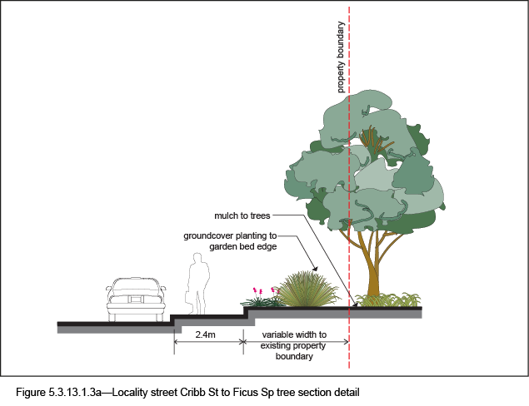

5.3.13.1.4 Planting

5.3.13.1.4.1 Street trees
- Table 5.3.13.1.4A sets out the approved street tree species for use on the various streets within Milton.
- Each street has a minimum of two approved street tree species to encourage variety and diversity within the precinct.
- Where two or more street trees are required on the same development frontage, a mixture of the appropriate species as listed in Table 5.3.13.1.4A is required.
- Feature street trees planted in natural ground at corner land dedications and in build-outs are to be planted with species listed in Table 5.3.13.1.4A.

5.3.13.1.4.2 Garden beds
- Shrub and groundcover species are to be selected from Table 5.3.13.1.4B.
- Garden beds are permitted in Cribb Street (locality street section) in accordance with the design specifications shown in Table 5.3.13.1.3.1A and the typical layout in Figure 5.3.13.1.3.a.

Table 5.3.13.1.4A—Street trees
Street | Tree species
Railway Terrace | Waterhousia floribunda 1  Flindersia australis 1  Xanthostemon chrysanthus  Melaleuca quinquenervia  Livistona australis  Delonix regia 2
Park Road | Delonix regia  Syzygium luehmannii
Park Road Corners | Peltophorum pterocarpum 3
Cribb Street | Harpullia pendula  Waterhousia floribunda  Ficus microcarpa var. Hillii
McDougall Street | Buckinghamia celsissima  Flindersia australis  Waterhousia floribunda
Manning Street | Buckinghamia celsissima  Waterhousea floribunda  Delonix regia 2  Peltophorum pterocarpum 2
Walsh Street | Buckinghamia celsissima  Melaleuca quinquenervia  Delonix regia  Peltophorum pterocarpum
Crombie Street | Xanthostemon chrysanthus  Flindersia australis  Delonix regia 2  Peltophorum pterocarpum 2
1 Can be used both as street tree and build-out tree
2 Build-out tree species
3 Corner land dedication feature tree species

Table 5.3.13.1.4B—Shrub and groundcover species
Shrub and groundcover Species
Dianella spp.
Dietes bicolour
Liriope muscari ‘Evergreen Giant’
Myoporum ellipticum
Themeda ‘Mingo’
Trachelospermum spp.

