7.2.1.6 Australia TradeCoast neighbourhood plan code

7.2.1.6.1 Application
- This code applies to assessing a material change of use, reconfiguring a lot, operational work or building work in the Australia TradeCoast neighbourhood plan area if:
- assessable development where this code is an applicable code identified in the assessment criteria column of a table of assessment for a neighbourhood plan (section 5.9); or
- impact assessable development.
- Land in the Australia TradeCoast neighbourhood plan area is identified on the NPM-001.6 Australia TradeCoast neighbourhood plan map and includes the following precincts:
- Pinkenba precinct (Australia TradeCoast neighbourhood plan/NPP-001);
- Airport precinct (Australia TradeCoast neighbourhood plan/ NPP-002);
- Old airport precinct (Australia TradeCoast neighbourhood plan/NPP-003);
- Fisherman Islands precinct (Australia TradeCoast neighbourhood plan/NPP-004);
- Lytton precinct (Australia TradeCoast neighbourhood plan/NPP-005);
- Hemmant precinct (Australia TradeCoast neighbourhood plan/NPP-006);
- Murarrie precinct (Australia TradeCoast neighbourhood plan/NPP-007).
Editor's note—Part of the neighbourhood plan area is covered by the Northshore Hamilton priority development area which Economic Development Queensland is responsible for planning under the Economic Development Act 2012.
- When using this code, reference should be made to section 1.5, section 5.3.2 and section 5.3.3.
Note—This neighbourhood plan includes a table of assessment. Refer to Table 5.9.6.A, Table 5.9.6.B, Table 5.9.6.C and Table 5.9.6.D.

7.2.1.6.2 Purpose
- The purpose of the Australia TradeCoast neighbourhood plan code is to provide finer grained planning at a local level for the Australia TradeCoast neighbourhood plan area.
- The purpose of the Australia TradeCoast neighbourhood plan code will be achieved through the overall outcomes including overall outcomes for each precinct of the neighbourhood plan area.
- The overall outcomes for the neighbourhood plan area are:
- Development in the Australia TradeCoast neighbourhood plan area occurs in accordance with Figure a to ensure cost-efficient provision of sewerage, water, stormwater and transport infrastructure.
- Activities producing high volumes of trade waste are to locate east of the Queensport Road sewage pump station.
- Waterfront and marine industries north of the river and west of the Gateway Bridge south of the river are gradually relocated to the mouth of the river. The redevelopment of these areas is to be of high quality.
- Public access is provided to the riverfront where this does not conflict with waterfront activities or impact on public safety.
- Industrial development requiring the use of over mass vehicles is located in the precincts adjacent to the Gateway Motorway and the Port of Brisbane Motorway subject to the activity being appropriate to that area.
- Pinkenba precinct (Australia TradeCoast neighbourhood plan/NPP-001) overall outcome is:
- Land adjacent to the Entrance Creek Wetland is developed for Low impact industry where the environmental values of the wetland are not compromised. Medium impact industry is suitable for the remainder of the precinct.
- Airport precinct (Australia TradeCoast neighbourhood plan/ NPP-002) overall outcomes are:
- Appropriate land use activities are identified in the Brisbane Airport master plan under the control of the Brisbane Airport Corporation.
- Any commercial and retail development has a nexus with airport activities.
- General or low-intensity retail activities are not accommodated.
- Old airport precinct (Australia TradeCoast neighbourhood plan/NPP-003) overall outcomes are:
- Medium impact industries are well presented due to the area’s high visibility.
- A 30m landscaped buffer is required for development adjacent to the Gateway Motorway.
- Direct access to the Gateway Motorway is not permitted.
- Retail development within the precinct is not consistent with the outcomes sought.
- Fisherman Islands precinct (Australia TradeCoast neighbourhood plan/NPP-004) overall outcomes are:
- Development on Fisherman Islands and Whyte Island is under the control of the Port of Brisbane Corporation which is identified in the Brisbane Port Land Use Plan 2013 as the assessment manager for all development in this precinct.
- Whyte Island has been identified by the Port of Brisbane Corporation and the Council as a location for industry requiring separation and is a strategic location for high impact industry and special industry in the short term.
- Lytton precinct (Australia TradeCoast neighbourhood plan/NPP-005) overall outcomes are:
- The Lytton Industrial Estate is suitable for medium impact industry.
- The separation distances between the Lytton Industrial Estate and residential areas make it appropriate for high impact industry and special industry which addresses visual impacts on vistas from residential development at Wynnum.
- Hemmant precinct (Australia TradeCoast neighbourhood plan/NPP-006) overall outcomes are:
- This precinct is suitable for a mix of low impact industry and medium impact industry uses. Medium impact industry is supported only where not in close proximity to residential areas.
- Development in close proximity to the residential areas of Hemmant and Lindum is suitable for:
- low impact industry and Centre activities.
- Centre activities only where they serve an administrative function directly related to specific manufacturing or distribution activities on the same sites or that directly service the needs of industries in the locality.
- Murarrie precinct (Australia TradeCoast neighbourhood plan/NPP-007) overall outcomes are:
- Medium impact industry is supported in this precinct.
- Development must be of a high quality.

7.2.1.6.3 Assessment criteria
The following table identifies the assessment criteria for assessable development.

Table 7.2.1.6.3—Criteria for assessable development
Performance outcomes | Acceptable outcomes
PO1  Development occurs in a manner that ensures the efficient provision of sewerage, water, stormwater and transport infrastructure. | AO1  Development proceeds in a manner consistent with Figure a.  Note—Development may be approved which does not accord with the Australia TradeCoast Staging Plan if it can be demonstrated that due to changed circumstances, infrastructure can be efficiently provided and if the applicant is prepared to fully fund infrastructure subject to an infrastructure agreement with the Council.

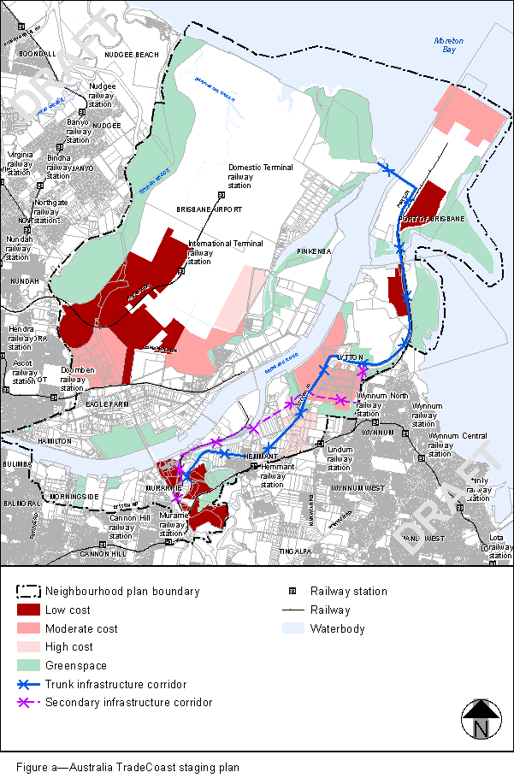
View the high resolution of Figure a–Australia TradeCoast staging plan (PDF file size is 426Kb)

