7.2.20.4 Toowong—Indooroopilly district neighbourhood plan code

7.2.20.4.1 Application
- This code applies to assessing a material change of use, reconfiguring a lot, operational work or building work in the Toowong—Indooroopilly district neighbourhood plan area if:
- assessable development where this code is an applicable code identified in the assessment criteria column of a table of assessment for a neighbourhood plan (section 5.9); or
- impact assessable development.
- Land in the Toowong—Indooroopilly district neighbourhood plan area is identified on the NPM-020.4 Toowong—Indooroopilly district neighbourhood plan map and includes the following precincts:
- Milton and Sylvan roads light industry precinct (Toowong—Indooroopilly district neighbourhood plan/NPP-001);
- Dean Street shops precinct (Toowong—Indooroopilly district neighbourhood plan/NPP-002);
- Government research precinct (Toowong—Indooroopilly district neighbourhood plan/NPP-003);
- Woodstock Avenue precinct (Toowong—Indooroopilly district neighbourhood plan/NPP-004);
- Taringa suburban centre precinct (Toowong—Indooroopilly district neighbourhood plan/NPP-005).
- When using this code, reference should be made to section 1.5, section 5.3.2 and section 5.3.3.
Note—This neighbourhood plan includes a table of assessment with level of assessment variations to those in sections 5.5, 5.6, 5.7, 5.8 and 5.10. Refer to Table 5.9.66.A, Table 5.9.66.B, Table 5.9.66.C and Table 5.9.66.D.

7.2.20.4.2 Purpose
- The purpose of the Toowong—Indooroopilly district neighbourhood plan code is to provide finer grained planning at a local level for the Toowong—Indooroopilly district neighbourhood plan area.
- The purpose of the Toowong—Indooroopilly district neighbourhood plan code will be achieved through overall outcomes including overall outcomes for each precinct of the neighbourhood plan area.
- The overall outcomes for the neighbourhood plan area are:
- The ‘green and leafy’ character of the district is maintained by retaining mature vegetation and planting appropriate vegetation as part of new development.
- Ecological corridors linking Mt Coot-tha and the Brisbane River are protected and enhanced.
- Buffers which only allow low impact uses (such as the golf course) are maintained contiguous to Indooroopilly Island to minimise disturbance to the permanent flying fox roosts.
- Parkland will be required where large sites are developed.
- Walking and cycling routes provide safe and legible connections between residential areas and key destinations including centres, the City Centre, the University of Queensland, community facilities, major parks and conservation reserves, and public transport nodes.
- Development is of a height, scale and form which is consistent with the amenity and character, community expectations and infrastructure assumptions intended for the relevant precinct, sub-precinct or site and is only developed at a greater height, scale and form where there is both a community need and an economic need for the development.
- Milton and Sylvan roads light industry precinct (Toowong—Indooroopilly district neighbourhood plan/NPP-001) overall outcomes are:
- Low–medium density residential development is supported on large parcels of land.
- Residential development:
- addresses impacts on future residents from surrounding non-residential uses and Milton Road;
- ensures building design is compatible with the surrounding residential character.
- Dean Street shops precinct (Toowong—Indooroopilly district neighbourhood plan/NPP-002) overall outcomes are:
- A mixture of residential and local retail uses are accommodated.
- Buildings must be compatible with traditional commercial character and building form in the area.
- Government research precinct (Toowong—Indooroopilly district neighbourhood plan/NPP-003) overall outcomes are:
- When existing government research activities cease in this precinct, residential development is supported.
- Development:
- respects the interface between existing residential areas, the Brisbane River, vegetation, natural wetlands, gullies and waterways, and open space links/edges;
- minimises traffic impacts on the external road system and surrounding residential area;
- incorporates public parkland, including pedestrian and cyclist facilities, along the Brisbane River.
- Woodstock Avenue precinct (Toowong—Indooroopilly district neighbourhood plan/NPP-004) overall outcomes are:
- Development ensures the maintenance and protection of ecological values, such as the mixed forest vegetation community and habitat corridor supporting local wildlife, as well as avian and arboreal wildlife moving throughout the surrounding area.
- Taringa suburban centre precinct (Toowong—Indooroopilly district neighbourhood plan/NPP-005) overall outcomes are:
- The precinct ensures retail and commercial services are consolidated into the centre’s traditional core.

7.2.20.4.3 Assessment criteria
The following table identifies the assessment criteria for assessable development.

Table 7.2.20.4.3.A—Criteria for assessable development
Performance outcomes |  | Acceptable outcomes
Building height
PO1  Development is of a height, scale and form that achieves the intended outcome for the precinct, improves the amenity of the neighbourhood plan area, contributes to a cohesive streetscape and built form character and is:  - consistent with anticipated density and assumed infrastructure demand;  - aligned to community expectations about the number of storeys to be built;  - proportionate to and commensurate with the utility of the site area and frontage width;  - designed to avoid a significant and undue adverse amenity impact to adjoining development;  - sited to enable existing and future buildings to be well separated from each other and avoid affecting the potential development of an adjoining site.  Note—Development that exceeds the intended number of storeys or building height can place disproportionate pressure on the transport network, public space or community facilities in particular.  Note—Development that is over-scaled for its site can result in an undesirable dominance of vehicle access, parking and manoeuvring areas that significantly reduce streetscape character and amenity. | AO1  Development complies with the number of storeys and building height in Table 7.2.20.4.3.B.  Note—Neighbourhood plans will mostly specify maximum number of storeys where zone outcomes have been varied in relation to the building height. Some neighbourhood plans may also specify height in metres. Development must comply with both parameters where maximum number of storeys and the height in metres are specified.
If located on a ridgelines as identified in Figure a
PO2  Development of a building must be designed to minimise impacts on views to Mt Coot-tha. |  | AO2  Development is designed so that the skyline of the building ensures that features such as lift motor rooms, plant and roof planes are part of an integrated design that minimises the visual bulk and prominence of these features.
If in the Dean Street shops precinct (Toowong—Indooroopilly district neighbourhood plan/NPP-002)
PO3  Development must complement the architectural style of the commercial character buildings in terms of building form, scale and materials. |  | AO3  Development for centre activities:  - is built to the front boundary on Dean Street;  - incorporates parapets above footpath awnings, with pedestrian shelter in the form of awnings over the footpath along the length of the Dean Street frontage;  - includes external building materials that complement surrounding building character.
PO4  Development does not provide car parking that dominates the frontage or impact on the visual amenity of the area. |  | AO4  Development provides car parking at the rear of the site, with minimal visual impact from the driveway entries, car parking and servicing areas.
If in the Government research precinct (Toowong—Indooroopilly district neighbourhood plan/NPP-003)
PO5  Development:  - integrates with and enhances the riparian amenity of the Brisbane River and incorporates public land;  - provides a setback from the Brisbane River that is designed to provide for public access, integration of a pedestrian/cyclist route, a multi-tiered vegetation buffer, bank stability measures, and suitable screening of buildings. |  | AO5  Development is set back a minimum of 100m from the high water mark of the Brisbane River to any building or structure.
PO6  Development minimises traffic impacts on the external road system and the surrounding community. |  | AO6.1  Development ensures that major vehicular access is restricted to Meiers Road.
AO6.2
Development with vehicular access to the site via Handel Street is restricted to ensure that the number of vehicles using the minor residential street is reasonable.
AO6.3
Development does not provide a vehicular connection along the riverside to the university.
AO6.4
Development provides adequate and convenient car parking on site to avoid any parking problems on Meiers Road.
PO7  Development is designed so that buildings complement the surrounding residential area and the vegetated setting and incorporate environmentally sustainable development principles. |  | AO7.1  Development has building setbacks that are a minimum of 6m from boundaries, particularly adjoining residential interfaces.
AO7.2
Development has buildings that are designed to follow the natural grades and step down the slope of the land rather than using cut-and-fill techniques.
AO7.3
Development has buildings that are unobtrusive when viewed from the Brisbane River, and minimise any heat or reflective glare.
AO7.4
Development retains existing mature vegetation and low-lying areas (wetlands), and respects the natural stormwater gullies on the site.
PO8  Development must provide for safe and secure 24-hour public access to the Brisbane River and public areas. |  | AO8.1  Development provides public access along the riverbank through the site from Meiers Road.
AO8.2
Development provides:
- pedestrian and cyclist access along the riverbank and includes pedestrian/bikeway paths;
- passive recreation features such as seats, and viewing areas;
- opportunities for public access along the road reserve adjacent to golf course.
AO8.3
Development provides barricades or security fencing that has low visual impact (e.g. dense landscaping).
If in the Taringa suburban centre precinct (Toowong—Indooroopilly district neighbourhood plan/NPP-005)
PO9  Development provides a building scale and form that is consistent with the density and character of the precinct and retains an appropriate scale and relationship with other buildings in the centre. |  | AO9  Development has a maximum gross floor area for non-residential uses that is the area of the site.
PO10  Development provides a building scale and form that considers the visual impacts of the rear of buildings, upon local view sheds, scenic backdrops and/or rhythm of the existing skyline, particularly when viewed from Walker Street and/or the railway corridor. |  | AO10.1  Development uses building materials and colours that minimise the impacts on the visual amenity of the area, particularly when viewed from the rear.
AO10.2
Development that has parking structures located at the rear of the building, incorporates external screening and/or plantings.
PO11  Development provides building setbacks that create a continuous and coherent streetscape and pedestrian shelter along the main pedestrian street frontages. |  | AO11.1  Development has buildings that are built to the front alignment or are set back not more than 3m where an active use of the space is proposed (e.g. outdoor dining).
AO11.2
Development has building awnings that are set back a minimum of 1.5m from the kerb line, to enable street tree planting.
AO11.3
Development has buildings built to their side boundary to ensure that they contribute to a continuation of building frontages and pedestrian awnings.

Table 7.2.20.4.3.B—Maximum building height
Development | Building height (number of storeys) | Building height (m)
If in the Dean Street shops precinct (Toowong—Indooroopilly district neighbourhood plan/NPP-002)
Any development in this precinct | 2 | 9.5
If in the Taringa suburban centre precinct (Toowong—Indooroopilly district neighbourhood plan/NPP-005)
Development of a site fronting Moggill Road between Swann Road and Briggs Street | 3 | 10.5
Development of a site fronting Walker Street and the railway corridor alignment | 4 | 14
Note—Gradation of height sympathetic to a site’s topography is preferred.
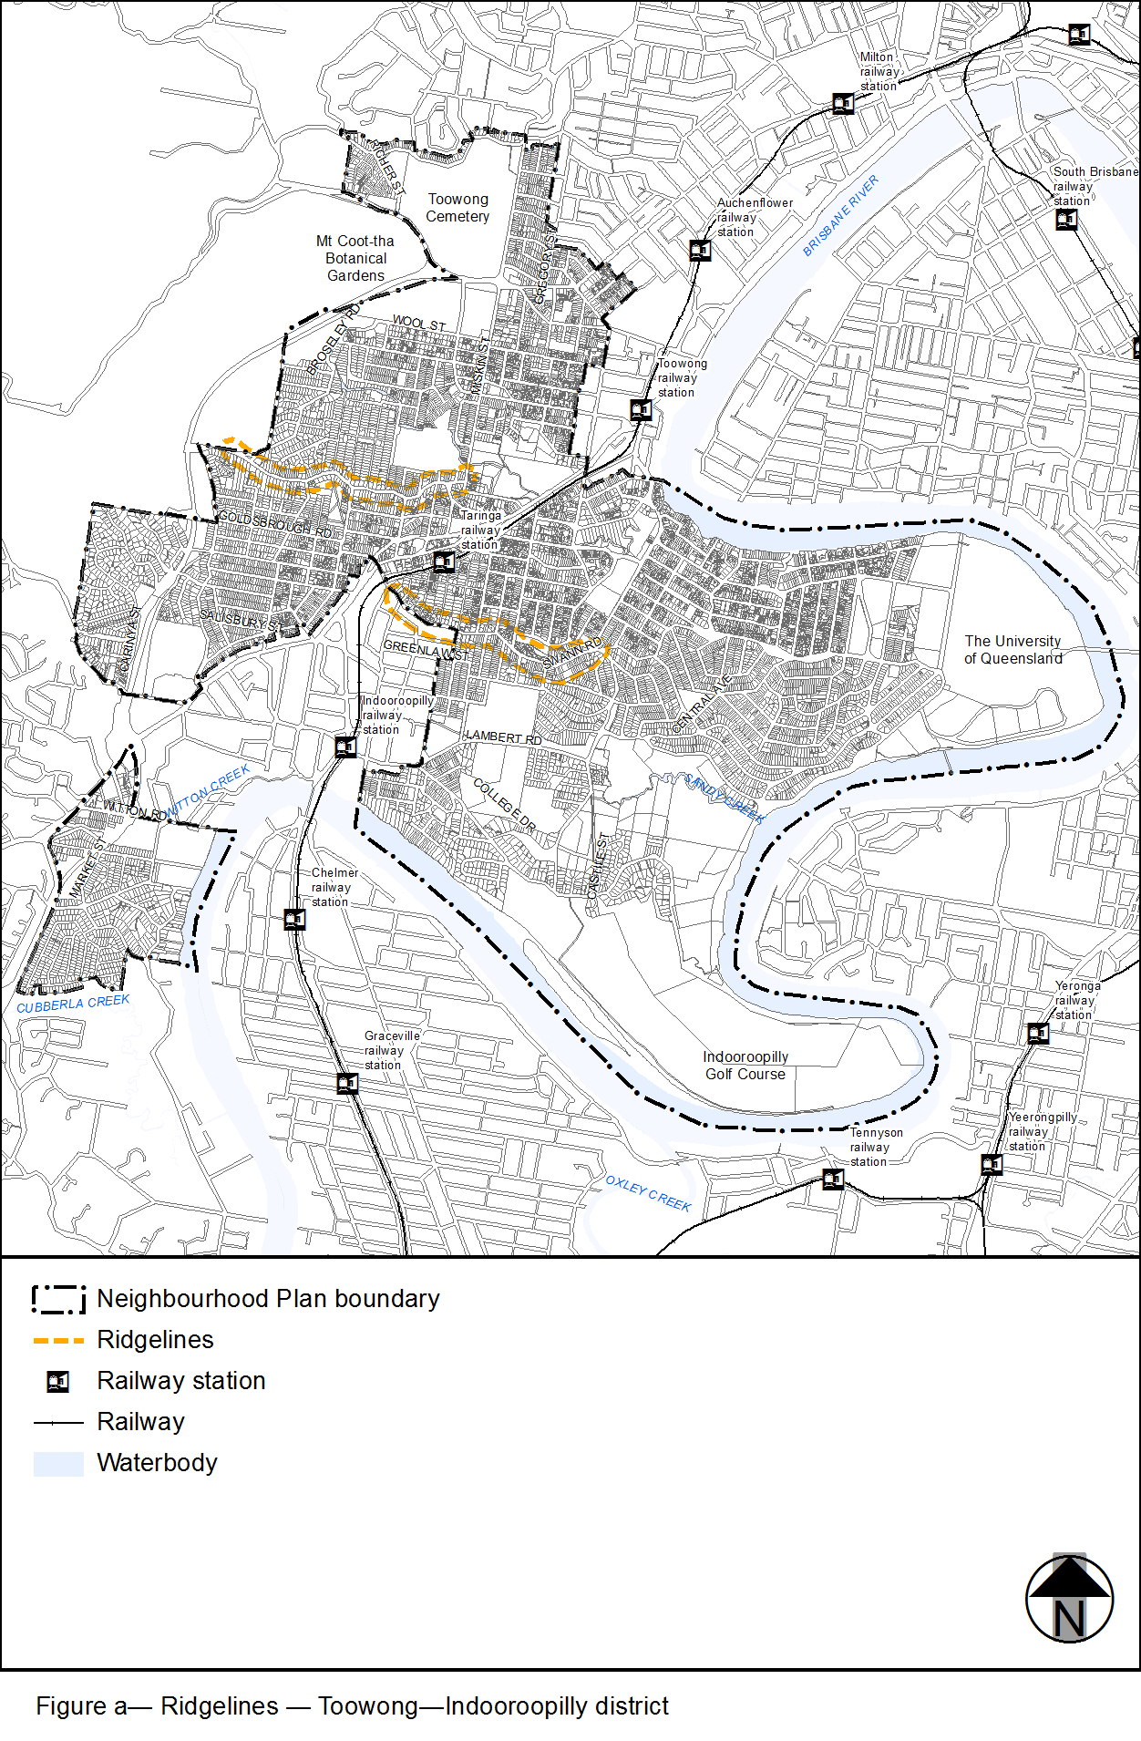
View the high resolution of Figure a–Ridgelines – Toowong–Indooroopilly district (PDF file size is 766Kb)

