7.2.23.4 Willawong neighbourhood plan code

7.2.23.4.1 Application
- This code applies to assessing a material change of use, reconfiguring a lot, operational work or building work in the Willawong neighbourhood plan area if:
- assessable development where this code is an applicable code identified in the assessment criteria column of a table of assessment for a neighbourhood plan (section 5.9); or
- impact assessable development.
- Land within the Willawong neighbourhood plan area is identified on the NPM-023.4 Willawong neighbourhood plan map and includes the following precincts:
- Willawong rural precinct (Willawong neighbourhood plan/NPP-001);
- Paradise wetland investigation precinct (Willawong neighbourhood plan/NPP-002);
- Remediation precinct (Willawong neighbourhood plan/NPP-003);
- Recycling industry precinct (Willawong neighbourhood plan/NPP-004).
- When using this code, reference should be made to section 1.5, section 5.3.2 and section 5.3.3.
Note—This neighbourhood plan includes a table of assessment. Refer to Table 5.9.70.A, Table 5.9.70.B, Table 5.9.70.C and Table 5.9.70.D.

7.2.23.4.2 Purpose
- The purpose of the Willawong neighbourhood plan code is to provide finer grained planning at a local level for the Willawong neighbourhood plan area.
- The purpose of the Willawong neighbourhood plan code will be achieved through overall outcomes including overall outcomes for each precinct of the neighbourhood plan area.
- The overall outcomes for the neighbourhood plan area are:
- Development protects and enhances the regionally significant ecosystems and environmental values which will improve the health and quality of the local waterways of Blunder Creek and Oxley Creek.
- The remediation of waste disposal areas and subsequent transformation into an extensive open space system, including 3 wetlands.
- The broad hectare rural character of the area is retained.
- The neighbourhood plan area has the potential to become a sporting focus for southern Brisbane. Proposals for new facilities demonstrate the environmental values of the neighbourhood plan area will not be compromised.
- The rehabilitation of extractive industry sites pays attention to the hydraulic regime, bank stability and revegetation to improve water quality.
- Further development of extractive industries is limited unless a need for the resources is required, sound environmental management practices can be demonstrated, and appropriate licensing secured.
- Development adjacent to wetlands outside waterway corridors has regard to effects on the water quality and hydraulic regime of the wetland and the potential for isolation of the wetland from significant native vegetation or habitat areas.
- Appropriate management strategies are developed and implemented for the conservation of any Aboriginal cultural heritage.
- Land subject to development constraints, character or environmental values specified in Figure a in this neighbourhood plan code or shown on an overlay map is protected from inappropriate development in order to maintain its character, natural and ecological significance.
- Willawong rural precinct (Willawong neighbourhood plan/NPP-001) overall outcomes are:
- This precinct maintains for the general broad hectare rural character within the neighbourhood plan area.
- Development preserves the rural character of the precinct and accommodates a range of rural and agricultural activities on lots of generally 4ha to 10ha that are carefully managed to minimise impacts on the waterway corridors.
- Development allows for the continuation of the Council Animal Pound which provides an important service to the southern parts of Brisbane.
- The further intensification of waste incineration operations on the Ace Waste site which is likely to be precluded by a number of factors, including the desired broad hectare rural character of the precinct and the future development of surrounding areas.
- Paradise wetland investigation precinct (Willawong neighbourhood plan/NPP-002) overall outcomes are:
- The precinct is being investigated as a possible area to accommodate new residential development with a choice of housing types, a centre to provide office and shop activities serving the local population and a mixed industry and business area that supports surrounding industrial areas.
- The ultimate layout, design, land use mix and density of any such future development will be determined by resolving the key issues including air quality, noise and separation distances to sensitive land uses, site contamination, flooding, habitat and ecological corridors, koala habitat, topography and slope stability and access for vehicles and public transport. Until these key issues are resolved no further development will be approved.
- Future development is also dependent on the provision of local and trunk infrastructure networks required to service the development and surrounding area. This infrastructure is not included in the Priority infrastructure plan and is therefore required to be demonstrated as part of any investigation.
- Remediation precinct (Willawong neighbourhood plan/NPP-003) overall outcomes are:
- A considerable proportion of open space in the remediation area will not be accessible to the public. Public access may, in time, be allowed to parts of the open space areas where there is no risk to the health of the community and the remediated landforms are stable and able to be cost-effectively maintained. Public access will be provided for passive recreational opportunities.
- The hard-fill site in the northern part of the remediation area may be developed as sporting fields in the future, subject to adequate compaction and settling of the fill material and the ongoing remedial and pollution control needs of the site.
- Sport and recreation facilities may also be developed on the least contaminated land in the eastern part of the remediation area (along Gooderham Road), following adequate remediation of that area.
- Sport and recreation facility sites within the remediation area may be required to incorporate adequate screening in recognition of their proximity to the low impact industries.
- The north-eastern part of the precinct will be landscaped to provide a visual buffer between Willawong transfer station and the Willawong rural precinct (Willawong neighbourhood plan/NPP-001).
- Development must demonstrate that the effectiveness of the remediation works will not be compromised.
- Recycling industry precinct (Willawong neighbourhood plan/NPP-004) overall outcomes are:
- Development for recycling industries must demonstrate synergies with the Willawong Transfer Station and associated waste streams. Development must also demonstrate low impacts for any sensitive uses and use best-practice technologies.
- Development must provide mounding of at least 3m high and a vegetated buffer.
- Uses considered consistent with the outcomes sought include the sale of recovered materials to the public.

7.2.23.4.3 Assessment criteria
The following table identifies the assessment criteria for assessable development.

Table 7.2.23.4.3—Criteria for assessable development
Performance outcomes | Acceptable outcomes
No performance outcomes prescribed. | No acceptable outcomes prescribed.

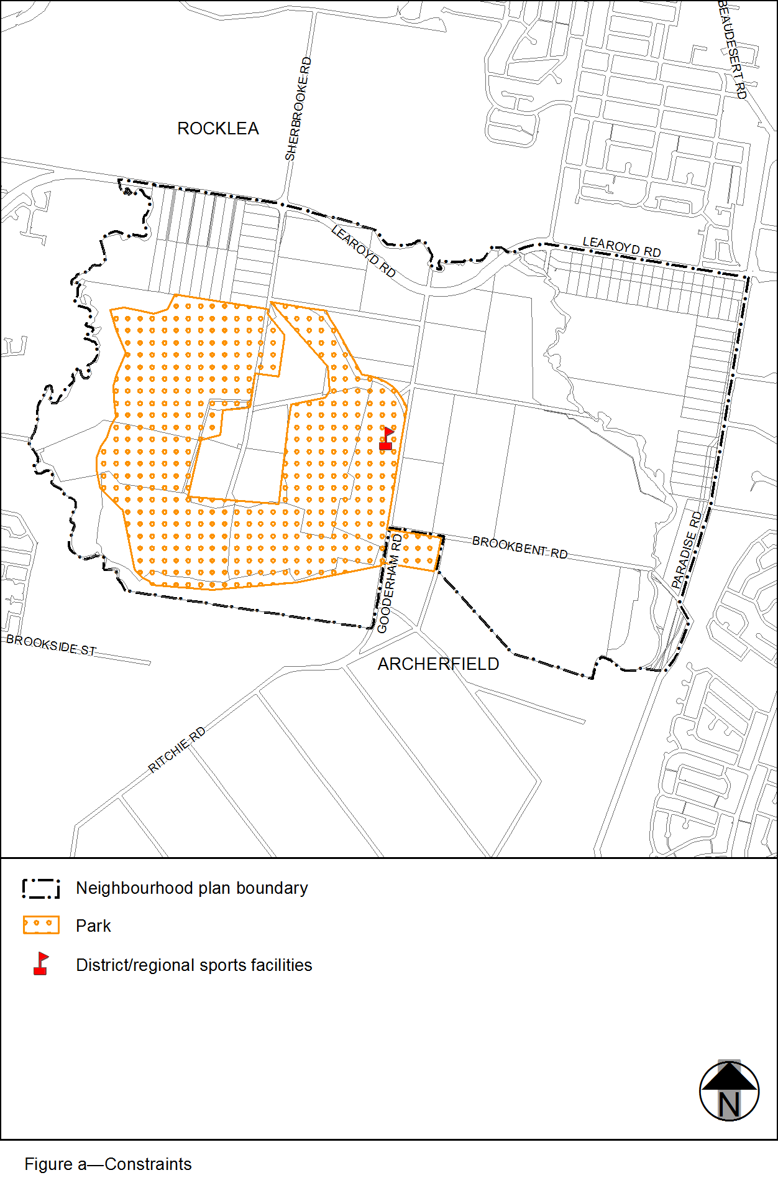
View the high resolution of Figure a–Constraints (PDF file size is 133Kb)

