7.2.14.1 New Farm and Teneriffe Hill neighbourhood plan code

7.2.14.1.1 Application
- This code applies to assessing a material change of use, reconfiguring a lot, operational work or building work in the New Farm and Teneriffe Hill neighbourhood plan area if:
- assessable development where this code is an applicable code identified in the assessment criteria column of a table of assessment for a neighbourhood plan (section 5.9); or
- impact assessable development.
- Land in the New Farm and Teneriffe Hill neighbourhood plan area is identified on the NPM-014.1 New Farm and Teneriffe Hill neighbourhood plan map and includes the following precincts:
- Low density living precinct (New Farm and Teneriffe Hill neighbourhood plan/NPP-001);
- Low–medium density living precinct (New Farm and Teneriffe Hill neighbourhood plan/NPP-002);
- Medium density living precinct (New Farm and Teneriffe Hill neighbourhood plan/NPP-003);
- Mixed use centre precinct (New Farm and Teneriffe Hill neighbourhood plan/NPP-004):
- Brunswick Street sub-precinct (New Farm and Teneriffe Hill neighbourhood plan/NPP-004a);
- Brunswick Street and Merthyr Road sub-precinct (New Farm and Teneriffe Hill neighbourhood plan/NPP-004b);
- Merthyr Road and Moray Street sub-precinct (New Farm and Teneriffe Hill neighbourhood plan/NPP-004c);
- James and Arthur streets sub-precinct (New Farm and Teneriffe Hill neighbourhood plan/NPP-004d);
- Merthyr Road and James Street sub-precinct (New Farm and Teneriffe Hill neighbourhood plan/NPP-004e).
- Parks precinct (New Farm and Teneriffe Hill neighbourhood plan/NPP-005):
- Howard Smith Wharves sub-precinct (New Farm and Teneriffe Hill neighbourhood plan/NPP-005a).
- When using this code, reference should be made to section 1.5, section 5.3.2 and section 5.3.3.
Note—This neighbourhood plan includes a table of assessment with level of assessment variations to those in sections 5.5, 5.6, 5.7, 5.8 and 5.10. Refer to Table 5.9.50.A, Table 5.9.50.B, Table 5.9.50.C and Table 5.9.50.D.

7.2.14.1.2 Purpose
- The purpose of the New Farm and Teneriffe Hill neighbourhood plan code is to provide finer grained planning at a local level for the New Farm and Teneriffe Hill neighbourhood plan area.
- The purpose of the New Farm and Teneriffe Hill neighbourhood plan code will be achieved through overall outcomes including overall outcomes for each precinct of the neighbourhood plan area.
- The overall outcomes for the neighbourhood plan area are:
- New Farm’s characteristic diversity of built form and village feel is retained.
- Infill development and redevelopment reflect New Farm’s established character and style.
- A mix of housing choices including affordable housing is retained and provided.
- Safe, comfortable and convenient accesses within, to and from New Farm and Teneriffe Hill is provided for pedestrians, cyclists and people with disabilities, including along major traffic routes such as Brunswick Street.
- A clear, formalised and highly interconnected street system including rear lanes is provided through the area.
- Development complements existing urban and landscape characteristics and cultural associations and contributes to the distinctive and identifiable character and sense of place of New Farm as a whole and of its distinctive neighbourhoods.
- Buildings are located and designed to form strong and attractive vistas and memorable landmarks.
- Important places, landmarks and cultural elements are recognisable and form a focus for development, orientation and travel throughout the area.
- New Farm and Teneriffe Hill provide a wide range of public space including:
- linear parks along the riverfront;
- local pocket parks within residential areas;
- sites for both casual and organised recreation;
- squares, plazas and courtyards within commercial activity nodes;
- conservation parks for environmental and landscape elements.
- These public spaces are improved by pedestrian links and defined by development that maximises casual surveillance.
- Amalgamation of sites benefits the community by providing increased open space, improved pedestrian linkages or useable public spaces.
- Mixed use development close to transport nodes provides after-hours uses to enhance activity, surveillance and security.
- Development is of a height, scale and form which is consistent with the amenity and character, community expectations and infrastructure assumptions intended for the relevant precinct, sub-precinct or site and is only developed at a greater height, scale and form where there is both a community need and an economic need for the development.
- Low density living precinct (New Farm and Teneriffe Hill neighbourhood plan/NPP-001) overall outcomes are:
- Teneriffe Hill provides high-quality and coherent housing.
- Proposals incorporate existing buildings through infill development.
- Extensions under or at the rear of existing buildings, or in the form of separate buildings, are appropriate on larger sites where they do not compromise the character of the area.
- Multiple dwellings are either contained in existing buildings, complement the character of existing houses, or provide affordable housing.
- Non-residential uses serve the local community and are only located in existing non-residential buildings.
- Low–medium density living precinct (New Farm and Teneriffe Hill neighbourhood plan/NPP-002) overall outcomes are:
- Proposals retain existing houses and are of a scale and character compatible with detached housing.
- Non-residential uses serve the local community and are located in existing non-residential buildings.
- Medium density living precinct (New Farm and Teneriffe Hill neighbourhood plan/NPP-003) overall outcomes are:
- This precinct is predominantly medium density, taking advantage of the benefits of high levels of accessibility and visual amenity that characterise this area.
- Development provides visual and physical links to the river.
- New developments north of Merthyr Road retain areas along the river frontage for public access.
- Car parking is located in basement or semi-basement areas in order to reduce the visual impact of cars on the streetscape.
- Non-residential uses serving the local community are compatible with the surrounding residential neighbourhood.
- New non-residential uses are incorporated within a mixed use development where residential uses dominate.
- Mixed use centre precinct (New Farm and Teneriffe Hill neighbourhood plan/NPP-004) overall outcomes are:
- Centres in the precinct develop as discrete nodes and contain a range of commercial and residential uses.
- Proposals include small-scale uses with limited tenancy sizes while providing a variety of tenancy types.
- Larger tenancy sizes are appropriate where involving a new community facility to service the needs of local residents.
- Development in the Brunswick Street sub-precinct (New Farm and Teneriffe Hill neighbourhood plan/NPP-004a):
- provides a wide range of retailing, entertainment and commercial uses that service the needs of New Farm residents and the wider community.
- Development in the Brunswick Street and Merthyr Road sub-precinct (New Farm and Teneriffe Hill neighbourhood plan/NPP-004b):
- ensures that it remains the primary neighbourhood centre providing a range of retailing, commercial and community services and facilities for the residents of New Farm and the surrounding area.
- Development in the Merthyr Road and Moray Street sub-precinct (New Farm and Teneriffe Hill neighbourhood plan/NPP-004c):
- ensures that it remains a secondary neighbourhood centre providing local services for New Farm residents. This centre has a limited commercial function.
- Development in the James and Arthur streets sub-precinct (New Farm and Teneriffe Hill neighbourhood plan/NPP-004d):
- ensures that it remains a secondary neighbourhood centre providing a similar function to the Merthyr Road and Moray Street sub-precinct (New Farm and Teneriffe Hill neighbourhood plan/NPP-004c);
- due to its proximity to Fortitude Valley, facilities including the existing hotel and cafes in this centre also service a wider area.
- Development in the Merthyr Road and James Street sub-precinct (New Farm and Teneriffe Hill neighbourhood plan/NPP-004e):
- ensures that it remains a smaller secondary neighbourhood centre providing local services for New Farm residents.
- Parks precinct (New Farm and Teneriffe Hill neighbourhood plan/NPP-005) overall outcomes are:
- Parks in this precinct, being New Farm Park, Teneriffe Park, Merthyr Park and Wilson Outlook Reserve, are enhanced as important public open space facilities for both active and passive recreation.
- The Merthyr Bowls Club and the New Farm Bowls Club are preserved as fundamental elements of the local open space system serving the needs of the local community.
- Development proposals demonstrate compatibility with existing open space and recreational uses, servicing local needs and public function.
- Development in the Howard Smith Wharves sub-precinct (New Farm and Teneriffe Hill neighbourhood plan/NPP-005a):
- will comprise a combination of new development and adaptation of heritage buildings and structures in an urban parkland setting;
- creates a vibrant, accessible, riverside recreation precinct comprising a mix of riverside parkland, open space, plazas, leisure oriented uses and commercial uses;
- retains its heritage values including the Howard Smith Wharves, Story Bridge, World War II Air Raid Shelters and cliffs;
- provides a complementary mix of uses at defined locations, including shops, restaurants, sport and recreation uses, community facilities, office and short-term accommodation uses that attract visitation and generate activity, promote recreation and leisure, and facilitate safe access and use throughout the sub-precinct;
- allows new development at a scale and location to reflect an integrated approach to the intended mix of uses, heritage, parkland and public access provision;
- provides disability-compliant public access and circulation for cyclists and pedestrians to and through the site, connecting the Riverwalk with the City Centre as well as providing new connections from the lower riverside areas to top of cliff locations to connect with Fortitude Valley and New Farm.

7.2.14.1.3 Assessment criteria
The following table identifies the assessment criteria for assessable development.

Table 7.2.14.1.3.A—Criteria for assessable development
Performance outcomes | Acceptable outcomes
General
PO1  Development is of a height, scale and form that achieves the intended outcome for the precinct, improves the amenity of the neighbourhood plan area, contributes to a cohesive streetscape and built form character and is:  - consistent with the anticipated density and assumed infrastructure demand;  - aligned with community expectations about the number of storeys to be built;  - proportionate to and commensurate with the utility of the site area and frontage width;  - designed to avoid a significant and undue adverse amenity impact to adjoining development;  - sited to enable existing and future buildings to be well separated from each other and avoids affecting the potential development of an adjoining site.  Note—Development that exceeds the intended number of storeys or building height can place disproportionate pressure on the transport network, public space or community facilities in particular.  Note—Development that is over-scaled for its site can result in an undesirable dominance of vehicle access, parking and manoeuvring areas that significantly reduce streetscape character and amenity. | AO1  Development complies with the number of storeys and building height set out in Table 7.2.14.1.3.B.  Note—Neighbourhood plans will mostly specify a maximum number of storeys where zone outcomes have been varied in relation to building height. Some neighbourhood plans may also specify height in metres. Development must comply with both parameters where maximum number of storeys and height in metres are specified.
PO2  Development provides open space that:  - is designed and located for the recreational, service and storage needs of residents;  - is exposed to sunlight and integrates with the living area of a dwelling. | AO2  Development in the Low density living precinct (New Farm and Teneriffe Hill neighbourhood plan/NPP-001), Low–medium density living precinct (New Farm and Teneriffe Hill neighbourhood plan/NPP-002) or Medium density living precinct (New Farm and Teneriffe Hill neighbourhood plan/NPP-003) allocates a minimum of 30% of the site to landscaped open space, with multiple dwellings being provided with minimum private open space comprising:  - in the Low density living precinct (New Farm and Teneriffe Hill neighbourhood plan/NPP-001), ground level area totalling 40m² for each ground level dwelling unit, including an area of at least 23m² with a minimum dimension of 4m;  - in the Low–medium density living precinct (New Farm and Teneriffe Hill neighbourhood plan/NPP-002), ground level area totalling 35m² for each ground level dwelling unit, including an area of at least 16m² with a minimum width of 4m, in each case, conveniently accessible from a living room;  Note—Any undercover area included in this calculation has a minimum head height of 2.4m.  - for above ground dwelling units in the Low–medium density living precinct (New Farm and Teneriffe Hill neighbourhood plan/NPP-002) or Medium density living precinct (New Farm and Teneriffe Hill neighbourhood plan/NPP-003), a balcony with a minimum area of 8m² and width of 2m conveniently accessible from a living room, or a rooftop area with a minimum area of 10m2 and width of 2m directly connected to the dwelling.
If in the Low density living precinct (New Farm and Teneriffe Hill neighbourhood plan/NPP-001)
PO3  Development and buildings are located to protect the amenity of residents, having regard to breezes, vegetation, sunlight, privacy and building separation. | AO3  Development is set back a minimum of 6m from the rear boundary.
If in the Low–medium density living precinct (New Farm and Teneriffe Hill neighbourhood plan/NPP-002)
PO4  Development ensures that building size and bulk is compatible with the existing detached housing and the scale and character of the street. | AO4  Development has a maximum gross floor area of:  - 60% of the site area if:  - the premises is used for a retirement facility; or  - the proposal includes a minimum of 30% of dwelling units as affordable housing;  - 55% of the site area if:  - the site at the appointed day is larger than 1,000m2 and has a frontage greater than 20m; or  - the site has a frontage of at least 20m and is adjoined by multiple dwellings or premises approved for multiple dwellings on 2 boundaries;  - the site is a corner site and the new development is located a minimum of 10m from any existing dwelling house on an adjoining lots;  - 50% of the site area in all other circumstances.
PO5  Development ensures building size and bulk is consistent with the existing high-quality housing character of the locality. | AO5  Development has a maximum site cover of 50%.
PO6  Development ensures buildings are situated on site to protect the amenity of residents having regard to breezes, vegetation, sunlight, privacy and building separation. | AO6  Development has a minimum setback of 6m from the rear boundary.
If in the Medium density living precinct (New Farm and Teneriffe Hill neighbourhood plan/NPP-003)
PO7  Development ensures new buildings maintain views to and from the river and other landmark sites identified in Figure a, and a visual relationship with other buildings in the vicinity. | AO7  Development is in accordance with the maximum number of storeys and building height set out in Table 7.2.14.1.3.B.
PO8  Development ensures building size and bulk is consistent with the medium density nature of the locality and retains an appropriate residential scale and relationship with other precincts in the neighbourhood plan area. | AO8  Development has a maximum gross floor area equal to the area of the site.
PO9  Development on larger sites comprises 2 or more individual structures, rather than 1 large structure. | AO9.1  Development has a minimum separation distance between buildings of 5m within the site.
AO9.2
Development has a maximum building wall length of 10m.
PO10  Development includes street setbacks which are compatible with existing setbacks in the area. | AO10  Development is set back a minimum of 6m from any road alignment.
PO11  Development includes visual and physical links to and along the river and ferry terminals and in particular, between Merthyr Park and Oxlade Drive. | AO11  Development provides:  - public access along the river north of Merthyr Road, as indicated in Figure a;  - improved pedestrian access to ferry terminals.
If in the Mixed use centre precinct (New Farm and Teneriffe Hill neighbourhood plan/NPP-004)
PO12  Development reflects the pedestrian nature and scale of the locality and retains an appropriate visual relationship with adjoining residential precincts. | AO12  Development is in accordance with the maximum number of storeys and building height set out in Table 7.2.14.1.3.B
PO13  Development and building size and bulk is consistent with existing small-scale development, sensitive to the surrounding residential environment and exhibits a positive relationship with the street. | AO13.1  Development has a maximum gross floor area of:  - 80% of the site area, or the gross floor area of the existing building, whichever is the greater; or  - the area of the site where the additional gross floor area is for affordable housing.
AO13.2
Development provides no less than 30% of the gross floor area of the first 3 storeys for residential use.
Note—This requirement does not apply to:
(a) the re-use of an existing non-residential building; or
(b) extensions to existing buildings that add less than 100m2 to the floor area of the building.
PO14  Development does not include blank walls and provides active street frontages at pedestrian levels to the street frontage. | AO14  Development includes non-residential uses in ground-storey tenancies addressing the street level.
PO15  Development provides for pedestrian protection and comfort. | AO15  Development and buildings provide awnings of at least 3m width on any side which fronts a public street.
PO16  Development including alterations and additions does not destroy important aspects of an existing building. | AO16.1  Development including alterations:  - is sympathetic to the existing building elements and is distinguishable from the original;  - repairs damaged building elements rather than replaces them, if possible.
AO16.2
Development including alterations and additions to buildings reinstates or reconstructs verandahs or awnings.
PO17  Development and building setbacks are consistent with the setbacks prevailing in the precinct. | AO17  Development and buildings are located on the front boundary.
PO18  Development is of a small scale and provides a diverse range of services.  Note—Alternative tenancy sizes to that prescribed are appropriate where a new facility serving local community needs requires a larger space. | AO18  Development with single tenancies are a maximum of:  - 80m2 for offices and shops at ground level;  - 150m2 for offices above ground level;  - 150m2 for food and drink outlets where a restaurant.
If in the Parks precinct (New Farm and Teneriffe Hill neighbourhood plan/NPP-005), where in the Howard Smith Wharves sub-precinct (New Farm and Teneriffe Hill neighbourhood plan/NPP-005a)
PO19  Development provides a mix of uses (including commercial uses) that complements the parkland setting of the sub-precinct by:  - creating uses which generate activity and promote visitation;  - promoting recreation and leisure uses;  - encouraging casual surveillance access and use to enhance safety. | AO19.1  Development provides diverse uses generating activity at different times of the day.
AO19.2
Development locates active uses at the ground storey of buildings in building locations 1 and 2 and in Heritage Buildings A, B, C and E shown in Figure b.
AO19.3
Development provides short-term accommodation only in building locations 1 and 2 in Figure b.
AO19.4
Development of office uses, where located at ground storey, comprises no more than 30% of the ground-storey gross floor area in any 1 building.
PO20  Development provides for public open space comprising parkland, accessible riverside areas, open space between buildings, plazas and other complementary public access and recreation areas. | AO20.1  Development ensures new buildings and structures are located in building locations 1 and 2 shown in Figure b.
AO20.2
Development ensures areas not occupied by new or existing buildings and structures are developed into publicly accessible passive and active open space and parkland, and include features such as:
- access paths (including walking tracks, footpaths, boardwalks and bicycle paths) and facilities to and from the parkland;
- ancillary buildings associated with the area’s public use (including kiosks, storage or maintenance sheds);
- BBQs/picnic facilities (including tables, seating and bins) and areas;
- cyclist paths and bicycle facilities;
- entry feature(s) and plazas;
- fencing;
- fishing platforms and boating facilities (including ramps, jetties, wharves);
- interpretative walls;
- items of cultural heritage;
- landscape and horticultural structures;
- lawns, gardens, planting and landscaped areas;
- lighting;
- lookout(s) or viewing platforms;
- nest boxes, bird hides, glider poles;
- parkland shelters and seating;
- play equipment, fitness equipment;
- public artwork/sculptures;
- public car parking areas and facilities;
- public lift structures and stairs;
- public toilets and other amenities (including drinking fountains);
- rock climbing area;
- shade/shelter and furniture (including tables and seating);
- signage, noticeboards and display panels containing park related or cultural heritage information;
- small-scale performance spaces/structures;
- water features;
- wharves and river access.
PO21  Development building scale and bulk:  - maintains the open space and heritage character of the precinct by limiting building footprints in area and location;  - reflects the precincts location adjoining the City Centre;  - shall not the exceed the height of the cliffs adjacent to building location 1;  - maintains the dominance of the Story Bridge at this location;  - avoids adverse impacts on the presence or setting of the surrounding heritage buildings, WWII air raid shelters, cliffs and Story Bridge;  - maximises land for public purposes including parkland, open space, accessible riverside areas, plazas and other complementary public access and recreation areas. | AO21.1  Development in building locations 1 and 2 ensures the maximum total site cover of the ground storey of all buildings is limited to a maximum of 10% of the total existing site area (comprising Lot 2 on SP 190806, Lot 3 on SP 190810, Lots 2 3 and 4 on RP 64991, Lot 4 on RP 52849 and Lot 4 on SP 128032) and is located within building locations 1 and 2 shown in Figure b.  Note—Site cover for the purposes of this acceptable outcome is the area contained by the outermost projection of a building or fixed structure at ground-storey.
AO21.2
Development in building location 1 ensures:
- the maximum building heights (excluding public lift and stair access structures) for areas 1.1, 1.2 and 1.3 shown in Figure b are in accordance with Table 7.2.14.1.3.B;
- area 1.1 contains stepping of the total building height to reflect the changing level of the footpath on its northern side;
- area 1.3 is to be occupied by an open structure to allow views to the heritage air raid shelter and amenities block at the Boundary Street end of the site.
AO21.3
Development in building location 2 ensures the maximum building height is in accordance with Table 7.2.14.1.3.B.
PO22  Development of any new building(s) and structure(s) must be sited to retain heritage values and allow for:  - views from and to the cliffs, Storey Bridge and wharves;  - public appreciation of the heritage places;  - servicing the eastern part of the precinct;  - public access throughout the precinct. | AO22.1  Development of new buildings or structures in building location 1 provides minimum setbacks in accordance with Table 7.2.14.1.3.C.
AO22.2
Development in building location 2 ensures that:
- minimum building setbacks are provided in accordance with Table 7.2.14.1.3.C;
- buildings adjoin the timber and concrete wharf deck at ground storey level and provide activation to adjoining public spaces;
- buildings may cantilever over the timber wharf deck by not greater than 1.5m for those storeys at or above RL9m (Pylons or building support structures are not to be provided onto the timber wharf deck.);
- storeys at or above RL9m may extend over the full extent of the concrete wharf deck adjacent to building location 2, and may be supported by pylons or similar building supports on the deck.
PO23  Development ensures building(s) or structures are designed to:  - integrate with the existing landscape through design, materials and colours;  - avoid imitating the historic detail of the heritage buildings and structures;  - retain the prominence and distinctiveness of the Story Bridge;  - provide a strong connection between indoor and outdoor uses;  - provide spaces that are flexible in use. | AO23  No acceptable outcome is prescribed.
PO24  Development ensures lift and stair structures are located to provide access between the riverside areas of the site and the top of the cliffs, and located to retain the heritage and landscape values of the site. | AO24  No acceptable outcome is prescribed.
PO25  Development ensures car parking is unobtrusive and integrated with development. | AO25  Development locates car parking below ground level or, where car parking is located above ground level it is to be located in building location 1.
PO26  Development retains the cultural heritage values of the sub-precinct. | AO26.1  Development retains, conserves and interprets existing heritage buildings and structures.
AO26.2
Development involving works to allow for adaptive re-use of the heritage buildings are consistent with the Burra Charter, best practice for conservation of heritage places and includes retention of their evidence of use, wear and patination of age.
AO26.3
Development retains and integrates the World War II air raid shelters into the site design in a way that allows for their appreciation by the public.
AO26.4
Development retains the timber wharf deck.
AO26.5
Development provides public access to the River’s edge on the timber and concrete wharf decks.
PO27  Development ensures the heritage office building and sheds (heritage buildings A, B, C and E shown in Figure b) are stabilised, preserved and adapted for compatible uses. | AO27.1  Development provides public access is to the wharves.
AO27.2
Development provides public riverfront access adjacent to heritage buildings A, B, C and E.
AO27.3
Development may provide boat berthing facilities adjacent to heritage buildings A, B, C and E.
PO28  Development provides public access through the site for pedestrians and cyclists in the following locations:  - between Boundary Street and the River Walk;  - between the top of the cliffs to the lower riverside areas of the sub-precinct (connecting Fortitude Valley, New Farm and surrounding suburbs to the riverside areas and the City Centre);  - Development maintains and where possible enhances the function and role of cycle access through the site. | AO28.1  Development provides disability-compliant public lifts and/or stairs between the riverside areas of the site to the top of the cliffs in the following locations:  - at or near building location 1 shown in Figure b (The lift may be integrated with the new buildings.);  - at or near the south-eastern end of the riverside park area (adjacent to Wilson Outlook Reserve).
AO28.2
Development of public access structures (such as lifts and stairs) are integrated within the sub-precinct.
AO28.3
Development of cycle paths ensures the width of all paths complies with the road corridor design and off road design sections of the Infrastructure design planning scheme policy.
AO28.4
Development of shared pedestrian and cyclist paths include the following appropriate treatments in accordance with Chapter 12 Public riverside facilities in the Infrastructure design planning scheme policy:
- contrasting pavement surfaces;
- adequate signage;
- bollards;
- lighting;
- street furniture;
- landscaping.
PO29  Development maximises public access to the river (except where existing heritage buildings or structures prevent direct access). | AO29  No acceptable outcome is prescribed.
PO30  Development of vehicular access, parking and servicing allows for:  - safe pedestrian and cyclist access through the site;  - minimal impacts on the provision and operation of the public open space;  - ongoing vehicular access to building location 2, building E and the eastern end of the site. | AO30.1  Development locates vehicle access to building location 1 shown in Figure b as near as practicable to Boundary Street.
AO30.2
Development limits access east of building location 1 shown in Figure b to taxis, tourist minibus, emergency and service vehicles.

Table 7.2.14.1.3.B—Maximum building height
Development | Building height  (number of storeys) | Building height (m)
If in the Low density living precinct (New Farm and Teneriffe Hill neighbourhood plan/NPP-001)
Any development in this precinct | 2 | 9.5
If in the Low–medium density living precinct (New Farm and Teneriffe Hill neighbourhood plan/NPP-002)
Any development in this precinct | 2 | 9.5
If in the Medium density living precinct (New Farm and Teneriffe Hill neighbourhood plan/NPP-003)
Any development in this precinct | 5 | 15
If in the Mixed use centre precinct (New Farm and Teneriffe Hill neighbourhood plan/NPP-004)
Any development in this precinct | 3 | 10.5
If in the Mixed use centre precinct (New Farm and Teneriffe hill neighbourhood plan/NPP-004), where in the Brunswick Street sub-precinct (New Farm and Teneriffe Hill neighbourhood plan/NPP-004a)
Any development in this precinct | 4 | 14
If in the Mixed use centre precinct (New Farm and Teneriffe hill neighbourhood plan/NPP-004), where in the Merthyr Road and James Street sub-precinct (New Farm and Teneriffe Hill neighbourhood plan/NPP-004e)
Any development in this precinct | 2 | 9.5
If within 10m of the boundary of any land included in the Low density living precinct (New Farm and Teneriffe Hill neighbourhood plan/NPP-001) or the Low–medium density living precinct (New Farm and Teneriffe Hill neighbourhood plan/NPP-002)
Any development in this precinct | 2 | 9.5
If in the Howard Smith Wharves sub-precinct (New Farm and Teneriffe Hill neighbourhood plan/NPP-005a)
Development of a site identified in Building location 1 in Figure b | Not specified | Not to exceed the height of the cliffs at any point, being RL23 and RL26.79
Development of a site identified in Building location 1, Area 1.1 in Figure b | Not specified | RL26.5m or 22.5m/7 storeys above natural ground level (whichever is less and ensuring the height of the cliffs is not exceeded)  A minimum distance of 5m in plan or elevation to the underside of the Storey Bridge deck
Development of a site identified in Building location 1, Area 1.2 in Figure b | Not specified | RL15.9m or 11.9m/4 storeys above natural ground level (whichever is less)
Development of a site identified in Building location 1, Area 1.3 in Figure b | Not specified | RL12m or 8m/3 storeys above natural ground level (whichever is less)
Development of a site identified in Building location 2 in Figure b | Not specified | RL21m or 17m/4 storeys above natural ground level (whichever is less)
Note—For buildings in the Low density living precinct (New Farm and Teneriffe Hill neighbourhood plan/NPP-001), if there is an existing building on the site which exceeds 2 storeys, new buildings are to be the same height as the existing building.
Note—For buildings in the Low–medium density living precinct (New Farm and Teneriffe Hill neighbourhood plan/NPP-002), an existing building where retained as part of development may exceed 2 storeys.
Note—Buildings in the Low–medium density living precinct (New Farm and Teneriffe Hill neighbourhood plan/NPP-002) are permitted to be 3 storeys and 9.5m to the underside of the ceiling of any habitable room if:
- the site at the appointed day is larger than 1,000m2 and has a frontage greater than 20m;
- or the site has a frontage of at least 20m and is adjoined by a multiple dwellings or premises approved for a multiple dwellings on two boundaries;
- or the site is a corner site and the new developed is located a minimum of 10m from any existing detached house or adjoining lot;
- or the proposal includes a minimum of 30% of dwelling units as affordable housing.
Note—The building height of development in the Medium density living precinct (New Farm and Teneriffe Hill neighbourhood plan/NPP-003) is measured to the underside of the ceiling of any habitable room.
Note—Buildings in the Mixed use centre precinct (New Farm and Teneriffe Hill neighbourhood plan/NPP-004) are permitted to be greater than 3 storeys and 10.5m where the height of the existing buildings which are retained on site as part of the development is greater than 3 storeys or 10.5m.
Note—The maximum of 4 storeys and 14m in the Brunswick Street sub-precinct (New Farm and Teneriffe Hill neighbourhood plan/NPP-004a) is only permitted where development is adjacent to the Medium density living precinct and the additional storey is for affordable housing.

Table 7.2.14.1.3.C—Minimum building setbacks
Development | Setbacks (m)
If in the Howard Smith Wharves sub-precinct (New Farm and Teneriffe Hill neighbourhood plan/NPP-005a)
Development of a site identified in Building location 1 in Figure b | - 5m to WWII air raid shelters;  - 17m to heritage buildings A, B and C shown in Figure b;  - 30m horizontal distance between the part of any new building directly underneath the Story Bridge and the Story Bridge Pylons.
If in the Howard Smith Wharves sub-precinct (New Farm and Teneriffe Hill neighbourhood plan/NPP-005a)
Development of a site identified in Building location 2 in Figure b | - 15m to the toe of the cliffs;  - 10m to the WWII air raid shelters;  - 10m between buildings.

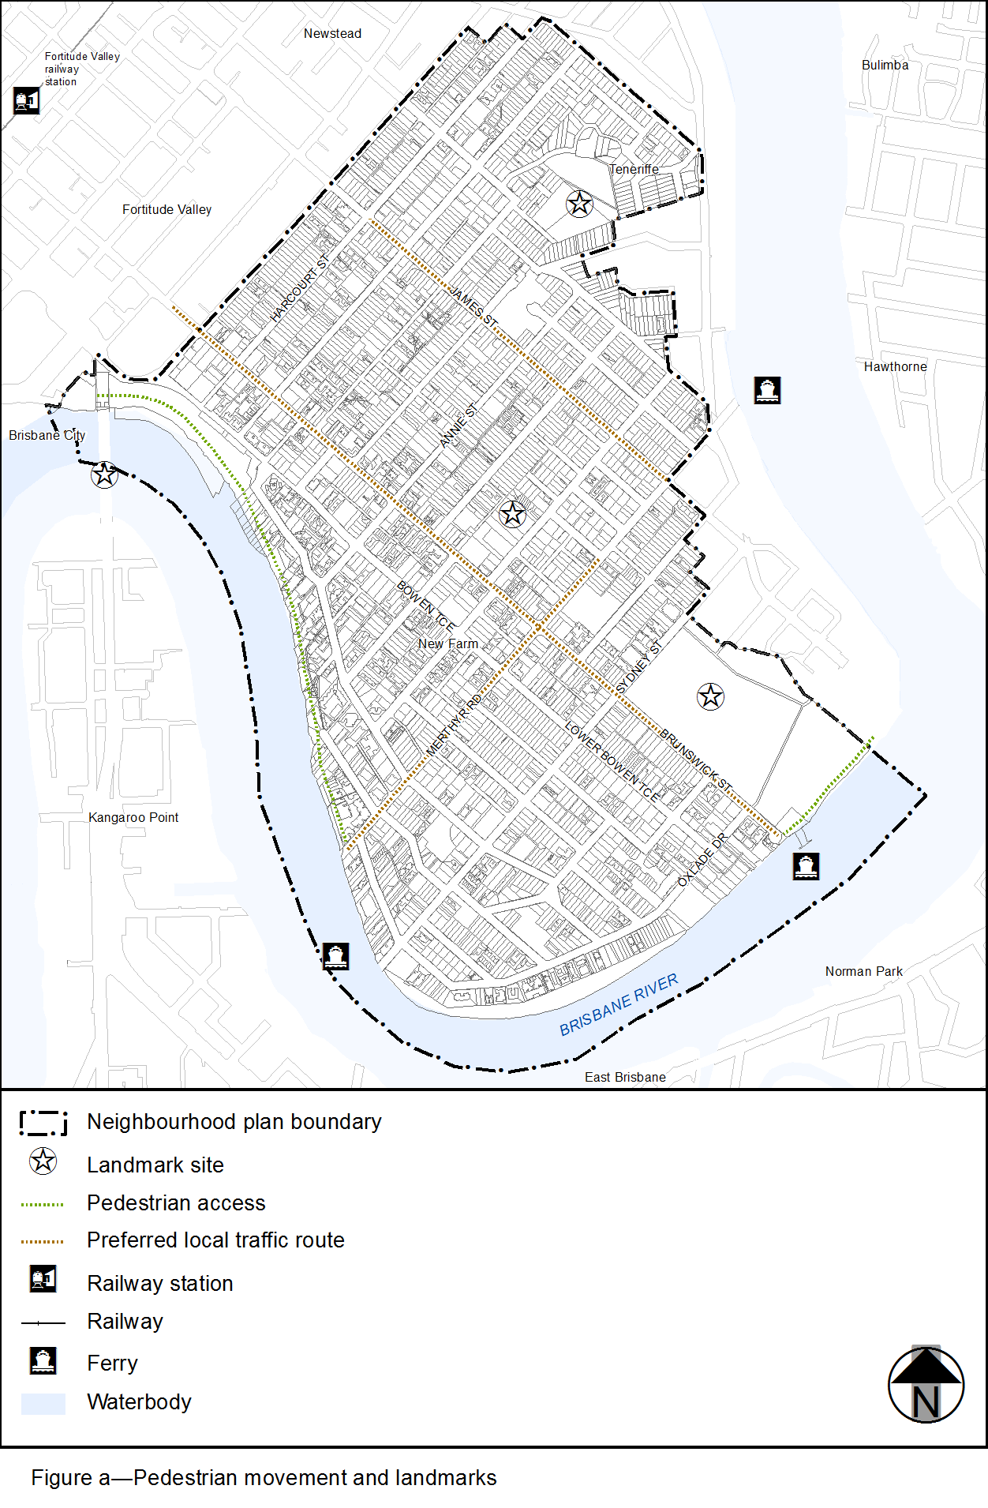
View the high resolution of Figure a–Pedestrian movement and landmarks (PDF file size is 430Kb)
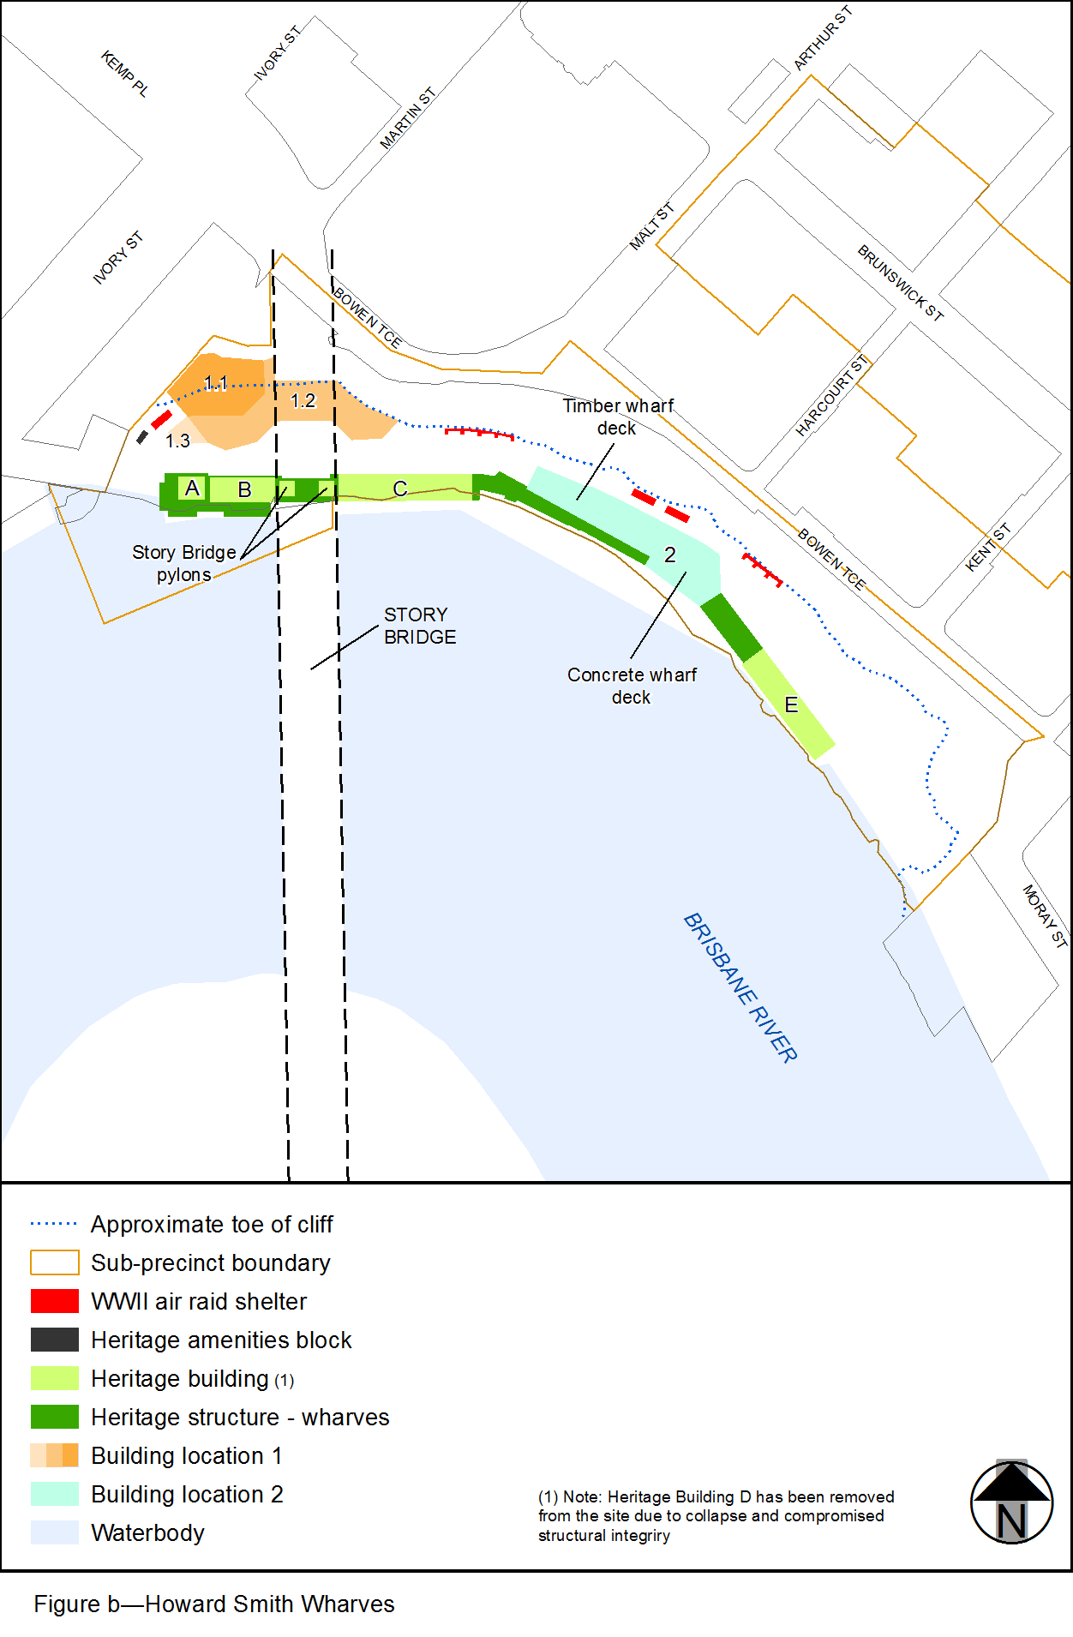
View the high resolution of Figure b–Howard Smith Wharves (PDF file size is 111Kb)

