7.2.18.3 River gateway neighbourhood plan code

7.2.18.3.1 Application
- This code applies to assessing a material change of use, reconfiguring a lot, operational work or building work in the River gateway neighbourhood plan area if:
- assessable development where this code is an applicable code identified in the assessment criteria column of a table of assessment for a neighbourhood plan (section 5.9); or
- impact assessable development.
- Land in the River gateway neighbourhood plan area is identified on the NPM-018.3 River gateway neighbourhood plan map and includes the following precincts:
- Morningside precinct (River gateway neighbourhood plan/NPP-001):
- Low–medium density residential sub-precinct (River gateway neighbourhood plan/NPP-001a);
- District centre sub-precinct (River gateway neighbourhood plan/NPP-001b).
- NPP-002: Seven Hills TAFE precinct (River gateway neighbourhood plan/NPP-002);
- NPP-003: Cannon Hill/Murarrie precinct (River gateway neighbourhood plan/NPP-003):
- Low–medium density residential sub-precinct (River gateway neighbourhood plan/NPP-003a);
- Wynnum Road corridor sub-precinct (River gateway neighbourhood plan/NPP-003b);
- Cannon Hill shopping centre sub-precinct (River gateway neighbourhood plan/NPP-003c);
- Park Hill south sub-precinct (River gateway neighbourhood plan/NPP-003d);
- Former CSIRO site sub-precinct (River gateway neighbourhood plan/NPP-003e);
- Cannon Hill Station sub-precinct (River gateway neighbourhood plan/NPP-003f).
- Minnippi precinct (River gateway neighbourhood plan NPP-004);
- Industry precinct (River gateway neighbourhood plan NPP-005).
- When using this code, reference should be made to section 1.5, section 5.3.2 and section 5.3.3.
Note—This neighbourhood plan includes a table of assessment with level of assessment variations to those in sections 5.5, 5.6, 5.7, 5.8 and 5.10. Refer to Table 5.9.58.A, Table 5.9.58.B, Table 5.9.58.C and Table 5.9.58.D.

7.2.18.3.2 Purpose
- The purpose of the River gateway neighbourhood plan code is to provide finer grained planning at a local level for the River gateway neighbourhood plan area.
- The purpose of the River gateway neighbourhood plan code will be achieved through overall outcomes including overall outcomes for each precinct of the neighbourhood plan area.
- The overall outcomes for the neighbourhood plan area are:
- The River gateway area is developed as a distinct, mixed use area, supporting additional housing opportunities, improved connectivity and additional local shops, cafes, services and facilities, as well as small- to medium-scale commercial and industrial development.
- Development is of scale and form that protects nearby residents and respects the interface of adjoining areas by carefully managing transitions.
- Development does not constrain the ability of existing development to operate.
- Development protects and enhances the long-term viability of environmentally significant areas, regional ecosystems, fauna habitat and movement corridors. The Seven Hills Bushland Reserve and Minnippi Parklands continue to provide a range of sustainable open space and recreational opportunities.
- Development is of a height, scale and form which is consistent with the amenity and character, community expectations and infrastructure assumptions intended for the relevant precinct, sub-precinct or site and is only developed at a greater height, scale and form where there is both a community need and an economic need for the development.
- Morningside precinct (River gateway neighbourhood plan/NPP-001) overall outcomes are:
- This precinct provides for a range of residential, retail and commercial uses along Wynnum Road which contributes to the revitalisation of the area into a vibrant urban village within the neighbourhood plan area.
- The mixed use area on the south eastern side of Wynnum Road extends through to Key Street and provides for site amalgamation and rear access. Site amalgamation is supported through a range of plot ratios. Redevelopment fronting Key Street is restricted to residential use and provides a transition in height to the residential area beyond. A similar transition in height is provided north of Wynnum Road.
- Increased plot ratios within the Low–medium density residential zone are supported to increase the viability of redevelopment and to provide for high-quality development outcomes.
- Building setbacks and land dedications will be required for new development on lots fronting Wynnum Road to provide for future road widening and creating a subtropical boulevard.
- The amalgamation of properties provides an opportunity to reduce the number of access ways and the number of vehicles accessing directly onto Wynnum Road.
- Development in this precinct cannot expect the same level of noise amenity as other parts of the city, due to the proximity of Brisbane Airport and its associated aircraft noise.
- Impact assessable uses consistent with the outcomes sought include:
- outdoor sales, industry or entertainment facility;
- service station where in the District centre sub-precinct (River gateway neighbourhood plan/NPP-001b).
- Seven Hills TAFE precinct (River gateway neighbourhood plan/NPP-002) overall outcomes are:
- Future redevelopment delivers residential and community uses that sensitively integrate with the character and scale of the neighbouring Low density residential zone, focusing on high-quality, ecologically sustainable design outcomes.
- Development delivers housing diversity, catering for a range of household types, and aged care.
- Development sensitively responds to the site topography and views from the surrounding area and maintains the vegetated character of the site.
- Significant bushland is preserved and additional public open space is provided for the recreational needs of residents within the precinct.
- The existing theatre complex is retained for community uses.
- The environmental and hydraulic characteristics of Perrin Creek are protected and managed.
- A safe and attractive pedestrian and cycle network provides direct, convenient access to local shops at The Corso, open space, schools and public transport and a local road network provides access through the site.
- Future redevelopment will require a structure plan that includes strategies to protect significant vegetation.
- Development in this precinct cannot expect the same level of noise amenity as other parts of the city, due to the proximity of Brisbane Airport and its associated aircraft noise.
- Cannon Hill/Murarrie precinct (River gateway neighbourhood plan/NPP-003) overall outcomes are:
- A range of residential, retail and commercial uses contribute to the revitalisation of Wynnum Road. Growth in this precinct provides for increased housing diversity, additional employment opportunities and greater use of active and public transport modes.
- Medium density residential development on the southern side of Wynnum Road provides a distinct break between the commercial nodes centred around the intersections with Creek Road and Barrack Road.
- Vehicular access to commercial, residential and mixed use development is encouraged at the rear of properties or side streets, rather than from Wynnum Road, in order to minimise traffic impacts on Wynnum Road.
- Building setbacks and land dedications will be required for new development on lots fronting Wynnum Road to allow for future road widening and creating a subtropical boulevard.
- Development must be compatible with the safety, security and operational requirements of the Brisbane Airport.
- Development in the Low–medium density residential sub-precinct (River gateway neighbourhood plan/NPP-003a):
- provides for additional residential densities in areas within close proximity to public transport and transitions between higher density development along the Wynnum Road corridor and nearby areas in the Low density residential zone;
- creates a new local park at Pickwick Street adjacent to the Wynnum Road corridor sub-precinct (River gateway neighbourhood plan/NPP-003b), to serve the increased population in the area south of Wynnum Road.
- Development in the Wynnum Road corridor sub-precinct (River gateway neighbourhood plan/NPP-003b):
- achieves a mix of land uses with centre activities and medium density residential development. Redevelopment of existing residential properties in this area supports the development of additional local shops, cafes, services and facilities, as well as small- to medium-scale commercial development;
- provides deep planting along the Wynnum Road frontages of areas in the Medium density residential zone, to act as a visual break to the built to boundary frontages of the adjacent mixed use areas, providing interest and variety for street users;
- provides transitions in scale to the adjoining residential areas, helping to preserve the character of the area and minimise potential shadowing and surveillance impacts;
- Development in this precinct cannot expect the same level of noise amenity as other parts of the city, due to the proximity of Brisbane Airport and its associated aircraft noise.
- Development in the Cannon Hill shopping centre sub-precinct (River gateway neighbourhood plan/NPP-003c):
- revitalises it as a mixed use centre, capitalising on its prominent position at the junction of Wynnum Road and Creek Road, with the Cannon Hill bus interchange on the western portion of the site;
- ensures that expansion or redevelopment of the Cannon Hill shopping centre exhibits a high standard of urban design and activates the frontage to Wynnum Road and Creek Road. Development provides for safe and convenient access across the site, and reduces the visual impact of open-air car parking by incorporating mature landscaping. A more-diverse land use mix in the sub-precinct is supported. Where residential activities are proposed, high- quality private open space and public realm must be provided. The ongoing operation of the Cannon Hill shopping centre is provided for in redevelopment proposals.
- Development in the Park Hill south sub-precinct (River gateway neighbourhood plan/NPP-003d):
- ensures that the large vacant site on the corner of Creek Road and Mitchell Boulevard is developed for low–medium density residential development that respects and preserves the amenity of the existing residential area;
- provides a connection to a new pedestrian and cycle link to the railway station to the west.
- Development in the Former CSIRO site sub-precinct (River gateway neighbourhood plan/NPP-003e):
- capitalises on its prominent location at the junction of Wynnum Road and Creek Road, and the large size and single ownership of the landholding. It will develop as a vibrant mixed use centre, accommodating a range of activities, including multiple dwellings, offices, shops, entertainment and open space;
- provides a new local park to meet the needs of residents in this sub-precinct which accommodates a range of dwelling types from low-rise townhouses to high-rise apartments;
- ensures that the district centre provides the main retail and commercial focus of the sub-precinct. It contains a variety of centre activities, including multiple dwelling, cinema, restaurant, shop, indoor sport and recreation, office and hotel uses, as well as publicly accessible, privately owned open space;
- comprising larger commercial and mixed use buildings positions them along Wynnum Road and Creek Road to respond to the high traffic exposure of these roads. Such development provides pedestrian access to the adjoining Southgate Business Park and the Cannon Hill railway station. Pedestrian movement is also facilitated through the site to provide convenient access to the Cannon Hill shopping centre and Cannon Hill bus interchange.
- Development in the Cannon Hill Station sub-precinct (River gateway neighbourhood plan NPP-003f):
- cannot expect the same level of noise amenity as other parts of the city, due to the proximity of Brisbane Airport and its associated aircraft noise.
- in the area to the south of the Cannon Hill railway station is medium density residential development, increasing housing choice in close proximity to high-frequency public transport and the Southgate Business Park.
- Minnippi precinct (River gateway neighbourhood plan/NPP-004) overall outcomes are:
- A network of shared bikeways and pedestrian pathways improve circulation and linkages to external features and communities, including Murarrie Recreation Reserve, Cannon Hill Shopping Centre, surrounding residential areas, Bulimba Creek and Minnippi Parklands from Creek Road and between Ellen Street and Wynnum Road.
- Industry precinct (River gateway neighbourhood plan/NPP-005) overall outcomes are:
- Development comprising the consolidation of existing uses is consistent with the outcomes sought in established industrial areas where impacts on existing sensitive zones are managed through separation distances. Separation distances between industry and sensitive zones are a minimum of 250m for medium impact industry and 500m for high impact industry, unless it can be demonstrated that emissions and risks can be quantified and effectively managed to achieve appropriate environmental outcomes.
- Existing parks and outdoor sport and recreation facilities within the precinct are retained.
- Pedestrian and bicycle connections to the riverside parks are improved. Development provides for a new off-road pedestrian/bicycle pathway connecting Colmslie Recreation Reserve and Colmslie Beach Reserve.
- Special industries are not consistent with the outcomes sought.

7.2.18.3.3 Assessment criteria
The following table identifies assessment criteria for assessable development.

Table 7.2.18.3.3.A—Criteria for assessable development
Performance outcomes | Acceptable outcomes
PO1  Development is of a height, scale and form that achieves the intended outcome for the precinct, improves the amenity of the neighbourhood plan area, contributes to a cohesive streetscape and built form character and is:  - consistent with the anticipated density and assumed infrastructure demand;  - aligned to community expectations about the number of storeys to be built;  - proportionate to and commensurate with the utility of the site area and frontage width;  - designed to avoid a significant and undue adverse amenity impact to adjoining development;  - sited to enable existing and future buildings to be well separated from each other and to avoid affecting the potential development of adjoining sites.  Note—Development that exceeds the intended number of storeys or building height can place disproportionate pressure on the transport network, public space or community facilities in particular.  Note—Development that is over-scaled for its site can result in an undesirable dominance of vehicle access, parking and manoeuvring areas that significantly reduce streetscape character and amenity. | AO1.1  Development complies with the number of storeys and building height in Table 7.2.18.3.3.B.  Note—Neighbourhood plans will mostly specify a maximum number of storeys where zone outcomes have been varied in relation to building height. Some neighbourhood plans may also specify height in metres. Development must comply with both parameters where maximum number of storeys and height in metres are specified.
AO1.2
Development has a maximum plot ratio that complies with Table 7.2.18.3.3.C.
AO1.3
Development has boundary setbacks that comply with Table 7.2.18.3.3.D.
Note—For development that fronts a street that is subject to a road-widening requirement, the minimum building setback is to be measured from the new property boundary.
PO2  Development provides a range of open space and recreational opportunities that meet the needs of the community. | AO2  Development incorporates future parks in accordance with Figure d.
PO3  Development of a sensitive use on land that is affected by environmental emissions generated by an operational rail corridor are:  - suitably located and orientated on the site;  - designed and finished to mitigate noise intrusion. | AO3  No acceptable outcome is prescribed.
If in the Morningside precinct (River gateway neighbourhood plan/NPP-001) or the Cannon Hill/Murarrie precinct (River gateway neighbourhood plan/NPP-003)
PO4  Development of buildings incorporates a design and form typology that:  - creates an interesting and cohesive streetscape;  - enables existing and future buildings to be well separated from each other to allow light penetration, air circulation and privacy and ensure windows are not built out by adjoining buildings;  - does not prejudice the development of adjoining sites;  - does not dominate the street or other pedestrian space;  - provides variation in building form, height and materials, and an articulated facade;  - sensitively responds to changes in topography and gradients. | AO4  Development above the second storey is:  - no more than 75% of the width of the site; or  - a maximum of 30m in any direction.  Note—The lesser of (a) or (b) is to be used.
PO5  Development protects the amenity of adjoining areas by:  - minimising impacts, including overshadowing, overlooking, and visual dominance;  - providing an appropriate interface by stepping down in height and scale at site boundaries;  - maintaining natural ventilation and light penetration to neighbouring habitable rooms, balconies and private open space. | AO5.1  Development adjoining a building height transition area shown in Figure c or Figure d has a maximum building height of 3 storeys within 10m of the common property boundary.
AO5.2
Development adjoining a building height transition area shown in Figure c has a maximum building height of 2 storeys within 10m from any property boundary if fronting Key Street.
AO5.3
Development fronting Key Street, Morningside or Ludwick Street, Cannon Hill within the building height transition area as shown in Figure a and Figure b is used for residential purposes only.
PO6  Development fronting Wynnum Road does not result in a significant increase in vehicular traffic entering and exiting onto Wynnum Road. | AO6  Development on Wynnum Road that does not achieve vehicle access from a rear lane or adjoining lane is limited to:  - a maximum building height of 3 storeys;  - a maximum plot ratio of 100%.
PO7  Development maintains the predominantly residential character of Ragoona Street. | AO7  Development above ground level and fronting Ragoona Street is for residential purposes only.
If in the Seven Hills TAFE precinct (River gateway neighbourhood plan/NPP-002)
PO8  Development achieves an integrated long-term vision for the site and demonstrates the following:  - residential development with a range of housing types, including dwelling houses;  - a mix of building heights to create interesting internal streetscapes;  - building heights above 3 storeys and up to 5 storeys concealed in the landscape and maintenance of the vegetated character of the site;  - preservation of amenity, outlook and levels of sunlight enjoyed by adjoining residents;  - building layout, heights and form that are sympathetic to views and vistas from public areas within and to/from the precinct;  - retention and protection of a minimum 1.1ha of existing bushland as a single area to the east of the site;  - new public open space of 2,500m2 minimum to meet the needs of the residents;  - dedication of 5,000m2 of land to Council for an integrated community hub;  - provision and dedication of land for a minimum of 50 car parking spaces to serve the integrated community hub;  - provision of performing arts space and community services space, including and retaining the existing theatre complex as part of the integrated community hub;  - a new local road network that provides access through the site, serving residential development, theatre complex and parkland;  - pedestrian and bicycle networks that provide connectivity to schools, shops, parks and public transport;  - infrastructure, including water, sewer and stormwater meets the needs of the development.  Note—A structure plan prepared in accordance with the Structure planning planning scheme policy can assist in demonstrating the achievement of this outcome.  Note—Development of the public open space is to be located west of the existing theatre.  Note—Further residential driveway access is not to be provided from D’Arcy Road. | AO8  No acceptable outcome is prescribed.
If in the Cannon Hill/Murarrie precinct (River gateway neighbourhood plan/NPP-003), where in the Cannon Hill shopping centre sub-precinct (River gateway neighbourhood plan/NPP-003c)
PO9  Development, redevelopment or expansion of the Cannon Hill Shopping Centre achieves the following:  - diversified land uses including shops, offices and residential, in accordance with Table 7.2.18.3.3.E;  - reduced building bulk and scale by using podium and tower building typology elements;  - podium heights that are a minimum of 2 storeys and built to the side boundary for a minimum distance of 10m from the front property boundary;  - podium levels occupied by retail, office or entertainment uses;  - podium wall planes articulated by providing recesses and projections, using a range of materials including glass to avoid creating a featureless or overbearing building facade;  - tower elements set back an average of 6m from the street frontage to reduce the visual dominance of the building in the streetscape;  - individual tower elements with a maximum building footprint of 1,200m2.  Note—This can be demonstrated using a concept plan. | AO9  No acceptable outcome is prescribed.
If in the Cannon Hill/Murarrie precinct (River gateway neighbourhood plan/NPP-003), where in the Park Hill south sub-precinct (River gateway neighbourhood plan/NPP-003d)
PO10  Development sensitively manages the interface to the adjoining 2-storey residential area. | AO10  Development provides a deep planted area with a minimum dimension of 4m along frontage to Mitchell Boulevard, Calliope Circuit and Rosewood Place.
If in the Cannon Hill/Murarrie precinct (River gateway neighbourhood plan/NPP-003), where in the Former CSIRO site sub-precinct (River gateway neighbourhood plan/NPP-003e)
PO11  Development includes new public open space to meet the recreational needs of residents and workers. | AO11  Development includes a minimum of 17.5% of the total site area (59,750m2) as publicly accessible open space as follows:  - a minimum of 2,500m2 of land is dedicated to Council for a local park, to be provided as a single parcel, centrally located within the Low–medium residential density zone of the site;  - 2 separate sites of publicly accessible, privately owned open space within the District centre zone with a minimum size of:  - 1,930m2;  - 2,070m2;  - a minimum of 1,500m2 of publicly accessible, privately owned open space in the Low–medium density residential zone.
PO12  Development within the District centre zone achieves a mix of uses, which complements the existing uses in the surrounding area. | AO12.1  Development within the District centre zone provides a range of land uses in accordance with Table 7.2.18.3.3.E.
AO12.2
Multistorey buildings within the District centre zone comprise non-residential centre activities on podium levels with either commercial or residential activities above.
AO12.3
Development for shop and restaurant uses on the site does not exceed 6,300m2, including:
- 1 shop being a supermarket of a maximum gross floor area of 2,500m2;
- other shops tenancies not exceeding 1,000m2 in gross floor area.
PO13  Development provides for safe and convenient vehicular access to Wynnum Road and Creek Road. | AO13  Development ensures new vehicular access and road layouts are constructed and dedicated to Council as specified in Figure d.

Table 7.2.18.3.3.B—Maximum building height
Development | Site area | Maximum building height (storeys(m))
If in the Morningside precinct (River gateway neighbourhood plan/NPP-001)
Development in the Morningside precinct (River gateway neighbourhood plan/NPP-001), where in the Low–medium density residential sub-precinct (River gateway neighbourhood plan/NPP-001a) | Not specified | 3 (9.5m)
Development in the Morningside precinct (River gateway neighbourhood plan/NPP-001), where in the District centre sub-precinct (River gateway neighbourhood plan/NPP-001b) | Less than 800m2 | 3 (11.5m)
 | 800m2 or greater | 5
If in the Cannon Hill/Murarrie precinct (River gateway neighbourhood plan/NPP-003)
Development in the Cannon Hill/Murarrie precinct (River gateway neighbourhood plan/NPP-003), where in the Low–medium density residential sub-precinct (River gateway neighbourhood plan/NPP-003a) | Not specified | 3 (9.5m)
Development in the Cannon Hill/Murarrie precinct (River gateway neighbourhood plan/NPP-003), where in the Wynnum Road corridor sub-precinct (River gateway neighbourhood plan/NPP-003b) where in the District centre zone | Less than 800m2 | 3 (11.5m)
 | 800m2 or greater | 5
Development in the Cannon Hill/Murarrie precinct (River gateway neighbourhood plan/NPP-003), where in the Wynnum Road corridor sub-precinct (River gateway neighbourhood plan/NPP-003b) where in the Medium density residential zone | Less than 800m2 | 3 (9.5m)
 | 800m2 or greater | 5
Development in the Cannon Hill/Murarrie precinct (River gateway neighbourhood plan/NPP-003), where in the Cannon Hill shopping centre sub-precinct (River gateway neighbourhood plan/NPP-003c) | Not specified | 5
Development in the Cannon Hill/Murarrie precinct (River gateway neighbourhood plan/NPP-003), where in the Park Hill south sub-precinct (River gateway neighbourhood plan/NPP-003d) | Not specified | 3 (9.5m)
 | Where within 20m of Mitchell Boulevard, Rosewood Place and Calliope Circuit | 2 (9.5m)
Development in the Cannon Hill/Murarrie precinct (River gateway neighbourhood plan/NPP-003), where in the Former CSIRO site sub-precinct (River gateway neighbourhood plan/NPP-003e) and in the Low–medium density residential zone | Not specified | 3 (9.5m)
Development in the Cannon Hill/Murarrie precinct (River gateway neighbourhood plan/NPP-003), where in the Former CSIRO site sub-precinct (River gateway neighbourhood plan/NPP-003e) and in the District centre zone | Not specified | 6–9
Development in the Cannon Hill/Murarrie precinct (River gateway neighbourhood plan/NPP-003), where in the Cannon Hill Station sub-precinct (River gateway neighbourhood plan/NPP-003f) and in the Medium density residential zone | Less than 800m2 | 3 (9.5m)
 | 800m2 or greater | 5
Note—In the Former CSIRO site sub-precinct NPP-003e refer to Figure e for maximum building heights locations.

Table 7.2.18.3.3.C—Maximum plot ratio
Development | Maximum plot ratio
If in the Morningside precinct (River gateway neighbourhood plan/NPP-001)
Development in the Morningside precinct (River gateway neighbourhood plan/NPP-001), where in the Low–medium density residential sub-precinct (River gateway neighbourhood plan/NPP-001a) | 80%
Development in Morningside precinct (River gateway neighbourhood plan/NPP-001), where in the District centre sub-precinct (River gateway neighbourhood plan/NPP-001b) | 125% where a site area is less than 800m2
 | 150% where a site area is 800m2 or greater but less than 1,200m2
 | 200% where the site area is 1,200m2 or greater
 | 150% where a site area is greater than 800m2 and with a frontage to Key Street
If in the Cannon Hill/Murarrie precinct (River gateway neighbourhood plan/NPP-003)
Development in the Cannon Hill/Murarrie precinct (River gateway neighbourhood plan/NPP-003), where in the Low–medium density residential sub-precinct (River gateway neighbourhood plan/NPP-003a) | 80%
Development in the Cannon Hill/Murarrie precinct (River gateway neighbourhood plan/NPP-003), where in the Wynnum Road corridor sub-precinct (River gateway neighbourhood plan/NPP-003b) and in the District centre zone | 125% where a site area is less than 800m2
 | 150% where a site area is 800m2 or greater but less than 1,200m2
 | 200% where the site area is 1,200m2 or greater
Development in the Cannon Hill/Murarrie precinct (River gateway neighbourhood plan/NPP-003), where in the Wynnum Road corridor sub-precinct (River gateway neighbourhood plan/NPP-003b) and in the Medium density residential zone | 80% where a site area is less than 800m2
 | 100% where a site area is 800m2 or greater but less than 1,200m2
 | 120% where the site area is 1,200m2 or greater but less than 2,000m2
Development in the Cannon Hill/Murarrie precinct (River gateway neighbourhood plan/NPP-003), where in the Cannon Hill shopping centre sub-precinct (River gateway neighbourhood plan/NPP-003c) | 125%
Development in the Cannon Hill/Murarrie precinct (River gateway neighbourhood plan/NPP-003), where in the Park Hill south sub-precinct (River gateway neighbourhood plan/NPP-003d) | 80% where in a Low–medium density residential zone
Development in the Cannon Hill/Murarrie precinct (River gateway neighbourhood plan/NPP-003), where in the Former CSIRO site sub-precinct (River gateway neighbourhood plan/NPP-003e) and in the Low–medium density residential zone | 145%
Development in the Cannon Hill/Murarrie precinct (River gateway neighbourhood plan/NPP-003), where in the Cannon Hill Station sub-precinct (River gateway neighbourhood plan/NPP-003f) and in the Medium density residential zone | 80% where a site area is less than 800m2
 | 100% where a site area is 800m2 or greater but less than 1,200m2
 | 150% where the site area is 1,200m2 or greater but less than 2,000m2
 | 180% where the site area is 2,000m2 or greater

Table 7.2.18.3.3.D —Minimum building setbacks ⁽¹⁾
Development | Minimum setbacks
Development | Ground storey | Second storey (centre activities excluding residential uses) | Second storey (residential uses) | Storeys 3–5
Morningside precinct (River gateway neighbourhood plan/NPP-001)
Development in the Morningside precinct (River gateway neighbourhood plan/NPP-001), where in the District centre sub-precinct (River gateway neighbourhood plan/NPP-001b) | Front – 3m  Side – 0m  Rear – 0m | Front – 0m  Side – 0m  Rear – 0m (2) | Front – 6m  Side – 3m  Rear – 6m | Front – 6m  Side – 3m  Rear – 6m
Development in the Morningside precinct (River gateway neighbourhood plan/NPP-001), where in the District centre sub-precinct (River gateway neighbourhood plan/NPP-001b) and fronting Key Street | Front – 6m  Side – 0m  Rear – 0m | Not specified | Front – 3m  Side – 3m  Rear – 9m | Front – 3m  Side – 3m (4)  Rear – 9m
Cannon Hill/Murarrie precinct (River gateway neighbourhood plan/NPP-003)
Development in the Cannon Hill/Murarrie precinct (River gateway neighbourhood plan/NPP-003), where in the Wynnum Road corridor sub-precinct (River gateway neighbourhood plan/NPP-003b) and fronting Wynnum Road | Front – 3m  Side – 0m (3)  Rear – 6m | Front – 0m  Side – 0m  Rear – 6m | Front – 3m  Side – 3m  Rear – 6m | Front – 3m  Side – 3m  Rear – 6m
Development in the Cannon Hill/Murarrie precinct (River gateway neighbourhood plan/NPP-003), where in the Wynnum Road corridor sub-precinct (River gateway neighbourhood plan/NPP-003b) and fronting Ludwick Street | Front – 6m  Side – 3m (3)  Rear – 10m | Not specified | Front – 6m  Side – 3m (3)  Rear – 10m | Front – 6m  Side – 3m (3)  Rear – 10m
Development in the Cannon Hill/Murarrie precinct (River gateway neighbourhood plan/NPP-003), where in the Park Hill south sub-precinct (River gateway neighbourhood plan/NPP-003d) | Front – 10m
Note—
(1) Where a development site is subject to a road-widening requirement, the alignment of the proposed widening is regarded as the street front property boundary.
(2) 3m is required where adjoining existing properties in a zone in the residential zones category.
(3) 10m wide easement is required to 1 side of lot.

Table 7.2.18.3.3.E—Land use mix
Development | Land use | Minimum % of total gross floor area | Maximum % of total gross floor area
Cannon Hill/Murarrie precinct (River gateway neighbourhood plan NPP-003)
Development in the Cannon Hill/Murarrie precinct (River gateway neighbourhood plan NPP-003), where in the Cannon Hill shopping centre sub-precinct (River gateway neighbourhood plan/NPP-003c) | Shop  Food and drink outlet | Not specified | 30%
Development in the Cannon Hill/Murarrie precinct (River gateway neighbourhood plan NPP-003), where in the Former CSIRO site sub-precinct (River gateway neighbourhood plan/NPP-003e) | Residential | 40% | 80%
 | Non-residential | 20% | 60%

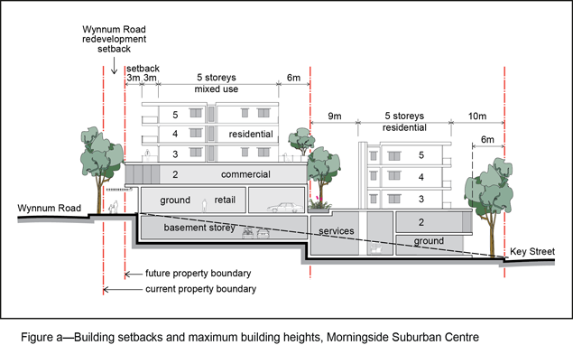
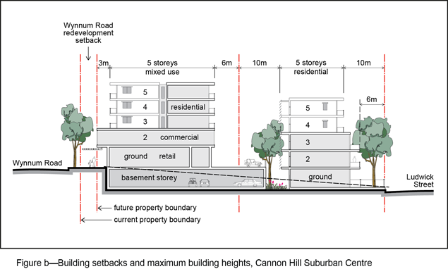
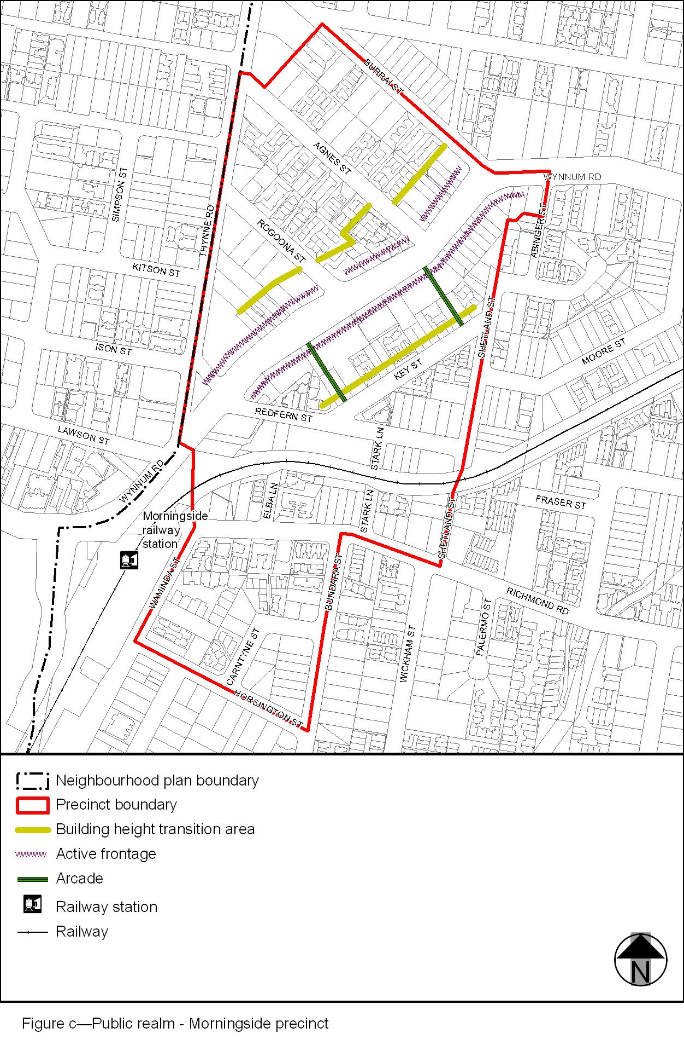
View the high resolution of Figure c–Public realm – Morningside precinct (PDF file size is 171Kb)
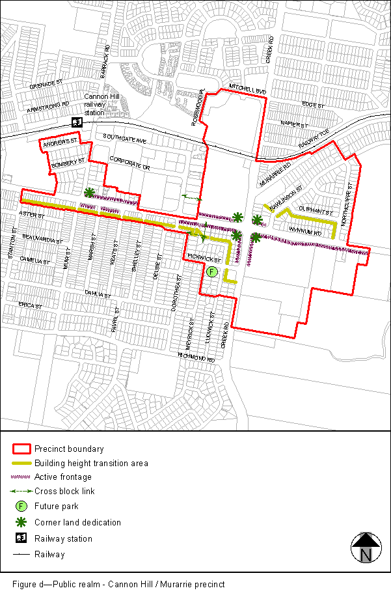
View the high resolution of Figure d–Public realm – Cannon Hill/Murarrie precinct (PDF file size is 179Kb)
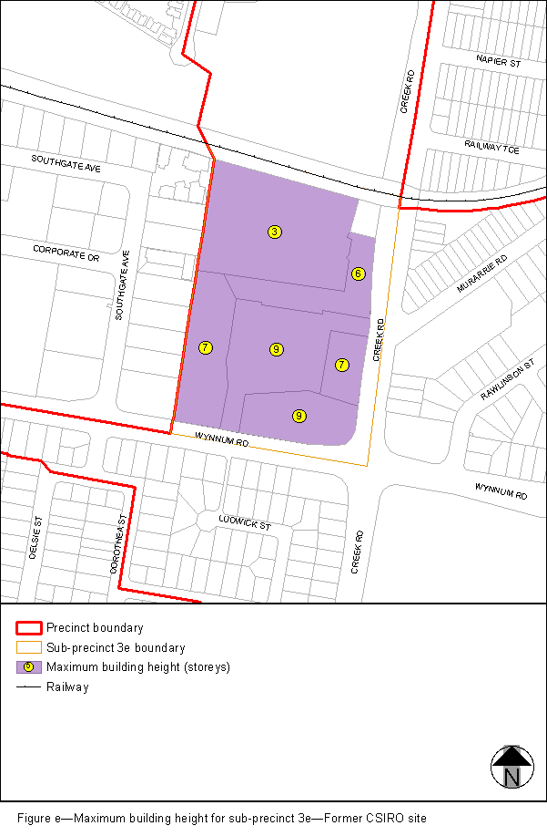
View the high resolution of Figure e–Maximum building height for sub-precinct 3e–Former CSIRO site (PDF file size is 87Kb)

