7.2.18.2 Richlands—Wacol corridor neighbourhood plan code

7.2.18.2.1 Application
- This code applies to assessing a material change of use, reconfiguring a lot, operational work or building work in the Richlands—Wacol corridor neighbourhood plan area if:
- assessable development where this code is an applicable code identified in the assessment criteria column of a table of assessment for a neighbourhood plan (section 5.9); or
- impact assessable development.
- Land within the Richlands Wacol corridor neighbourhood plan area is identified on the NPM-018.2 Richlands—Wacol corridor neighbourhood plan map and includes the following precincts:
- Wacol industrial precinct (Richlands—Wacol corridor neighbourhood plan/NPP-001):
- Sanananda Barracks industrial sub-precinct (Richlands—Wacol corridor neighbourhood plan NPP-001a);
- Sanananda Barracks mixed industry and business sub-precinct (Richlands—Wacol corridor neighbourhood plan NPP-001b).
- Richlands central precinct (Richlands—Wacol corridor neighbourhood plan/NPP-002):
- Richlands rail hub sub-precinct (Richlands—Wacol corridor neighbourhood plan/NPP-002a);
- Richlands core sub-precinct (Richlands—Wacol corridor neighbourhood plan/NPP-002b);
- Richlands frame sub-precinct (Richlands—Wacol corridor neighbourhood plan/NPP-002c;).
- Richlands east precinct (Richlands—Wacol corridor neighbourhood plan/NPP-003):
- Queensland Police Service Academy sub-precinct (Richlands—Wacol corridor neighbourhood plan/NPP-003a).
- When using this code, reference should be made to section 1.5, section 5.3.2 and section 5.3.3.
Note—This neighbourhood plan includes a table of assessment with level of assessment variations to those in sections 5.5, 5.6, 5.7, 5.8 and 5.10. Refer to Table 5.9.57.A, Table 5.9.57.B, Table 5.9.57.C and Table 5.9.57.D.

7.2.18.2.2 Purpose
- The purpose of the Richlands—Wacol corridor neighbourhood plan code is to provide finer grained planning at a local level for the Richlands—Wacol corridor neighbourhood plan area.
- The purpose of the Richlands—Wacol corridor neighbourhood plan code will be achieved through overall outcomes including overall outcomes for each precinct of the neighbourhood plan area.
- The overall outcomes for the neighbourhood plan area are:
- Richlands and Wacol are strategically important industrial areas of Brisbane and are major employment generators.
- The Richlands railway station is a key catalyst in developing a central economic hub providing a variety of commercial and retail services that are accessible by public transport and support local industrial and residential areas.
- Transport improvements including key road network upgrades and new local road connections, improve travel throughout the growing industrial and residential areas. Connections from the area to the surrounding highways and motorways are managed by the state government.
- Community facilities are co-located with public open space. Part of the former Richlands State School site is retained for community facilities.
- Development is of a height, scale and form which is consistent with the amenity and character, community expectations and infrastructure assumptions intended for the relevant precinct, sub-precinct or site and is only developed at a greater height, scale and form where there is both a community need and an economic need for the development.
- Wacol industrial precinct (Richlands—Wacol corridor neighbourhood plan/NPP-001) overall outcomes are:
- The precinct provides a strategic economic development and employment area within Brisbane's western industrial corridor and is developed for:
- low impact industry;
- medium impact industry;
- high impact industry.
- Industrial areas are not compromised by the inclusion of non-industrial uses except where explicitly allowed in the Sanananda Barracks mixed industry and business sub-precinct (Richlands—Wacol corridor neighbourhood plan NP/NPP-001b).
- Development in the Sanananda Barracks industrial sub-precinct (Richlands—Wacol corridor neighbourhood plan/NPP-001a):
- supports low impact industrial development;
- ensures that access to sites within this sub-precinct is via vehicular access points to Boundary Road as shown in Figure a.
- Development in the Sanananda Barracks mixed industry and business sub-precinct (Richlands—Wacol corridor neighbourhood plan/NPP-001b):
- has uses that are consistent with the outcomes sought including low impact industrial development and a limited amount of office, food and drink outlets and shops;
- ensures any office development is located along the Boundary Road frontage to improve activation and surveillance of the street;
- ensures a small support service area not exceeding 6,000m2 in gross floor area is located along Boundary Road that supports the function of the Wacol industrial precinct (Richlands—Wacol corridor neighbourhood plan/NPP-001). This accommodates small scale tenancies to support local businesses. A shop (supermarket) where in excess of 1,500m2 is not consistent with the outcomes sought in this support service area;
- ensures that the National Servicemen's Association Memorial Centre (Nasho's) is publicly accessible and remains a prominent feature within the sub-precinct. A district park is located on the Nasho’s site (refer to Figure a).
- Richlands central precinct (Richlands—Wacol corridor neighbourhood plan/NPP-002) overall outcomes are:
- The industrial areas in this precinct are developed predominantly for low impact industry and medium impact industry. High impact industry is supported in specific localities at least 500m from sensitive uses.
- The southern portion of the precinct is the employment and retail centre for Richlands, with centre activities located close to the Richlands railway station.
- Residential uses surround the centre with a range of housing types and densities developed to house existing and future residents.
- Existing commercial and retail activities located outside a zone in the centre zones category or the Specialised centre zone along Government Road are redeveloped as medium density residential.
- Development in the Richlands rail hub sub-precinct (Richlands—Wacol corridor neighbourhood plan/NPP-002a):
- ensures its core function is a transport interchange and park and ride;
- ensures any redevelopment of the park and ride facility accommodates commercial office and retail uses with active ground-storey spaces;
- where land is no longer required for transport infrastructure, convenience retail uses and an indoor sport and recreation facility are consistent with the outcomes sought.
- The Richlands core sub-precinct (Richlands—Wacol corridor neighbourhood plan/NPP-002b) precinct is a retail, commercial, office, entertainment and residential area, servicing the local community and industrial areas. Development in this sub-precinct:
- ensures that new development addresses the Bullockhead Creek waterway corridors and is the focal point of design and function of the centre;
- constructs new roads in a traditional grid layout and accommodates direct and connected pedestrian and cycle paths;
- where for retail uses avoids internal malls;
- may provide temporary ground-level parking where the site forms an early stage of retail and commercial development.
- Development in the Richlands frame sub-precinct (Richlands—Wacol corridor neighbourhood plan/NPP-002c):
- supports a range of uses including high-technology low impact industry, office, educational establishment including a tertiary education facility, showrooms and larger scale retail activities;
- ensures that access to the sub-precinct is limited with no direct vehicular access to Progress Road and limited access to Garden Road;
- uses gaps between buildings to maximise views to the D’Aguilar Range, Mt Coot-tha and the Brisbane CBD;
- may provide temporary parking at ground level where the site forms an early stage of retail or commercial development.
- For development in the Richlands east precinct (Richlands — Wacol corridor neighbourhood plan/NPP-003):
- The area north of Freeman Road is developed for low impact industry and medium impact industry.
- Little Doris Creek runs east from C J Greenfield Complex and is retained as part of any development.
- New roads achieve a traditional grid layout and accommodate adequate space for pedestrian and cycle paths that form part of an integrated network.
- Development in the Queensland Police Service Academy sub-precinct (Richlands—Wacol corridor neighbourhood plan/NPP-003a):
- The Queensland Police Service Academy is expected to continue operation for the short to medium term. Should this facility close or relocate, industry, education, office park or sport and recreation uses are consistent with the outcomes sought;
- supports uses that generate high volumes of traffic due to the location of the site;
- does not support residential uses.

7.2.18.2.3 Assessment criteria
The following table identifies assessment criteria for assessable development.

Table 7.2.18.2.3.A—Criteria for assessable development
Performance outcomes | Acceptable outcomes
PO1  Development is of a height, scale and form that achieves the intended outcome for the precinct, improves the amenity of the neighbourhood plan area, contributes to a cohesive streetscape and built form character and is:  - consistent with anticipated density and assumed infrastructure demand;  - aligned to community expectations about the number of storeys to be built;  - proportionate to and commensurate with the utility of the site area and frontage width;  - designed to avoid a significant and undue adverse amenity impact to adjoining development;  - sited to enable existing and future buildings to be well separated from each other and to not avoid affecting the potential development of adjoining sites.  Note—Development that exceeds the intended number of storeys or building height can place disproportionate pressure on the transport network, public space or community facilities in particular.  Note—Development that is over-scaled for its site can result in an undesirable dominance of vehicle access, parking and manoeuvring areas that significantly reduce streetscape character and amenity. | AO1  Development complies with the number of storeys and building height in Table 7.2.18.2.3.B.  Note—Neighbourhood plans will mostly specify maximum number of storey where varying zone outcomes in relation to building height. Some neighbourhood plans may also specify height in metres. Development must comply with both parameters where maximum number of storeys and height in metres are specified.
PO2  Development on sites adjoining Bullockhead Creek waterway corridor (as shown on the Waterway corridors overlay) are designed to enable casual surveillance of the corridor public spaces to improve safety. | AO2.1  Development ensures buildings are set back a minimum of 5m from the Bullockhead Creek waterway corridor.
AO2.2
Development locates employee recreation areas and offices nearest to Bullockhead Creek and provides for passive surveillance and overlooking of the waterway corridor.
AO2.3
Development provides and maintains pedestrian access to the Bullockhead Creek pedestrian and cycleway to enable workers to easily access the open space corridor.
PO3  Development for sensitive uses located on land that is affected by environmental emissions generated by an operational rail corridor mitigates noise impacts on the development generated by the rail corridor. | AO3  No acceptable outcome is prescribed.
PO4  Development provides movement network infrastructure that is sequenced in an ordered and coordinated manner to ensure efficient connections. | AO4.1  Development provides pedestrian and bicycle paths in accordance with Figure a, Figure b and Figure d.
AO4.2
Development provides road improvements, including intersection improvements, in accordance with Figure a, Figure b and Figure c.
If in the Wacol industrial precinct (Richlands—Wacol corridor neighbourhood plan/NPP-001)
PO5  Development does not compromise the safe function and operation of the local road network. | AO5  Development does not provide vehicle access and servicing from Waterford Road where access is available from Tile Street or Clendon Street.
PO6  Development retains a vegetative buffer along the Waterford Road frontage. | AO6  Development ensures existing significant native vegetation in the buffer area is retained.
PO7  Development provides pedestrian and cycle paths that allow for:  - efficient movement through the precinct;  - promotion of walking and cycling to local mixed industry and business uses. | AO7  Development provides a pedestrian and cycle bridge over Bullockhead Creek that is constructed to allow for emergency vehicles.
If in the Wacol industrial precinct (Richlands—Wacol corridor neighbourhood plan/NPP-001), where in the Sanananda Barracks industrial sub-precinct (Richlands—Wacol corridor neighbourhood plan/NPP-001a) or the Sanananda Barracks mixed industry and business sub-precinct (Richlands—Wacol corridor neighbourhood plan/NPP-001b)
PO8  Development provides an integrated internal precinct transport network. | AO8  Development ensures access to Boundary Road is limited as shown in Figure a and no direct access is provided to the Ipswich Motorway.
If in the Wacol industrial precinct (Richlands—Wacol corridor neighbourhood plan/NPP-001), where in the Sanananda Barracks mixed industry and business sub-precinct (Richlands—Wacol corridor neighbourhood plan/NPP-001b)
PO9  Development provides a support services area with office, food and drink outlet and shop uses that:  - support the needs of the local industrial activity area;  - provide a range of commercial services that support the employees of the local industrial businesses;  - incorporate a built form and design that address the proposed park;  - have a role and function that are in accordance with the surrounding network of centres. | AO9.1  Development ensures the maximum combined gross floor area within the sub-precinct for office, food and drink outlet and shop is 6,000m².
AO9.2
Development has a maximum tenancy size that does not exceed:
- for a shop (supermarket) – 1,500m2 gross floor area;
- for an office, food and drink outlet and shop –1,000m2 gross floor area for each tenancy.
AO9.3
Development includes a maximum of 1 shop (supermarket).
AO9.4
Development ensures office, food and drink outlet and shop uses include active frontages to the proposed park as indicated in Figure a.
PO10  Development retains the National Servicemen's Association Memorial Centre for use by the National Servicemen's Association or for other community-related facilities. | AO10.1  Development retains the existing National Servicemen's Association Memorial Centre as public open space in its current location.
AO10.2
Development dedicates parkland to Council and is sufficient to retain the National Servicemen's Association Memorial Centre as indicated in Figure a.
PO11  Development ensures non-industry uses for office, food and drink outlet and shop uses, including a supermarket, are identifiable as a support services area by developing in proximity to Boundary Road and limiting building height to be comparable to surrounding industry, in accordance with Table 7.2.18.2.3.B. | AO11  Development including office, food and drink outlet and shop is sited near Boundary Road as shown in Figure a.
PO12  Development for an office achieves a compact building form to:  - retain significant native vegetation;  - provide new landscaped areas which contribute to the established ecological values of the sub-precinct;  - provide car parking. | AO12  Development provides basement car parking where sufficient setback from the root zone of significant vegetation is maintained.
PO13  Development provides a new district park which is integrated with adjoining land uses. | AO13  Development ensures the district park is integrated with and adjacent to any office, food and drink outlet or shop uses.
If in the Richlands central precinct (Richlands—Wacol corridor neighbourhood plan/NPP-002)
PO14  Development ensures:  - vehicle entrances and car parking are designed and located to minimise disruption to building frontages, the pedestrian environment and waterway corridor, to reduce the visual impact on the street environment;  - driveway crossovers maintain the integrity, quality and primacy of footpaths;  - car parking is co-located to facilitate an internal integrated vehicle circulation system between individual sites. | AO14.1  Development provides access points to Garden Road and Progress Road in accordance with Figure b.
AO14.2
Development ensures that vehicle access points where in a zone in the centre zones category are located at least 30m from each other.
AO14.3
Development adjoining or fronting a waterway corridor incorporates active frontages in buildings towards the waterway corridor.
PO15  Development promotes crime prevention through environmental design principles for pedestrians and cyclists using active transport connections located along the waterway corridors. | AO15  Development of retail premises incorporate active frontages where identified in Figure b.
PO16  Development ensures the scale and location of development is appropriate for the display and sale of bulky goods on a major road. | AO16.1  Development fronts and addresses Progress Road, Garden Road and Government Road.
AO16.2
Development is set back a maximum of 6m and a minimum of 3m from the Progress Road, Garden Road and Government Road frontage.
PO17  Development ensures a new local park is provided in the Richlands frame sub-precinct (Richlands—Wacol corridor neighbourhood plan/NPP-002c) that is accessible and preserves public access to regionally significant views. | AO17.1  Development ensures a new local park of not less than 5,000m2 is dedicated to Council. A minimum of 1,250m2 of land is dedicated to Council from each of the following sites:  - Lot 26 on SP100594;  - Lot 69 on RP72981;  - Lot 58 on RP50038;  - Lot 37 on SP127006.
AO17.2
Development ensures any existing mature vegetation is retained as part of the park.
AO17.3
Development ensures the local road network provides frontage to the new local park and provides direct pedestrian and cycle links from Garden Road and Government Road.

Table 7.2.18.2.3.B —Maximum building height, gross floor area and site specific limits
Precinct | Maximum building height (storeys/m) | Maximum gross floor area | Additional site specific limits
If in the Sanananda Barracks mixed industry and business industrial sub-precinct (Richlands—Wacol corridor neighbourhood plan NPP-001b)
Any development in this precinct | 5 storeys or 21m if located north of Boundary Road  3 storeys or 15m elsewhere | Not specified | Maximum building footprints for individual office developments is 30m x 30m  Buildings are set back a minimum of 10m from Boundary Road  Separation distance between adjacent buildings is a minimum of 10m  For lots adjoining the Boundary Road habitat and biodiversity corridor:  - building site cover does not exceed 85%;  - a building setback to the habitat and biodiversity corridor boundary is a minimum width of 3m.
Any shop, office and food and drink outlet development in the support services area | Not specified | 6,000m2 maximum combined gross floor area. | Not specified
If in the Richlands core sub-precinct (Richlands—Wacol corridor neighbourhood plan/ NPP-002a)
Any development in this precinct | 6 storeys or 21m | 150% | Not specified
If in the Richlands frame sub-precinct (Richlands—Wacol corridor neighbourhood plan/NPP-002c)
Any development in this precinct | 3 storeys or 11m | 125% | Buildings are set back a maximum of 6m and a minimum of 3m from the Progress Road, Garden Road and Government Road frontages.
If in the Richlands central precinct (Richlands—Wacol corridor neighbourhood plan/NPP-002)
Development of a site in the Medium density residential zone | 5 storeys or 18m | 125% | Not specified
If in the Richlands central precinct (Richlands—Wacol corridor neighbourhood plan/NPP-002)
Development of a site in the Medium density residential zone, where a site adjoins the Low density residential zone or the Low-medium density residential zone | 2 storeys within 10m from the common property boundary | Not specified | Development is set back a minimum of 3m from the common side and 6m from rear boundaries.
 | 4 storeys within 10m to 20m from that same property boundary | Not specified
 | 4 storeys within 10m from the property boundary to the street where a site has frontage to a local road that includes a residential area not within a sub-precinct | Not specified | The total length of any structure does not exceed 25m within 20m of the boundary.

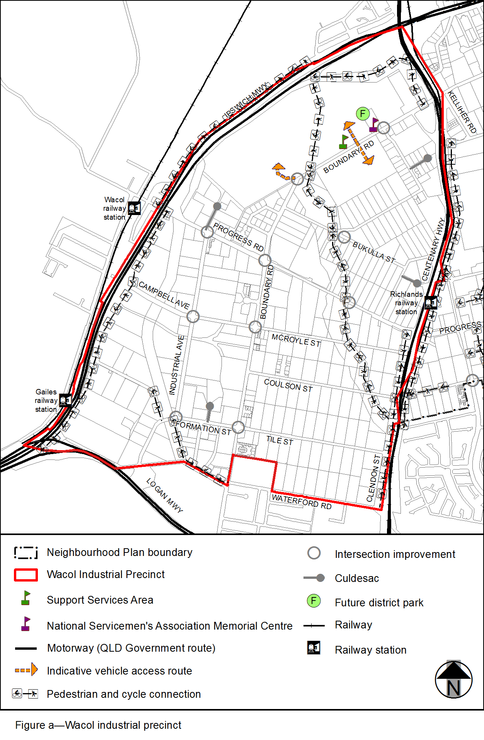
View the high resolution of Figure a–Wacol industrial precinct (PDF file size is 239Kb)
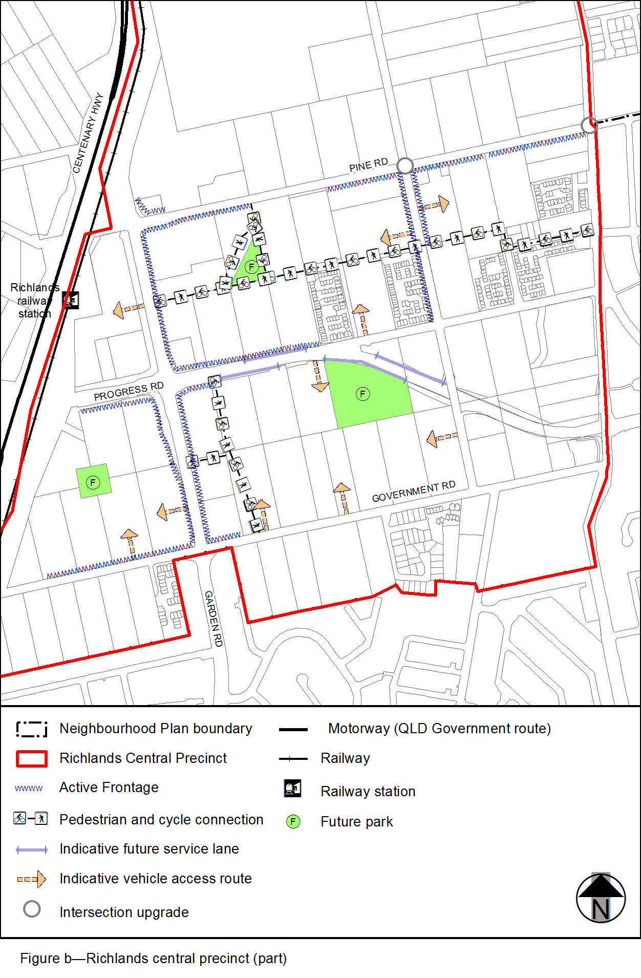
View the high resolution of Figure b–Richlands central precinct (PDF file size is 175Kb)
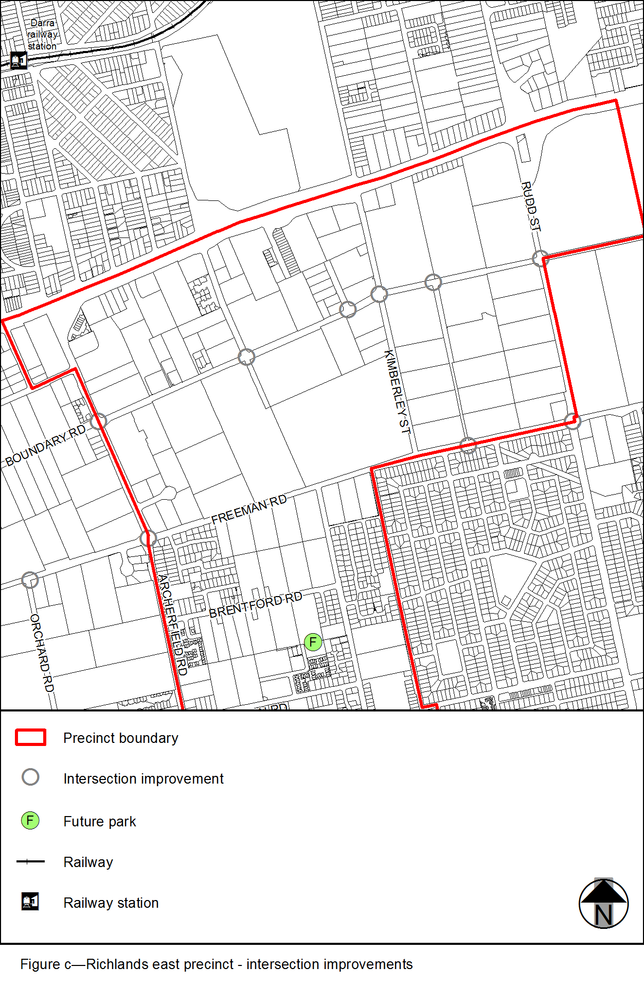
View the high resolution of Figure c–Richlands east precinct - inspection improvements (PDF file size is 169Kb)
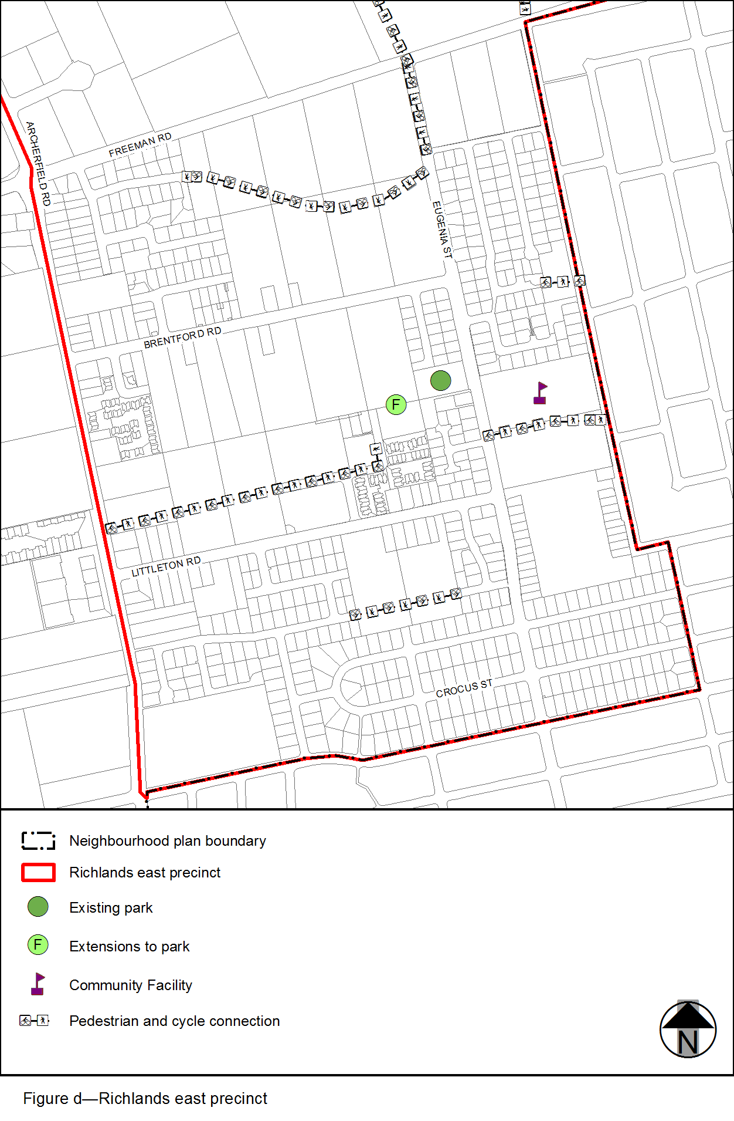
View the high resolution of Figure d–Richlands east precinct (PDF file size is 166Kb)

